

BCSE308L - Computer Networks

DIGITAL ASSIGNMENT 3
TOPIC: LATENCY Analysis using Wireshark

NAME: Ashish Bhandari

REG No: 24BCE1858

SLOT: F2 + TF2

SUBMITTED TO: Dr. T. Subbulakshmi

INTRODUCTION

Network performance is a critical factor in modern communication systems, where data is continuously transmitted across networks under varying traffic conditions. One of the key parameters that defines network performance is latency, which refers to the time delay experienced during data transmission from source to destination.
With the increasing demand for real-time applications such as video streaming, online gaming, and cloud computing, understanding how latency behaves under different traffic loads becomes essential. This Distributed Assignment (DA) focuses on analyzing network latency using Wireshark by capturing packets under normal, low, medium, and high traffic conditions. The study aims to observe how latency varies and impacts overall network efficiency.

OBJECTIVES

- To analyze network latency using Wireshark under different traffic conditions.
- To generate and compare latency values for normal, low, medium, and high traffic scenarios.
- To understand the relationship between traffic load and delay in packet transmission.
- To visualize latency variations using graphs and statistical analysis tools.
- To identify patterns and performance bottlenecks in the network based on latency behavior.

The DA was initiated using a combination of video tutorials and technical articles that explain network latency and packet analysis using Wireshark. The videos provided practical guidance on capturing and analyzing network traffic, while the articles helped in understanding the concept of latency and its impact on network performance.
These resources guided the design and execution of the experiment.

References (Links)
- https://www.youtube.com/watch?v=1Rbx_LRPABM&t=344s
- http://youtube.com/watch?v=0VO4z0_dHzI
- https://www.ibm.com/think/topics/latency
- https://www.gokinetic.com/blog/what-is-network-latency

ARCHITECTURE
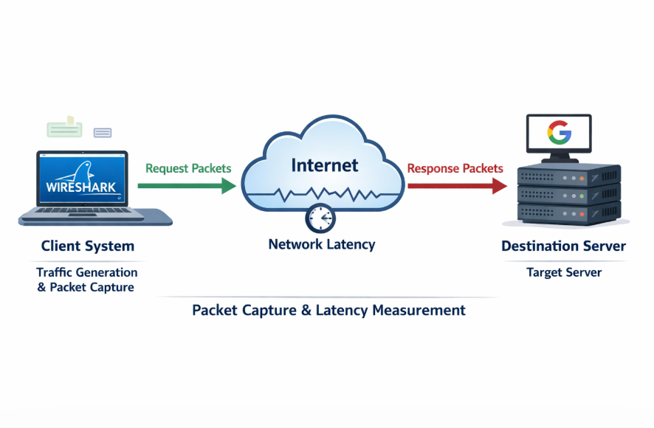
· Client system generates network traffic (using commands like ping)
· Wireshark captures all incoming and outgoing packets
· Packets travel through the internet (network introduces latency)
· Destination server receives request and sends response
· Response packets travel back to the client
· Wireshark records timestamps of request and response
· Latency is calculated using round-trip time (RTT)

PROCEDURE
- Install and open Wireshark on the system.
- Select the active network interface (Wi-Fi/Ethernet) for capturing packets.
- Click on Start Capture to begin capturing live network traffic.
- Ensure a stable internet connection before generating traffic.

Normal Traffic Generation
- Open Command Prompt / Terminal and execute:
- ping google.com
- Allow 10–15 packets to be transmitted and then stop the command.
- Stop packet capture in Wireshark and save the file as normal.pcap.

Low Traffic Generation
- Start a new capture in Wireshark.
- Generate low traffic using:
- ping -n 20 google.com
- Stop the capture after completion and save as low.pcap.

7. Medium Traffic Generation
- Start another capture session in Wireshark.
- Generate medium traffic using:
- ping -n 100 google.com
- Stop capture and save as medium.pcap.

8. High Traffic Generation
- Start a new capture session.
- Generate high traffic using:
- ping -n 500 google.com
- Stop capture and save as high.pcap.

9. Packet Filtering and Analysis
- Open each capture file and apply the filter:
icmp.type == 0
to extract ICMP Echo Reply packets containing RTT values.
- For TCP-based analysis, apply filters such as:
tcp.analysis.ack_rtt

10. Graph Generation
- Open Statistics → IO Graph in Wireshark.
- Set Y-axis to AVG / MAX / MIN / SUM
- Set Y Field as:
icmp.resptime
- Generate graphs for each traffic condition.
- Use TCP Stream Graphs (Round Trip Time Graph) for additional RTT analysis.

11. Data Recording
- Capture screenshots of all generated graphs for normal, low, medium, and high traffic conditions.
- Save all .pcap files and graphs for further analysis and documentation.

NORMAL TRAFFIC
G1_normal_avg
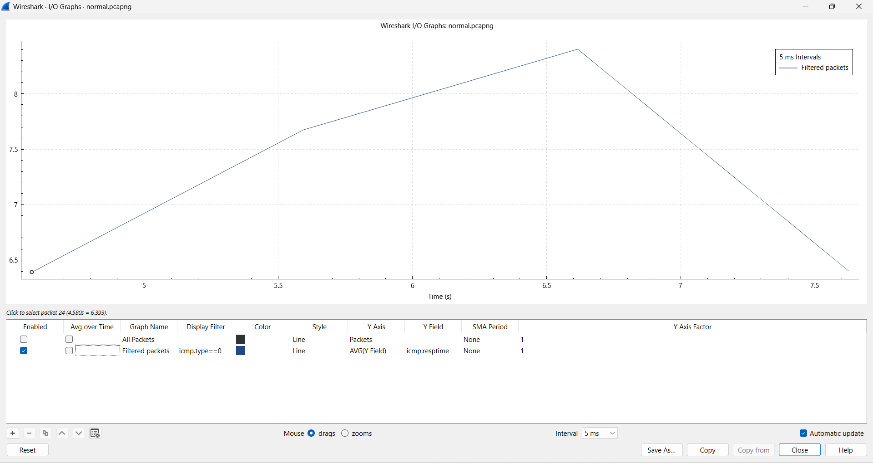
- · The average RTT remains relatively stable throughout the capture, indicating a consistent network performance under normal traffic conditions.
- · Minor fluctuations in latency are observed, which are typical due to background network processes and routing variations.
- · The absence of sharp spikes suggests that there is no congestion in the network during normal traffic.
- · The RTT values fall within a narrow range, confirming low delay and efficient packet transmission.
- · This graph establishes a baseline for comparing latency behavior under higher traffic conditions.

G2_normal_tcp.stream eq 2 && tcp.analysis.ack_rtt
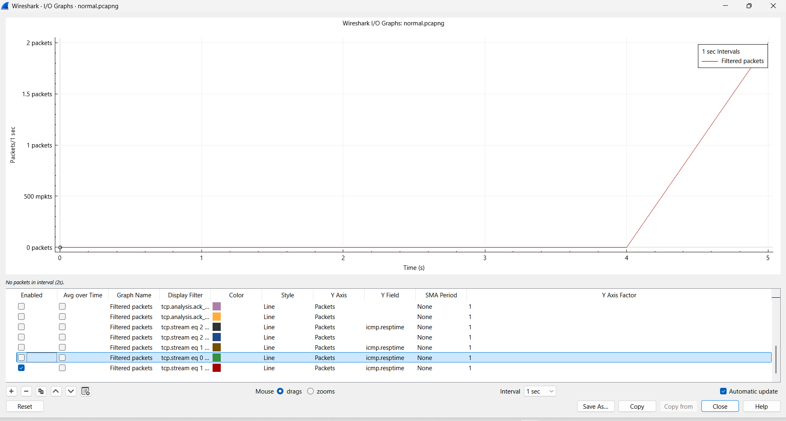
- · The average RTT remains relatively stable throughout the capture, indicating a consistent network performance under normal traffic conditions.
- · Minor fluctuations in latency are observed, which are typical due to background network processes and routing variations.
- · The absence of sharp spikes suggests that there is no congestion in the network during normal traffic.
- · The RTT values fall within a narrow range, confirming low delay and efficient packet transmission.
- · This graph establishes a baseline for comparing latency behavior under higher traffic conditions.

G3_normal_tcp.analysis.ack_rtt
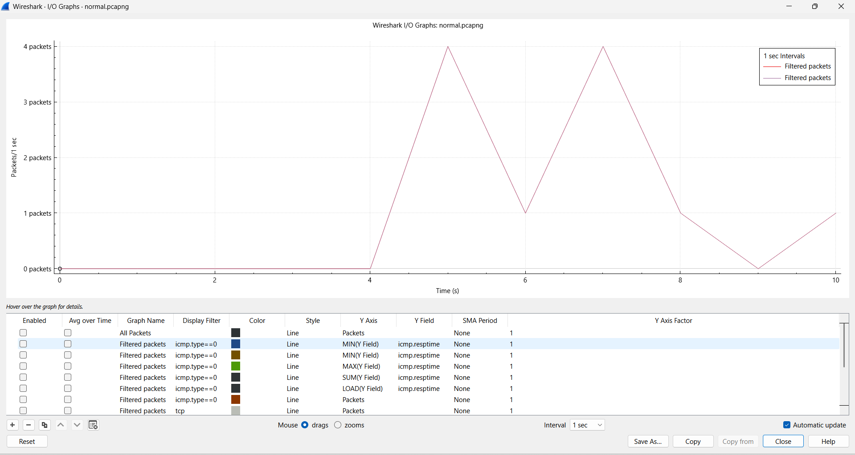
- The overall TCP RTT values remain low and consistent, indicating efficient end-to-end communication.
- Slight variations in RTT are visible due to normal TCP acknowledgment timing and network conditions.
- The absence of large deviations confirms that there is no network congestion under normal traffic.
- The graph shows that TCP connections maintain steady performance without retransmissions or delays.
- This graph validates that TCP-based latency aligns with ICMP-based latency under normal conditions.

G4_normal_rtt
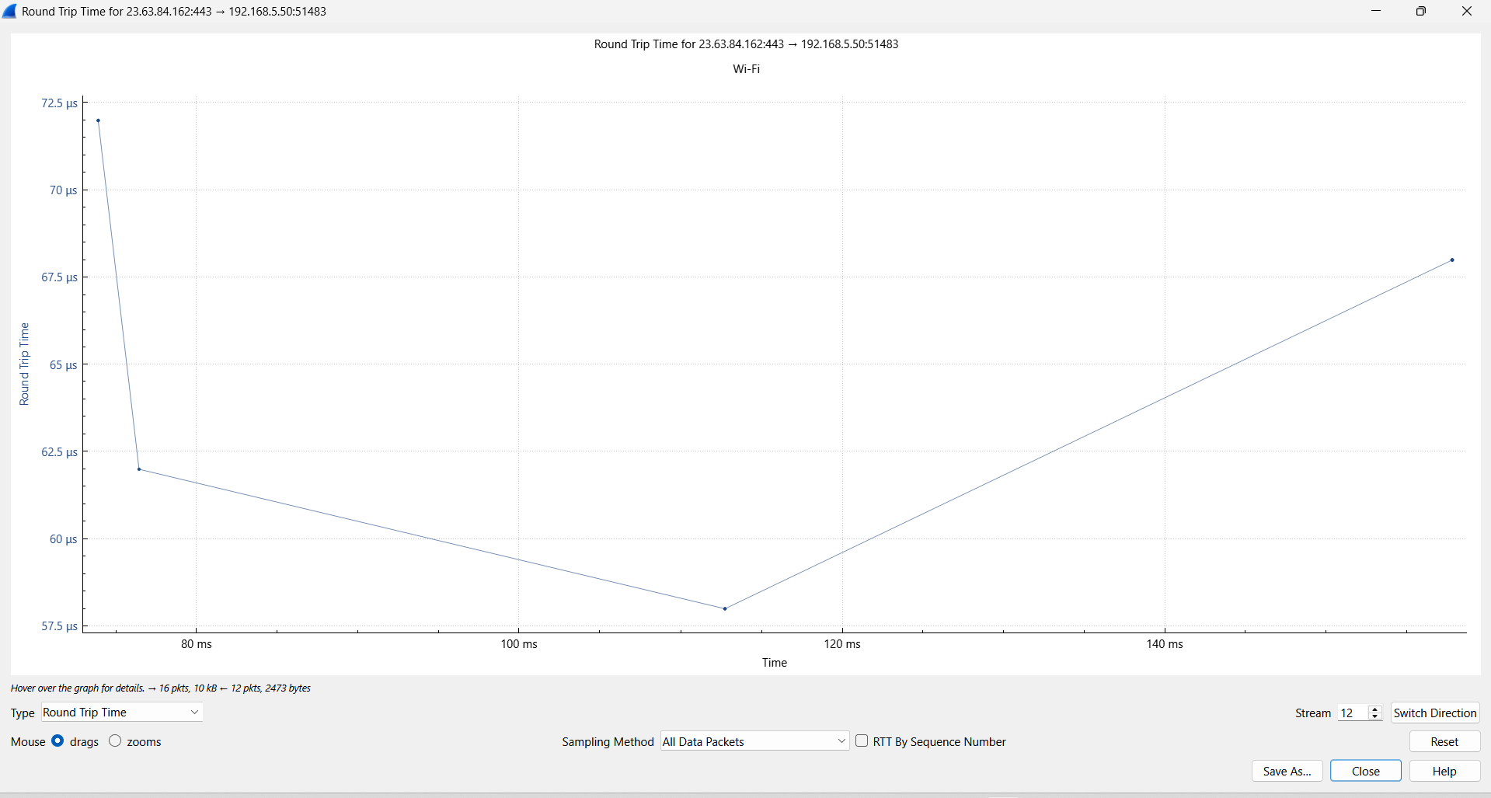
- · The RTT values exhibit a smooth pattern with gradual changes, indicating stable network behavior.
- · The lack of abrupt spikes suggests that the network is not experiencing congestion or packet loss.
- · The RTT values remain within a low range, confirming efficient data transmission.
- · The graph shows consistent timing between packet transmission and acknowledgment.
- · This behavior is characteristic of a lightly loaded network under normal traffic conditions.

G5_normal_count_frames
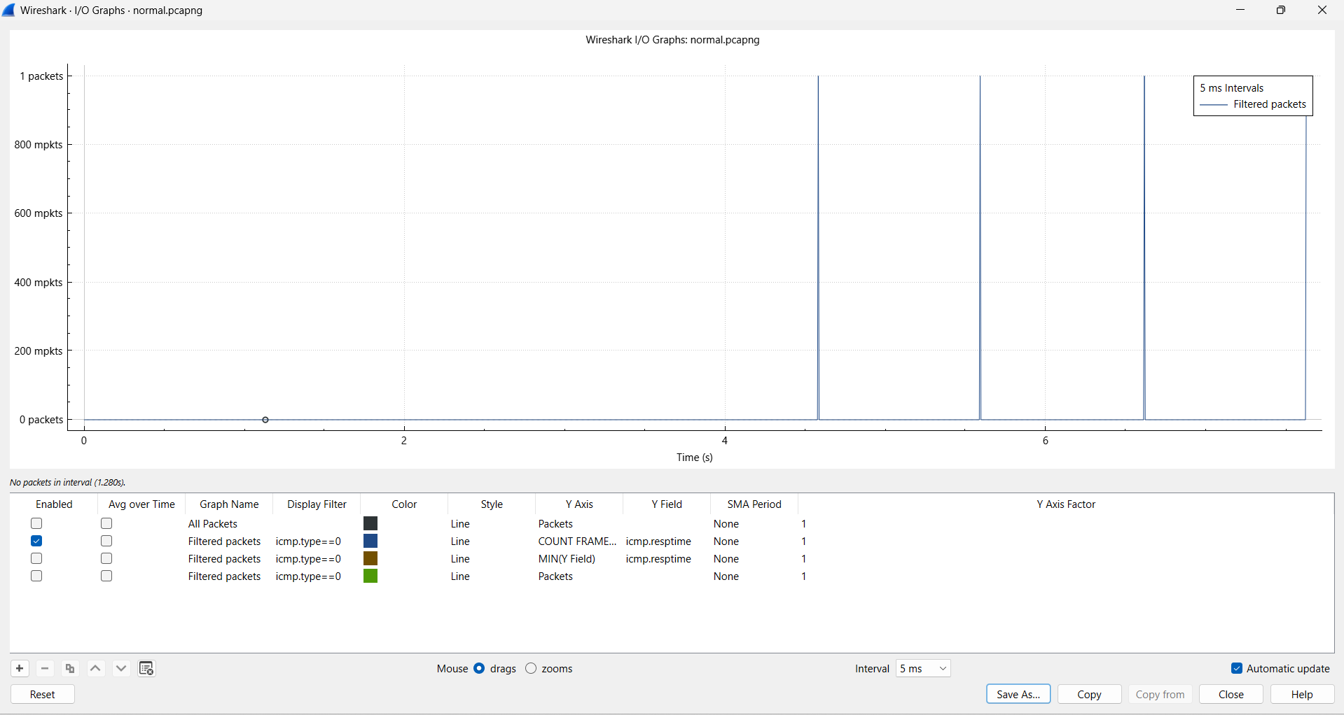
- · The packet count remains low and consistent, indicating minimal network load during normal traffic.
- · The graph shows sparse packet transmission, confirming that only limited traffic is present.
- · Occasional small increases in packet count represent normal background communication.
- · The absence of high peaks indicates that the network is not under stress or heavy usage.
- · This graph supports the conclusion that the network is operating under low load conditions.

All graphs under normal traffic conditions exhibit stable behavior with minimal variation, establishing a baseline for comparison with higher traffic scenarios.

LOW TRAFFIC

G6_low_avg
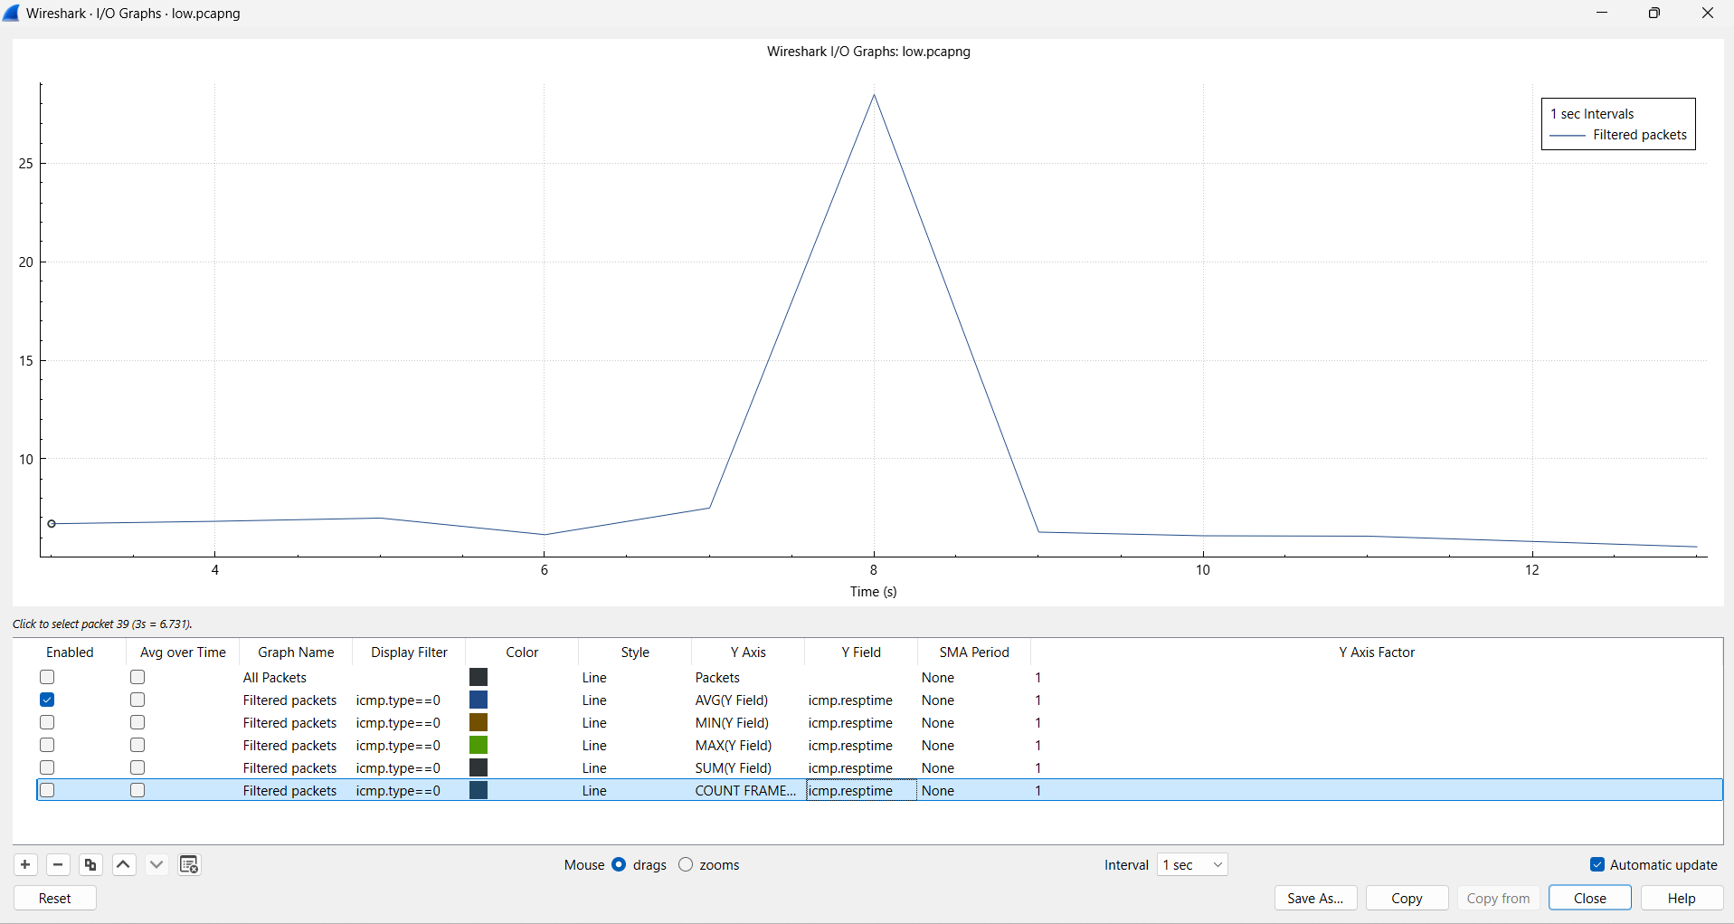
- · Compared to normal traffic, the average RTT in low traffic shows slightly higher variation with occasional spikes.
- · A noticeable peak is observed in low traffic, indicating intermittent delay not present in normal conditions.
- · While normal traffic remains stable, low traffic introduces minor fluctuations due to uneven packet intervals.
- · The baseline latency remains similar, but variability increases under low traffic.
- · This indicates that even a small increase in traffic can introduce slight delay inconsistencies.

G7_low_tcp.stream eq 0 && tcp.analysis.ack_rtt
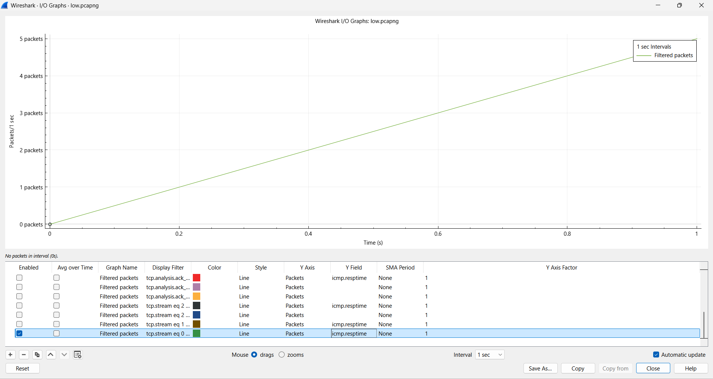
- The TCP stream RTT in low traffic shows more variation compared to the stable pattern in normal traffic.
- The gradual increase in RTT indicates accumulation of acknowledgments over time in low traffic.
- Unlike normal traffic, low traffic introduces slight irregularities in TCP response timing.
- The absence of sharp spikes still indicates no congestion, but variability is higher than normal.
- This suggests that TCP performance begins to vary slightly even under low traffic load.

G8_low_tcp.analysis.ack_rtt
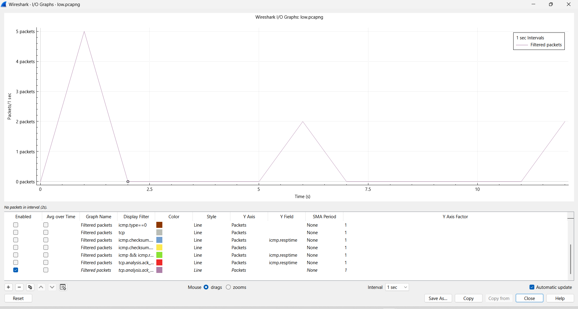
- Compared to normal traffic, TCP RTT values in low traffic show more scattered behavior.
- The graph indicates occasional delays in acknowledgment packets under low traffic.
- Normal traffic maintains consistent RTT, whereas low traffic introduces mild fluctuations.
- The increase in RTT variability suggests minor network delays due to packet handling.
- However, the absence of extreme spikes confirms that the network is still not congested.

G9_low_rtt
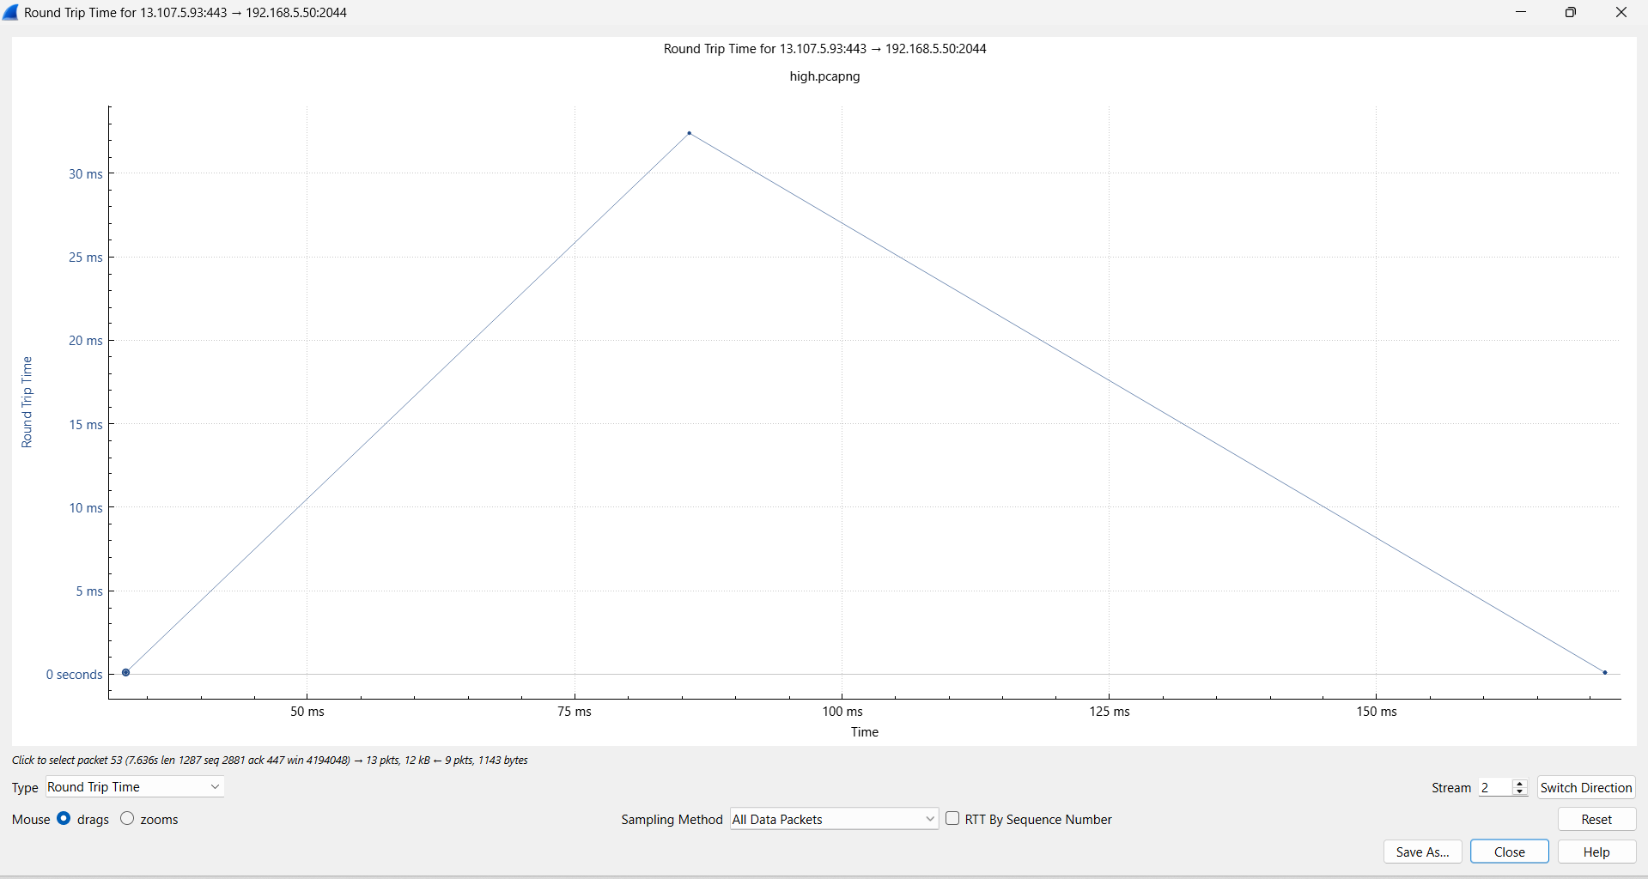

- The RTT graph in low traffic shows a peak pattern, unlike the smoother curve observed in normal traffic.
- This indicates temporary delay buildup followed by recovery, which is absent in normal conditions.
- The variation in RTT suggests slight instability introduced by increased packet interactions.
- Normal traffic shows consistent RTT, while low traffic reflects minor performance fluctuations.
- This demonstrates that RTT becomes more dynamic even with a small increase in traffic.

G10_low_count_frames
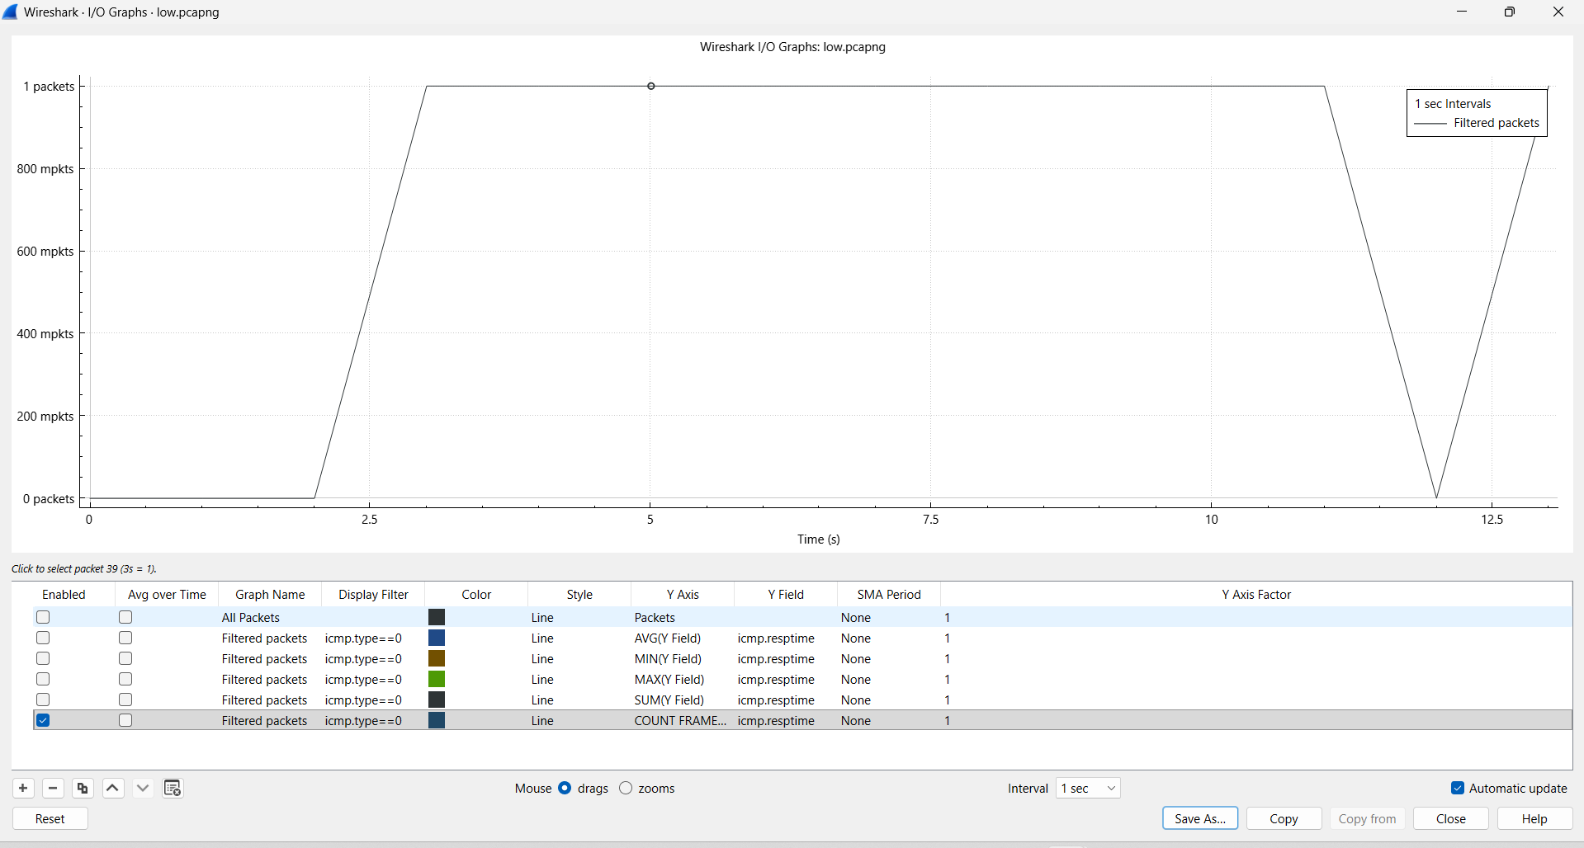
- Packet count in low traffic is higher and more distributed compared to sparse packet flow in normal traffic.
- The graph shows periodic increases in packet transmission, unlike the minimal activity in normal conditions.
- This increase in packet count explains the slight rise in latency variation observed in low traffic.
- Normal traffic maintains very low packet density, while low traffic shows moderate activity.
- This confirms that increased packet frequency directly impacts latency behavior.

“Compared to normal traffic, low traffic introduces slight variations in RTT while still maintaining overall network stability.”
“No significant congestion is observed, but minor fluctuations indicate the beginning of increased network activity.”

MEDIUM TRAFFIC
G11_medium_avg
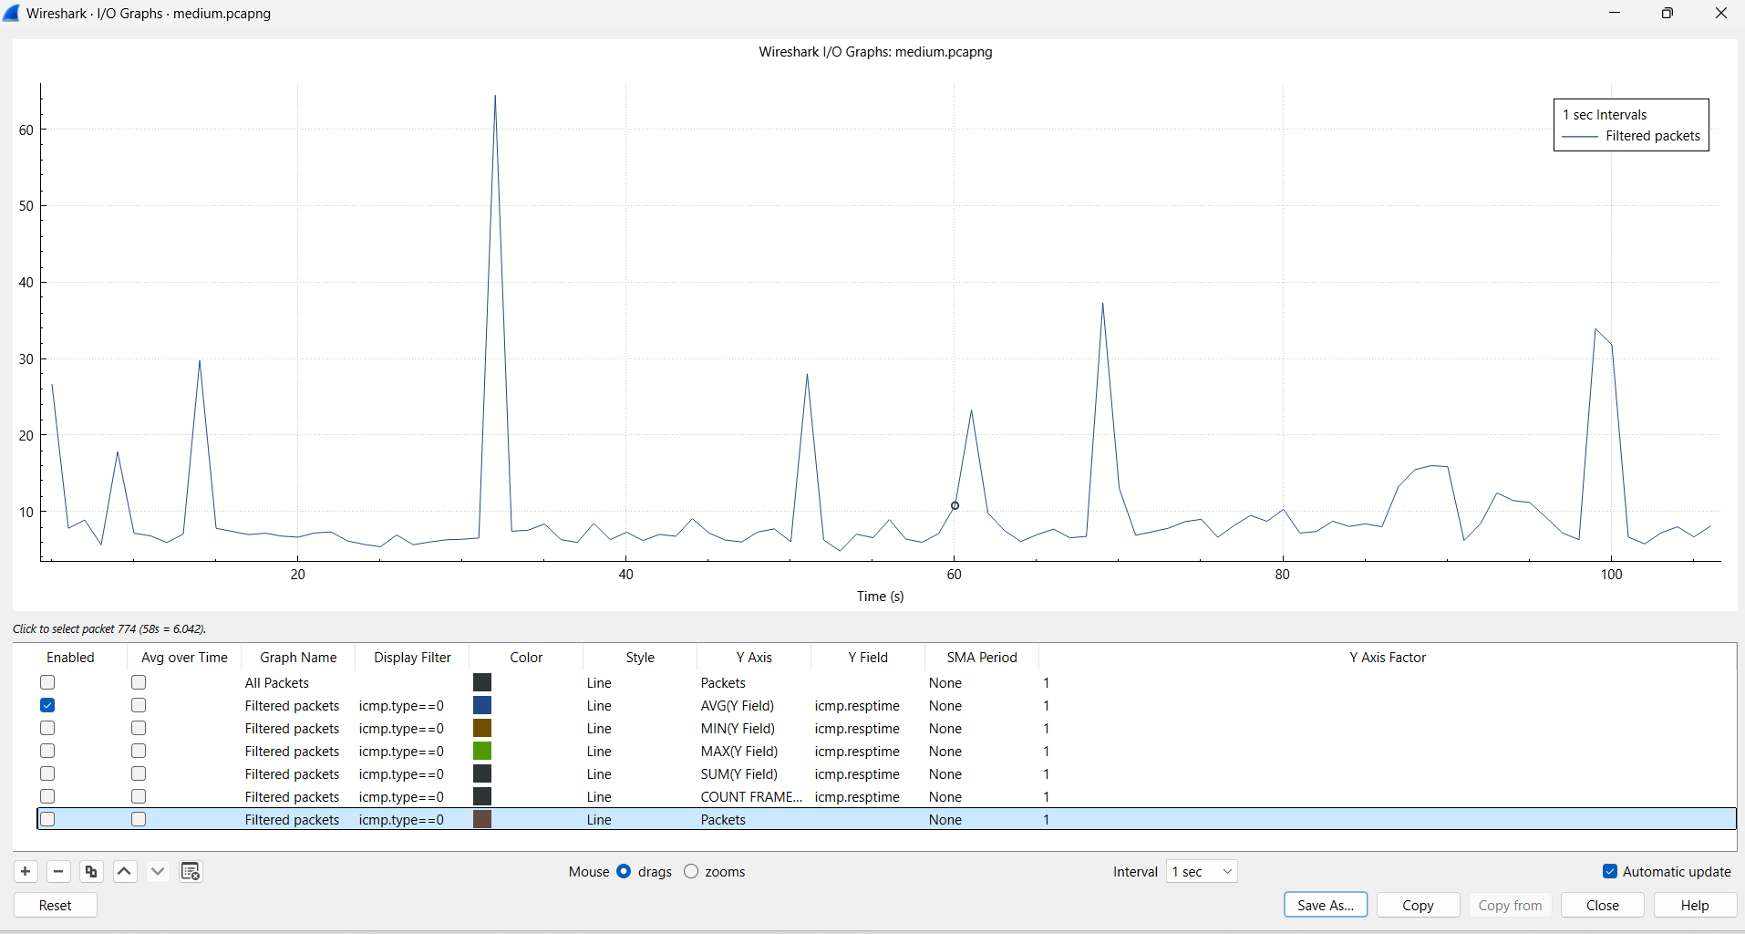
- · Compared to normal and low traffic, the average RTT in medium traffic shows significant spikes, indicating increased delay.
- · The presence of multiple peaks suggests intermittent congestion not observed in lower traffic conditions.
- · While normal traffic remains stable and low traffic shows slight variation, medium traffic introduces clear instability.
- · The baseline RTT increases slightly, reflecting higher processing and transmission delays.
- · This demonstrates that latency becomes highly dynamic as traffic load reaches medium levels.

G12_medium_tcp.stream eq 1 && tcp.analysis.ack_rtt
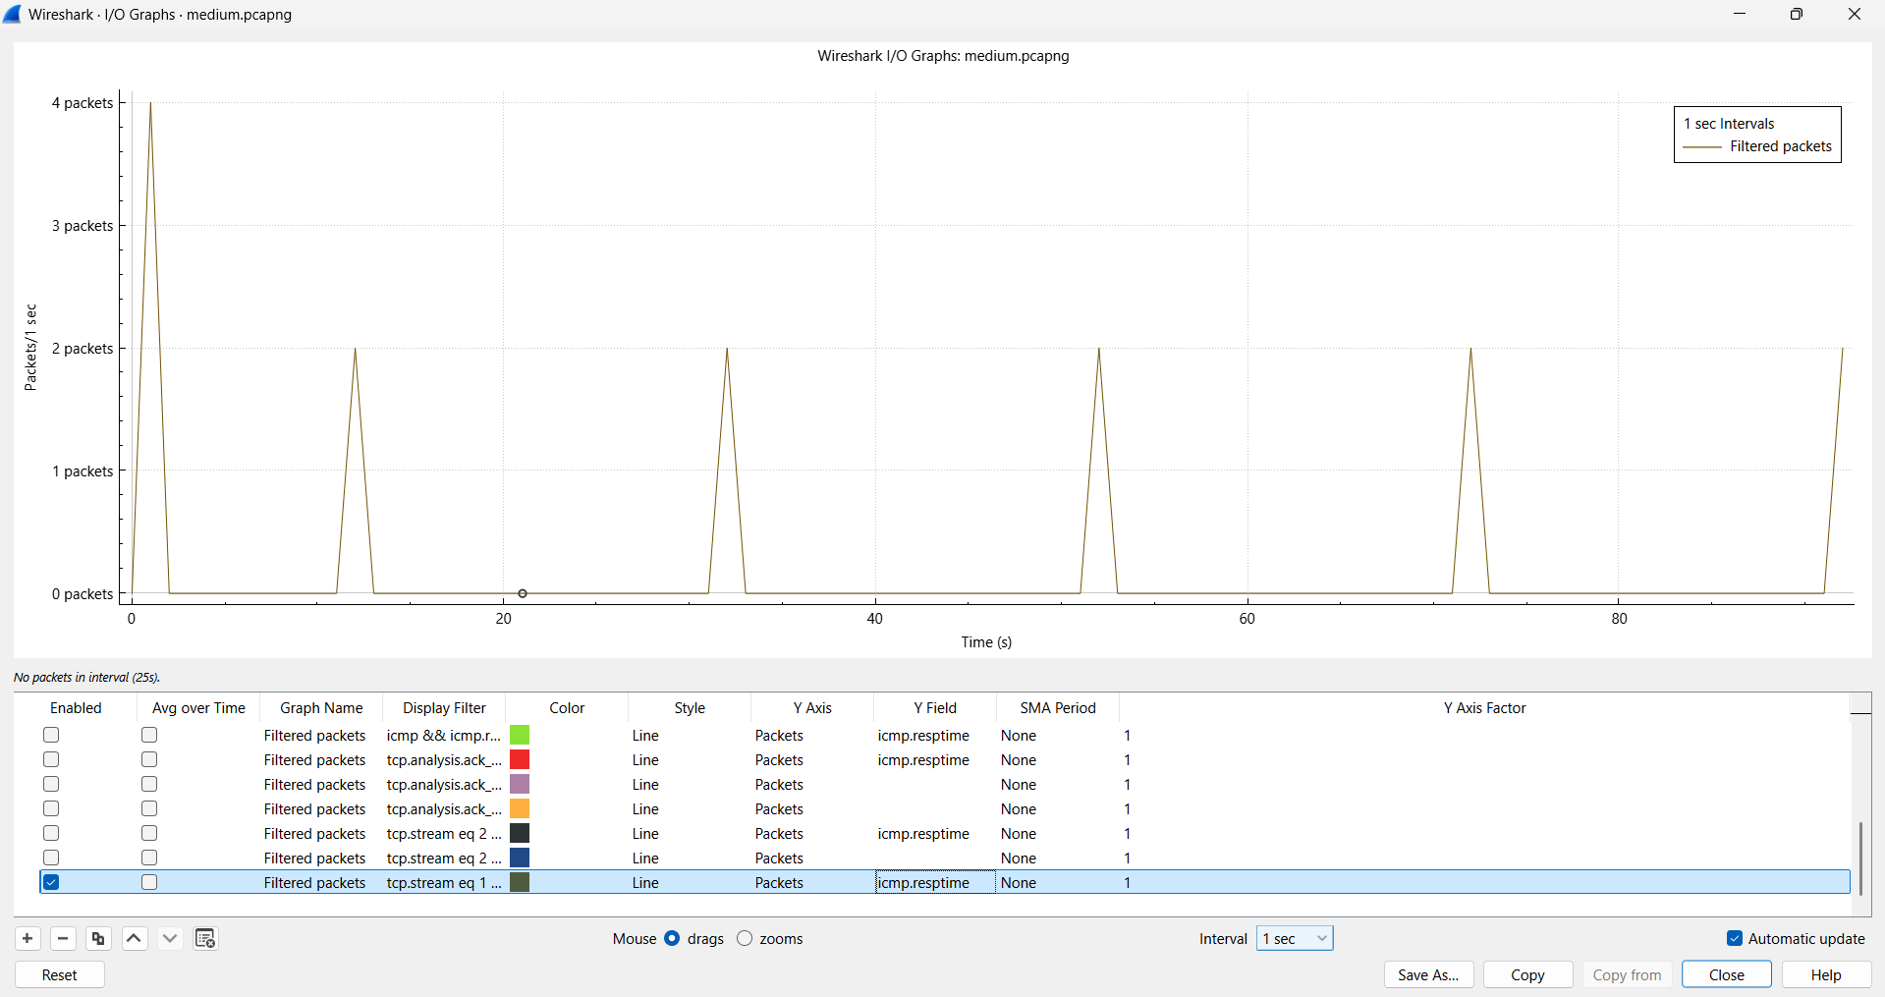
- · The TCP stream RTT in medium traffic shows periodic spikes, unlike the smooth patterns in normal and low traffic.
- · These spikes indicate delayed acknowledgments due to increased packet flow.
- · Compared to low traffic, the variation is more frequent and pronounced.
- · The regular pattern of peaks suggests repeated bursts of traffic affecting TCP performance.
- · This confirms that TCP latency becomes more sensitive under medium traffic conditions.

G13_medium_tcp.analysis.ack_rtt
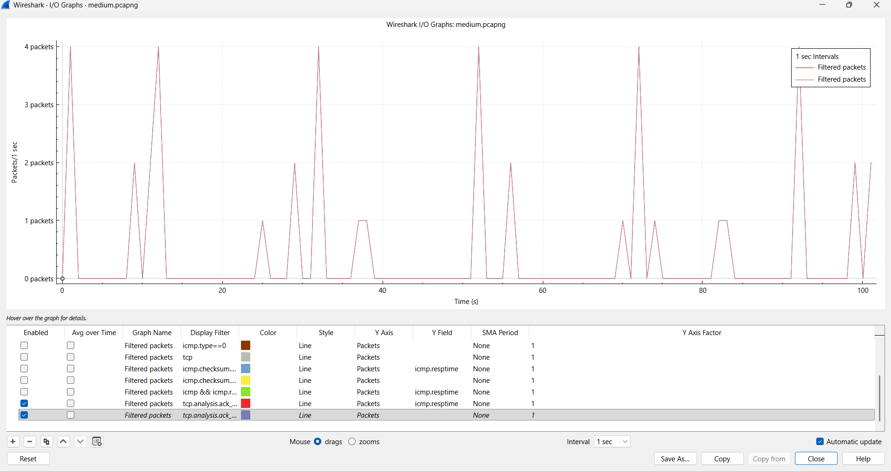
- · The overall TCP RTT distribution in medium traffic is more scattered compared to normal and low traffic.
- · Frequent spikes indicate variability in acknowledgment timing due to increased network activity.
- · Unlike the stable behavior in normal traffic, medium traffic shows irregular latency patterns.
- · The increased spread of RTT values suggests uneven packet delivery and processing delays.
- · This highlights the impact of medium traffic on TCP performance consistency.

G14_medium_rtt
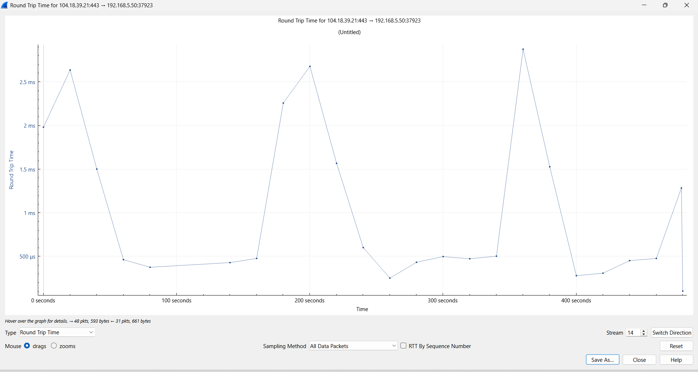
- · The RTT graph shows repeated peaks and drops, unlike the smoother curves in normal and low traffic.
- · These peaks indicate temporary congestion followed by recovery phases.
- · Compared to low traffic, the fluctuations are more frequent and intense.
- · The variation in RTT suggests dynamic network conditions with changing load levels.
- · This confirms that medium traffic introduces noticeable instability in latency

G15_medium_count_frames
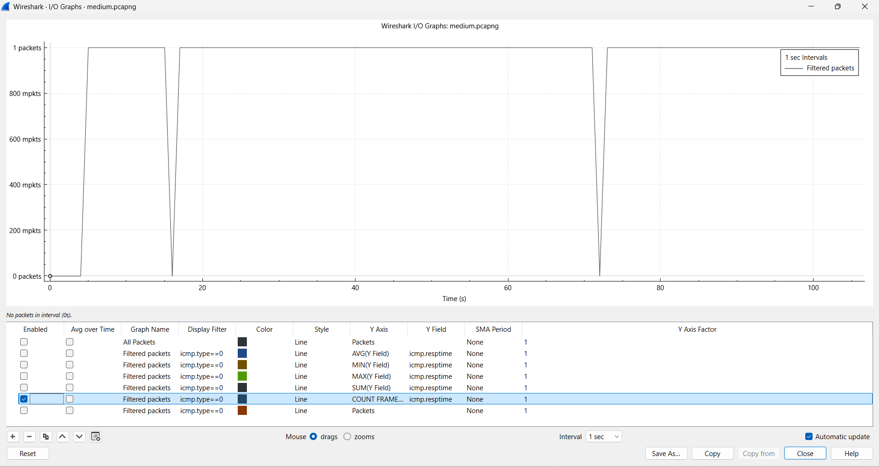
- · Packet count in medium traffic is significantly higher and more irregular compared to normal and low traffic.
- · The graph shows bursts of packet transmission, indicating increased network activity.
- · These bursts correspond to the latency spikes observed in RTT graphs.
- · Unlike the steady pattern in normal traffic, medium traffic exhibits uneven packet distribution.
- · This demonstrates that increased packet density directly contributes to latency variation.

“Compared to normal and low traffic, medium traffic introduces significant fluctuations in RTT due to increased packet transmission and network load.”
“The presence of frequent spikes indicates intermittent congestion and reduced stability in network performance.”

HIGH TRAFFIC

G16_high_avg
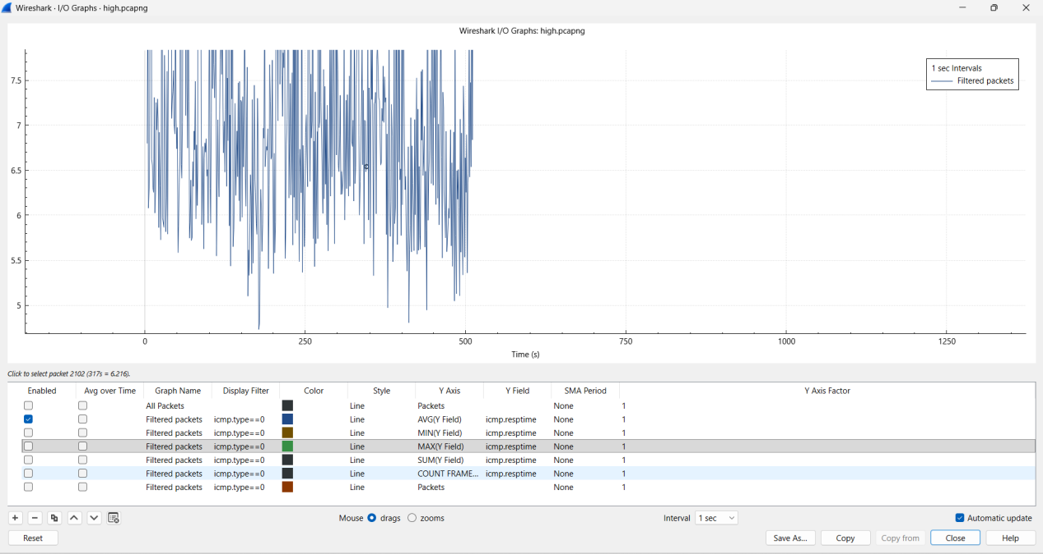
- · Compared to normal traffic, the average RTT in high traffic shows continuous fluctuations with no stable pattern.
- · The graph exhibits dense variations, indicating heavy network load and frequent delay changes.
- · Unlike the stable and flat trend in normal traffic, high traffic shows persistent instability.
- · The increased variability reflects congestion and higher packet processing delays.
- · This confirms that latency becomes highly unpredictable under high traffic conditions.

G17_high_tcp.stream eq 2 && tcp.analysis.ack_rtt
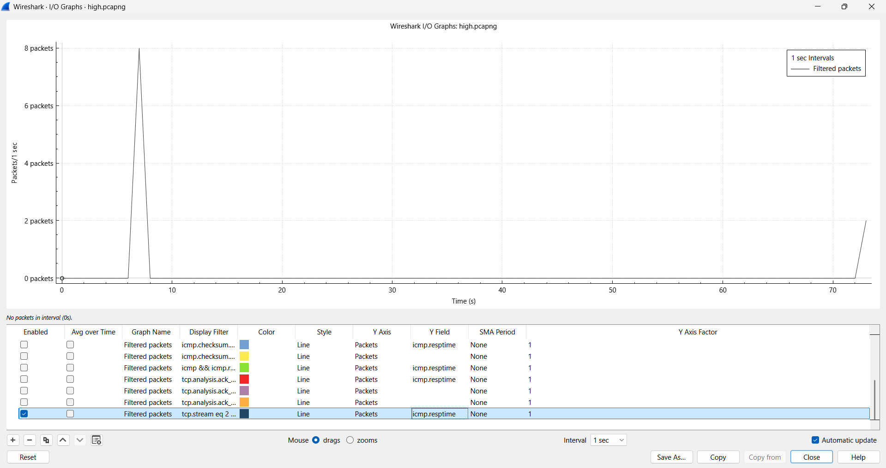
- · The TCP stream RTT in high traffic shows irregular spikes compared to the smooth behavior in normal traffic.
- · Sudden increases in RTT indicate delayed acknowledgments due to congestion.
- · Unlike normal traffic, the RTT values are inconsistent and widely distributed.
- · The graph reflects unstable TCP performance under heavy load.
- · This demonstrates that TCP communication is significantly affected by high traffic conditions.

G18_high_tcp.analysis.ack_rtt
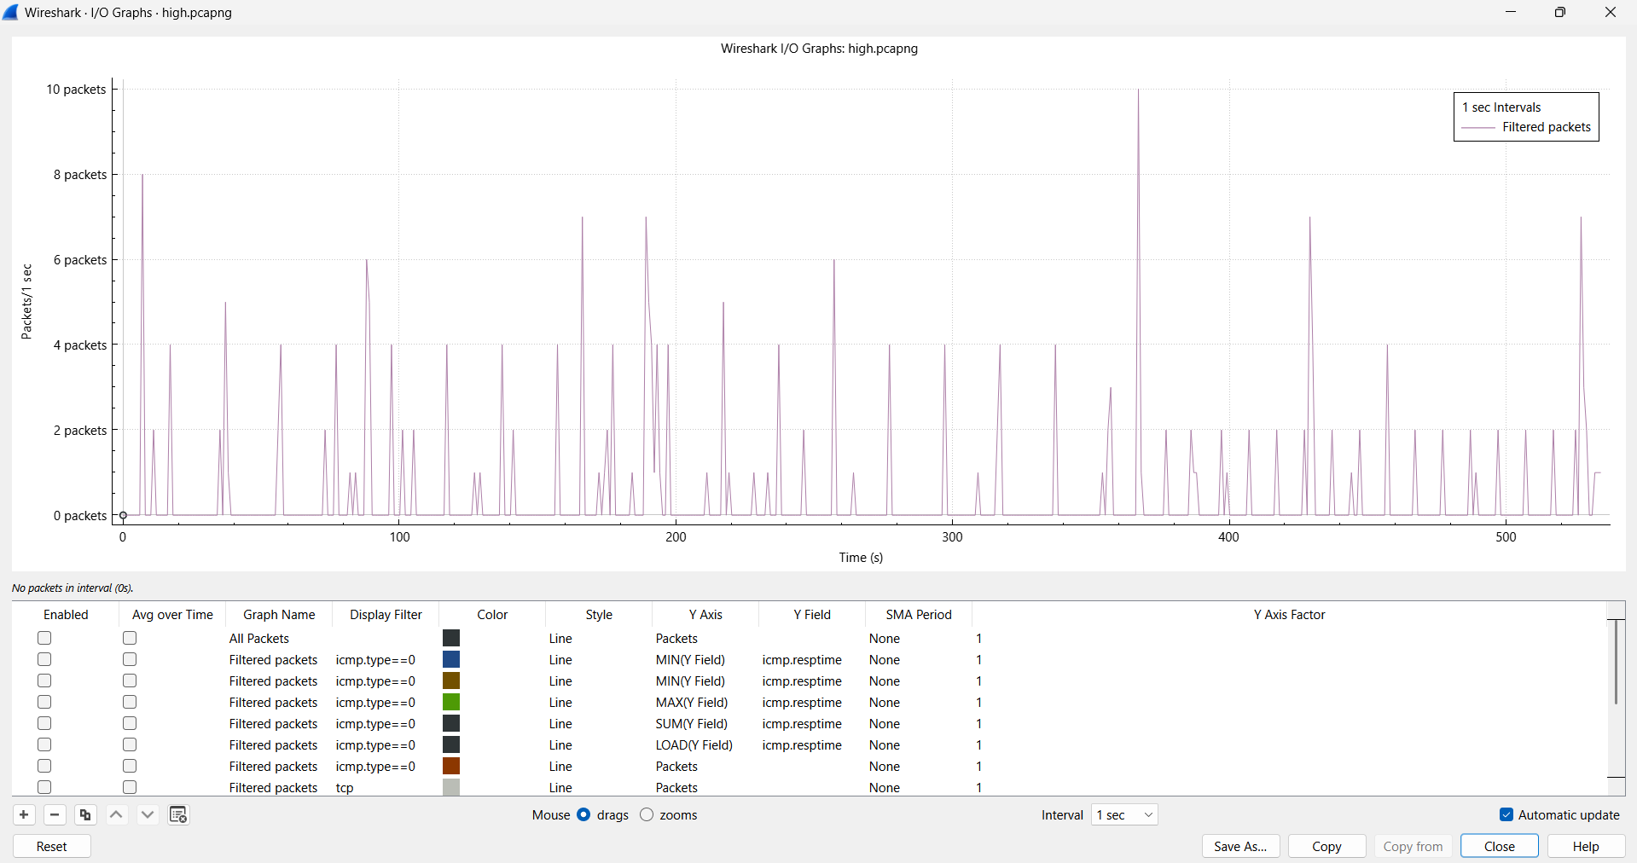
- · The overall TCP RTT distribution in high traffic is highly scattered compared to the consistent pattern in normal traffic.
- · Frequent peaks indicate network congestion and retransmission effects.
- · The variability in RTT is much greater than in normal conditions.
- · The graph shows uneven packet acknowledgment timing due to heavy load.
- · This confirms that TCP latency becomes highly unstable under high traffic.

G19_high_rtt
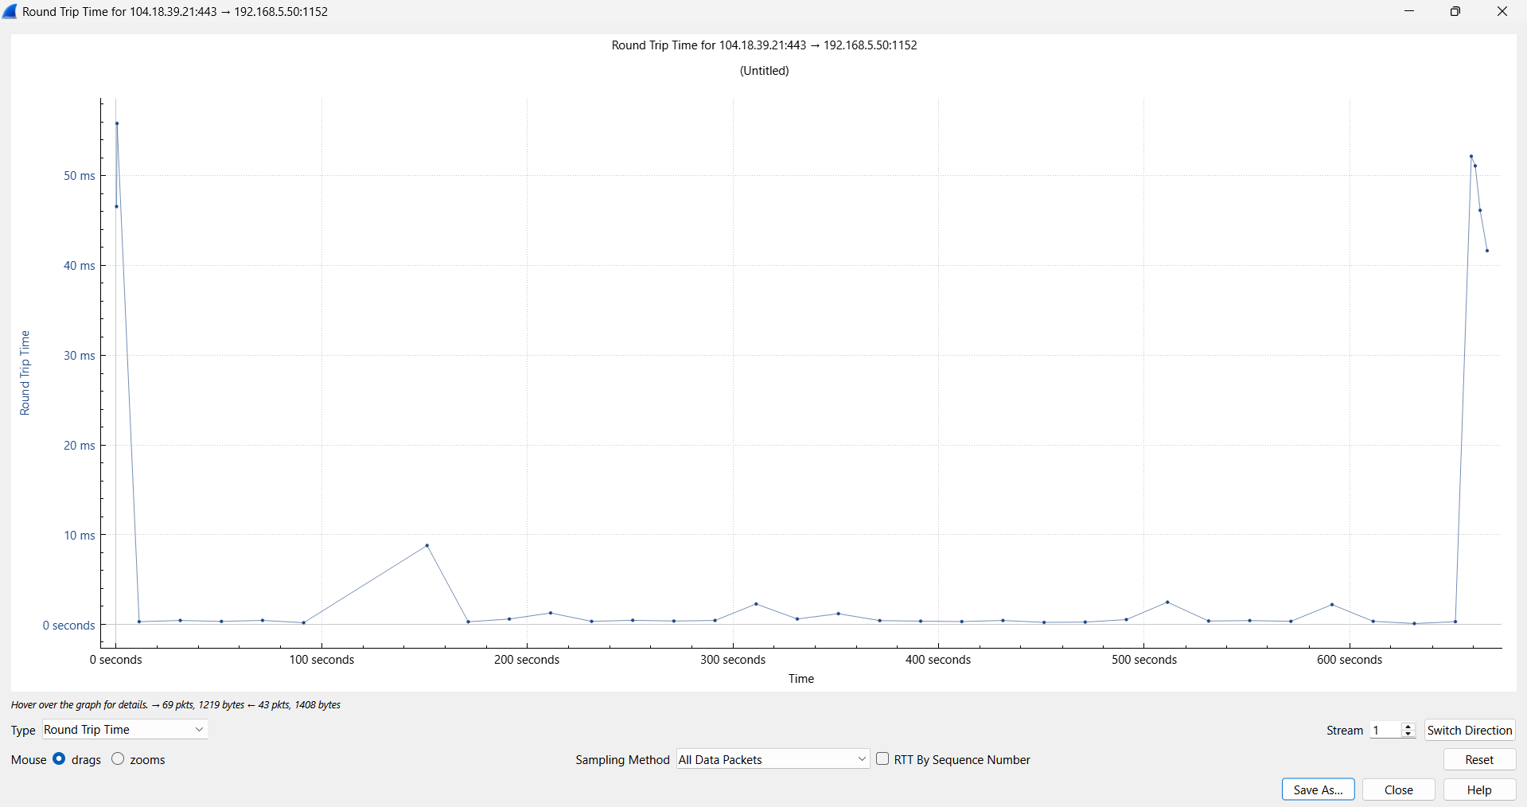
- · The RTT graph shows sharp spikes reaching very high values compared to the smooth curve in normal traffic.
- · These spikes indicate severe congestion and delay accumulation.
- · The variation in RTT is significantly higher than in normal conditions.
- · The graph reflects sudden performance degradation under heavy traffic.
- · This demonstrates that high traffic introduces extreme latency fluctuations.

G20_high_count_frames
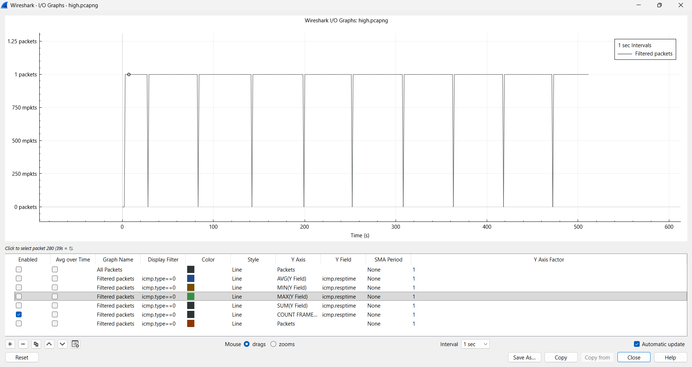
- · Packet count in high traffic is significantly higher and more frequent compared to the sparse distribution in normal traffic.
- · The graph shows continuous packet transmission, indicating heavy network usage.
- · Frequent peaks correspond to the latency spikes observed in RTT graphs.
- · Unlike normal traffic, there are almost no idle intervals between packets.
- · This confirms that high packet density directly leads to increased latency and instability.

“Compared to normal traffic, high traffic results in significant fluctuations, increased latency, and unstable network behavior due to congestion.”
“As traffic increases from normal to high, RTT variation increases drastically, indicating reduced network performance and efficiency.”

Trends Observed from the Experiment
- Latency (RTT) remains low and stable under normal traffic conditions.
- With low traffic, minor fluctuations in RTT begin to appear.
- Medium traffic introduces noticeable spikes and variability in latency.
- High traffic results in frequent and irregular RTT spikes, indicating congestion.
- Packet count increases progressively from normal → high traffic, directly impacting latency.
- TCP RTT follows a similar trend as ICMP RTT but shows more sensitivity to traffic changes.
- The difference between minimum and maximum RTT widens as traffic increases.
- Network behavior transitions from stable → moderately variable → highly unstable.
- Congestion effects become visible only after medium traffic levels.
- Under high traffic, latency becomes unpredictable and inconsistent.

New Findings from the Experiment
- Even low traffic can introduce small but measurable latency variations.
- TCP-based RTT provides more detailed insight compared to ICMP RTT.
- Packet bursts (seen in medium traffic) directly correlate with latency spikes.
- High traffic causes non-linear increases in delay, not just gradual growth.
- Network latency is affected not only by traffic volume but also by packet distribution patterns.
- RTT graphs reveal that temporary congestion occurs in bursts, not continuously.
- The system handles moderate traffic efficiently but shows instability at higher loads.
- Different TCP streams exhibit different latency behaviors under the same conditions.
- Latency variation is a better indicator of congestion than average latency alone.
- Even when average RTT is low, spikes can indicate underlying network stress.

Recommendations
- Implement load balancing techniques to evenly distribute traffic and avoid congestion.
- Use Quality of Service (QoS) policies to prioritize important network traffic.
- Continuously monitor RTT and latency metrics to detect early signs of network issues.
- Optimize network routing paths to reduce delay and packet travel time.
- Reduce unnecessary background traffic to maintain low latency conditions.
- Increase bandwidth capacity to efficiently handle high traffic loads.
- Use TCP optimization techniques to minimize acknowledgment delays.
- Deploy network monitoring tools like Wireshark for real-time traffic analysis.
- Implement congestion control mechanisms to prevent packet loss and delay spikes.
- Design network systems that can handle variable traffic conditions efficiently.

“The experiment demonstrates that latency is highly dependent on traffic intensity, and effective network management is essential to maintain performance under varying load conditions.”

Use of AI in the Distributed Assignment

Artificial Intelligence tools were utilized to enhance the efficiency and accuracy of this Distributed Assignment. AI was used to assist in understanding complex networking concepts such as latency, RTT, and traffic behavior under different conditions.
AI also helped in organizing the experimental workflow, generating structured procedures, and suggesting appropriate filters and commands for Wireshark analysis. Additionally, AI was used to interpret graph patterns and identify trends in latency across normal, low, medium, and high traffic conditions.
Furthermore, AI assisted in drafting clear inferences, identifying key findings, and formulating recommendations based on observed data. This significantly improved the clarity, presentation, and analytical depth of the assignment.
Overall, the use of AI contributed to faster analysis, better visualization understanding, and improved documentation quality.

Conclusion
This Distributed Assignment successfully analyzed network latency using Wireshark under different traffic conditions including normal, low, medium, and high traffic. The study demonstrated how latency, measured using Round Trip Time (RTT), varies with increasing network load.
Under normal traffic, the network exhibited stable and low latency with minimal fluctuations. As traffic increased to low and medium levels, noticeable variations and occasional spikes in RTT were observed. In high traffic conditions, the network showed significant instability with frequent and sharp latency spikes, indicating congestion and performance degradation.
The experiment clearly highlights that network latency is highly dependent on traffic intensity and packet distribution. It also shows that while networks can handle moderate traffic efficiently, performance degrades rapidly under heavy load.
Overall, this analysis provides valuable insights into network behavior and emphasizes the importance of traffic management, monitoring, and optimization techniques to maintain efficient and reliable communication in real-world networks.

“Thus, effective network design and traffic control mechanisms are essential to ensure consistent performance across varying traffic conditions.”

YOUTUBE LINK:
https://youtu.be/9SalbUeAM3U

GITHUB REPOSITORY LINK:
https://github.com/Ashish01-starter/Computer_Networks/tree/Ashish01-starter-patch-1-Network_Analysis_using_latency

REFERENCES:
• https://www.youtube.com/watch?v=1Rbx_LRPABM&t=344s
• http://youtube.com/watch?v=0VO4z0_dHzI
• https://www.ibm.com/think/topics/latency
• https://www.gokinetic.com/blog/what-is-network-latency

Acknowledgement
I would like to express my sincere gratitude to my parents for their continuous support and encouragement. I also thank VIT SCOPE and the university for providing the opportunity to carry out this assignment as part of the current semester coursework.
I extend my appreciation to the faculty and course instructors for their guidance. I also thank my friends and online resources for their support.

