AI Engineer Roadmap 2026

Following is the roadmap for AI Engineer, ML Engineer or Gen AI Engineer. It includes FREE learning resources for technical skills (or tool skills) and soft (or core) skills ⛷️

This roadmap is designed based on the analysis of hundreds of AI jobs and our own experience of working on AI projects at Atliq Technologies (https://www.atliq.com/) where we have worked on 25+ AI projects in last two year alone. More than 90% of our clients at Atliq are SMEs (Small to medium size enterprises) based in USA.

Link of AI engineer jobs analysis: https://github.com/Codebasics-Content/job-scrapper/blob/main/Analysis/GenAI%20%26%20DataScience/data_visualizer.ipynb

AI case studies at AtliQ: https://www.atliq.com/case-studies

Link of our full YouTube video for this roadmap: https://youtu.be/zwUSZD3t_BU

Find Your Suitability: Before you start your learning journey, it is important you find out if AI engineering career really suits your natural abilities and interests. Take this test to know your suitability: https://codebasics.io/survey/find-your-match-ds

Proceed further if the results show that this career role matches you.

Total Duration: 8 Months (4 hours of study every day, 6 days a week)

Roadmap is valid for freshers and experienced professionals.

Check below diagrams for tech vs core skills as well as some optional skills.

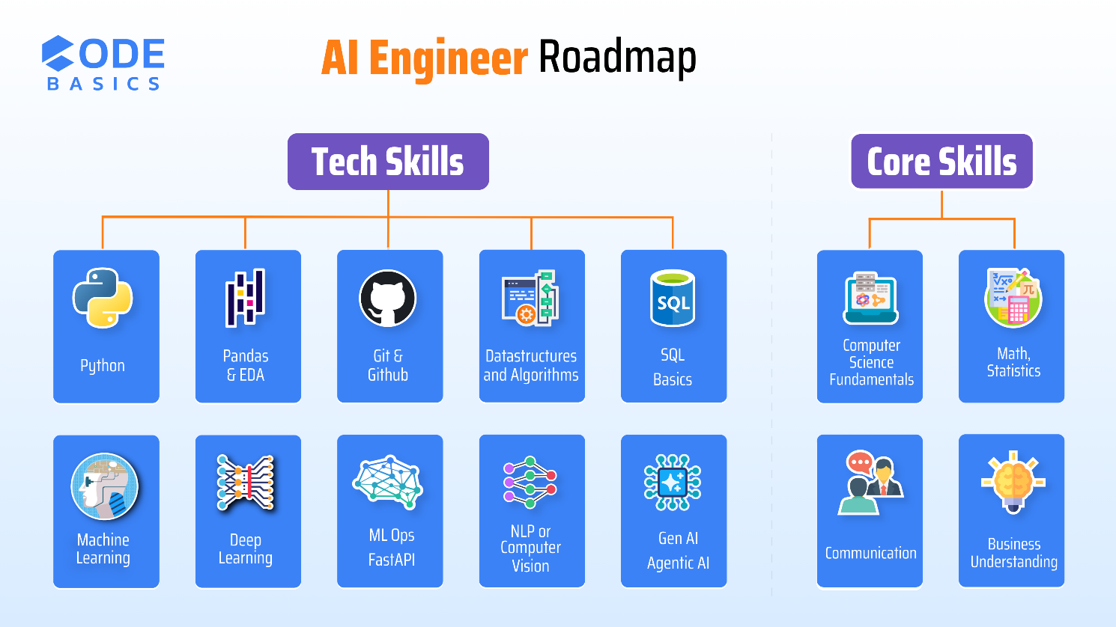

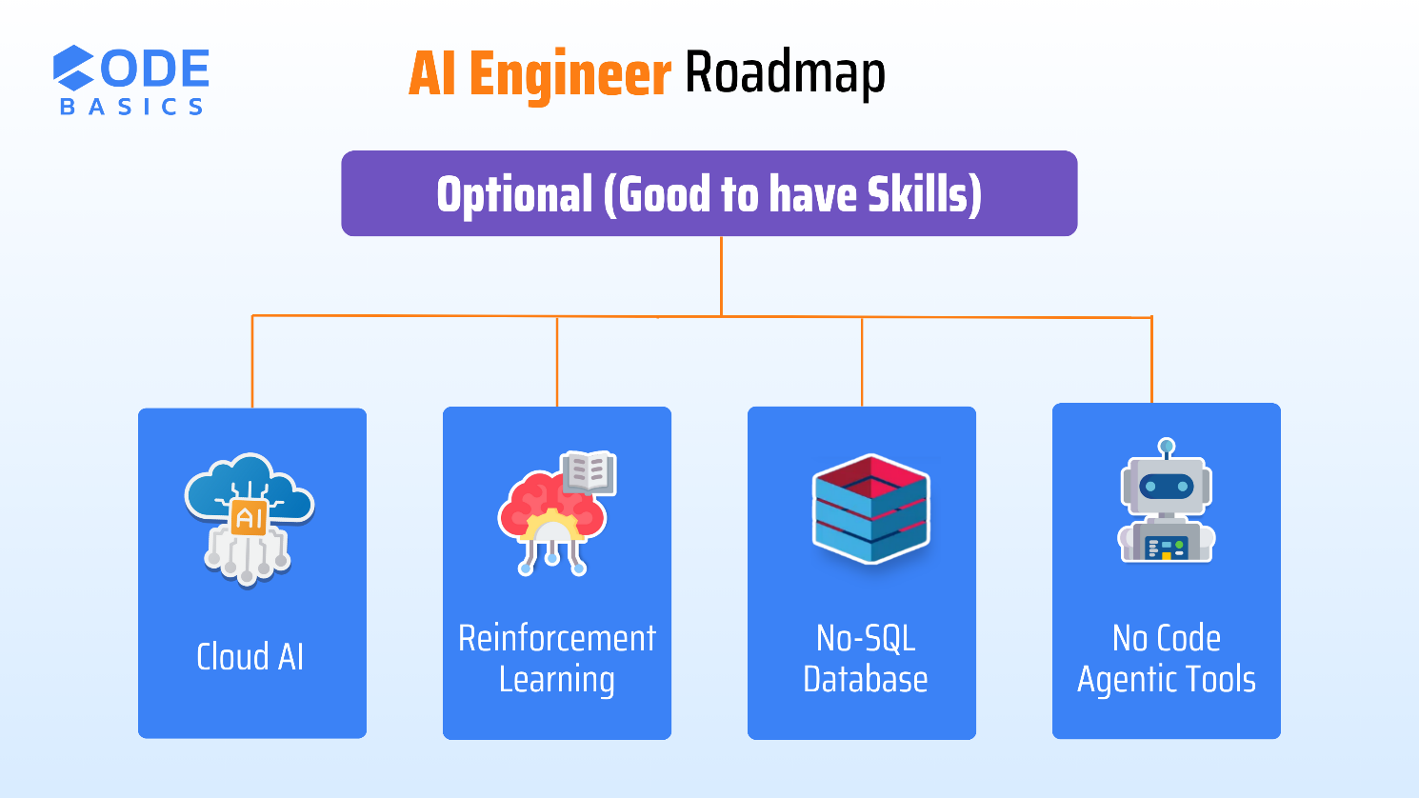

Mindset before we begin the learning journey

Have this mindset of an expert handyman, who has strong fundamentals, wide knowledge of tools and a judgement of picking a right tool at the right time.

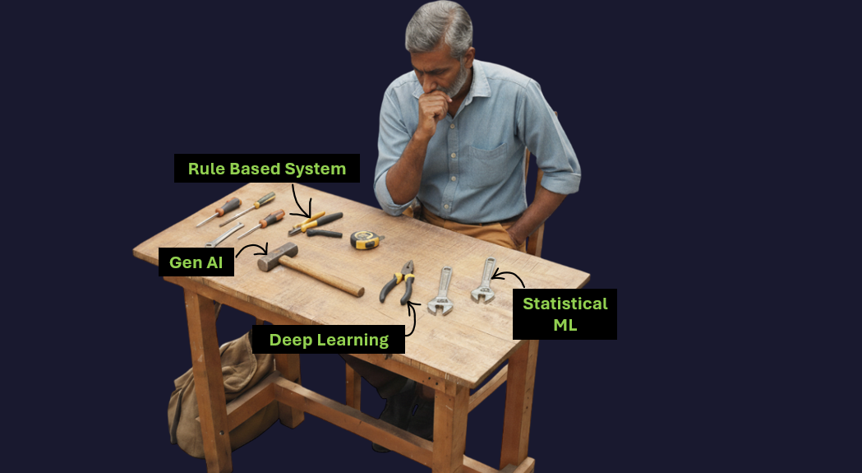

Week 1: AI Basics + Beginners Python 🐍

- Topics
  - AI Basics
    - Understand AI landscape by developing basic understanding of ML, DL, NLP, Gen AI and Agentic AI
  - Python is THE programming language for AI. Learn the following topics,
    - Variables, Numbers, Strings
    - Lists, Dictionaries, Sets, Tuples
    - If condition, for loop
    - Functions, Lambda Functions
    - Modules (pip install)
    - Read, Write files
    - Exception handling
    - Classes, Objects

  - For your understanding, here we’ve included a code snippet in Python that trains a Random Forest machine learning model

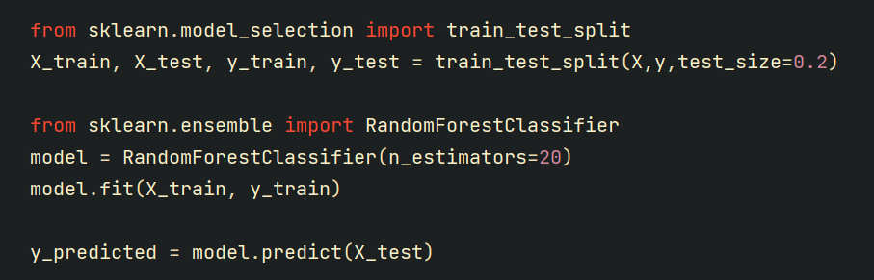
- Learning Resources
  - Track A (Free)
    - AI Basics: https://www.youtube.com/watch?v=VGFpV3Qj4as
    - Python Tutorials (Codebasics) on YouTube (first 16 videos) - https://bit.ly/3X6CCC7
    - Corey’s Python Tutorials: https://bit.ly/3uqUgaZ
    - Codebasics python HINDI tutorials - https://bit.ly/3vmXrgw
    - EXTREMELY IMPORTANT: Use ChatGPT as your personal tutor in case you have questions or facing issues

  - Track B (Affordable Fees)
    - AI Bootcamp: https://codebasics.io/bootcamps/ai-data-science-bootcamp-with-virtual-internship

- LinkedIn - Core Skill
☐ Create a professional-looking LinkedIn profile.
    - Have a clear profile picture and banner image.
    - Add tags such as: Open to work etc.

☐ Use this LinkedIn Checklist to create a profile: Click here.

- Assignment
☐ Track A: Finish all these exercises: https://bit.ly/3k1mof5
☐ Track B: Finish exercises and quizzes for relevant topics
☐ Create a professional-looking LinkedIn profile.
- Why LinkedIn is important?
  - Imagine you are skilled at making samosas. You open a shop in a village where the footfall is very low. You are now struggling to sustain the business. Your best friend then gives you advice to move the shop to a busy street in a big city. You move it to a city and now your business is flourishing.
  - LinkedIn is like that busy street where your profile will be noticed by hundreds of people. Creating good looking profile (i.e. opening a shop) is only a first step, you need to build strong online credibility (i.e. making tasty samosas and providing good customer service) which we will discuss in the further sections.
  - Many people have this wrong mindset that “I will learn technical skills first and work on LinkedIn at last”. Building online credibility will take a long time hence it is better to start working on it from day 1


Week 2: Data Structures and Algorithms in Python

- Topics
  - Data structures basics, Big O notation
  - Data structures: Arrays, Hash Table, Linked List, Stack, Queue, Tree, Graph
  - Algorithms: Binary search, Bubble sort
  - Recursion

- Learning Resources
  - DSA YouTube Playlist: https://bit.ly/3uiW2Lf
    - You can skip these videos # 15, 16, 17, 18, 19

- Communication – core skill
  - Start attending toastmasters’ sessions to improve communication: https://www.toastmasters.org/

- Motivation
  - Conversation with Senior director of Fractal: https://www.youtube.com/watch?v=BaAA7kNjeZw

- Assignment
☐ Finish all these exercises in this same playlist: https://bit.ly/3uiW2Lf

Week 3: Advanced Python 🐍

- Topics
  - Inheritance, Generators, Iterators
  - List Comprehensions, Decorators
  - Multithreading, Multiprocessing
- Learning Resources
  - Python Tutorials (Codebasics) on YouTube (17th to 27th video) - https://bit.ly/3X6CCC7

- Assignment
☐ Finish all these exercises in this same playlist: https://bit.ly/3X6CCC7
- Core/Soft Skills
  - Linkedin
    - Start following AI influencers.
      - Yann LeCun: https://www.linkedin.com/in/yann-lecun/
      - Andrej Karpathy: https://x.com/karpathy
      - Daliana Liu: https://www.linkedin.com/in/dalianaliu/
      - Nitin Aggarwal: https://www.linkedin.com/in/ntnaggarwal/
      - Dhaval Patel: https://www.linkedin.com/in/dhavalsays/

    - Increase engagement.
      - Start commenting meaningfully on AI and career-related posts.
      - Helps network with others working in the industry build connections.
      - Learning and brainstorming opportunity.
    - Remember online presence is a new form of resume
  - Business Fundamentals - Soft Skill
    - Learn business concepts from ThinkSchool and other YT Case Studies
    - Example: How Amul beat competition: https://youtu.be/nnwqtZiYMxQ
  - Discord
    - Start asking questions and get help from the community. This post shows how to ask questions the right way: https://bit.ly/3I70EbI
    - Join codebasics discord server: https://discord.gg/r42Kbuk
- Assignment
☐ Write meaningful comments on at least 10 AI related LinkedIn posts
☐ Note down your key learnings from 3 case studies on ThinkSchool and share them with your friend.

- Motivation
  - How Kaggle helped this person become ML engineer: https://bit.ly/3RFVruy

Week 4: Version Control (Git, Github) 📊

- Topics
  - What is the version control system? What is Git and GitHub?
  - Basic commands: add, commit, push.
  - Branches, reverting change, HEAD, Diff and Merge
  - Pull requests.

- Learning Resources
  - YT playlist (codebasics): https://bit.ly/3SECQQ7
  - YT playlist (Corey): https://bit.ly/3T0Yrmb

- Core/Soft Skills
  - Presentation skills
    - Death by PowerPoint: https://youtu.be/Iwpi1Lm6dFo
- Assignment
☐ Write 2 meaningful blog posts on the AI tech topic. For example, how CNNs work? Writing blogs or creating videos will help you build “Teaching skills” which will be helpful when you are talking to a non-tech business stakeholder while working as an AI engineer. Check the job post where they specifically look for strong stakeholder communication skills:

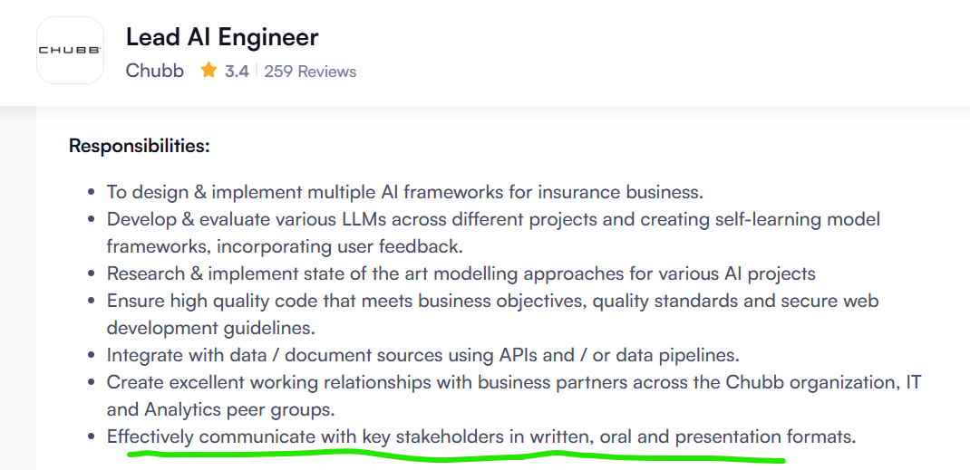

- Motivation
  - Himanshu Dubey: https://www.linkedin.com/in/himanshud2611/
  - Himanshu Dubey (twitter): https://x.com/himanshustwts?lang=en
  - Yadnyesh Chakane: https://www.linkedin.com/in/yadnyesh-chakane-472260202/

Week 5: Numpy, Pandas, Data Visualization, SQL 📊

- Tech Skills
  - Numpy, Pandas, Matplotlib, Seaborn
    - Go through chapter 4 and 5 in this course (entire chapter is free): https://codebasics.io/courses/math-and-statistics-for-data-science
  - SQL
    - Basics of relational databases.
    - Basic Queries: SELECT, WHERE LIKE, DISTINCT, BETWEEN, GROUP BY, ORDER BY
    - Joins: Left, Right, Inner, Full
    - SQL Tutorial on YouTube: https://www.youtube.com/watch?v=Rm0xH2Vpfi0

Week 6, 7, 8: Math & Statistics for AI 👨‍🎓

- Math and Statistics for AI
  - Topics to Learn
    - Basics: Descriptive vs inferential statistics, continuous vs discrete data, nominal vs ordinal data
    - Linear Algebra: Vectors, Metrices, Eigenvalues and Eigenvectors
    - Calculus: Basics of integral and differential calculus
    - Basic plots: Histograms, pie charts, bar charts, scatter plot etc.
    - Measures of central tendency: mean, median, mode
    - Measures of dispersion: variance, standard deviation
    - Basics of Probability
    - Distributions: Normal distribution
    - Correlation and covariance
    - Central limit theorem
    - Hypothesis testing: p value, confidence interval, type 1 vs type 2 error, Z test

  - Learning Resources
    - Track A (Free)
      - Learn the above topics from this excellent Khan academy course on statistics and probability.
      - Course link: https://www.khanacademy.org/math/statistics-probability
      - While doing khan academy course, when you have doubts, use statquest YouTube channel: https://www.youtube.com/@statquest
      - Use this free YouTube playlist: https://bit.ly/3QrSXis
      - Another great youtube channel: https://www.youtube.com/@3blue1brown
    - Track B (Affordable Fees)
      - Learn the key concepts of Math and Statistics that lay the foundations for a strong data science career: https://codebasics.io/courses/math-and-statistics-for-data-science

- Assignment
☐ Finish all exercises in this playlist: https://bit.ly/3QrSXis
☐ Finish all exercises in Khan academy course.
☐ Track B: Finish exercises and quizzes for relevant topics.

Week 9, 10, 11: Machine Learning ⚒️

- It is good to have overview and then explore in depth on a need-to-know basis
- Is statistical ML still relevant in Gen AI era? Refer to this post for detailed answer: https://www.linkedin.com/posts/dhavalsays_is-statistical-ml-dead-in-gen-ai-age-we-activity-7355439576363991040-JGxo?utm_source=share&utm_medium=member_desktop&rcm=ACoAAAHeAToBefXXCt3hf_hHmb_-yy7lz8bBNns

- Machine Learning: Preprocessing
  - Handling NA values, outlier treatment, data normalization
  - One hot encoding, label encoding
  - Feature engineering
  - Train test split
  - Cross validation
- Machine Learning: Model Building
  - Types of ML: Supervised, Unsupervised
  - Supervised: Regression vs Classification
  - Linear models
    - Linear regression, logistic regression
    - Gradient descent
  - Nonlinear models (tree-based models)
    - Decision tree
    - Random forest
    - XGBoost
  - Model evaluation
    - Regression: Mean Squared Error, Mean Absolute Error, MAPE
    - Classification: Accuracy, Precision-Recall, F1 Score, ROC Curve, Confusion matrix
  - Hyperparameter tuning: GridSearchCV, RandomSearchCV
  - Unsupervised: K means, DBScan, Dimensionality reduction (PCA)

- Learning Resources
  - Track A
    - YouTube playlist (more than 2 million views): https://bit.ly/3io5qqX
    - First 21 videos
    - Feature engineering playlist: https://bit.ly/3IFa3Yf
  - Track B (Affordable Fees)
    - AI Bootcamp: https://codebasics.io/bootcamps/ai-data-science-bootcamp-with-virtual-internship

- Core/Soft Skills
  - Project Management
    - Scrum: https://scrumtrainingseries.com/
    - Kanban: https://youtu.be/jf0tlbt9lx0
    - Tools: JIRA, Notion
- Assignment
☐ Complete all exercises in ML playlist: https://bit.ly/3io5qqX
☐ Work on 2 Kaggle ML notebooks
☐ Write 2 LinkedIn posts on whatever you have learnt in ML
☐ Discord: Help people with at least 10 answers
☐ Track B: Finish exercises and quizzes for relevant topics

Week 12, 13: DevOps, ML Ops, FastAPI ️

- Topics
  - What is API? FastAPI for Python server development
  - What is ML Ops? Experiment Tracking with MLFlow
  - DevOps Fundamentals: CI/CD pipelines, containerization (Docker, Kubernetes)
  - Familiarity with at least one cloud platform (AWS or Azure)
  - For a fresher role, you can skip everything else except FastAPI but having the knowledge of all these topics will give you an unfair advantage.

- Learning Resources
  - Track A:
    - FastAPI tutorial: https://bit.ly/497p6Ex
    - What is ML Ops: https://bit.ly/3R4uGA0
    - MLFlow Tutorial: https://www.youtube.com/watch?v=6ngxBkx05Fs
    - Docker Tutorial: https://bit.ly/3uCNpeE
  - Track B (Affordable Fees):
    - AI Bootcamp: https://codebasics.io/bootcamps/ai-data-science-bootcamp-with-virtual-internship

- Start contributing to opensource
  - Use ChatGPT as your friend to get help on opensource contribution
  - Find any repository, check issues and filter for Good first issue. Here is the screenshot from huggingface Github repo
  - You can also try some simple repositories such as,
    - https://github.com/Mindinventory/MindSQL/issues
    - https://github.com/izam-mohammed/ragrank
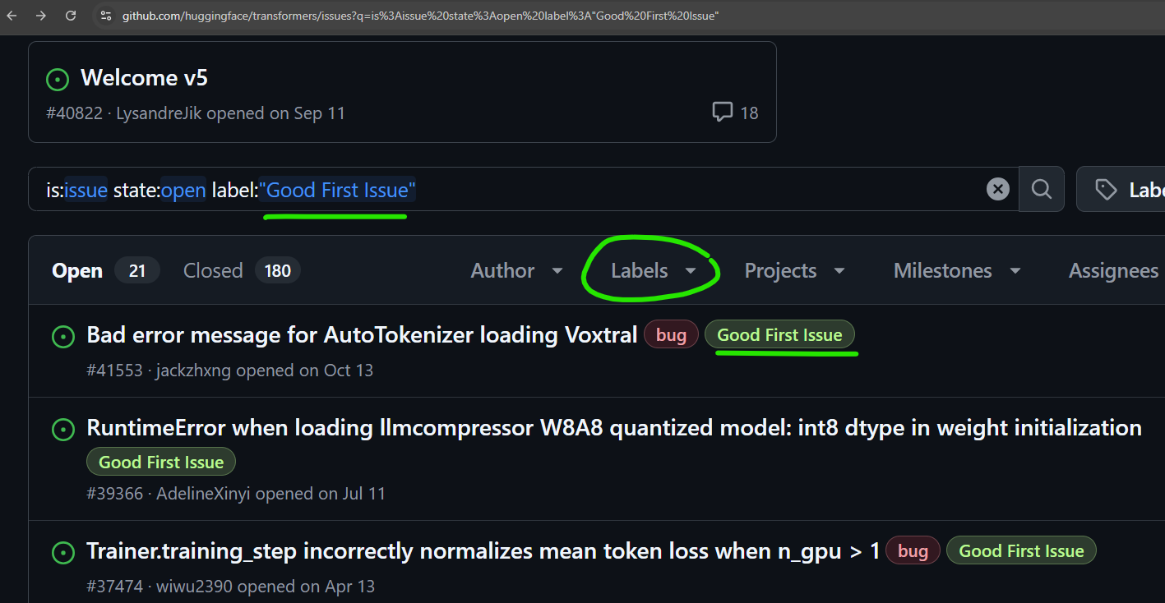

- Motivation
  - ML Engineer after 12th: https://bit.ly/3DqwLTY

Week 14: Machine Learning Projects🎯

- Regression Project: Bangalore property price prediction
  - YouTube playlist link: https://bit.ly/3ivycWr
Project covers the following
    - Data cleaning
    - Feature engineering
    - Model building and hyper parameter tuning
    - Write flask server as a web backend
    - Building website for price prediction
    - Deployment to AWS
- ATS Resume Preparation
  - Resumes are dying but not dead yet. Focus more on online presence.
  - Here is the resume tips video along with some templates you can use for your data analyst resume: https://www.youtube.com/watch?v=buQSI8NLOMw
  - Use this checklist to ensure you have the right ATS Resume: Check here.
- Portfolio Building Resources:
You need a portfolio website in 2025. You can build your portfolio by using these free resources.
- GitHub
  - Upload your projects with code on github and using github.io create a portfolio website
  - Codebasics bootcamp student portfolio: https://codebasics.io/portfolio/Lalith-kumar-Dabilpuram
- Assignment
  - In above two projects, make following changes
☐ Use FastAPI instead of flask. FastAPI tutorial: https://youtu.be/Wr1JjhTt1Xg
☐ Classification project: Take any classification project using a Kaggle dataset and build end to end solution along with deployment to AWS or Azure
☐ Add a link of your projects in your resume and LinkedIn.
(Tag Codebasics, Dhaval Patel and Hemanand Vadivel with the hashtag #dsroadmap24 so we can engage to increase your visibility)

Week 15, 16, 17, 18: Deep Learning 🤖

- Topics
  - What is a neural network? Forward propagation, back propagation
  - Building multilayer perceptron
  - Special neural network architectures
    - Convolutional neural network (CNN)
    - Sequence models: RNN, LSTM
    - Transformers

- Learning Resources
  - Track A (Free)
    - Deep Learning playlist (tensorflow): https://bit.ly/3vOZ3zV
      - Skip video # 16, 17, 29, 43, 44, 45, 48,
    - End to end potato disease classification project: https://bit.ly/3QzkVJi
    - CampusX PyTorch playlist: https://bit.ly/3K353Qg

  - Track B (Affordable Fees):
    - AI Bootcamp: https://codebasics.io/bootcamps/ai-data-science-bootcamp-with-virtual-internship

- Assignment
☐ Instead of potato plant images use tomato plant images or some other image classification dataset.
☐ Deploy to Azure instead of GCP.
☐ Create a presentation as if you are presenting to stakeholders and upload video presentation on LinkedIn.

Week 19, 20, 21: NLP or Computer Vision

- Many AI engineers choose a specialized track which is either NLP or Computer vision. You don’t need to learn both.
- Natural Language Processing (NLP)
  - Topics
    - Regex
    - Text presentation: Count vectorizer, TF-IDF, BOW, Word2Vec, Embeddings
    - Text classification: Naïve Bayes
    - Fundamentals of Spacy & NLTP library
    - One end to end project
  - Learning Resources
    - NLP YouTube playlist: https://bit.ly/3XnjfEZ
      - Skip S3 E2 (End to End NLP Project)

  - Classification Project: Log Classification System
    - YouTube link: https://bit.ly/4hu5EoL
    - Project covers the following
      - How to use hybrid approach (regex, BERT, Logistic Regression and LLM) for classification)
      - DB Scan clustering
    - Building FastAPI Backend

- Computer Vision (CV)
  - Use cases: In AtliQ, we had a project where a grocery store manager would take a picture of fridge and backend program will identify items, their count etc. For such use case you need to use CV.

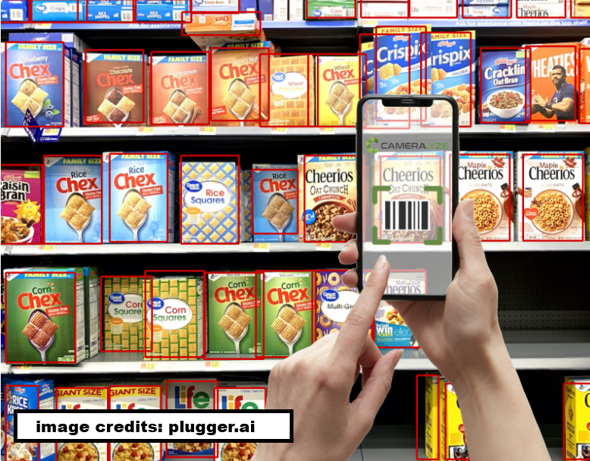

  - Topics
    - Basic image processing techniques: Filtering, Edge Detection, Image Scaling, Rotation
    - Library to use: OpenCV
    - Convolutional Neural Networks (CNN) – Already covered in deep learning.
    - YOLO
    - Data preprocessing, augmentation – Already covered in deep learning.
- Assignment
☐ NLP Track: Complete exercises in this playlist: https://bit.ly/3XnjfEZ

Week 22, 23, 24: Gen AI and Agentic AI 📃

- Topics
  - What is LLM, Vector databases, Embeddings
  - RAG (Retrieval Augmented Generation)
  - Langchain framework
  - MCP
  - Agentic frameworks: LangGraph, CrewAI
  - LLM Fine Tuning

- Learning Resources
  - Gen AI crash course: https://bit.ly/3Fn7Zoh
  - What is MCP: https://youtu.be/tzrwxLNHtRY
  - Build your MCP server: https://youtu.be/jLM6n4mdRuA
  - Agentic AI Tutorial using LangGraph : https://www.youtube.com/watch?v=CnXdddeZ4tQ
  - Crew AI: https://www.youtube.com/watch?v=G42J2MSKyc8
  - LLM Fine Tuning: https://youtu.be/IIvORO248Zs

Week 25, 26, 27: Gen AI, Agentic AI Projects

- Topics
  - Projects that include using LLMs, RAG, Agents to solve real life problems
- Learning Resources
  - Gen AI project playlist: https://bit.ly/4ilzEnX

Week 28, 29: Unguided AI Projects ️

- It is important that you work on a few end-to-end unguided projects. This is something you can add to your resume with confidence.
- Projects that you can build free using data challenges
  - Build RAG Chatbot using Role Based Access Control (RBAC): https://bit.ly/47SttUq
  - Use NLP to detect adverse drug events: https://bit.ly/43oup1y

Week 30, 31, 32: Azure or AWS

- Cloud skills (Azure or AWS) are essential especially for experienced AI engineer roles. When we analyzed AI engineer jobs, we found Azure to be at the top among all cloud providers when it comes to AI.
- For freshers, it is ok even if they do not learn cloud skills. Normally interviewers do not expect cloud skills in a fresher job opening BUT if you know this skill then that will bring unfair advantage for you.
- Topics
  - Azure
    - Azure fundamentals: Resource groups, subscriptions, regions, storage, IAM
    - Compute and deployment services: azure functions, azure app service, azure Kubernetes service (AKS)
    - AI, ML: Azure ML, OpenAI service, Cognitive services
    - MLOps and Monitoring: Azure ML Pipelines, Devops/GitHub actions, model monitoring
  - AWS
    - AWS fundamentals: Accounts, regions, S3, IAM
    - Compute and deployment services: Lambda, App Runner, EKS
    - AI, ML: SageMaker, Bedrock, AWS AI Services
    - MLOps and Monitoring: SageMaker Pipelines, CodePipeline/CodeBuild, Model Monitor/CloudWatch
- Learning Resources
  - There are tons of free resources you can find on internet. We do not have specific suggestions at this point but some day in future we plan to produce free videos on these topics in our YouTube channel

Optional

- At least one no-code agentic tool such as N8N, Make or Zapier
- One no-sql database (e.g. mongodb)

Week 33 onwards… 😀😀😀

- More projects 📽️
- Online brand building through LinkedIn, Kaggle, Discord, Open-source contribution 👨‍👩‍👧‍👦
- Job application and Success 🚀

Tips for effective learning 🔥

- Spend less time in consuming information, more time in
  - Digesting
  - Implementing
  - Sharing
- Group learning
  - Use partner-and-group-finder channel on codebasics discord server for group study and hold each other accountable for the progress of your study plan. Here is the discord server link: https://discord.gg/r42Kbuk

