**VIDNYAN MAHAVIDYALAYA, MALKAPUR**

**One Week “Remedial Course” For “C Programming Language”**

Date of the Program: 22th February, 2021 at 10:00 AM

No. of Participants: 63 students

No. of Beneficiary: 63 students

Vidnyan Mahavidyalaya, Malkapur held One Week “Remedial Course” For “C Programming

Language” for the B.Sc. I Year students by the Department Of Computer Science. With the permission of the Principal Dr. B.B.Wankhade we successfully conduct this course. Under the guidance of Head of the Department Prof. Punam M. Ingale , Prof. Pratiksha Khande completed this course.

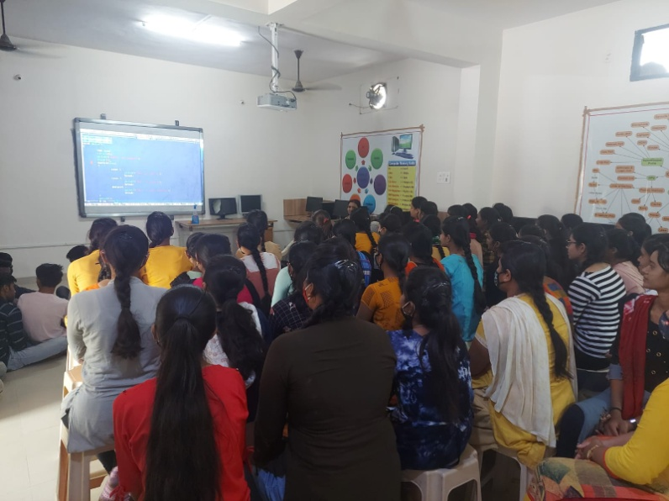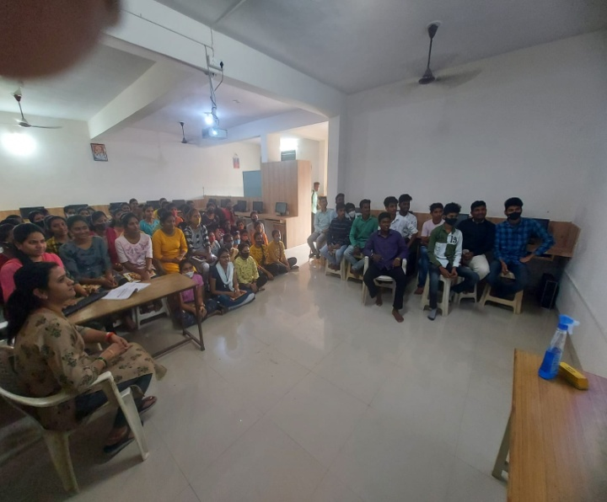  
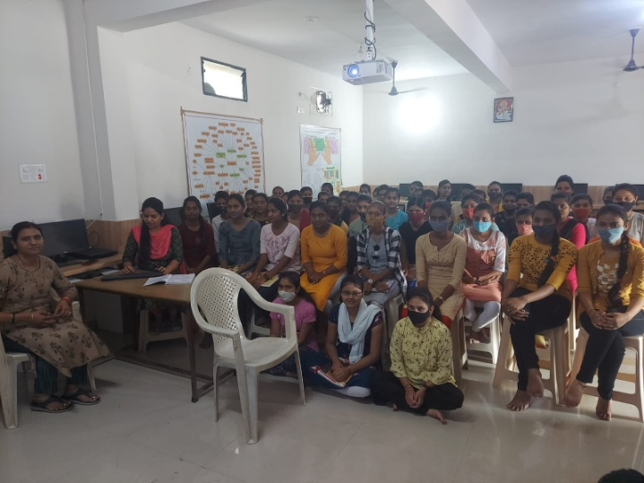

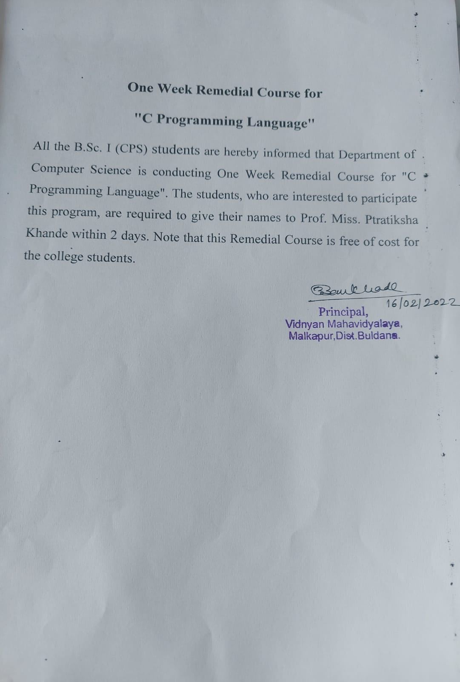

**Student Feedback**

