**Assignment 1:**

**Q1.**

**Connect to the Store Sales Data - order table.**

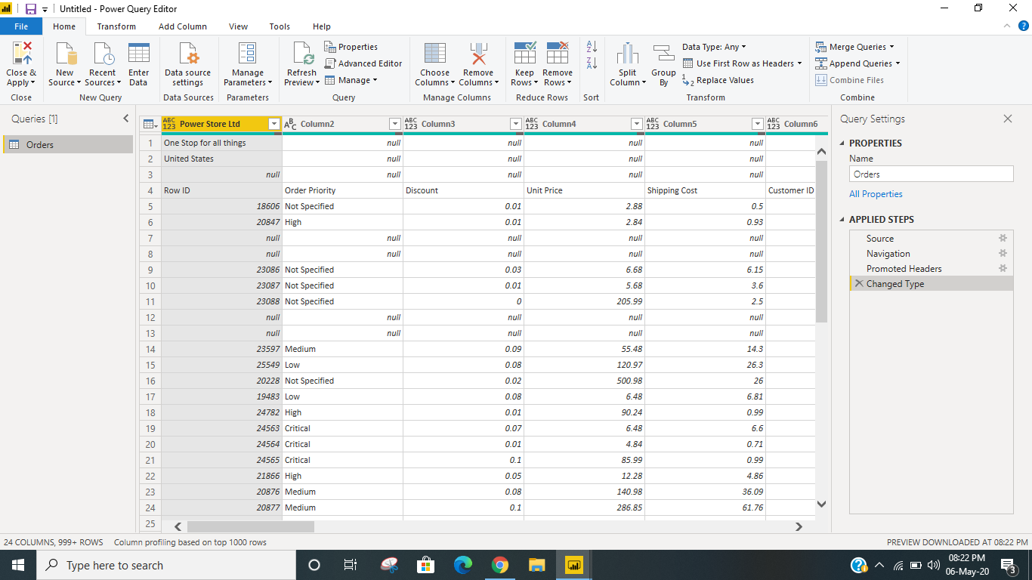

**Remove all the blank rows.**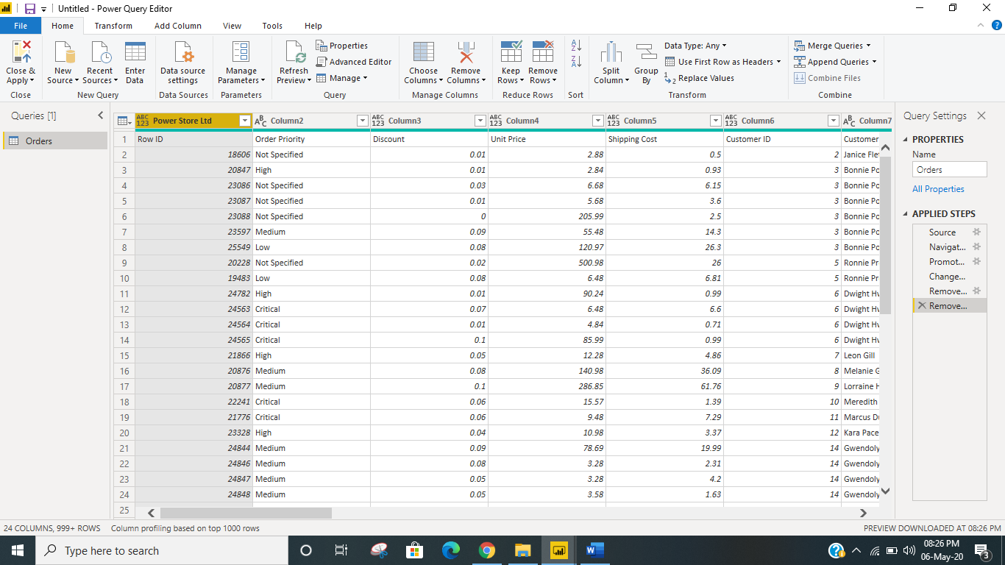

**Update the column header**

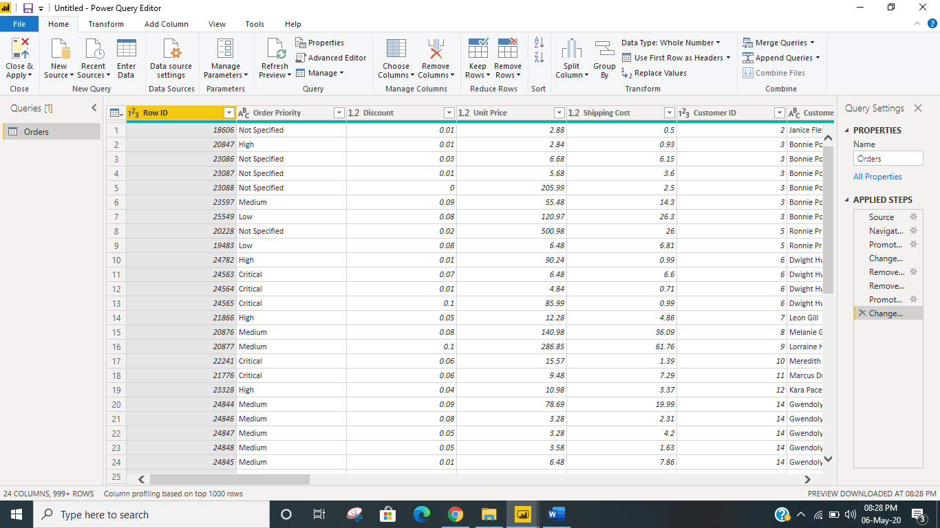

**Create a text table and show the sales in terms of**

**Customers , Product Category , Regions**

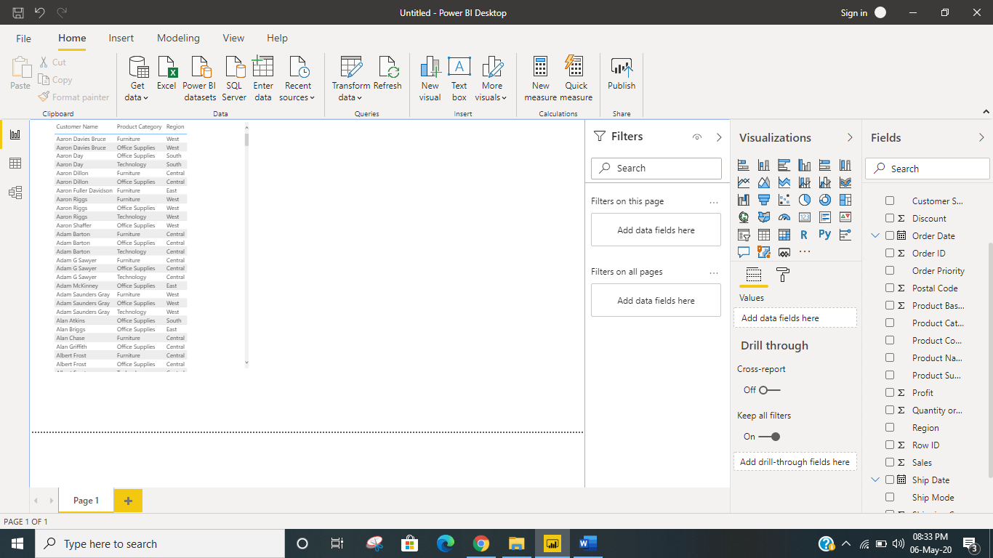

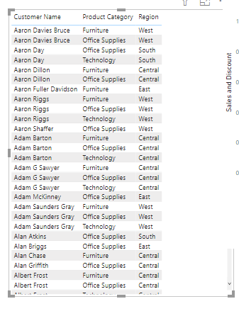

**Create a line and Clustered Column Chart showing the Sales and Discount as per the State or Province − Format the bars and line with different colors –**

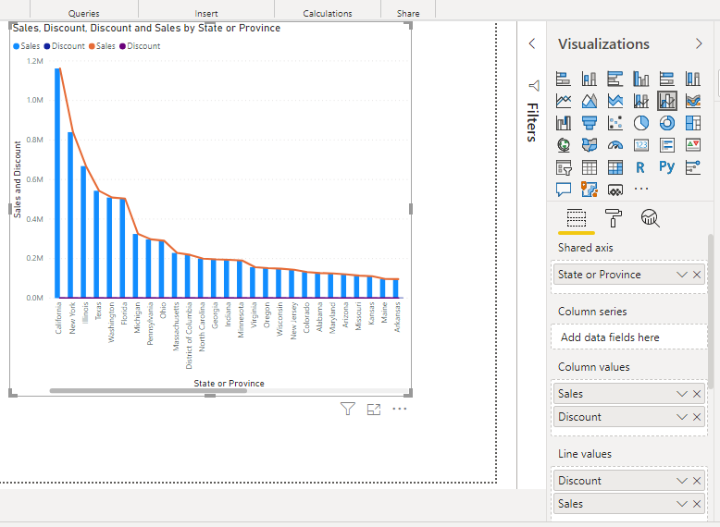

**Which state has the highest sales in terms Technology**

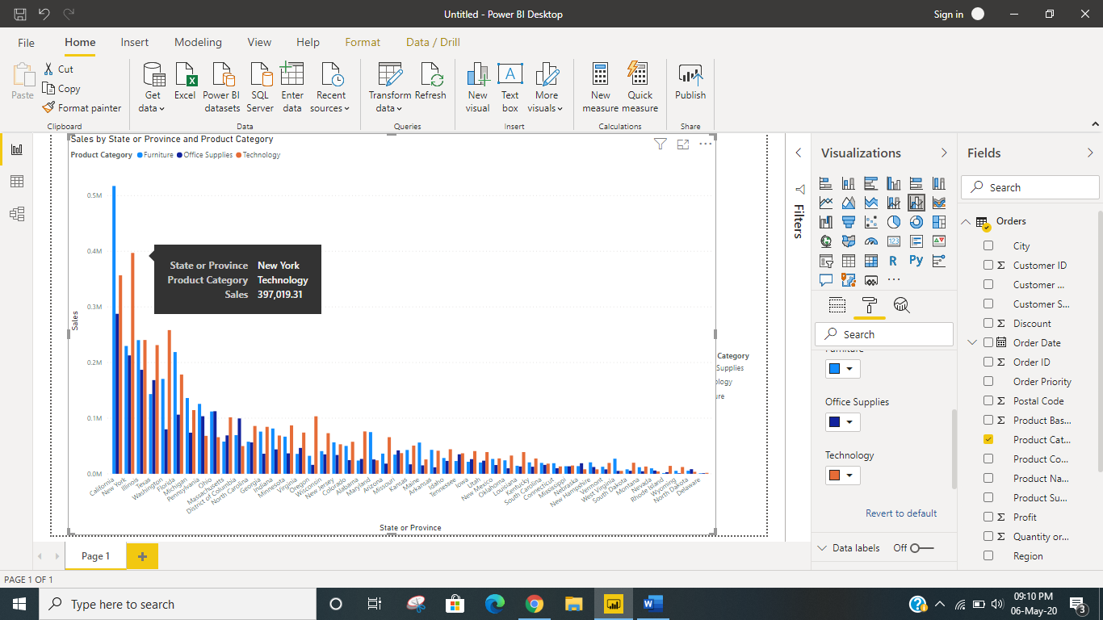

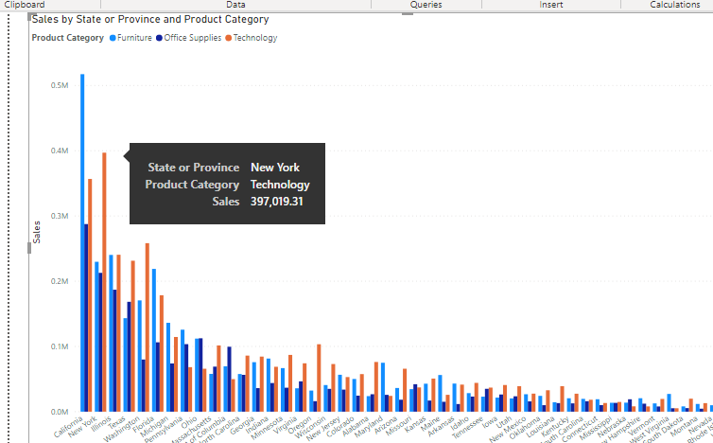

**Q• Create a Donut Chart showing sales in terms of Product category**

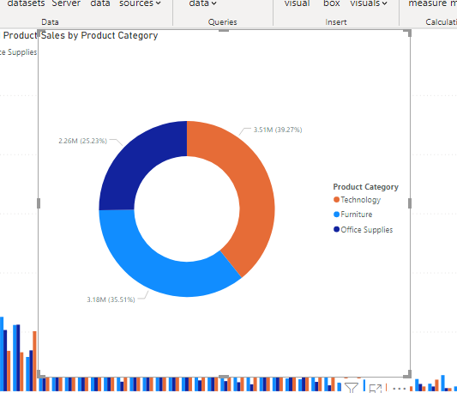

**Q. Create a Slicer and show the regions in dropdown. See how all the visuals mentioned above behaving when a particular region is selected.**

