Migrations

The term "matapercept" doesn't correspond to any widely recognized concept or entity. However, based on similar terms, you might be referring to one of the following:

1. **Metapercept Technology Services LLP**: This is an IT services company specializing in full-stack development, cloud-managed services, and technical writing. Their expertise includes technologies like VueJS, AngularJS, Firebase, and more.
2. **Matace P 100mg/500mg Tablet**: This is a medication used for pain relief, containing Aceclofenac (100mg) and Paracetamol (500mg). It's commonly prescribed for conditions like rheumatoid arthritis, osteoarthritis, and other musculoskeletal pains.
3. **Meta-Accuracy**: In psychology, meta-accuracy refers to an individual's awareness of how they are perceived by others. It involves understanding the impressions one makes on different people, such as a romantic partner or a best friend.

# DCOX to DITA

DCOX (DITA Community Oxygen XML) refers to a set of tools, frameworks, or plugins designed to enhance the use of Oxygen XML Editor for DITA (Darwin Information Typing Architecture) authoring and publishing. It provides an optimized environment for creating, editing, and managing DITA content within Oxygen XML Editor.

## Key Features of DCOX for DITA:

1. **Enhanced DITA Authoring** – Provides additional **customizations, templates, and automation** to streamline DITA documentation.
2. **Integration with CMS** – Supports **integration with DITA CMS or Git-based repositories** for version control and collaboration.

Custom Publishing Pipelines – Extends Oxygen XML’s DITA-OT (DITA Open Toolkit) to provide better output generation (PDF, HTML, etc.).

1. **Validation and QA Features** – Includes **DITA validation rules, link checking, and structure enforcement** for high-quality documentation.
2. **Plugin Support** – Can include **DITA-OT plugins or other Oxygen XML Editor enhancements** for better usability.



# HTML to DITA

**HTML to DITA** refers to the process of converting **HTML content** into **DITA (Darwin Information Typing Architecture) XML format** for structured documentation. This conversion is useful for organizations transitioning from web-based content to **structured authoring** in DITA for better content reuse, multi-channel publishing, and standardization.

## Key Aspects of HTML to DITA Conversion:

1. **HTML Elements Mapping to DITA**

1. **Types of DITA Topics Created from HTML:**

**Concepts**: General descriptions and explanations.

**Tasks**: Step-by-step instructions.

**References**: Tables, lists, or other structured data.

1. **Conversion Methods:**

**Manual Conversion**: Copying and restructuring HTML content into DITA XML manually.

**Automated Tools & Scripts**: Using Python, XSLT, or Oxygen XML Editor plugins.

**DITA-OT Plugins**: Some **DITA Open Toolkit (DITA-OT)** plugins support HTML input for conversion.

**CMS-Based Migration**: If content is stored in a CMS, it can be extracted and mapped to DITA formats.

1. **Benefits** of **HTML to DITA Conversion:**  
   ✅ Better Content Reuse – Write once, publish everywhere.  
   ✅ Standardized Structure – Enforces consistent documentation practices.  
   ✅ Multi-Channel Output – Generate PDFs, HTML5, EPUB, and more from a single source.  
   ✅ Metadata & Filtering – Use DITA attributes for conditional publishing.

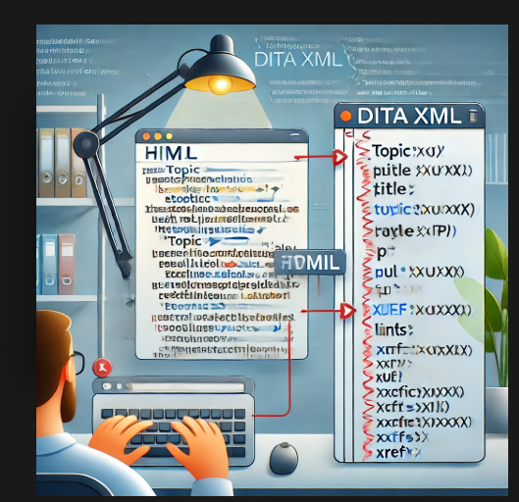

# MD to DITA

**MD to DITA** refers to converting **Markdown (MD) files** into **DITA (Darwin Information Typing Architecture) XML format** for structured documentation. This is particularly useful for teams managing technical documentation in Markdown but needing the structured, reusable, and multi-channel publishing capabilities of DITA.

## Key Aspects of MD to DITA Conversion

### 1️Mapping Markdown Elements to DITA

|  |  |
| --- | --- |
| **Markdown (MD)** | **DITA Equivalent** |
| # Heading 1 | <title> (within a topic) |
| ## Heading 2 | <title> (within a section) |
| *Italic* or _Italic_ | <i> |
| **Bold** or __Bold__ | <b> |
| > Blockquote | <note> |
| - List item or * List item | <ul><li> (unordered list) |
| 1. List item | <ol><li> (ordered list) |
| `Inline code` | <codeph> |
|  |  |
| Code block |  |
| ``` | <codeblock> |
| [Link text](URL) | <xref href="URL"/> |
| ![Alt text](image.png) | <image href="image.png"/> |

## 2️.Types of DITA Topics Created from Markdown

* **Concept Topics** – General explanations (.md files with headings and paragraphs).
* **Task Topics** – Step-by-step guides (.md files with numbered lists).
* **Reference Topics** – Tables, definitions, and technical specifications.

## 3️ Conversion Methods

✅ **Manual Conversion** – Copy and restructure Markdown into DITA XML.  
✅ **Automated Tools & Scripts** – Use Python, Pandoc, or XSLT transformations.  
✅ **DITA-OT Plugins** – Some **DITA Open Toolkit (DITA-OT)** plugins allow direct Markdown input.  
✅ **Oxygen XML Editor** – Supports Markdown import and conversion into DITA topics.

### 4️ Benefits of MD to DITA Conversion

**Structured Content** – DITA enforces a strict information architecture.

**Content Reuse** – Use **conrefs** to avoid duplication.

**Multi-Channel Publishing** – Generate **PDF, HTML5, EPUB, and more** from a single source.

**Conditional Filtering** – Use **DITA attributes** for audience-specific content.

