

PRT661 – DATA SCIENCE PRACTICE

Assessment 1: Group Project Proposal and Design Plan

AUSTRALIAN ELECTRICITY DEMAND FORECASTING

USING MACHINE LEARNING AND TIME SERIES ANALYTICS

Theme 2: Predictive Analytics and Forecasting

Student IDs Student Names

Ashish Shrestha: S388084

Bishal Dahal: S388095

Sudip Lamichhane: S388085

Suraj Raut: S391201

Submission Date: 16/08/2026

1. Project Overview and Objectives
This project designs and operates a continuous electricity demand forecasting and verification platform across seven Australian regions: five NEM (NSW1, QLD1, SA1, VIC1, TAS1), plus WA (WEM) and Darwin-Katherine (NT), producing half hourly 2026 forecasts from a moving cutoff and verifying each against actual demand as it arrives, including AEMO's retrospective corrections.
The project objectives are to:
- Acquire and integrate half hourly demand for all seven regions, handling each platform's retrospective corrections
- Engineer per region lag, temporal and weather features supporting 48 interval per day forecasting
- Build and continuously verify per region models under a rolling, correction aware validation strategy
- Deliver paired forecasting and verification dashboards communicating predicted demand and model accuracy
2. Theme 2 Justification
Reliable short term forecasts support capacity planning and peak demand preparedness across the NEM; under forecasting risks shortfalls, over forecasting wastes resources. This remains genuine Theme 2 work, now extended to continuous multi region forecasting: demand shows region specific weekly and seasonal periodicity (Richardson et al., 2025), supporting lag feature engineering, per region comparison and correction aware validation. Target: Operational Demand (MW) per region, excluding rooftop solar (AEMO, n.d.).
3. Problem Statement
Target variable: half hourly Operational Demand (MW) across seven regions defined in Section 1. WA and NT sit outside the NEM on separate operator platforms and are integrated as independently handled sources, not assumed identical to the NEM feed (AEMO, n.d.; NTESMO, n.d.).
Forecast horizon: continuous rolling forecast from the current cutoff date to 31 December 2026, at 48 half hourly intervals per day: 17,520 intervals per region across the full (non-leap) year.
Modelling window: 1 January 2022 to cutoff, prioritising recent years consistent with post 2022 electrification and distributed energy resource trends.
4. Data Sources and Data Strategy
Primary: AEMO half hourly Actual Operational Demand, all five NEM regions. AEMO also publishes five minute values (linearly interpolated from the half hourly figures) and daily aggregates from the same table. AEMO issues dedicated Update files when a retroactive correction is required, commonly due to SCADA data quality issues, and this update data overrides the original real time published record (AEMO, n.d.). The data strategy therefore models every actual demand record with two states: provisional (first published) and canonical (post correction). WA adds AEMO WEM half hourly demand; Darwin-Katherine adds NTESMO demand, without NEM correction files (NTESMO, n.d.).
Secondary: BOM Climate Data Online temperature per region, converted to Heating/Cooling Degree Days (BOM, n.d.).
Table 1 sets out the proposed per region feature variables.
Variable | Source | Justification
Operational Demand (lag: interval 1, day 1, week 1) | AEMO, per region | Captures persistence and periodicity
Half hour of day, DOW, month, season | Derived | Captures diurnal/weekly/seasonal cycles
Temperature (HDD/CDD) | BOM, per region | Established heating/cooling driver (Richardson et al., 2025)
Public holiday flag | Derived, per region | Demand deviates from routine patterns
Table 1. Proposed per region dataset variables.
5. System Architecture
Figure 1 shows the eight layer platform: sources feed continuous ingestion, including a correction file listener; raw storage preserves lineage; a Data Quality & Correction layer reconciles provisional against canonical records; curated features feed independent per region models; forecasts freeze in a repository kept separate from canonical actuals; and a Verification & Presentation layer compares the two, monitors performance, and serves both dashboards. Unlike a one way pipeline, the architecture closes a feedback loop: verification findings feed back into the Forecasting Engine (dashed arrow), letting the system run continuously rather than as a single trained and forgotten model.
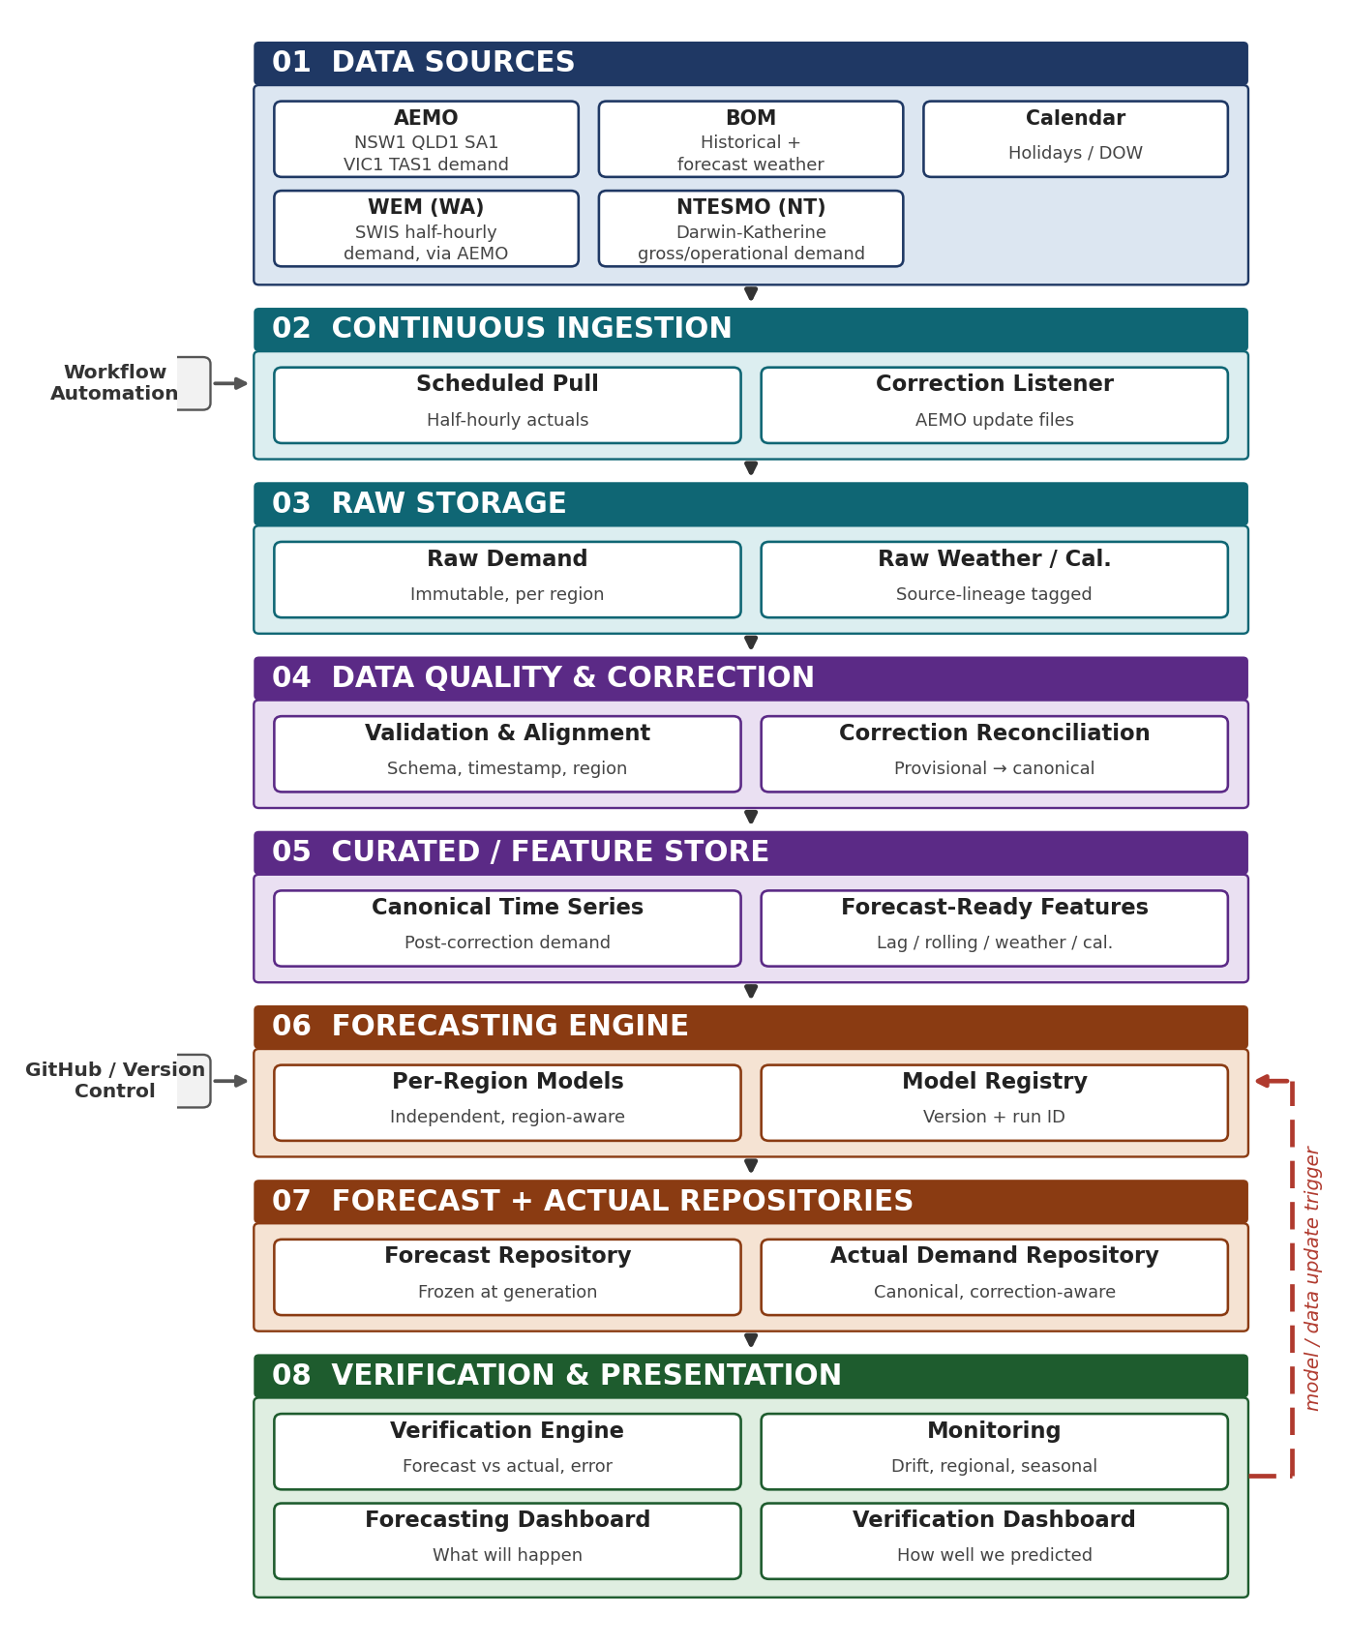
Figure 1. Proposed platform architecture, with verification feedback loop.
6. Continuous Verification and the Rolling Boundary
Figure 2 illustrates the cycle: at any cutoff, the platform holds actual demand and frozen forecasts through the cutoff (validated historical) and forecast only values beyond it (future forecast); the boundary advances daily as actuals arrive. Each forecast is generated once, frozen, and verified against that original value which prevents future information leaking into historical evaluation (Hewamalage, Ackermann, & Bergmeir, 2022).
If AEMO later issues a retrospective correction, the Verification Engine recalculates that day's error against the corrected actual and flags the metric as recalculated, rather than silently overwriting the first pass result operationalising AEMO's own correction mechanism (Section 4).
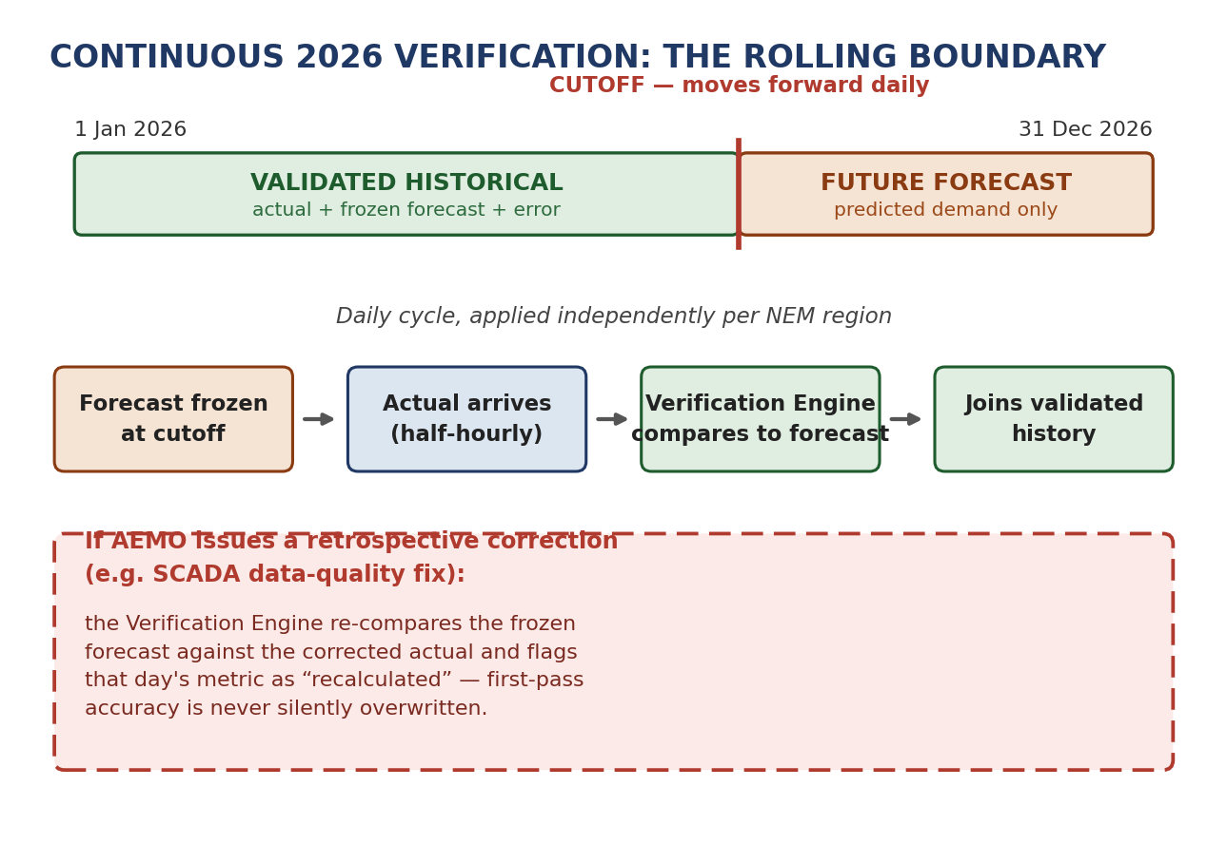
Figure 2. Continuous verification cycle and correction aware recalculation.
7. Forecasting Methodology
Independent per region models are the primary approach: the regions differ materially in climate, population, industry mix and scale, making region specific modelling more defensible than one shared model (Richardson et al., 2025). A three tier comparison runs per region: seasonal naive baseline, statistical SARIMA, and machine learning models (Random Forest, Gradient Boosting); deep learning stays a stretch extension given group capacity (Akhtar et al., 2023; Alsmadi et al., 2025). An optional hierarchical reconciliation step, checking regional forecasts sum to an independently forecast NEM total, is well established but scoped as a stretch.
Validation remains strictly chronological walk forward, applied per region; metrics are MAE, RMSE, MAPE and bias, the last to catch systematic under or over forecasting (Hyndman & Athanasopoulos, 2021).
8. Dashboard Architecture
Figure 3 shows the two dashboard design, sharing one data layer. Dashboard A (Forecasting & Demand Intelligence) answers "what will happen": region selector, annual/daily/half hourly views, forecasts clearly distinguished from actuals. Dashboard B (Verification & Model Performance) answers "how well did we predict": MAE/RMSE/MAPE/bias, actual vs predicted and error over time charts, regional comparison. No accuracy or demand figures are populated until real models are trained; both are illustrative layouts only.
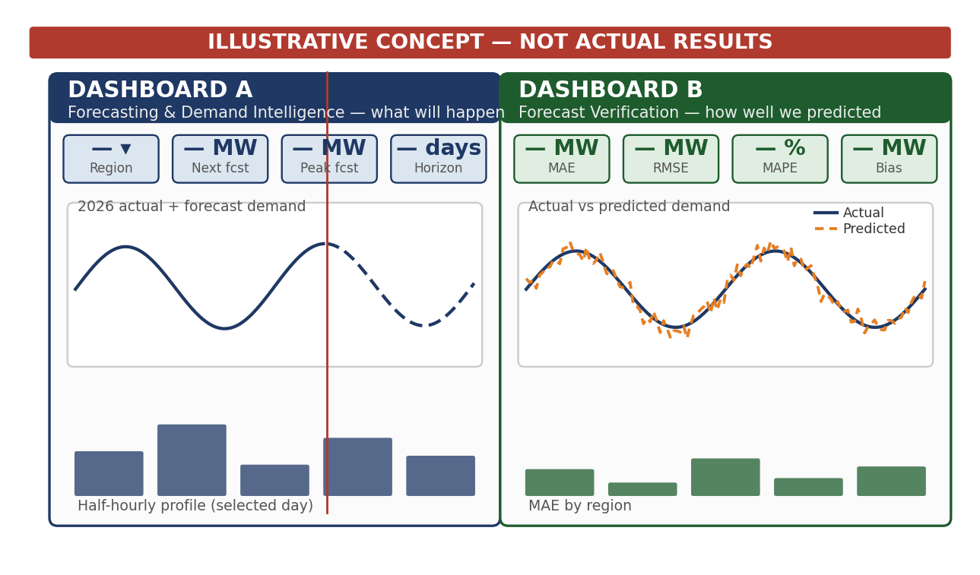
Figure 3. Illustrative dual dashboard concept
9. Team Structure and Task Allocation
Table 2 sets out the proposed workload allocation; all members contribute to integration and final validation regardless of role.
Student | Primary Role | Key Deliverable
Sudip | Data Acquisition & Correction Handling Lead | Verified seven region dataset, correction handling logic
Suraj | Data Engineering Lead | Cleaned, aligned, feature engineered per region pipeline
Ashish | Forecasting Lead | Per region baseline, statistical and ML models
Bishal | Verification & Dashboard Lead | Verification engine, both dashboard mock ups
Group | Architecture & Automation Lead | System diagrams, GitHub, workflow automation
Table 2. Proposed team responsibility matrix.
10. Initial Risk Analysis
Table 3 lists the principal risks introduced by this expanded scope.
Risk | Likelihood | Impact | Mitigation
Seven region half hourly volume (~48× prior scope) | Medium | Medium | Prove pipeline on one region first, then scale
AEMO correction files missed or mishandled | Medium | High | Dedicated listener; test against known correction cases
Per region model accuracy diverges | Medium | Medium | Report accuracy per region, not just NEM wide
Table 3. Initial risk register.
11. Ethics, Privacy and Security
Privacy risks are low as the data sets from AEMO and BOM are still aggregated, impersonal, and open license across all five regions (AEMO, n.d.). Security considerations remain unchanged: there are no credentials required, and standard GitHub authentication procedures are in place. In view of the operational costs associated with underestimation of peak demand, the purpose of the verification dashboard is unique in that it makes model constraints evident. The forecasts are provided with explicit uncertainty, as decision support tools, not automatic controls.
12. Project Feasibility / Conclusion
The current scope is technically feasible within the time available to the team, considering that there is a dataset with half hourly data for five regions, a tested single region SARIMA baseline model, AEMO’s documented procedure for correcting estimates, and walk forward approach as long as the pipeline is proven in one region first, with hierarchical reconciliation and the second dashboard considered stretch goals.

13. References
Akhtar, S., Shahzad, S., Zaheer, A., Ullah, H. S., Kilic, H., Gono, R., Jasiński, M., & Leonowicz, Z. (2023). Short-term load forecasting models: A review of challenges, progress, and the road ahead. Energies, 16(10), 4060. https://doi.org/10.3390/en16104060
Alsmadi, L., Lei, G., & Li, L. (2025). Forecasting day-ahead electricity demand in Australia using a CNN-LSTM model with an attention mechanism. Applied Sciences, 15(7), 3829. https://doi.org/10.3390/app15073829
Australian Energy Market Operator. (n.d.). About the National Electricity Market (NEM). Retrieved August 16, 2026, from https://www.aemo.com.au/energy-systems/electricity/national-electricity-market-nem/about-the-national-electricity-market-nem
Australian Energy Market Operator. (n.d.). Operational demand data. Retrieved August 14, 2026, from https://www.aemo.com.au/energy-systems/electricity/national-electricity-market-nem/data-nem/operational-demand-data
Bureau of Meteorology. (n.d.). Climate data online. Retrieved August 13, 2026, from http://www.bom.gov.au/climate/data/
Hewamalage, H., Ackermann, K., & Bergmeir, C. (2023). Forecast evaluation for data scientists: Common pitfalls and best practices. Data Mining and Knowledge Discovery, 37(2), 788–832. https://doi.org/10.1007/s10618-022-00894-5
Hyndman, R. J., & Athanasopoulos, G. (2021). Forecasting: Principles and practice (3rd ed.). OTexts.
Northern Territory Electricity System and Market Operator. (n.d.). Darwin-Katherine data. Retrieved August 16, 2026, from https://ntesmo.com.au/data/darwin-katherine
Richardson, D., Hobeichi, S., Sweet, L., Rey-Costa, E., Abramowitz, G., & Pitman, A. J. (2025). Predicting Australian energy demand variability using weather data and machine learning. Environmental Research Letters, 20(1), 014028. https://doi.org/10.1088/1748-9326/ad9b3b

