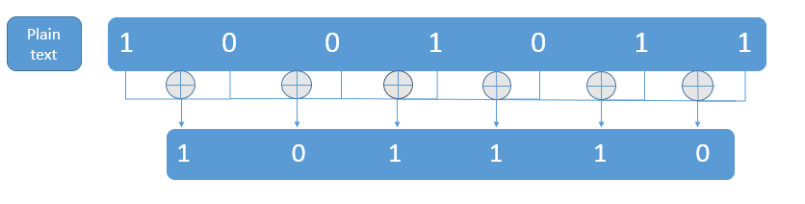

Plain text = 1001011

We will XOR consecutive elements of first row(1001011) to get second row(101110)

Then we will XOR consecutive elements of second row(101110) to get element of third row(11001).

We will follow this procedure until we get single element in a row.

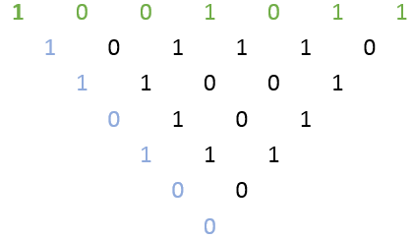

Green line(1001011) is plain text and Blue line(1110100) is cipherText

Now we will do the reverse procedure to get back our plain text.

We will take Blue line(1110100) as input as shown below

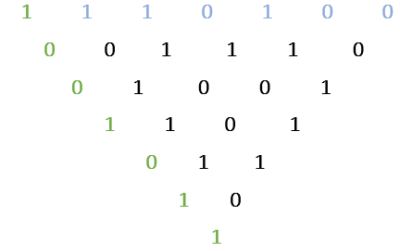

And get out our Green(1001011) plain text by following the same procedure.