WIPRO CAPSTONE PROJECT REPORT

Name | Ashish Kumar
Superset ID | 5388673
Organization | Wipro
Project Type | Capstone Project
Project Name | Automation Testing using Selenium PyTest Framework
 | Automation Testing using Behave BDD Framework
Domain | E-Commerce
Module Title | Best Buy Headphones Automation

SYNOPSIS
The Wipro Capstone Project focuses on automating the Best Buy Headphones module using two separate automation frameworks: Selenium WebDriver with Python PyTest framework and Behave BDD framework. The automation validates country selection, Top Deals navigation, headphones category selection, product validation, Add to Cart functionality, and cart verification workflow.
The framework was designed using the Page Object Model (POM) architecture to improve maintainability, reusability, and scalability. Screenshots, logs, reports, and reusable utility files were integrated to support execution tracking and debugging.
The project includes End-to-End, positive, and negative testing scenarios using industry-standard automation testing practices.

PROJECT DESCRIPTION
The automation framework automates the complete workflow of the Best Buy Headphones module. The framework performs homepage validation, country selection, Top Deals navigation, headphones category selection, product validation, Add to Cart operation, and cart verification.
Separate page classes were implemented for Home, Headphones, Product, and Cart modules using Selenium Python Page Object Model framework.
The project also includes Behave BDD implementation where business scenarios are written in Gherkin syntax and integrated with Selenium automation scripts using Given-When-Then structure.

SELENIUM PYTEST FRAMEWORK

TEST STRATEGY
The project uses Selenium WebDriver with Python PyTest framework for automation testing. The framework supports:
- End-to-End Testing
- Positive Testing
- Negative Testing
- Data-Driven Testing
Tools Used:
- Selenium WebDriver
- PyTest
- Allure Reports
- Logging Module
- Python
- OpenPyXL
- WebDriver Manager

TEST ENVIRONMENT
Operating System | Windows 10
IDE | PyCharm Community Edition
Browser | Google Chrome
Framework | Selenium WebDriver + PyTest
Design Pattern | Page Object Model (POM)
Programming Language | Python
Reporting Tool | Allure Reports

FRAMEWORK ARCHITECTURE
Wipro_Selenium_Project
├── config
├── logs
├── pages
├── reports
│ ├── allure-results
│ └── allure-report
│
├── screenshots
├── test_data
├── tests
├── utilities
├── conftest.py
├── pytest.ini
├── requirements.txt
└── run_tests.bat

TEST EXECUTION
The automation suite includes:
- 1 End-to-End Test Case
- 7 Positive Test Cases
- 3 Negative Test Cases
The End-to-End test validates the complete Best Buy Headphones workflow from homepage navigation until Add to Cart and cart verification.

SELENIUM TEST CASE SUMMARY
S.No | Test Type | Test Scenario | Expected Result | Status
1 | End-to-End | Complete Best Buy Headphones Workflow | User successfully adds product to cart and verifies cart details | Passed
2 | Positive | Best Buy Website Validation | Best Buy homepage opens successfully | Passed
3 | Positive | United States Selection Validation | United States region selected successfully | Passed
4 | Positive | Top Deals Navigation Validation | Top Deals page opens successfully | Passed
5 | Positive | Headphones Navigation Validation | Headphones section opens successfully | Passed
6 | Positive | Random Headphone Category Selection | Selected headphone category opens successfully | Passed
7 | Positive | Add to Cart Validation | Product added to cart successfully | Passed
8 | Positive | Cart Verification Validation | Cart displays selected product successfully | Passed
9 | Negative | Invalid Website URL Validation | Error handled successfully for invalid URL | Passed
10 | Negative | Wrong Country Selection Validation | Incorrect country selection handled successfully | Passed
11 | Negative | Invalid Section Navigation Validation | Invalid section navigation handled successfully | Passed

END-TO-END FLOW VALIDATION
The End-to-End automation validates the complete business workflow including:
• Best Buy Homepage Validation
• United States Region Selection
• Top Deals Navigation
• Headphones Section Navigation
• Random Headphone Category Selection
• Product Selection Validation
• Add to Cart Functionality
• Cart Verification Validation

POSITIVE TEST CASES
Positive Test Case 1 – Best Buy Website Validation
• Validates successful navigation to the Best Buy website
• Verifies homepage loading successfully
• Checks homepage URL validation
Positive Test Case 2 – United States Selection Validation
• Validates country selection functionality
• Selects “United States” region
• Verifies successful homepage redirection
Positive Test Case 3 – Top Deals Navigation Validation
• Validates Top Deals navigation functionality
• Opens Top Deals section
• Verifies successful page navigation
Positive Test Case 4 – Headphones Navigation Validation
• Validates headphones category navigation
• Opens headphones section successfully
• Verifies successful category loading
Positive Test Case 5 – Random Headphone Category Selection
• Validates headphone category card selection
• Opens selected headphone category
• Verifies successful category navigation
Positive Test Case 6 – Add to Cart Validation
• Validates Add to Cart functionality
• Selects headphone product successfully
• Verifies successful cart addition
Positive Test Case 7 – Cart Verification Validation
• Validates cart summary functionality
• Verifies selected product in cart
• Confirms successful cart validation

NEGATIVE TEST CASES
Negative Test Case 1 – Invalid Website URL Validation
• Opens invalid website URL
• Validates application error handling
• Verifies unsuccessful page loading
• Ensures invalid URL handling functionality
Negative Test Case 2 – Wrong Country Selection Validation
• Selects incorrect country option
• Validates country selection handling
• Verifies navigation restriction functionality
• Ensures unsupported region validation
Negative Test Case 3 – Invalid Section Navigation Validation
• Attempts invalid section navigation
• Validates application navigation handling
• Verifies unavailable section handling
• Ensures invalid navigation restriction
ALLURE REPORTS
• Integrated Allure Reports with PyTest
• Generates professional execution reports
• Displays passed and failed test status
• Captures screenshots during execution
• Maintains execution history
• Displays step-by-step execution flow
• Helps debugging and tracking failures
• Provides detailed execution summary

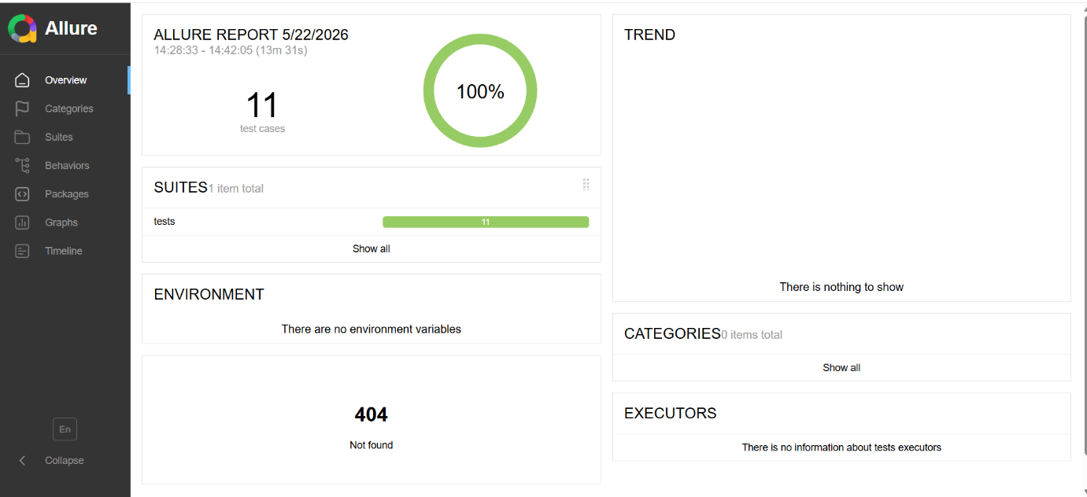

TEST OUTPUTS
The framework automatically captures screenshots during important execution stages including Best Buy homepage validation, United States selection, Top Deals navigation, headphones category page, random headphone category selection, Add to Cart validation, and cart order summary verification.
Detailed execution logs are generated using Python logging framework for debugging and execution tracking.

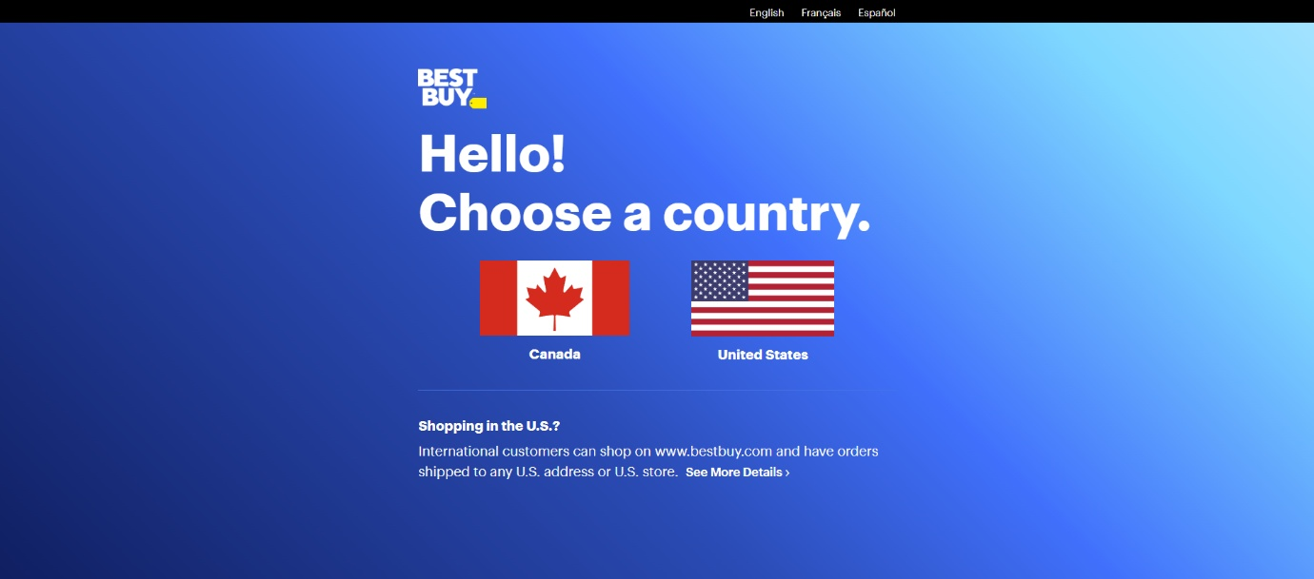
Fig 1: BestBuy Website Validation

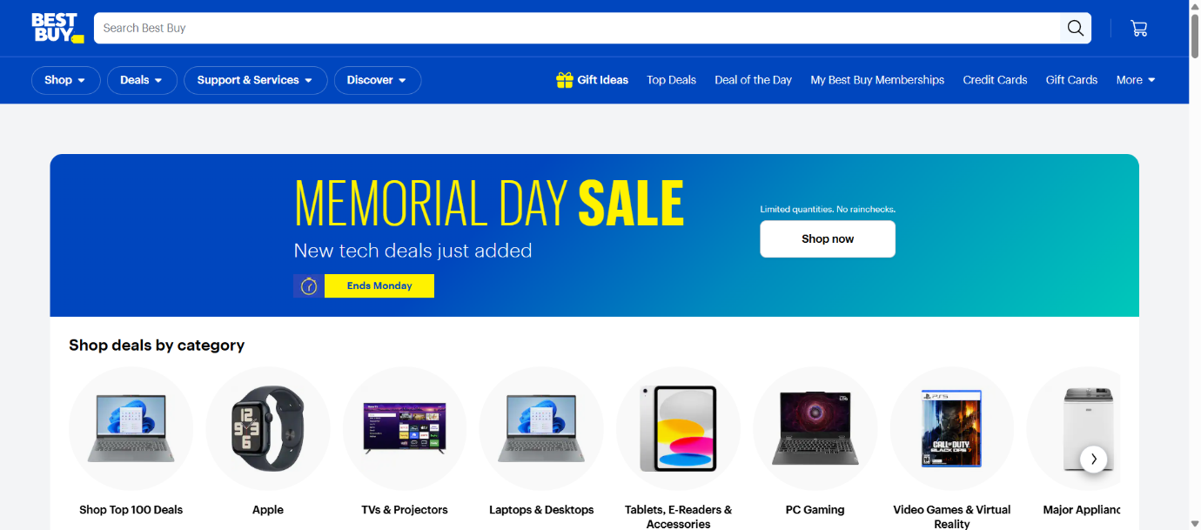
Fig 2: United States Selection

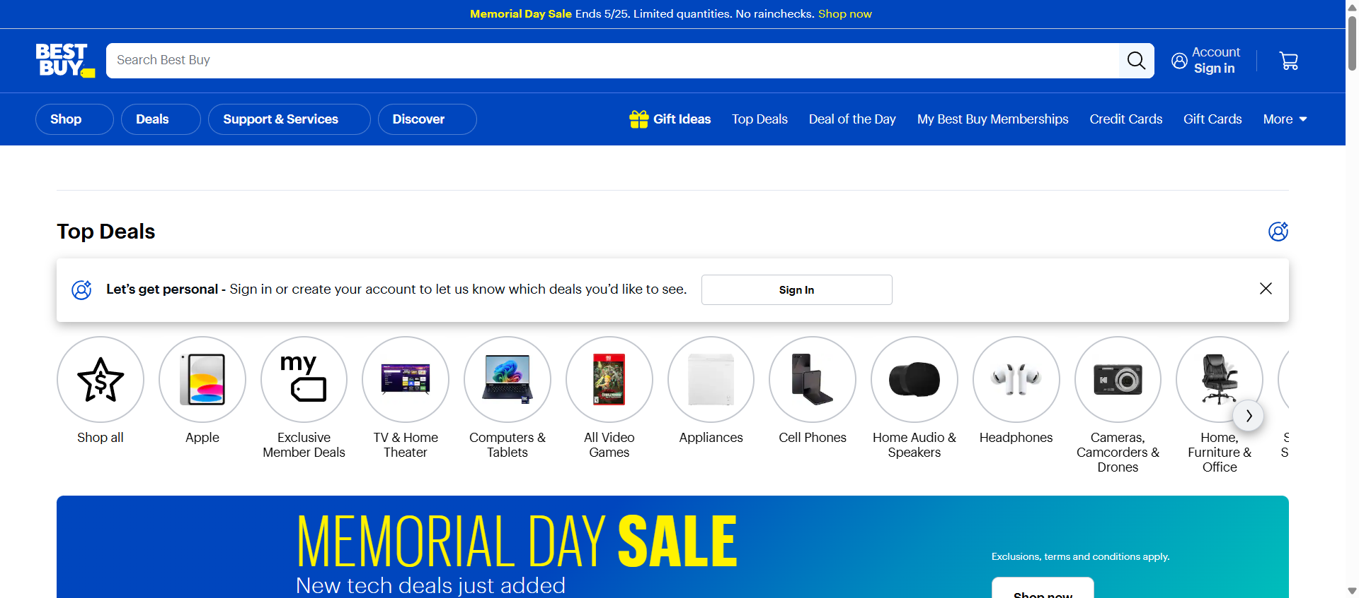
Fig 3: Top Deals Navigation

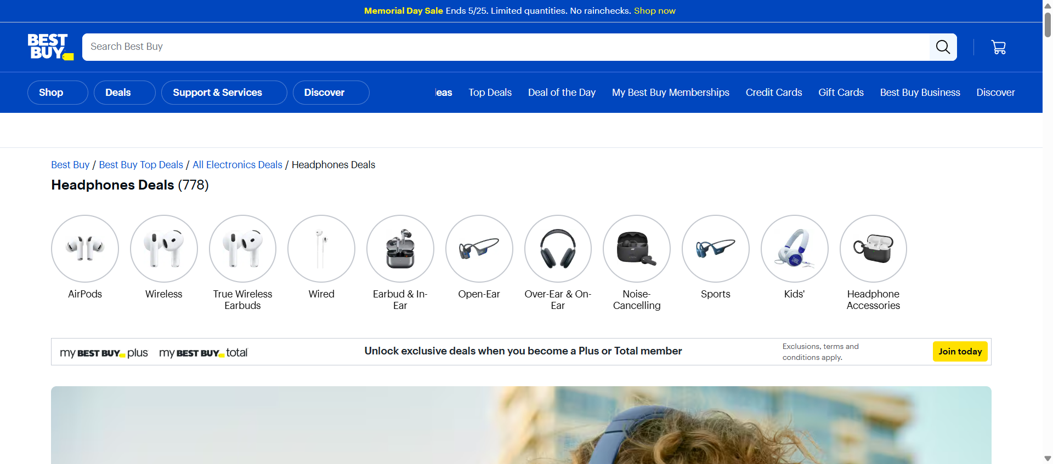
Fig 4: Headphones Category Page

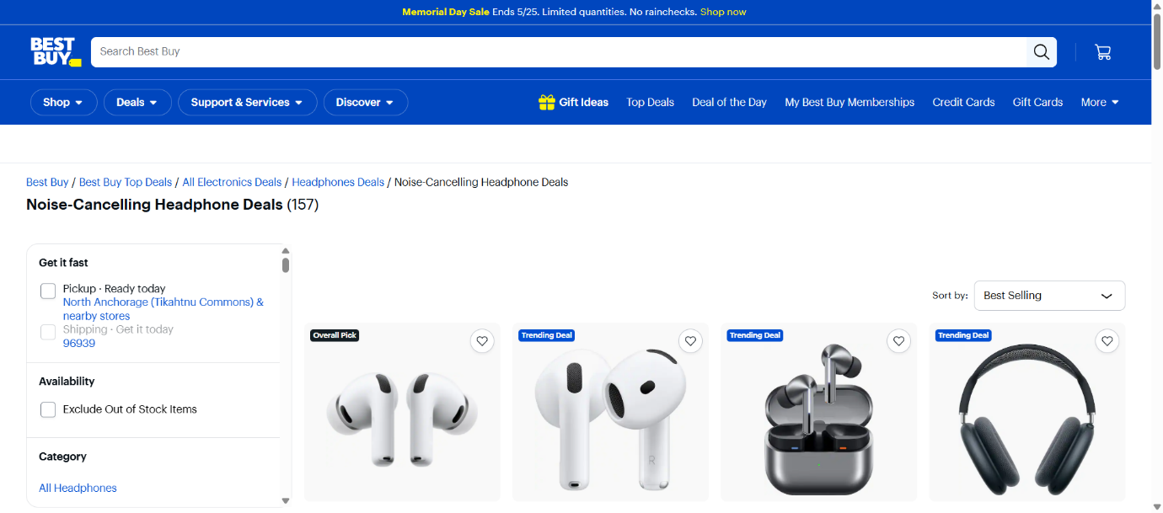
Fig 5: Random Headphone Category Selection

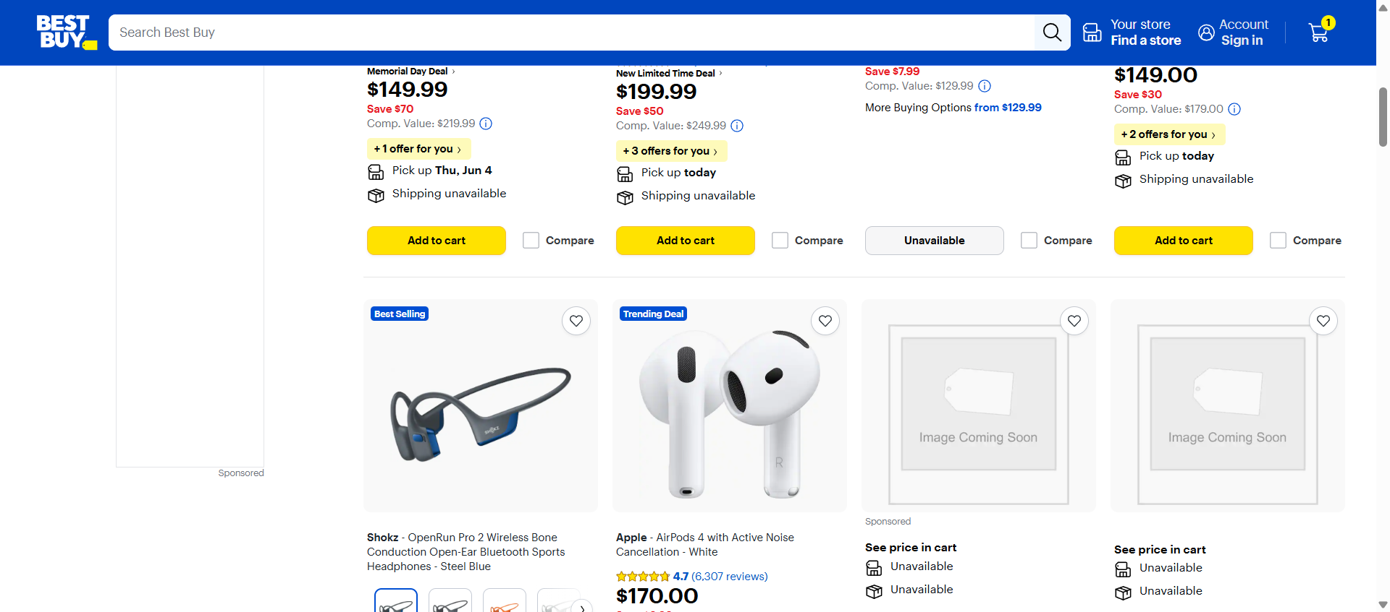

Fig 6: Products Added to Cart

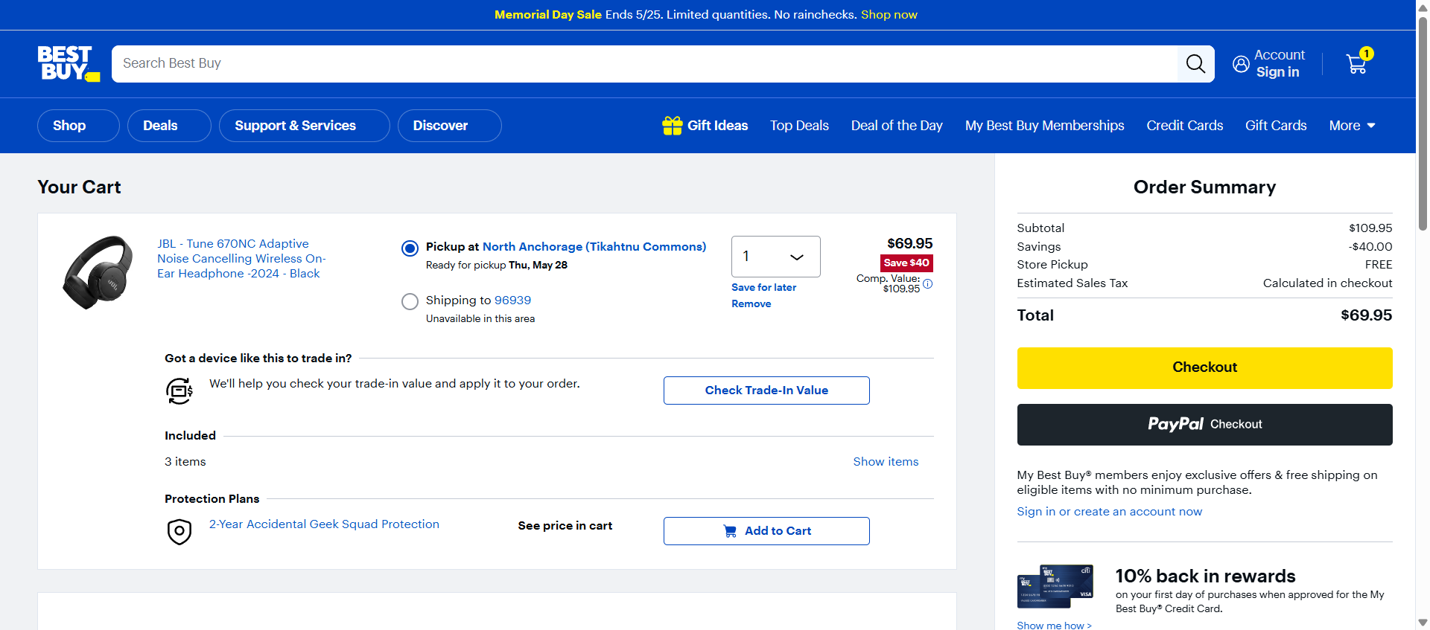
Fig 7: Cart Order Summary

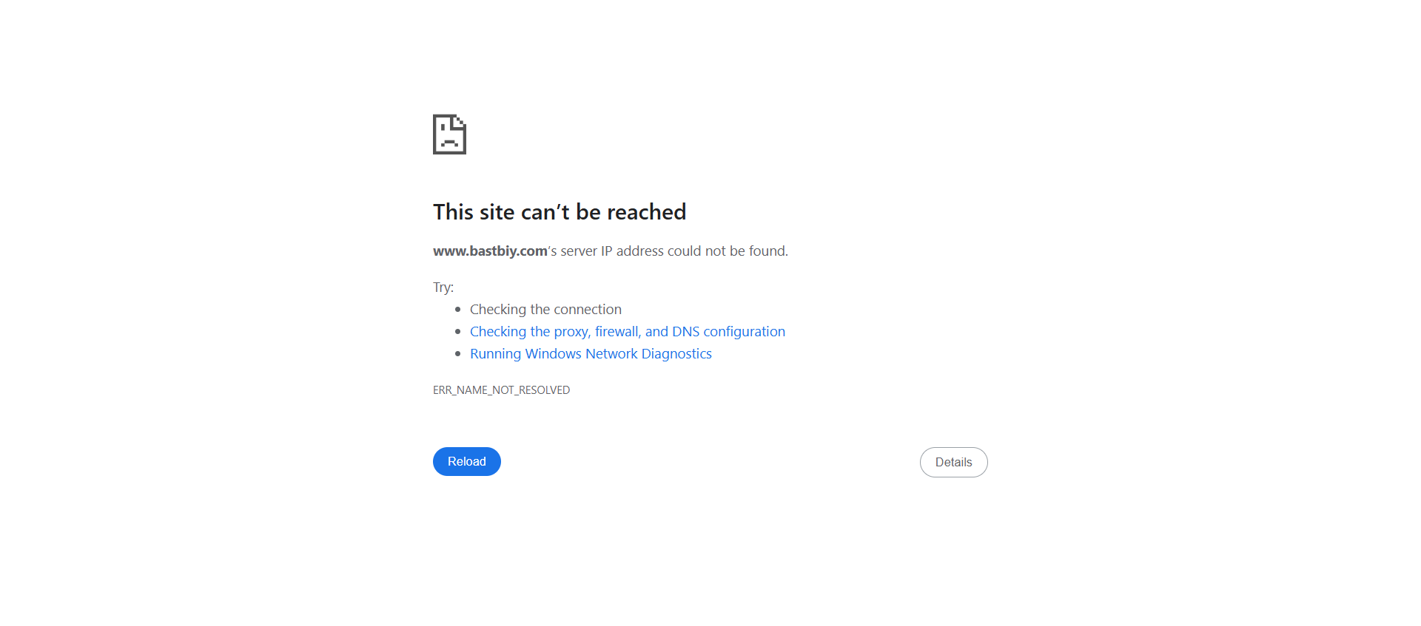
Fig 8: Wrong Website URL Validation

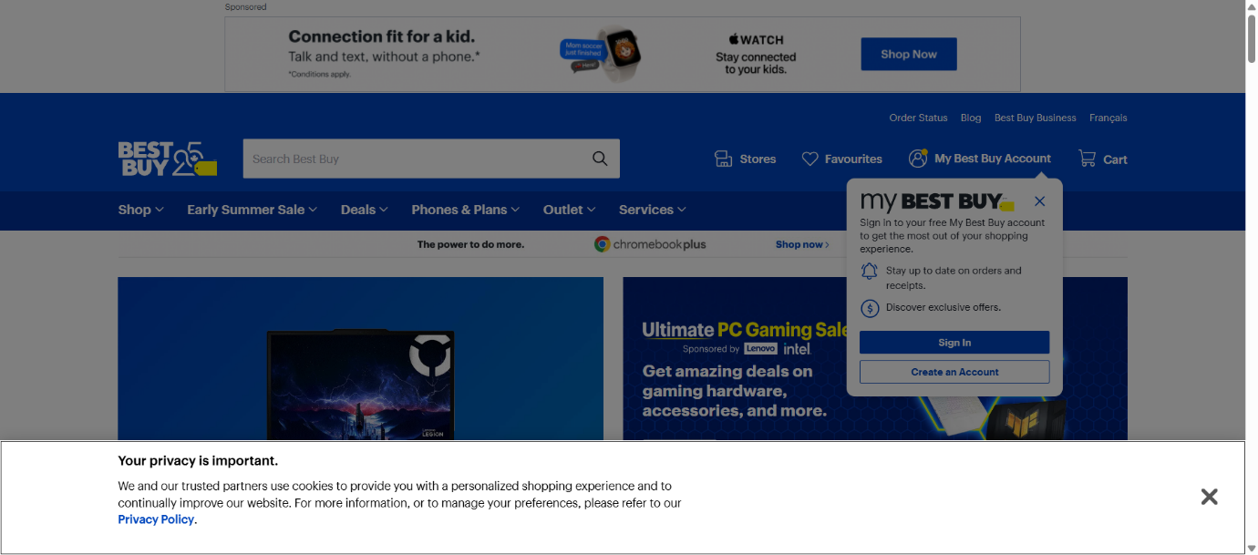
Fig 9: Wrong Country Selection

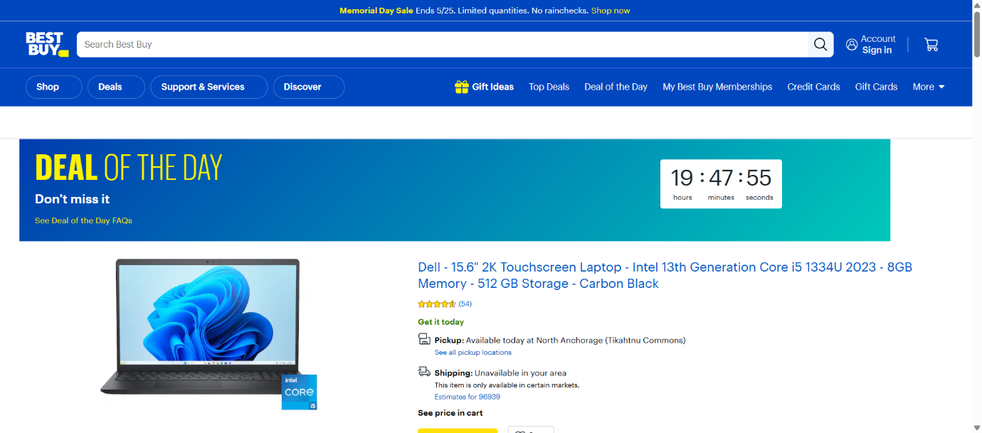
Fig 10: Wrong Section Navigation

TEST REPORT
- Total Tests Executed: 11
- Tests Passed: 11
- Tests Failed: 0
- Automation Accuracy: 100%

CONCLUSION
The Selenium PyTest automation framework successfully validates the Best Buy Headphones application using End-to-End, Positive, and Negative testing approaches.
The framework is designed using:
• Selenium WebDriver
• PyTest Framework
• Page Object Model (POM)
• Allure Reporting
• Logging Framework
• Data-Driven Testing

The automation framework improves:
• Test maintainability
• Reusability
• Scalability
• Reporting quality
• Automation reliability
The framework successfully validates critical business workflows including Best Buy homepage validation, United States region selection, Top Deals navigation, headphones category selection, product selection, Add to Cart functionality, and cart order summary verification.
All test cases executed successfully with professional reporting, screenshot capture, and detailed execution logs.
Overall, the project demonstrates a practical and professional Selenium automation framework for real-world E-Commerce web application testing.

SELENIUM BDD FRAMEWORK

TEST STRATEGY
The project uses Selenium WebDriver with Python Behave BDD framework for automation testing.
• End-to-End Testing
• Positive Testing
• Negative Testing
• Data-Driven Testing
• Behavior-Driven Development (BDD)
Tools Used:
• Selenium WebDriver
• Behave BDD
• Allure Reports
• Logging Module
• Python
• OpenPyXL
• WebDriver Manager

TEST ENVIRONMENT
Operating System | Windows 10
IDE | PyCharm Unified Product
Browser | Google Chrome
Framework | Selenium WebDriver + Behave
Design Pattern | Page Object Model (POM)
Reporting Tool | Allure Reports
Test Approach | Behavior Driven Development

FRAMEWORK ARCHITECTURE
Wipro_BDD_Project
├── config
├── features
│ ├── e2e.feature
│ ├── positive_cases.feature
│ ├── negative_cases.feature
│ ├── environment.py
│ └── steps
│ ├── e2e_steps.py
│ ├── positive_steps.py
│ └── negative_steps.py
│
├── logs
├── pages
├── reports
│ ├── allure-results
│ └── allure-report
├── screenshots
├── utilities
├── behave.ini
├── requirements.txt
└── run_tests.py
TEST EXECUTION
The automation suite includes:
• 1 End-to-End Test Scenario
• 7 Positive Test Scenarios
• 3 Negative Test Scenarios
The End-to-End scenario validates the complete Best Buy Headphones workflow from homepage navigation until Add to Cart and cart order summary verification.

SELENIUM TEST SCENARIO SUMMARY
S.No | Test Type | Test Scenario | Expected Result | Status
1 | End-to-End | Complete Best Buy Headphones Workflow | User successfully adds product to cart and verifies cart details | Passed
2 | Positive | Best Buy Website Validation | Best Buy homepage opens successfully | Passed
3 | Positive | United States Selection Validation | United States region selected successfully | Passed
4 | Positive | Top Deals Navigation Validation | Top Deals page opens successfully | Passed
5 | Positive | Headphones Navigation Validation | Headphones section opens successfully | Passed
6 | Positive | Random Headphone Category Selection | Selected headphone category opens successfully | Passed
7 | Positive | Add to Cart Validation | Product added to cart successfully | Passed
8 | Positive | Cart Verification Validation | Cart displays selected product successfully | Passed
9 | Negative | Invalid Website URL Validation | Error handled successfully for invalid URL | Passed
10 | Negative | Wrong Country Selection Validation | Incorrect country selection handled successfully | Passed
11 | Negative | Invalid Section Navigation Validation | Invalid section navigation handled successfully | Passed

END-TO-END FLOW VALIDATION
The End-to-End automation validates the complete business workflow including:
• Best Buy Homepage Validation
• United States Region Selection
• Top Deals Navigation
• Headphones Section Navigation
• Random Headphone Category Selection
• Product Selection Validation
• Add to Cart Functionality
• Cart Verification Validation
POSITIVE TEST SCENARIOS
Positive Test Scenario 1 – Best Buy Website Validation
• Validates successful navigation to the Best Buy website
• Verifies homepage loading successfully
• Checks homepage URL validation
Positive Test Scenario 2 – United States Selection Validation
• Validates country selection functionality
• Selects “United States” region
• Verifies successful homepage redirection
Positive Test Scenario 3 – Top Deals Navigation Validation
• Validates Top Deals navigation functionality
• Opens Top Deals section
• Verifies successful page navigation
Positive Test Scenario 4 – Headphones Navigation Validation
• Validates headphones category navigation
• Opens headphones section successfully
• Verifies successful category loading
Positive Test Scenario 5 – Random Headphone Category Selection
• Validates headphone category card selection
• Opens selected headphone category
• Verifies successful category navigation
Positive Test Scenario 6 – Add to Cart Validation
• Validates Add to Cart functionality
• Selects headphone product successfully
• Verifies successful cart addition
Positive Test Scenario 7 – Cart Verification Validation
• Validates cart summary functionality
• Verifies selected product in cart
• Confirms successful cart validation

NEGATIVE TEST SCENARIOS
Negative Test Scenario 1 – Invalid Website URL Validation
• Opens invalid website URL
• Validates application error handling
• Verifies unsuccessful page loading
• Ensures invalid URL handling functionality
Negative Test Scenario 2 – Wrong Country Selection Validation
• Selects incorrect country option
• Validates country selection handling
• Verifies navigation restriction functionality
• Ensures unsupported region validation
Negative Test Scenario 3 – Invalid Section Navigation Validation
• Attempts invalid section navigation
• Validates application navigation handling
• Verifies unavailable section handling
• Ensures invalid navigation restriction
BDD IMPLEMENTATION
The framework follows Behavior Driven Development using:
• Feature Files
• Step Definition Files
• Gherkin Syntax
• Given-When-Then Structure
• Scenario-Based Automation Testing
• Selenium WebDriver Integration
• Reusable Step Implementations
• Page Object Model (POM) Architecture

ALLURE REPORTS
• Integrated Allure Reports with Behave BDD
• Generates professional execution reports
• Displays passed and failed scenario status
• Captures screenshots during execution
• Maintains execution history
• Displays step-by-step scenario execution flow
• Helps debugging and tracking failures
• Provides detailed execution summary
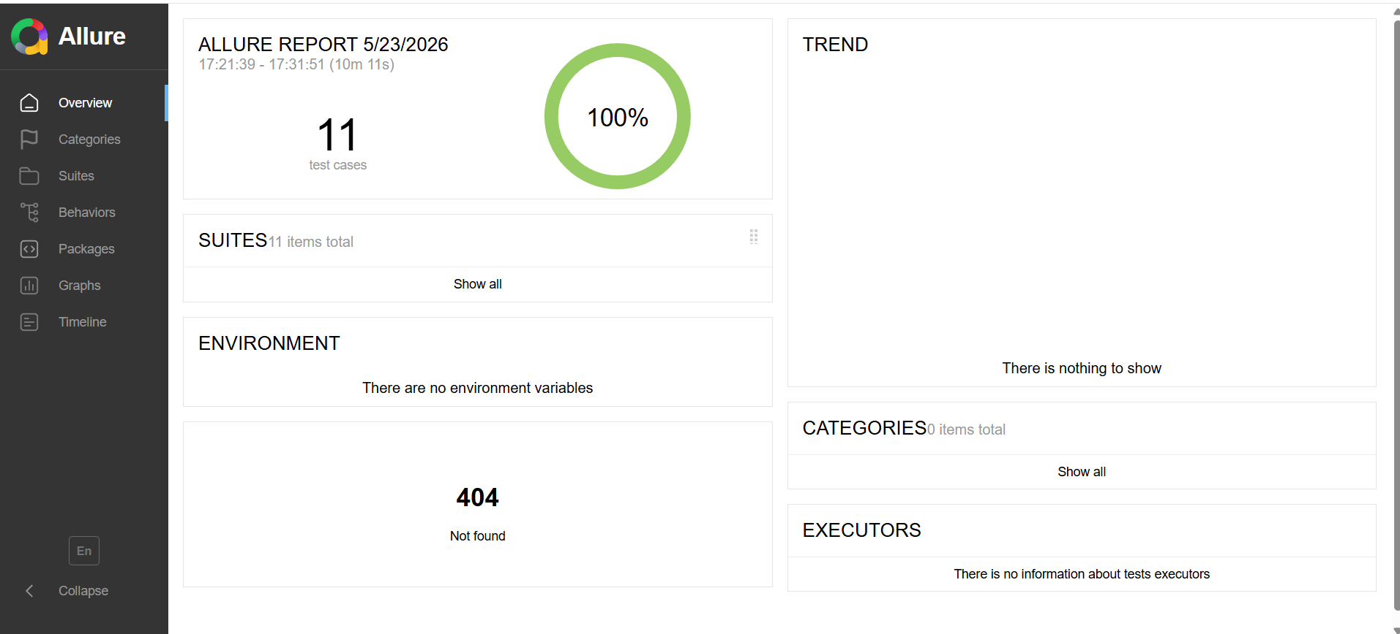

TEST OUTPUTS
The framework automatically captures screenshots during important execution stages including Best Buy homepage validation, United States region selection, Top Deals navigation, headphones category page, random headphone category selection, Add to Cart validation, and cart order summary verification.
Detailed execution logs are generated using Python logging framework for debugging and execution tracking.


Fig 1: BestBuy Website Validation


Fig 2: United States Selection


Fig 3: Top Deals Navigation


Fig 4: Headphones Category Page


Fig 5: Random Headphone Category Selection



Fig 6: Products Added to Cart


Fig 7: Cart Order Summary


Fig 8: Wrong Website URL Validation

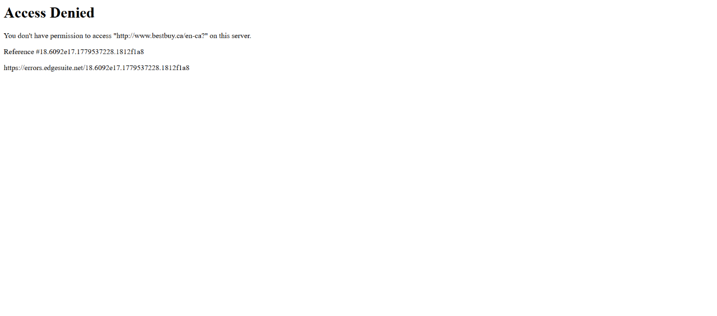
Fig 9: Wrong Country Selection

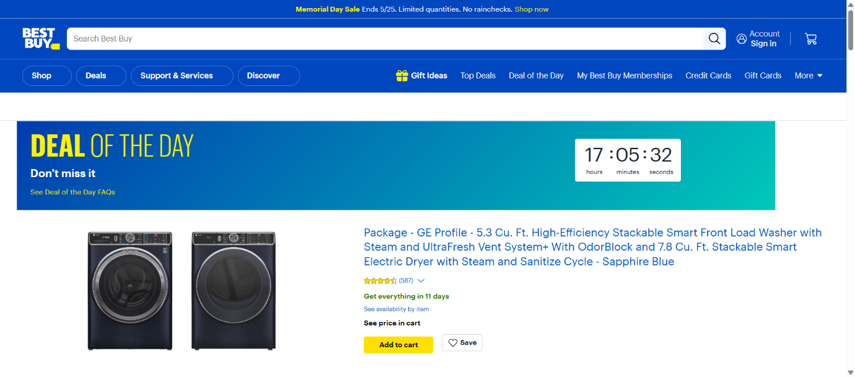
Fig 10: Wrong Section Navigation

TEST REPORT
- Total Scenarios Executed: 11
- Scenarios Passed: 11
- Scenarios Failed: 0
- Automation Accuracy: 100%

CONCLUSION
The Selenium Behave BDD automation framework successfully validates the Best Buy Headphones application using Behavior Driven Development methodology.
The framework is implemented using:
• Selenium WebDriver
• Behave BDD Framework
• Gherkin Feature Files
• Step Definition Files
• Page Object Model (POM)
• Allure Reporting
• Data-Driven Testing
The framework validates complete business workflows including:
• BestBuy Homepage Validation
• United States Region Selection
• Top Deals Navigation
• Headphones Category Navigation
• Random Headphone Category Selection
• Product Selection Validation
• Add to Cart Functionality
• Cart Order Summary Verification
The implementation of Feature Files and Given-When-Then structure improves readability, maintainability, and collaboration between technical and non-technical users.
The framework also includes:
• Professional Allure Reports
• Screenshot Evidence
• Detailed Execution Logs
• Positive and Negative Testing
• Reusable Automation Components
All scenarios executed successfully with accurate validations and detailed reporting.
Overall, the project demonstrates a professional real-world BDD automation framework with scalable architecture, reusable components, and reliable automated testing practices.

