**Computer Graphics LAB**

**(**Experiment 3**)**

|  |
| --- |
| **NAME :** Ashish Sharma  **SAP ID :** 500087115  **BATCH :** B-4 |

* Creating Simple Graphics Primitive in C language :

**CODE :**

#include<graphics.h>

#include<conio.h>

int main()

{

int gd=DETECT,gm;

initgraph (&gd,&gm,"c:\\tc\\bgi");

printf("\n\nLINE");

line(110,50,250,50);

printf("\n\n\n\nRECTANGLE");

//SYNTAX - rectangle(int left, int top, int right, int bottom);

rectangle(115,100,275,150);

printf("\t\t\t\n\n\n\n\n\n\nARC(Semi-circle)");

//SYNTAX - arc(int x, int y, int start_angle,int end_angle, int radius); {where,(x, y) is the center of the arc.}

arc(160,200,180,0,50);

printf("\t\n\n\n\nCIRCLE");

//SYNTAX - circle(x, y, radius); {where,(x, y) is center of the circle.}

circle(160,320,50);

getch();

}

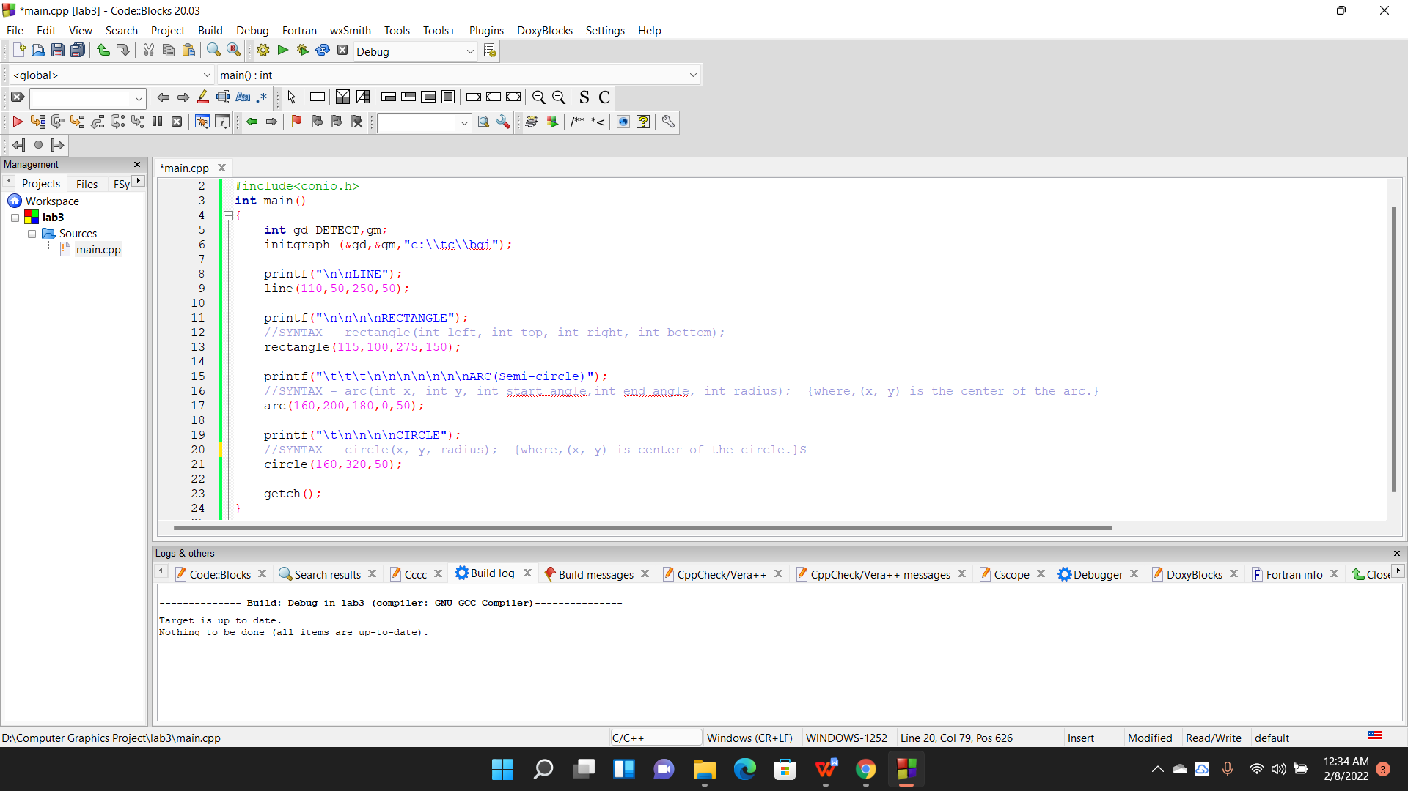

**OUTPUT :**

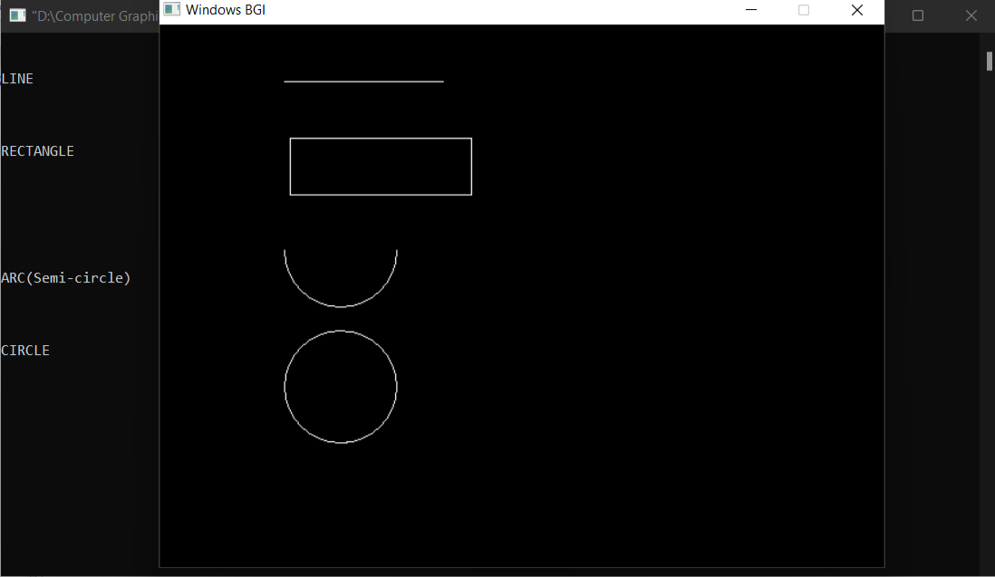

**>>> END <<<**