Name: Devansh Upadhyay

Roll No 53

Program Code:

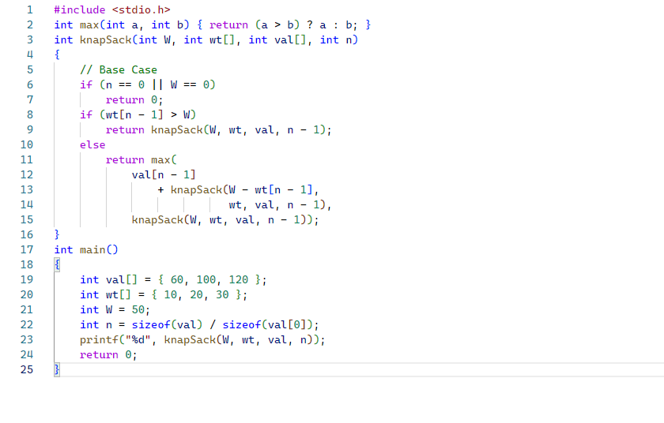

Output: 