Name: Devansh Upadhyay

Roll No. 53

Program for Bubble Sort:

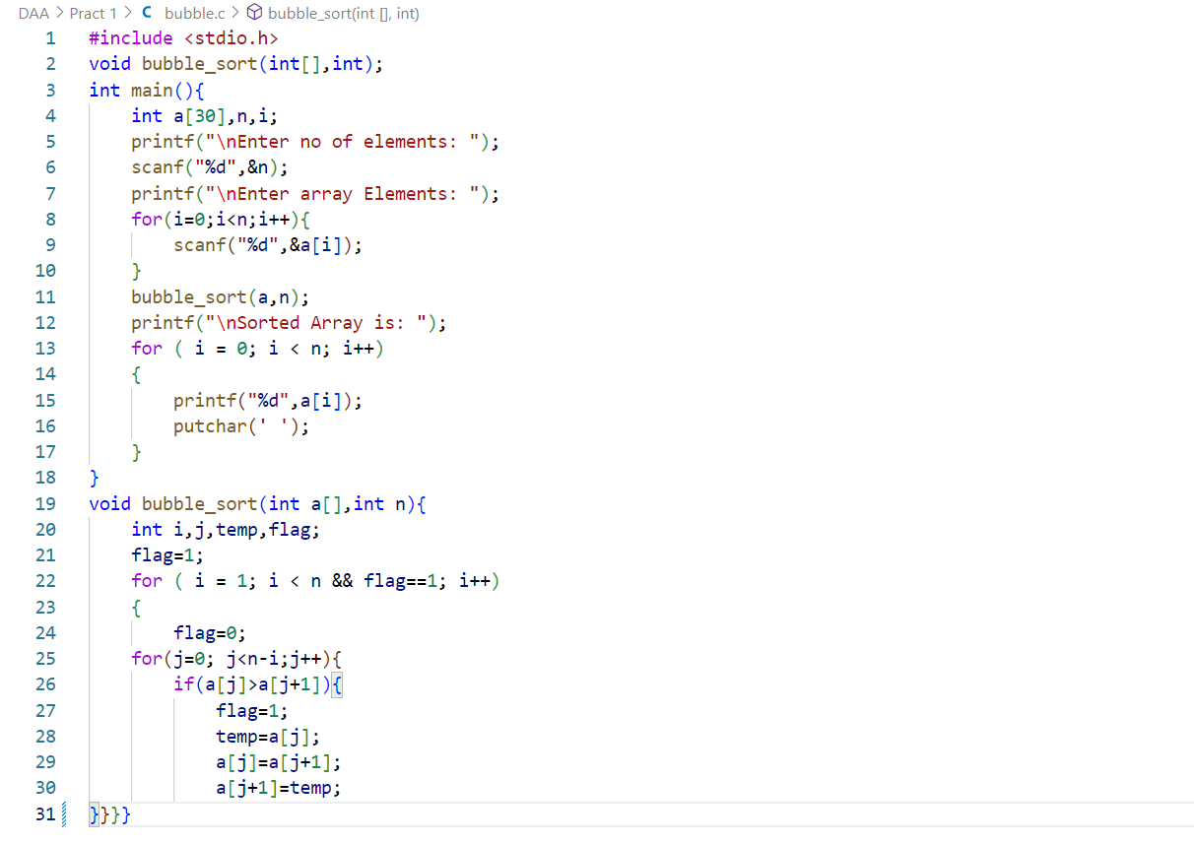

Output for Bubble Sort:

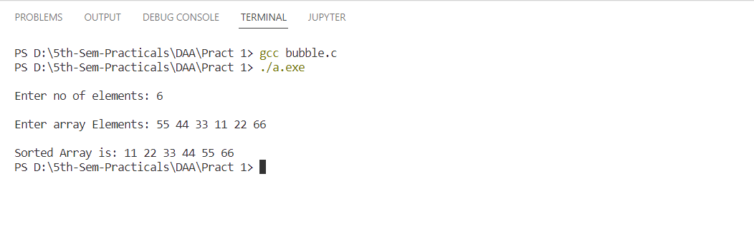

Program for Merge Sort:

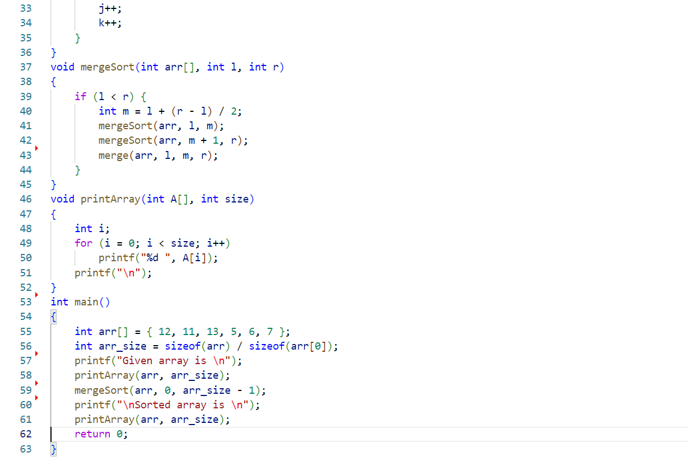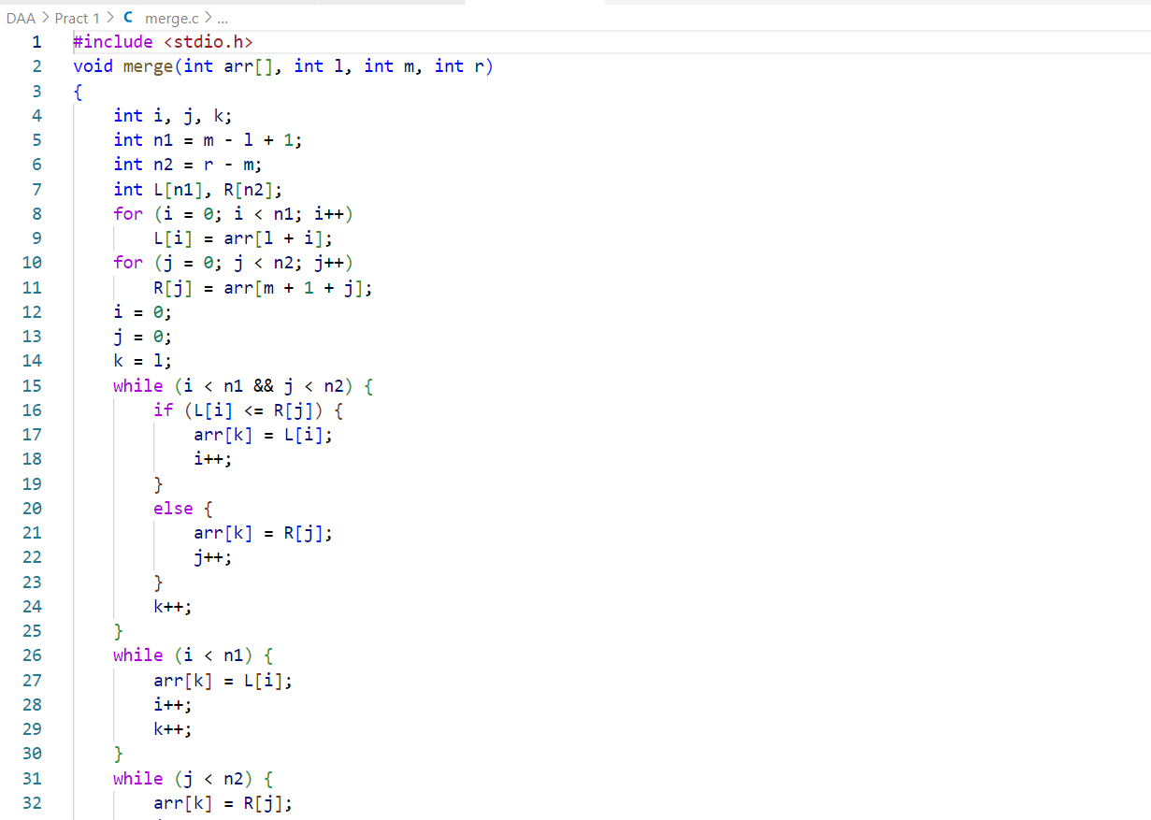

Output for Merge Sort:

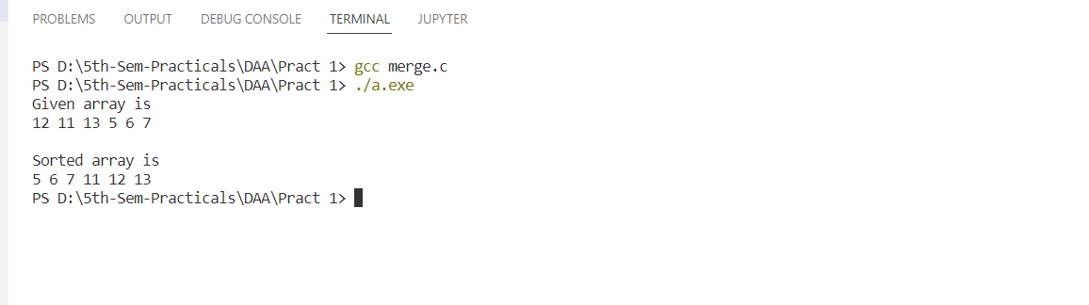

Program for Quick Sort:

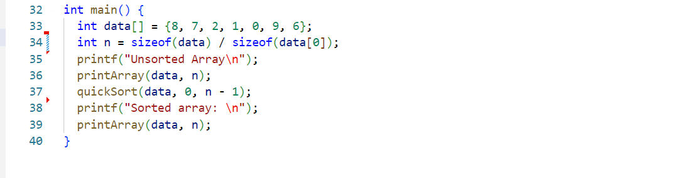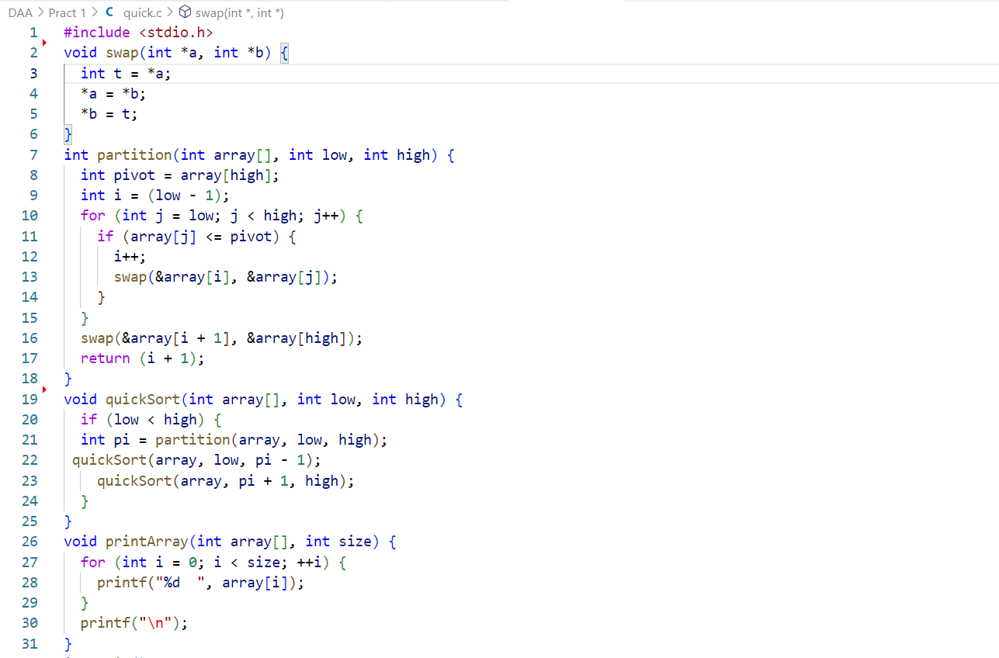

Output for Quick Sort: 