Linear Regression

1. Introduction
Linear Regression is one of the simplest and most widely used statistical techniques in Machine Learning. It models the relationship between a dependent variable (y) and one or more independent variables (X) by fitting a linear equation.

2. Mathematical Foundation
• Simple Linear Regression: y = β₀ + β₁x + ε
• Multiple Linear Regression: y = β₀ + β₁x₁ + β₂x₂ + … + βnxn + ε
Where β₀ is the intercept, β₁...βn are coefficients, and ε is the error term. The goal is to minimize the cost function, usually Mean Squared Error (MSE).
Below is a visualization of Linear Regression:
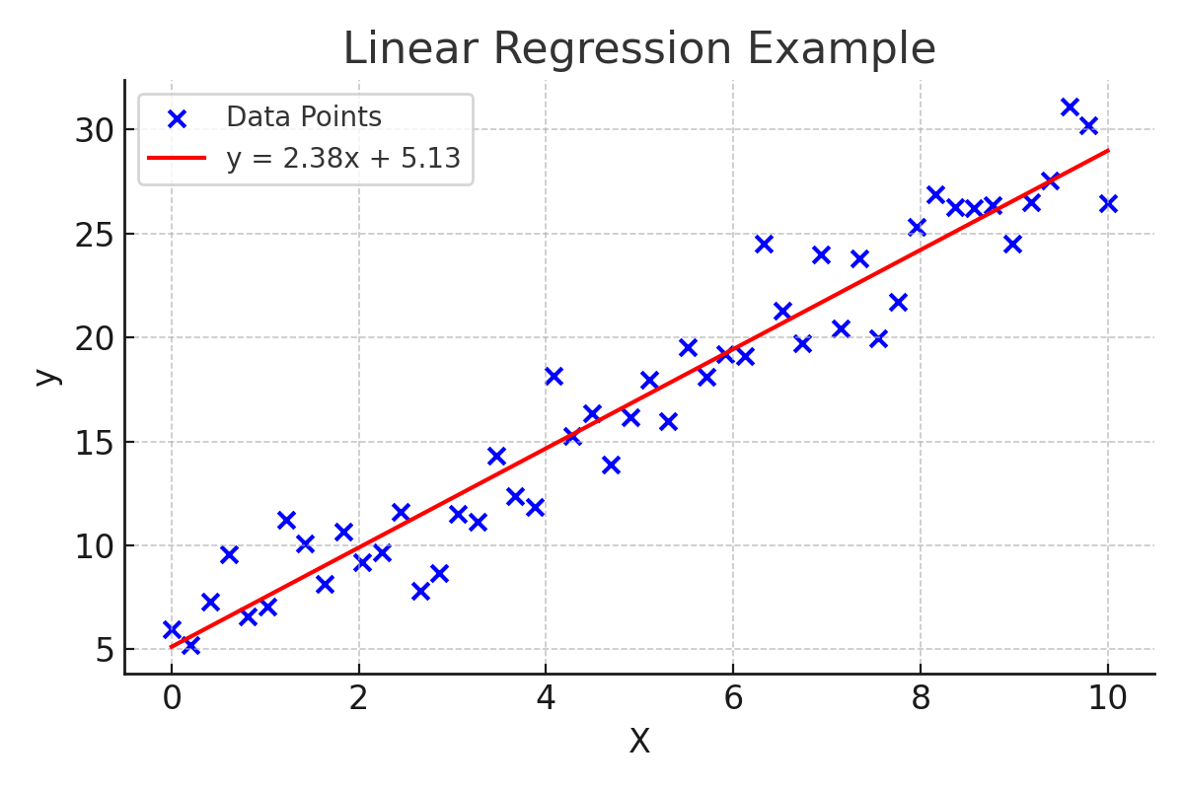

3. Assumptions of Linear Regression
• Linearity: The relationship between X and y is linear.
• Independence: Observations are independent of each other.
• Homoscedasticity: Constant variance of residuals.
• Normality: Residuals should be normally distributed.

4. Cost and Loss Functions
In Linear Regression, the model learns by minimizing the difference between the predicted values and the actual values.
• Loss Function: Measures the error for a single training example. For regression, the most common loss function is the Squared Error Loss:
L(y, ŷ) = (y - ŷ)²
where y is the actual value, and ŷ is the predicted value.
• Cost Function: Represents the average error over all training examples. The most widely used cost function is the Mean Squared Error (MSE):
J(β) = (1/m) Σ (yᵢ - ŷᵢ)²
where m is the number of training examples. The optimization process adjusts the coefficients β to minimize this cost.
Minimizing the cost function is typically done using optimization techniques such as Gradient Descent or the Normal Equation.

4. Steps in Building a Linear Regression Model
- • Data Collection
- • Exploratory Data Analysis
- • Splitting dataset into training/testing
- • Fitting the model
- • Evaluating with metrics (R², RMSE, MAE)
- • Making predictions
Workflow diagram:
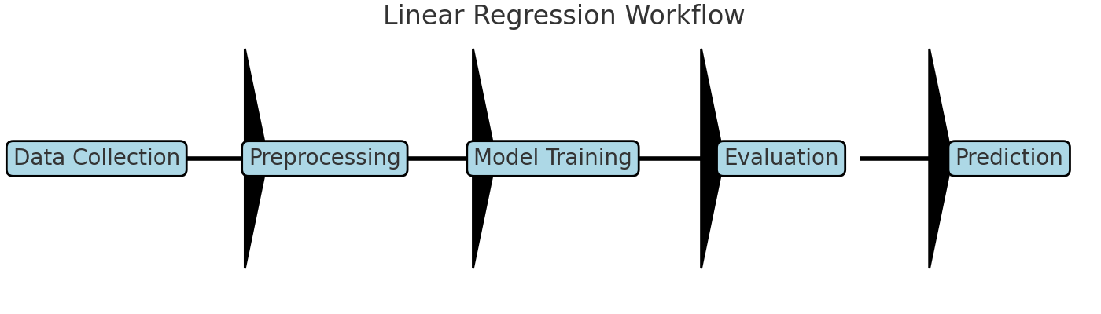

5. Advantages & Limitations
Advantages:
• Simple to understand and implement
• Interpretable coefficients
• Works well for linearly separable data
Limitations:
• Assumes linearity
• Sensitive to outliers
• Cannot capture complex relationships

6. Python Implementation Example
Example using scikit-learn:
from sklearn.linear_model import LinearRegression
import numpy as np
X = np.array([[1],[2],[3],[4],[5]])
y = np.array([2,4,5,4,5])
model = LinearRegression()
model.fit(X, y)
print('Coefficient:', model.coef_)
print('Intercept:', model.intercept_)
print('Prediction for 6:', model.predict([[6]]))

7. Real-World Use Cases
• Predicting house prices based on features like size and location
• Forecasting sales based on advertising spend
• Medical research – predicting disease progression
• Economics – analyzing the impact of variables on GDP or inflation

