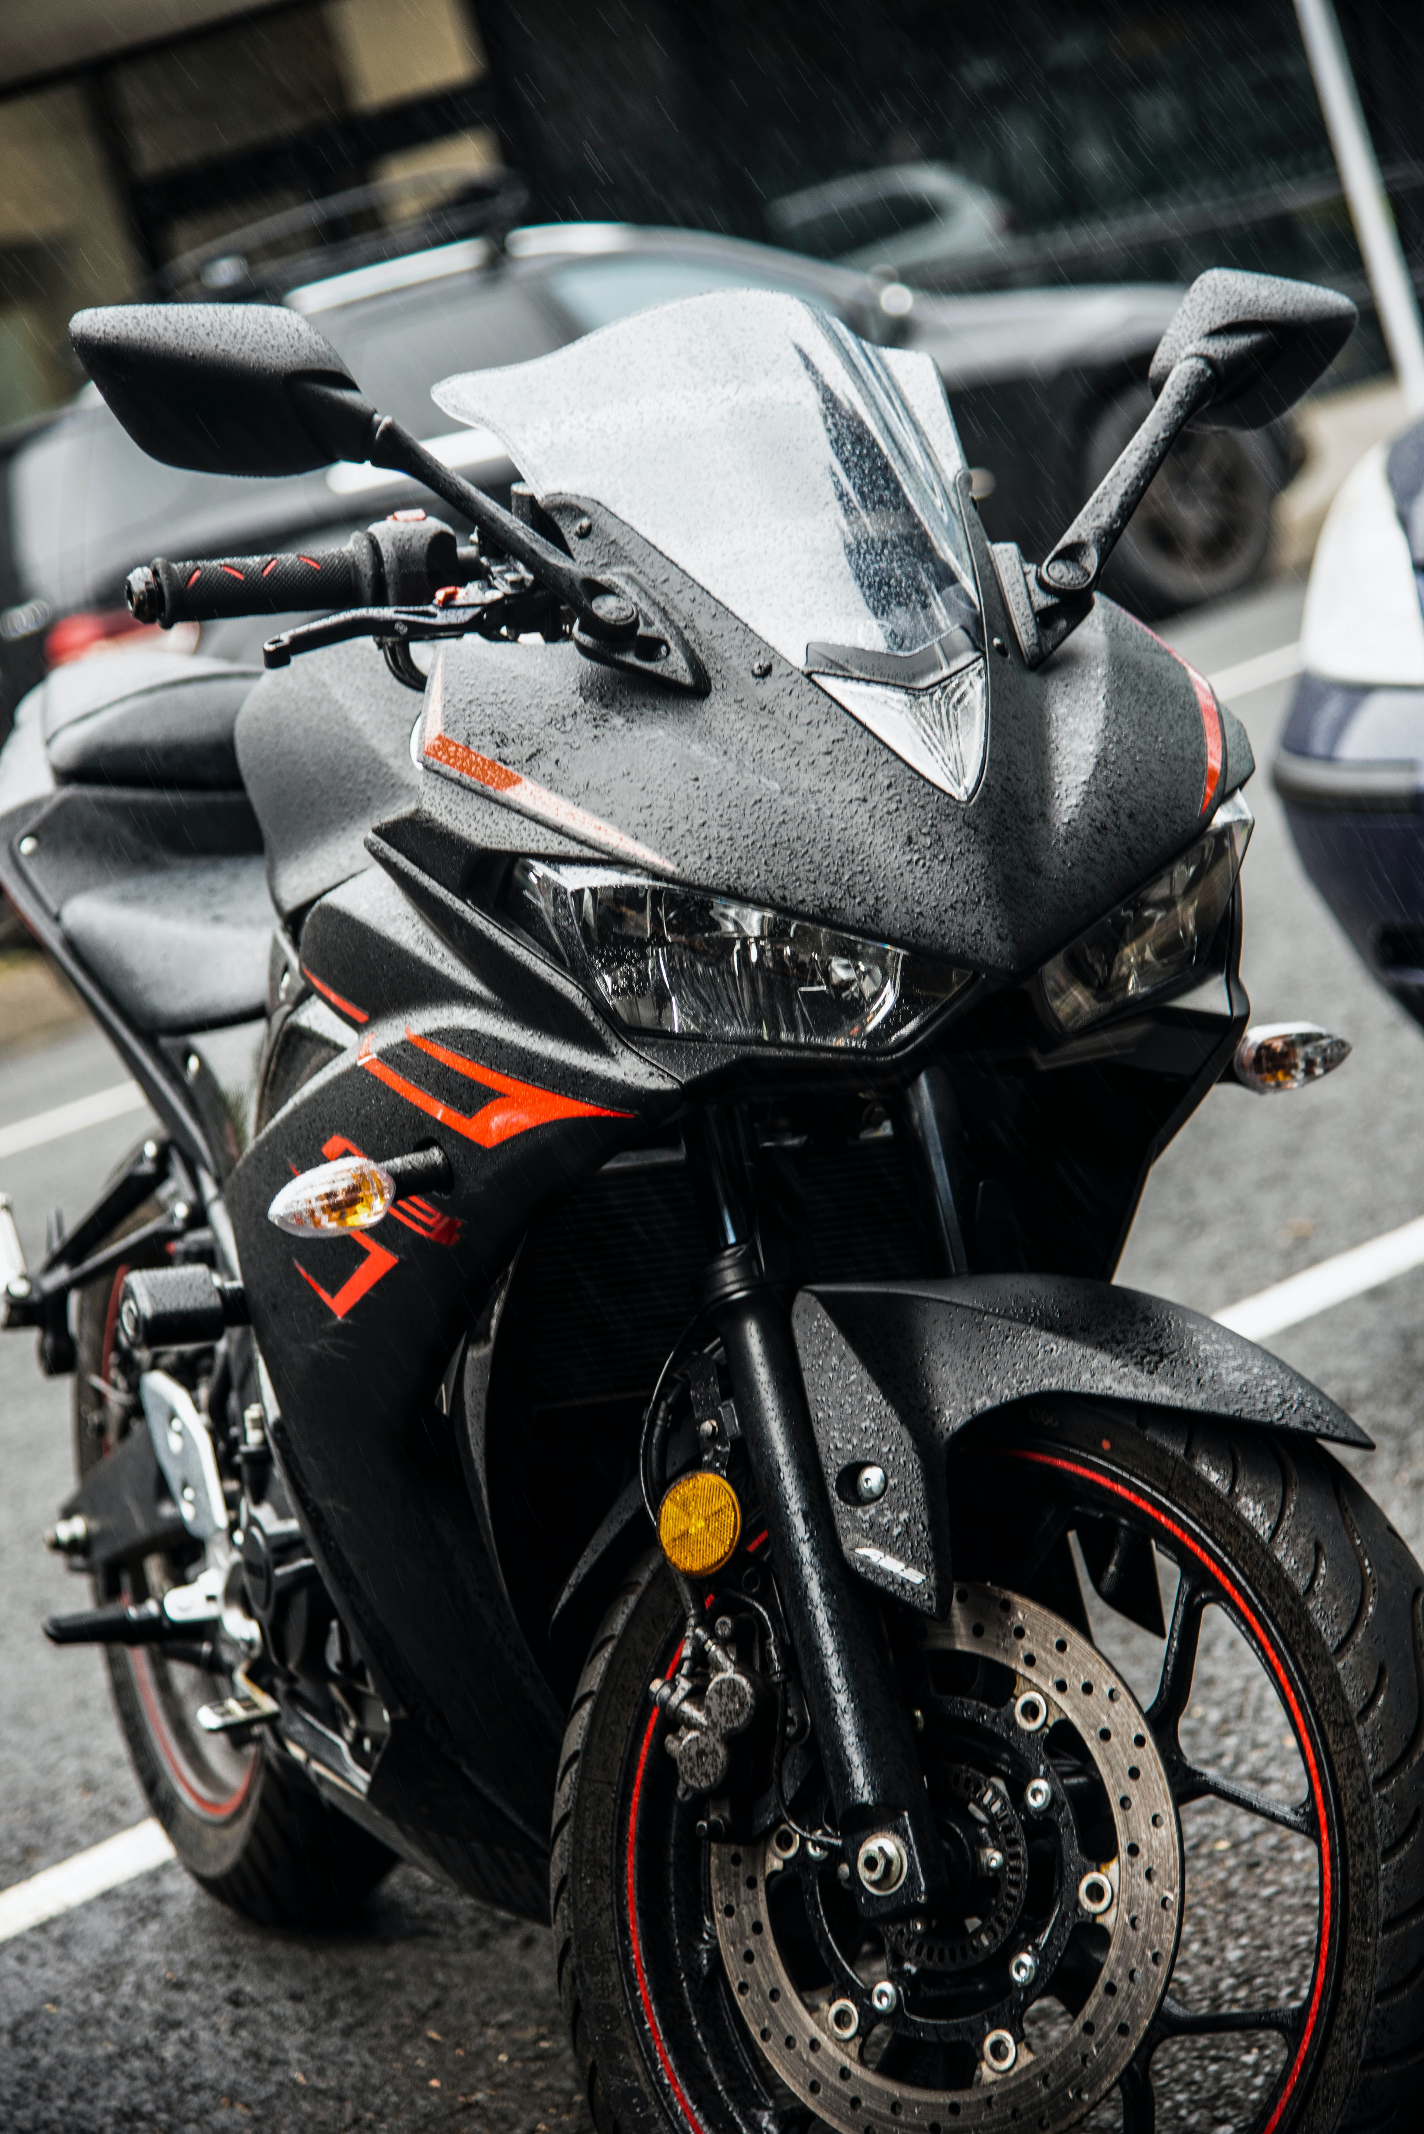
Bikes:
This is a bike. It is used for transport. You can read more about bikes over here:
https://en.wikipedia.org/wiki/Bicycle

