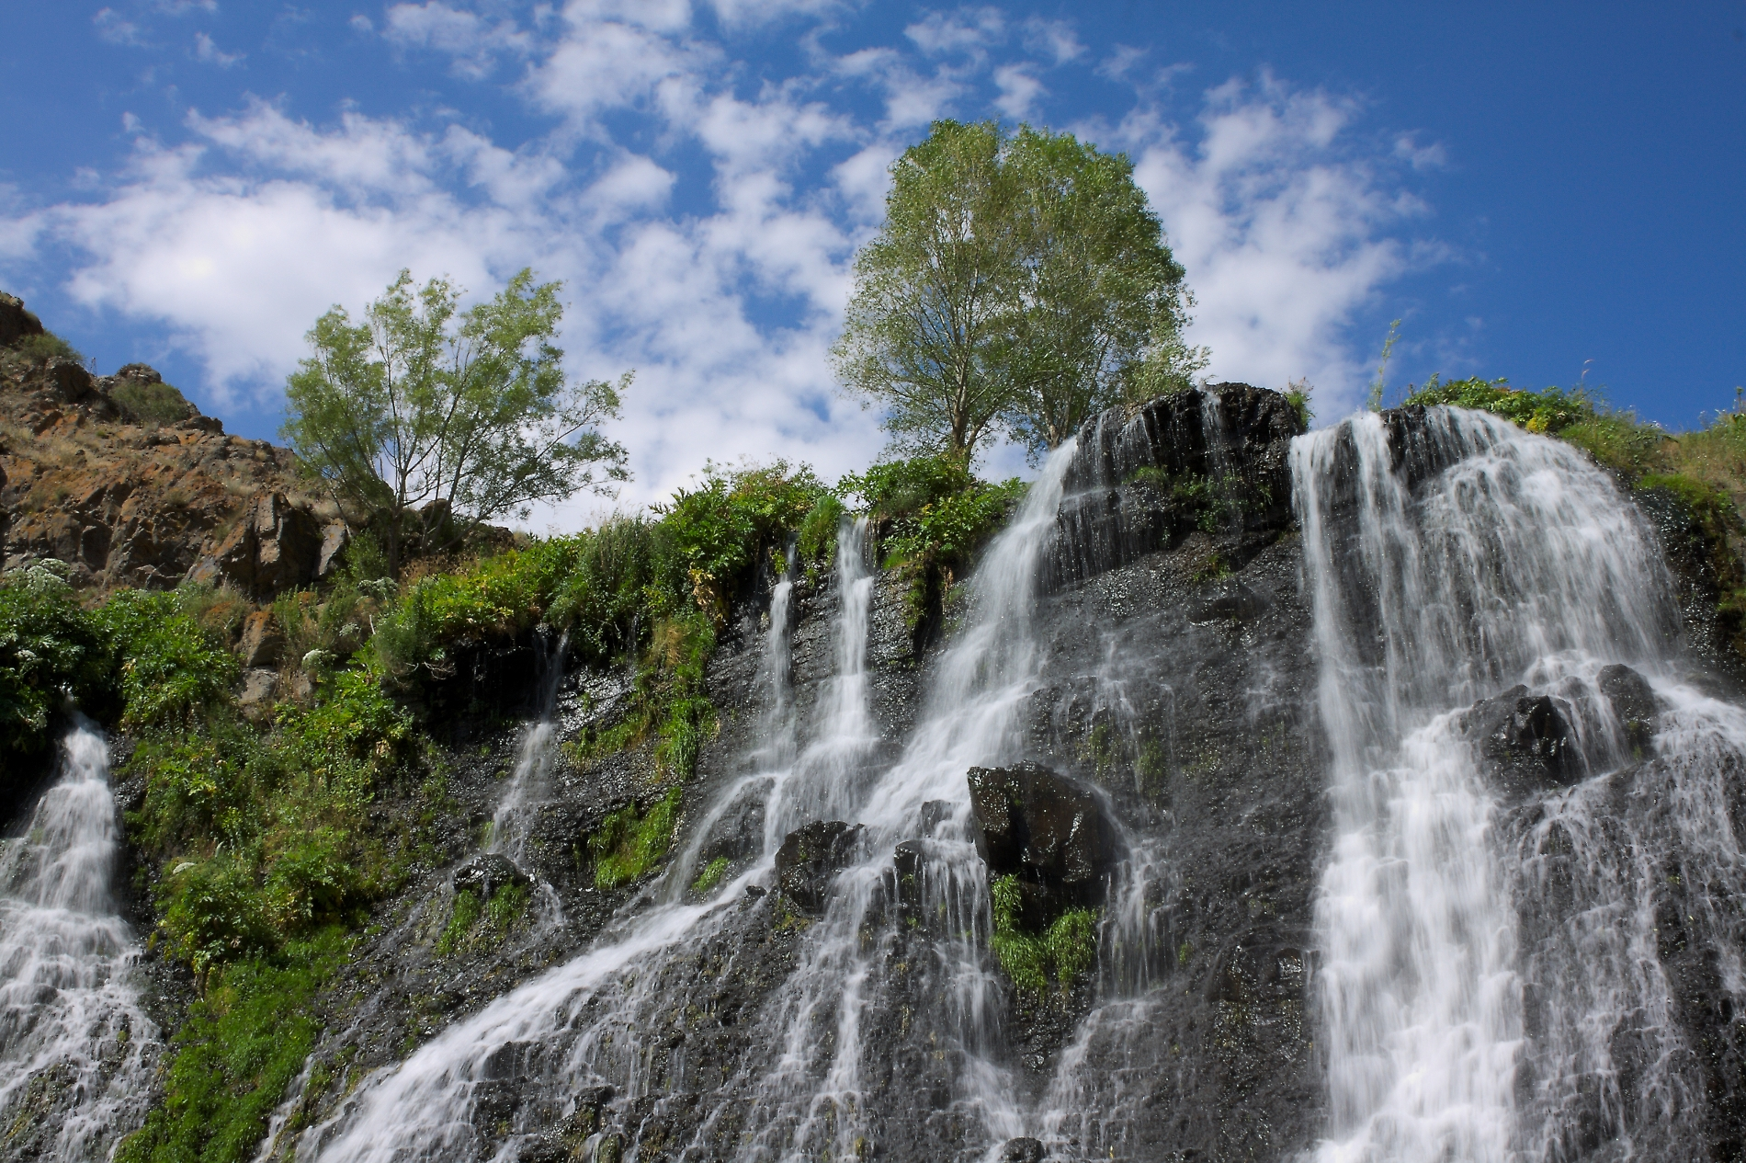
Nature:
Nature, in the broadest sense, is the natural, physical, material world or universe. "Nature" can refer to the phenomena of the physical world, and also to life in general. The study of nature is a large, if not the only, part of science. Although humans are part of nature, human activity is often understood as a separate category from other natural phenomena.
You can refer to the link:
https://en.wikipedia.org/wiki/Nature

The above is an image of Shaqi jrvej.
Mountain
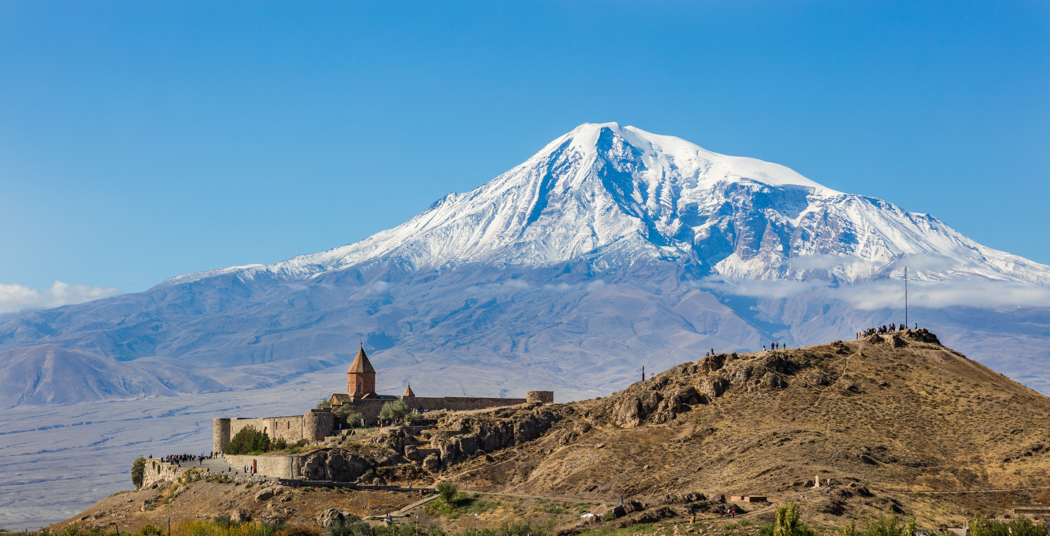
A mountain is a large landform that rises above the surrounding land in a limited area, usually in the form of a peak.
An example of a mountain is:
A line representation of a mountain is given below:
If a mountain is assumed to be a cone, then it’s volume can be given by the formula:
We now present a table of the height of highest mountains:
Name of Moutnain | Height of peak (in m)
Mt Everest | 8848
K2 | 8611
Kangchenjunga | 8,586

