ARMY INSTITUTE OF TECHNOLOGY, PUNE
Department of Computer Engineering
CLOUD COMPUTING
Group B — Assignment 1
Simulating a Cloud Environment and Implementing a Custom Min-Min Scheduling Algorithm using CloudSim 3.0.3
Scheduling Cloudlets Across Heterogeneous Virtual Machines Based on Minimum Completion Time
Name | Ashish Kumar
Class | TE COMP A
Roll No. | 3315
Subject | Cloud Computing
Platform Used | CloudSim 3.0.3, Java 11, Visual Studio Code, Ubuntu Linux

1. Abstract
Cloud computing provides computing resources such as processing power, storage, and virtual machines through a shared infrastructure. Efficient scheduling of tasks among virtual machines is important because poor scheduling can increase execution time and reduce resource utilization.
In this assignment, a cloud computing environment is simulated using CloudSim 3.0.3. The simulated environment contains one datacenter, one physical host, three virtual machines with different processing capacities, and six cloudlets representing user tasks.
A custom Min-Min scheduling algorithm is implemented to assign cloudlets to virtual machines. The algorithm calculates the expected completion time of each cloudlet on every available VM and selects the cloudlet having the smallest completion time. The selected cloudlet is then assigned to the appropriate VM.
The experiment demonstrates the implementation of a scheduling algorithm that is not directly available as a standard CloudSim scheduling policy.

2. Introduction
Cloud computing is a technology that provides computing resources to users on demand. A cloud infrastructure generally consists of physical machines, virtual machines, storage resources, and networking resources.
When several tasks are submitted to a cloud environment, they must be assigned to available virtual machines. This process is called task scheduling. The main objective of task scheduling is to efficiently utilize available resources while reducing task execution time.
CloudSim is a simulation framework that allows cloud computing environments to be modeled and tested without requiring an actual cloud infrastructure.
In this project, CloudSim is used to simulate a cloud environment, and a custom Min-Min scheduling algorithm is implemented to schedule cloudlets among heterogeneous virtual machines.

3. Objectives
- To understand the basic concepts of cloud simulation.
- To configure and use CloudSim 3.0.3.
- To create a simulated datacenter.
- To create virtual machines with different processing capacities.
- To create cloudlets representing user tasks.
- To implement the Min-Min scheduling algorithm.
- To execute the scheduling algorithm using CloudSim.
- To analyze the resulting VM–task assignments.

4. Software and Hardware Requirements
Software
Software | Configuration
Operating System | Ubuntu Linux
Programming Language | Java
JDK | Java 11.0.32
Cloud Simulator | CloudSim 3.0.3
IDE | Visual Studio Code

Hardware
The simulation can be performed on a standard computer with at least 4 GB RAM and a modern processor.

5. CloudSim Environment
CloudSim provides several components for creating a simulated cloud environment. The major components used in this project are:
- Datacenter: Represents the cloud infrastructure.
- Host: Represents a physical computing machine.
- Virtual Machine: Represents a virtualized computing resource.
- Cloudlet: Represents a computational task submitted by a user.
- Broker: Acts as an intermediary between the user and the cloud datacenter.

Architecture used in this experiment
CloudSim
|
Datacenter
|
Host
|
+---------+---------+
| | |
VM0 VM1 VM2
1000 MIPS 2000 MIPS 3000 MIPS
| | |
+---------+---------+
|
Cloudlets
|
Min-Min Scheduler

6. Cloud Scenario
The experiment consists of one datacenter and one physical host. Three virtual machines with different processing capabilities are created.
VM | Processing Capacity
VM0 | 1000 MIPS
VM1 | 2000 MIPS
VM2 | 3000 MIPS

Six cloudlets are created:
Cloudlet | Length
C0 | 4000 MI
C1 | 7000 MI
C2 | 10000 MI
C3 | 3000 MI
C4 | 8000 MI
C5 | 5000 MI

MI means Million Instructions, while MIPS means Million Instructions Per Second. The estimated execution time is calculated using:
Execution Time = Cloudlet Length / VM MIPS

For example:
Cloudlet = 4000 MI
VM = 2000 MIPS

Execution Time = 4000 / 2000
= 2 seconds

7. Min-Min Scheduling Algorithm
Min-Min is a task scheduling algorithm used to assign tasks to available computing resources.
The algorithm first calculates the expected completion time of every unscheduled cloudlet on every available VM. For each cloudlet, the VM providing the minimum completion time is identified.
Among all cloudlets, the cloudlet with the smallest minimum completion time is selected and assigned to its corresponding VM.
The VM's availability time is then updated and the process is repeated until all cloudlets are scheduled.
Algorithm Steps
- Create a list of all unscheduled cloudlets.
- Calculate execution time for every cloudlet on every VM.
- Calculate the completion time for each VM–cloudlet combination.
- Find the minimum completion time for every cloudlet.
- Select the cloudlet with the globally smallest completion time.
- Assign the cloudlet to the selected VM.
- Update the VM's availability time.
- Remove the cloudlet from the unscheduled list.
- Repeat until all cloudlets are scheduled.

8. Implementation
The project was implemented using Java 11 and CloudSim 3.0.3. The main stages of the implementation are described below.

8.1 CloudSim Initialization
CloudSim is initialized with one user and the current simulation calendar.
int numUsers = 1;
Calendar calendar = Calendar.getInstance();
boolean traceFlag = false;

CloudSim.init(
numUsers,
calendar,
traceFlag
);

8.2 VM Creation
Three VMs are created with different MIPS values:
int[] mips = {
1000,
2000,
3000
};

This creates a heterogeneous cloud environment.

8.3 Cloudlet Creation
Six cloudlets are created with different workloads:
long[] lengths = {
4000,
7000,
10000,
3000,
8000,
5000
};

8.4 Min-Min Implementation
The core of the custom algorithm calculates execution time:
double executionTime =
(double) cloudlet.getCloudletLength()
/ vm.getMips();

The algorithm then determines the VM that provides the earliest completion time. The selected cloudlet is assigned using:
selectedCloudlet.setVmId(
selectedVm.getId()
);

The availability time of the VM is then updated. This implementation allows CloudSim to execute the cloudlets according to the VM assignments produced by the custom Min-Min algorithm.

9. Results
After implementing the algorithm, the simulation was executed successfully using CloudSim. The program displays the scheduling decisions and the final execution results.
Scheduling Output
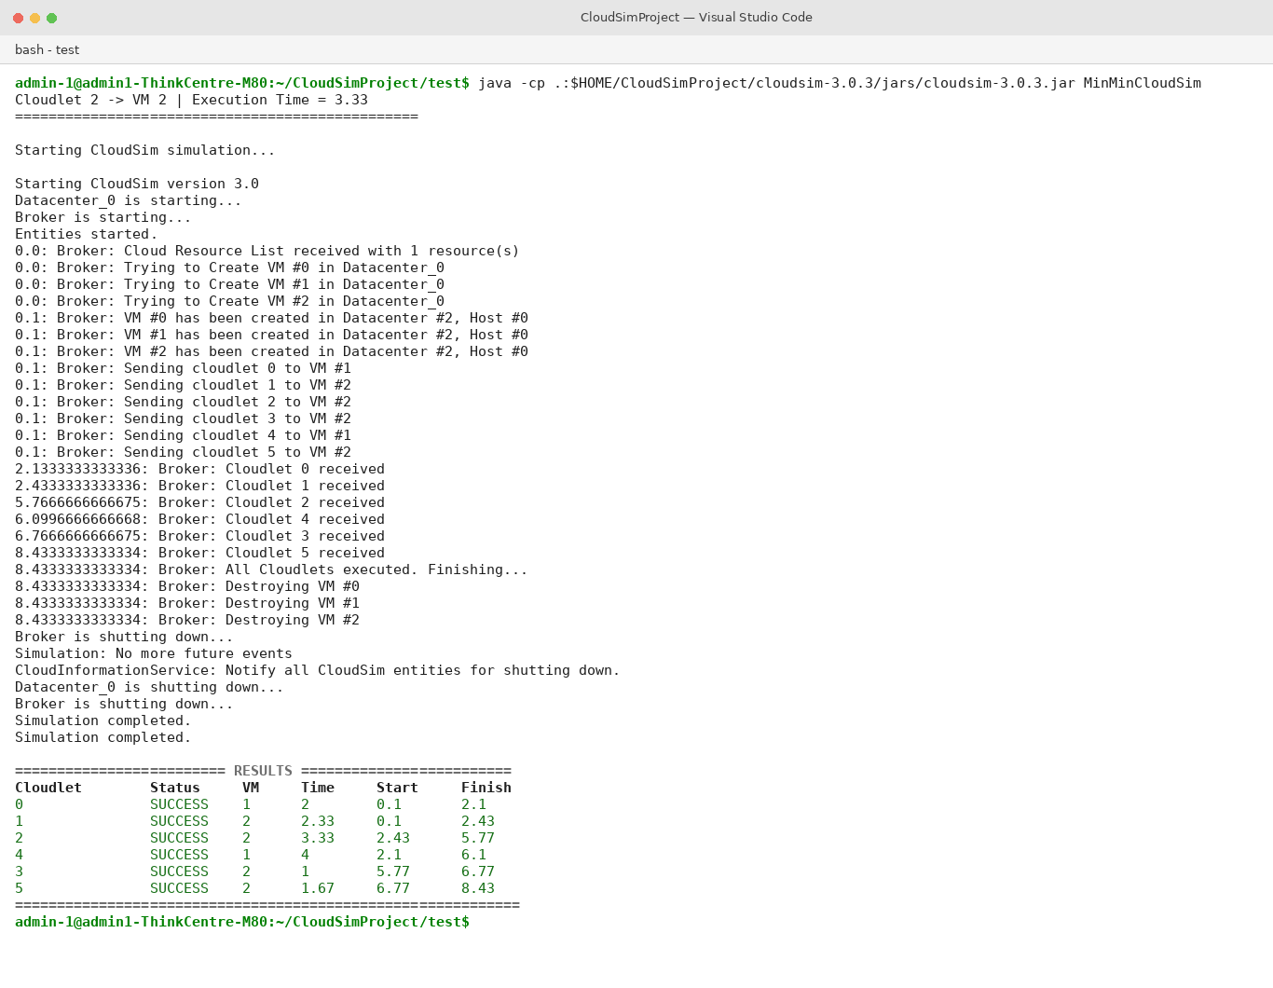
Fig. 1: Terminal output of the MinMinCloudSim program showing the CloudSim simulation log and the final scheduling results table.
Results Table
Cloudlet | Status | VM | Execution Time | Start Time | Finish Time
C0 | SUCCESS | VM1 | 2 | 0.1 | 2.1
C1 | SUCCESS | VM2 | 2.33 | 0.1 | 2.43
C2 | SUCCESS | VM2 | 3.33 | 2.43 | 5.77
C3 | SUCCESS | VM2 | 1 | 5.77 | 6.77
C4 | SUCCESS | VM1 | 4 | 2.1 | 6.1
C5 | SUCCESS | VM2 | 1.67 | 6.77 | 8.43

All six cloudlets were scheduled and executed successfully, with the simulation completing at 8.43 seconds. Cloudlets C1, C2, C3, and C5 were assigned to VM2 (3000 MIPS), while C0 and C4 were assigned to VM1 (2000 MIPS), reflecting the Min-Min algorithm's preference for the fastest available VM at each scheduling decision, subject to each VM's current workload.

10. Analysis
The simulation demonstrates how the Min-Min scheduling algorithm assigns cloudlets based on their expected completion times.
Since VM0, VM1, and VM2 have different processing capacities, the same cloudlet can have different execution times depending on the VM selected. For example, a 4000 MI cloudlet requires approximately:
VM0: 4000 / 1000 = 4 seconds
VM1: 4000 / 2000 = 2 seconds
VM2: 4000 / 3000 ≈ 1.33 seconds

Therefore, VM2 provides the shortest execution time for this task when all VMs are equally available.
However, Min-Min also considers the existing workload of each VM. Consequently, the algorithm does not blindly assign every cloudlet to the fastest VM. Instead, it considers the expected completion time and attempts to minimize the earliest completion among the remaining tasks.

11. Advantages
The Min-Min scheduling algorithm provides several benefits:
- Considers task execution time.
- Can work with heterogeneous VMs.
- Attempts to reduce task completion time.
- Is relatively simple to implement.
- Can be customized and tested using CloudSim.

12. Limitations
Some limitations of Min-Min are:
- It may favor smaller tasks.
- Large tasks may experience longer waiting times.
- Execution-time calculations increase with the number of tasks and VMs.
- It does not directly optimize every cloud metric such as energy consumption or network cost.

13. Conclusion
In this assignment, a cloud computing environment was successfully simulated using CloudSim 3.0.3. The environment consisted of a datacenter, physical host, three heterogeneous virtual machines, and six cloudlets.
A custom Min-Min scheduling algorithm was implemented to assign cloudlets to the available virtual machines. The algorithm calculated the expected completion time of each cloudlet and selected the scheduling decision with the minimum completion time.
The experiment demonstrates that CloudSim can be used not only to simulate standard cloud environments but also to implement and evaluate custom scheduling algorithms. The project provides a basic foundation for further research and experimentation with cloud task scheduling.

14. Future Scope
The project can be extended by:
- Comparing Min-Min with Max-Min scheduling.
- Comparing Min-Min with Round Robin scheduling.
- Adding more VMs and cloudlets.
- Measuring makespan and resource utilization.
- Implementing energy-aware scheduling.
- Developing a hybrid scheduling algorithm.

15. References
- CloudSim — Cloud Computing Simulation Framework.
- CloudSim 3.0.3 source code and examples.
- Research papers on Min-Min task scheduling.
- Java documentation.

