ASSIGNMENT 1
Cloud Computing
Fundamental Concepts • Cloud Architecture • Deployment Models
NAME — ASHISH KUMAR
ROLL NO — 3315
BATCH — T1

Topic: Basics of Cloud Computing — Concepts, Architecture & Deployment Models
Submitted as part of academic coursework

TABLE OF CONTENTS
1. Introduction to Cloud Computing 3
2. Fundamental Concepts of Cloud Computing 4
3. Components of Cloud Architecture 5
4. Cloud Service Models 8
5. Cloud Deployment Models 9
6. Advantages of Cloud Computing 11
7. Conclusion 12
8. References 12

1. Introduction to Cloud Computing
Cloud Computing is the on-demand delivery of computing resources — such as servers, storage, databases, networking, software, and analytics — over the Internet (“the cloud”) on a pay-as-you-go basis. Instead of owning and maintaining physical data centers, individuals and organizations can rent access to computing power from a cloud service provider, paying only for what they use.
It eliminates the need for heavy upfront hardware investment, offers flexibility to scale resources instantly, and enables users to access their applications and data from anywhere with an internet connection.

1.1 Key Characteristics of Cloud Computing
Characteristic | Description
On-Demand Self-Service | Users can provision computing resources (servers, storage) automatically without human interaction with the provider.
Broad Network Access | Services are available over the network and accessed through standard mechanisms via laptops, mobiles, and tablets.
Resource Pooling | Provider's computing resources are pooled to serve multiple consumers using a multi-tenant model.
Rapid Elasticity | Resources can be elastically provisioned and released, sometimes automatically, to scale rapidly with demand.
Measured Service | Resource usage is monitored, controlled, and billed transparently on a pay-per-use basis.

2. Fundamental Concepts of Cloud Computing
Before exploring architecture and deployment, it is important to understand the core building-block concepts that make cloud computing possible:

2.1 Virtualization
The technology that creates virtual (rather than physical) versions of servers, storage devices, and networks. It allows multiple virtual machines to run on a single physical machine, improving resource utilization.

2.2 Scalability & Elasticity
Scalability is the ability to handle growing workloads by adding resources, while elasticity refers to automatically scaling resources up or down based on real-time demand — ensuring cost efficiency.

2.3 Multi-Tenancy
A single instance of software or infrastructure serves multiple customers (tenants), each with isolated and secure access to their own data, while sharing the same underlying resources.

2.4 On-Demand Provisioning
Computing resources are automatically allocated and de-allocated as needed, without requiring manual intervention from the service provider.

2.5 How Cloud Computing Works
The diagram below illustrates the step-by-step flow of a typical cloud computing request:
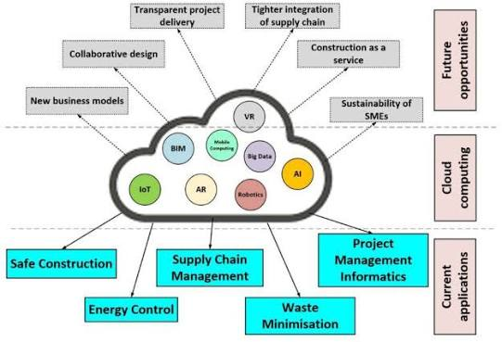

Workflow of a Cloud Computing Request

3. Components of Cloud Architecture
Cloud architecture refers to the various components — such as databases, softwareapplications, and infrastructure resources — needed to build a cloud. It is broadly divided into two major parts: the Front End and the Back End, which communicate with each other through a network, typically the Internet.
Figure 2: Cloud Computing Architecture — Front End, Network & Back End

3.1 Front End
The Front End is the part visible to and used by the client or user. It consists of the client's device, the interface (web browser or application), through which users interact with and access cloud services.

3.2 Back End
The Back End refers to the cloud itself, comprising all the resources required to provide cloud computing services. It includes:
- Application — the software or platform that the cloud is delivering to the client.
- Service — the type of service being accessed (SaaS, PaaS, or IaaS).
- Runtime Cloud — provides the execution environment (virtual machines) for the deployed application.
- Storage — the space and databases where data is stored and managed.
- Infrastructure — the physical hardware: servers, networking equipment, and data centers.
- Management — software responsible for monitoring, allocating, and coordinating resources.
- Security — mechanisms for identity management, encryption, and access control that protect data.

3.3 Network
The network (usually the Internet) enables communication and data exchange between the front end and the back end, allowing users to send requests and receive responses in real time.

4. Cloud Service Models
Cloud services are broadly classified into three fundamental models, each offering a different level of control, flexibility, and management:
Service Model | Description & Examples
IaaS (Infrastructure as a Service) | Provides virtualized computing resources — servers, storage, and networking — over the internet. Users manage OS, applications & data. Examples: AWS EC2, Microsoft Azure VMs, Google Compute Engine.
PaaS (Platform as a Service) | Provides a platform allowing developers to build, run, and manage applications without worrying about the underlying infrastructure. Examples: Google App Engine, Microsoft Azure App Service, Heroku.
SaaS (Software as a Service) | Delivers fully functional software applications over the internet on a subscription basis; the provider manages everything. Examples: Gmail, Google Workspace, Microsoft 365, Dropbox.

Figure 3: Responsibility Split Across On-Premises, IaaS, PaaS & SaaS

5. Cloud Deployment Models
A cloud deployment model defines where the infrastructure resides, who manages it, and who has access to it. There are four primary deployment models:

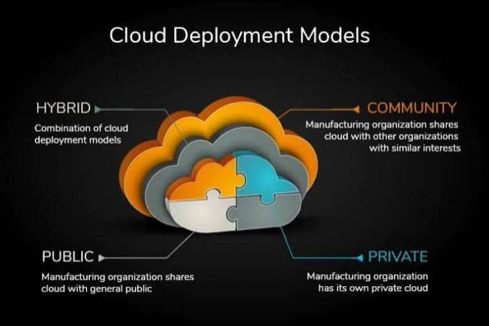
Figure 4: Public, Private, Hybrid & Community Cloud Deployment Models
Deployment Model | Description
Public Cloud | Owned and operated by third-party providers and shared among multiple organizations over the public internet. Low cost & highly scalable, but offers less control. E.g., AWS, Azure, Google Cloud.
Private Cloud | Dedicated exclusively to a single organization, hosted either on-premises or by a third party. Offers greater security & control but is costlier. E.g., VMware Private Cloud, OpenStack.
Hybrid Cloud | A combination of public and private clouds that allows data and applications to be shared between them, offering greater flexibility and optimized costs.
Community Cloud | Shared infrastructure used by several organizations with common concerns (security, compliance, jurisdiction) such as government bodies or research institutions.

6. Advantages of Cloud Computing
- Cost Efficiency — eliminates the need for large upfront investment in hardware and infrastructure.
- Scalability — resources can be scaled up or down instantly based on demand.
- Accessibility — services can be accessed anytime, anywhere with an internet connection.
- Reliability — data backup, disaster recovery, and high availability are easier to implement.
- Automatic Updates — providers manage software updates and security patches.
- Collaboration — enables real-time collaboration and file sharing across teams globally.

7. Conclusion
Cloud computing has revolutionized the way organizations and individuals access and utilize computing resources. By understanding its fundamental concepts, architectural components, and various deployment models, one can make informed decisions about adopting the right cloud strategy — balancing cost, control, security, and scalability according to specific business or personal needs.

8. References
- NIST Special Publication 800-145 — The NIST Definition of Cloud Computing.
- Official documentation — Amazon Web Services (AWS).
- Official documentation — Microsoft Azure.
- Official documentation — Google Cloud Platform.

