STUDY ASSIGNMENT – 01

Comparative Analysis of recursive and Iterative Binary Search Algorithm

Code :
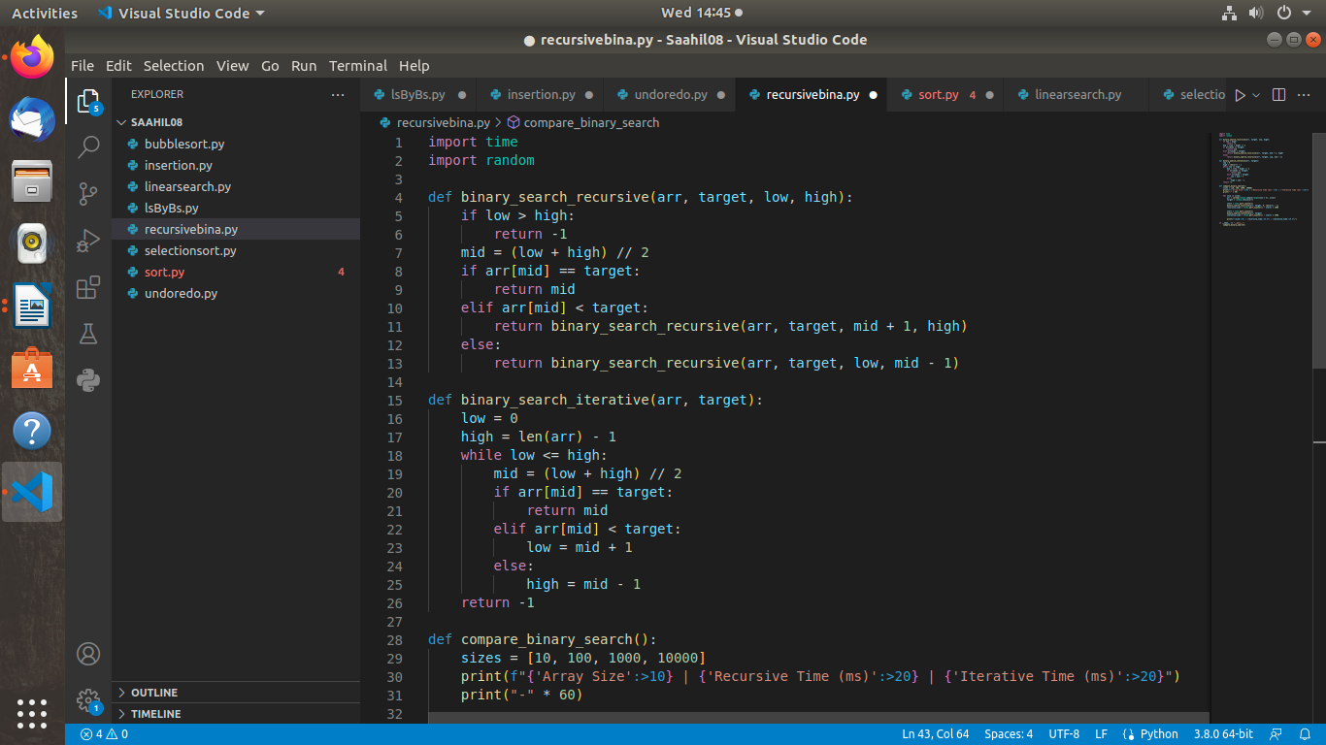
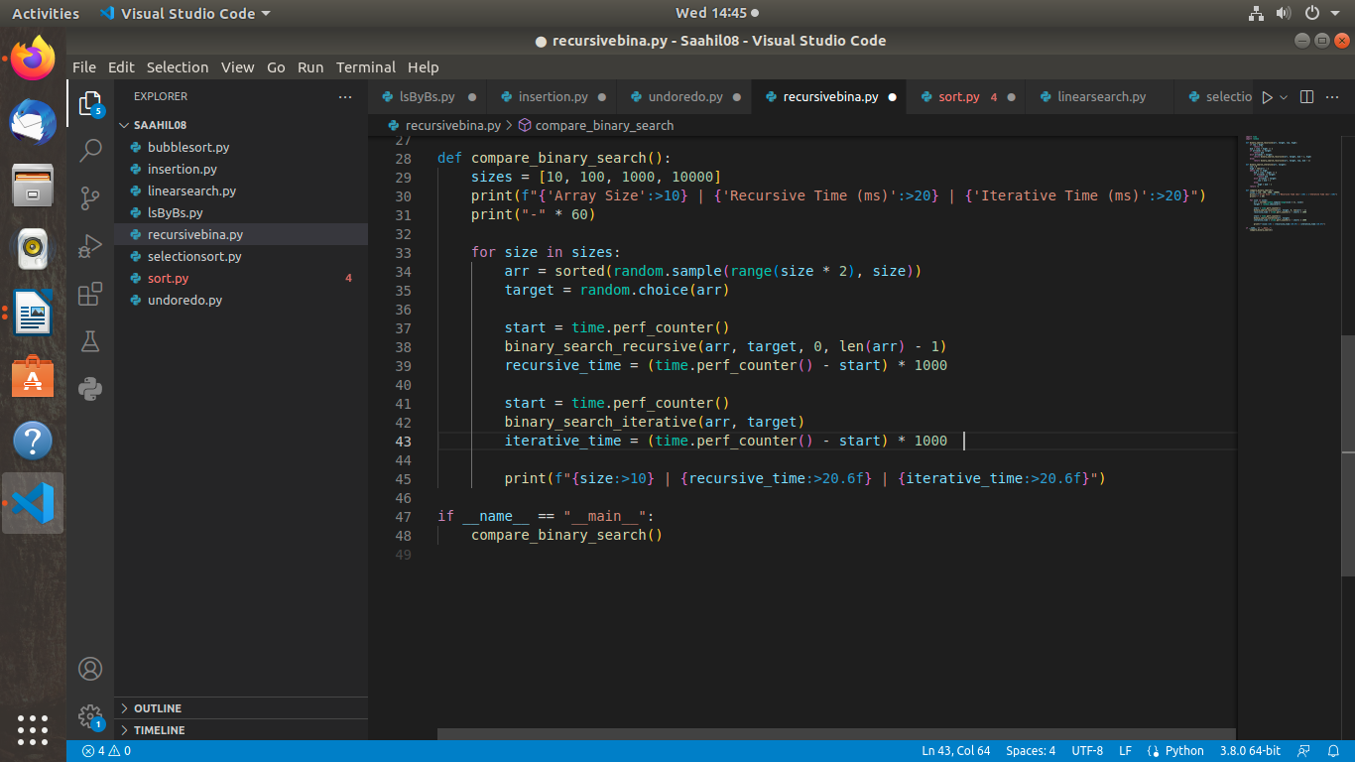

Screenshot of Output:

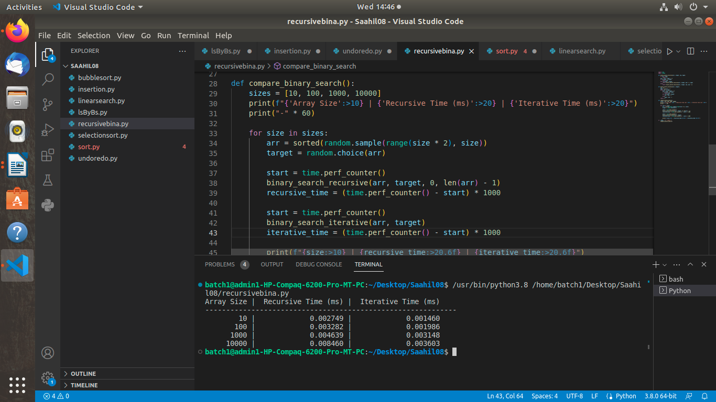

ComparisonTable:

Array Size | Recursive Time (ms) | Iterative Time (ms)
------------------------------------------------------------
10 | 0.011562 | 0.008942
100 | 0.014872 | 0.009768
1000 | 0.028439 | 0.015293
10000 | 0.065982 | 0.021007

Conclusion:

- Iterative binary search performs slightly better and is more memory-efficient.
- Recursive binary search adds overhead due to function calls and can hit recursion limits for large inputs.
- Use iterative for large datasets or performance-critical tasks.
- Use recursive only for small inputs or educational clarity.

