# Design

## Introduction to Design

Design is an important phase of development process in which developers develop the system based on the specific requirements and needs of their customers.

## Structural Design/Model

Structural design which is mostly based on mathematical model, statistical model as well as the computer algorithms.

### Final Class Diagram

A Class Diagram is a static diagram which shows a static representation of a system. It involves structures like Classes, Attributes and Operations. It also shows the relationship between all the classes within the system.

## Behavioral Model

Behavioral Model are basically a dynamic model which shows how the system responds according to the actions performed from the environment or users.

### Activity Diagram

Activity Diagram is an important behavioral diagram which narrates the dynamic aspects of the system. It is an advanced version of flow chart which is used to represent the flow from one activity to the other.

|  |  |  |
| --- | --- | --- |
| Notation Used | Notation | Description |
| Action |  | Shows what activity is done |
| Initial |  | Shows the starting of the activity |
| Final |  | Shows the ending of the activity |
| Fork |  | Splits one flow into multiple flow |
| Join |  | Joins two actions into one |
| Decision |  | Decides the condition |
| Control Flow |  | Shows the flow of activity |
| Send Signal |  | Sends message through the system |
| Accept Signal |  | Receive message sent from the system |
| Swimlane |  | Group related activities into one column vertical or horizontal |
| Activity Interrupt |  | Interrupts the flow of the activity with a lightning bolt |
| Accept Time Event |  | Event which stops the flow of an activity for a certain specific time |
| Interruptible Activity Region |  | Activity terminated if interruption occurs. |

Here are all of my activity diagrams:-

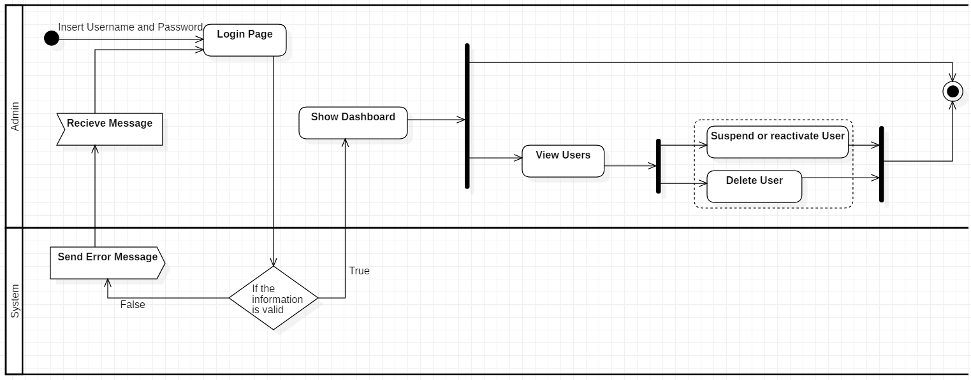

Figure 1 Admin Login Activity Diagram

The above activity diagram is about how an admin of the system works and can operate its functions. First admin opens up a login page where he/she provides the required information i.e username and password, if the provided information is incorrect the system sends a error message to the login page(Looping is done if information is not correct). If provided information is correct the admin is redirected to the admin dashboard where he can view users and can suspend,delete as well as reactivate users.

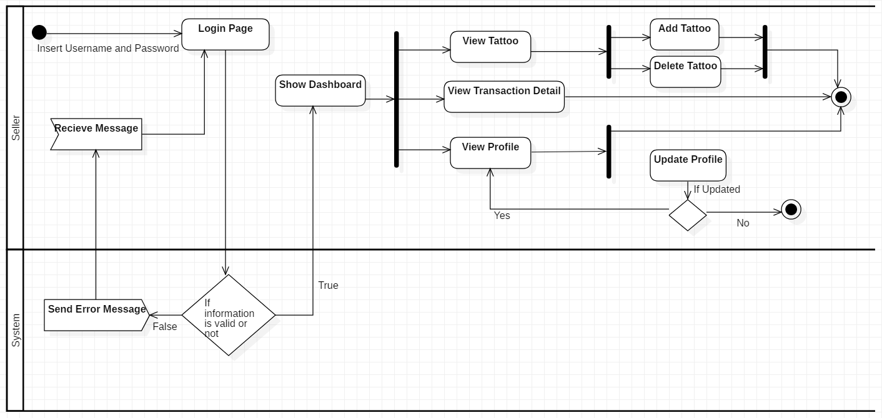

Figure 2 Artist Login Activity Diagram

The above activity diagram is abot how an seller (which is a artist) of the system works and can operate its functions. First seller opens up a login page where he/she provides the required information i.e username and password, if the provided information is incorrect the system sends a error message to the login page(Looping is done if information is not correct). If the provided information are correct the artist is redirected to the artist dashboard where he/she can view tattoos, view transaction details and view profiles. In tattoos artist can delete as well as add tattoos and artist and update their profile as well as upload a photo.

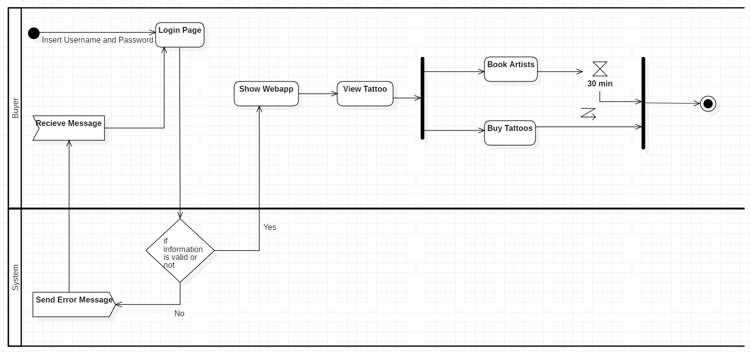

Figure 3 User Login Activity Diagram

The above activity diagram is abot how an Buyer (which is a normal user) of the system works and can operate its functions. First buyer opens up a login page where he/she provides the required information i.e username and password, if the provided information is incorrect the system sends a error message to the login page(Looping is done if information is not correct). If the provided information are correct the User is redirected to the webapp where he/she can view tattoo and buy it as well, users can also book artists in the artist section.

### Sequence Diagram

Sequence Diagram is a diagram which shows how actors interact with objects in a sequential order. It shows how and what order the objects in the system function.

|  |  |  |
| --- | --- | --- |
| Notation Used | Notation | Description |
| Actor |  | It is an entity which interacts with the objects of the diagram. |
| Lifeline |  | It interacts with other objects during the sequence. |
| Message Arrow |  | Shows the flow of the diagram. |
| Alternate Frame |  | It is if else statement. |
| Loop Frame |  | It is a loop statement used for repetition of a part. |

Here are my sequence diagrams: -

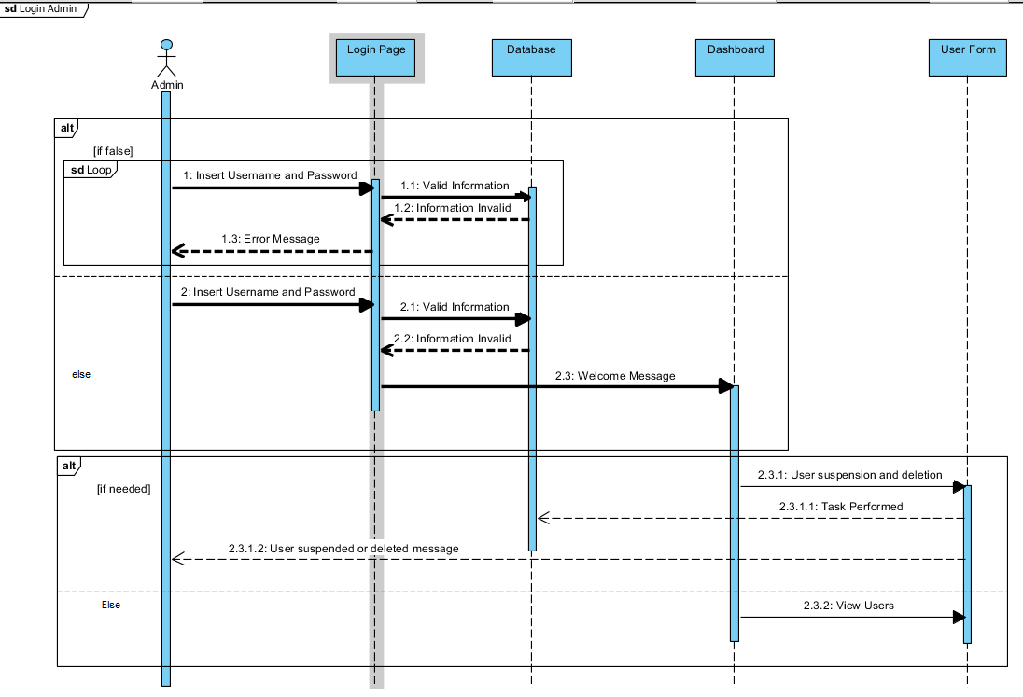

Figure 4 Admin Login Sequence

The above sequence diagram is about how a admin logs into the system. First the admin enters the login page where he/she provides the required information. If correct then admin is redirected into the admin dashboard where admin can suspend, reactivate as well as delete users.

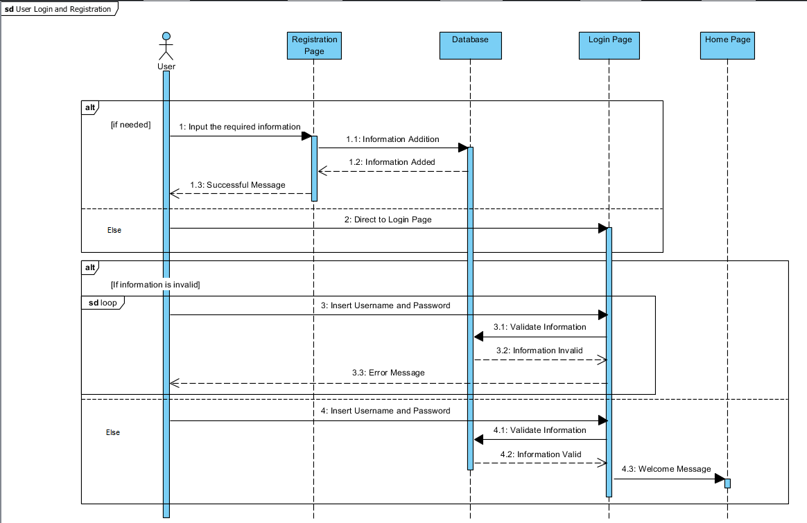

Figure 5 User Register and Login Sequence

The above sequence diagram is about how a User registers itself and logs into the system. First the user enters the registration page where he/she provides the required information which is then stored into the database. Then user is redirected to the login page where he/she provides the required information. If correct then user is redirected into the home page of the webapp where user can view tattoos and artists as well as buy tattoos and book artists.

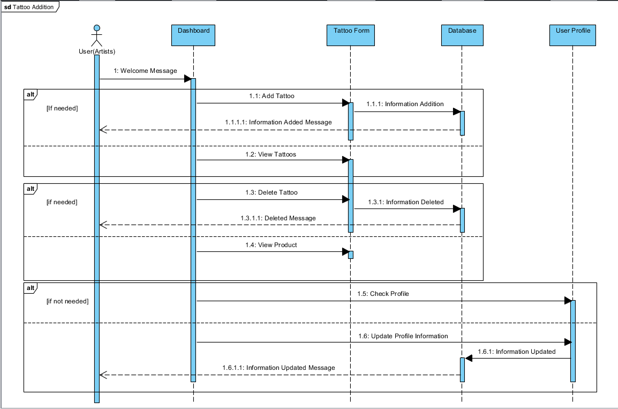

Figure 6 Tattoo Sequence

The above sequence diagram is about how a Artist adds tattoos into the system. First the artist enters the artist dashboard from there artist enters the view tattoo page where artist can find a tattoo form from which the artists can add tattoos which is stored in the database, artists can delete their tattoos as well but cannot delete other artists tattos. Here artists can check their profile and add information about them or update details or even add photos.

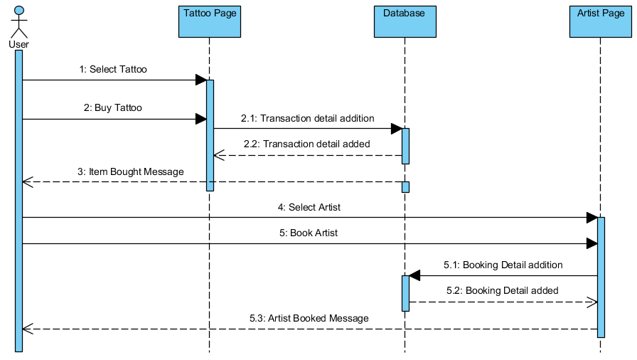

Figure 7 Buying Sequence

The above sequence diagram is about how a user can buy tattoos and book artists from the system. For buying tattoo first the user enters the tattoo pageers where all the available tattoos are shown from their user can select one and buy it. From there the transaction details are stored and bought message is sent to the user. Now for booking artist first the user enters the artist page where all the available artists are shown from their user can select one and book it. From there the booking details are stored and booked message is sent to the user.

## Database Model

It is a logical structure which is used to determine how data in the system is stored, manipulated, processed and organized.

### Data Dictionary

Data dictionary is simply a repository of metadata which is a set of files which stores all the collection of tables with metadata. It also contains relationship to other data.

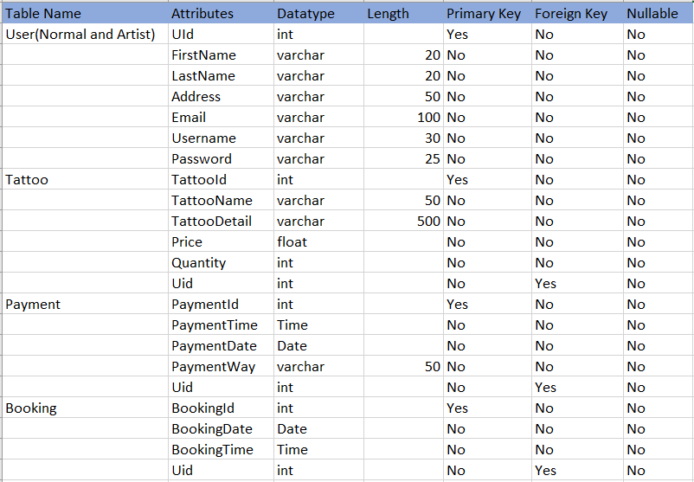

Figure 8 Data Dictionary

### ER Diagram

ER diagram is a diagram which shows the relationships between all the entities within the system. A ERD consists of entities with its attributes and relationship between the entities.

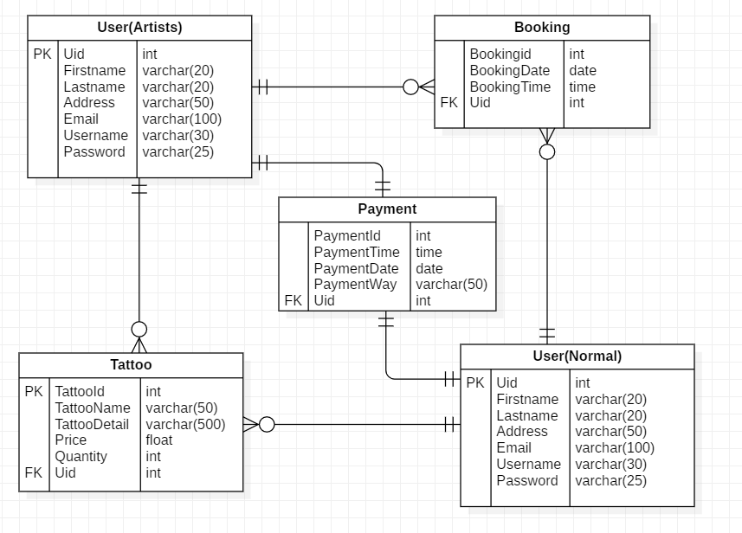

Figure 9 ER Diagram

## Architectural Model

Architectural model is mainly known as the blueprint of the system as it contains both the elements of structural model as well as behavioral model. For this system I have follow MVC pattern and it follows a 3-tier architecture such as:

1. Model
2. View
3. Controller

## UI Modeling

User interface modeling is a development technique used by computer application developers.

### Prototyping

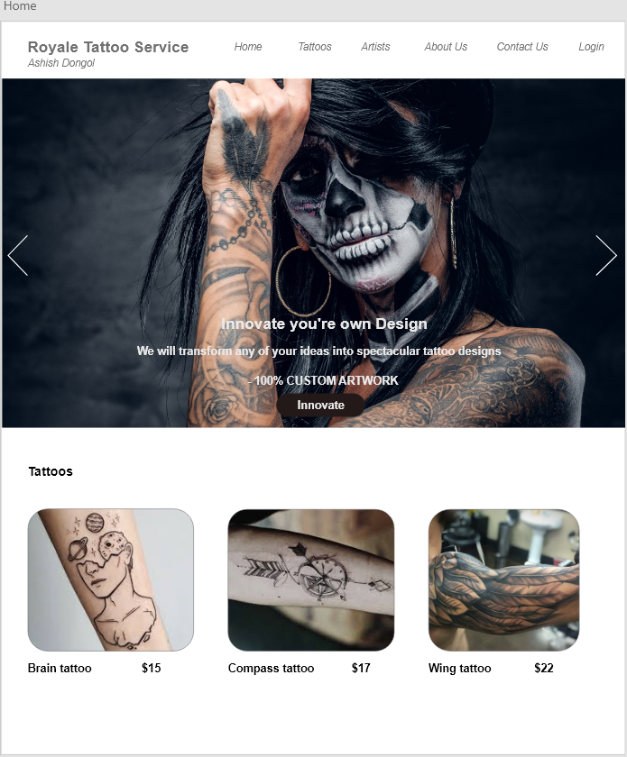Prototype is a rough sketch which shows how the project will look in the future and It will be used as a basis to create that software. There are many types or categories of prototyping but the most commonly used is paper prototyping as it can be done very easily. Here is my prototype of the web app: -

Figure 10 Home Page

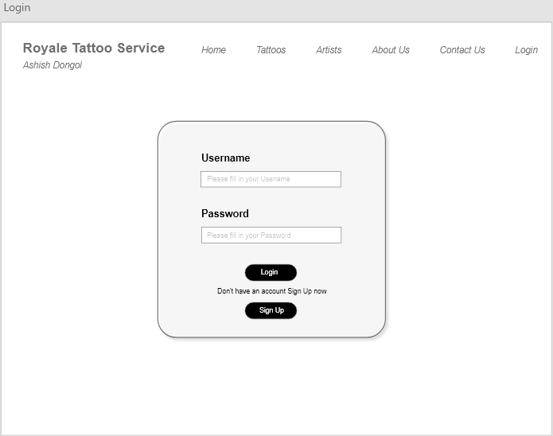

Figure 11 Login Page

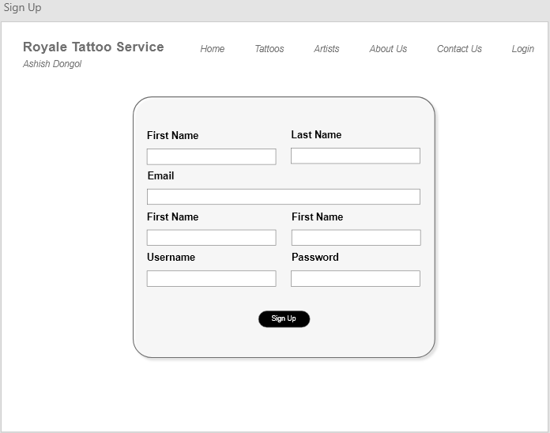

Figure 12 Registration Page

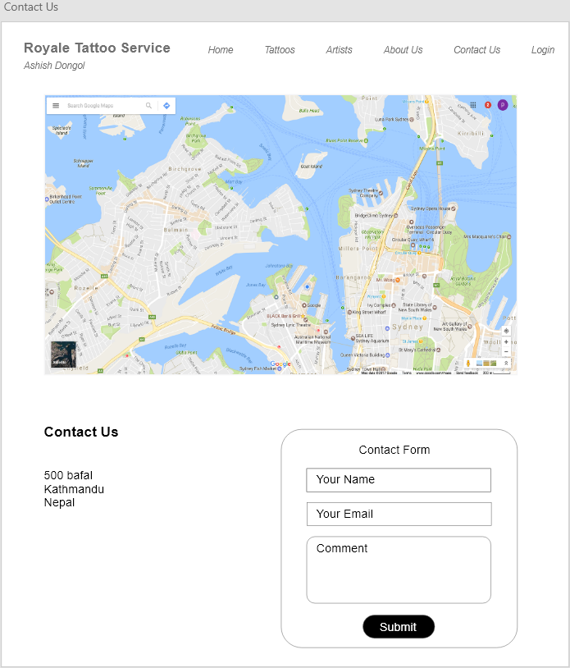

Figure 13 Contact Us Page

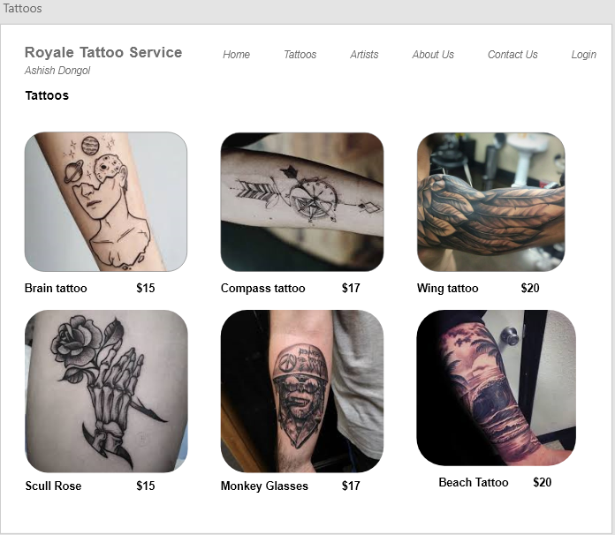

Figure 14 Tattoos Page

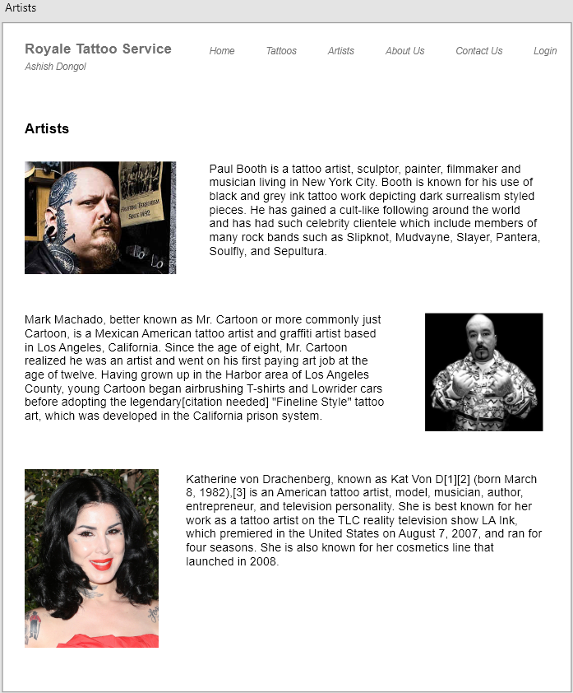

Figure 15 Artists Page



Figure 16 About Us Page

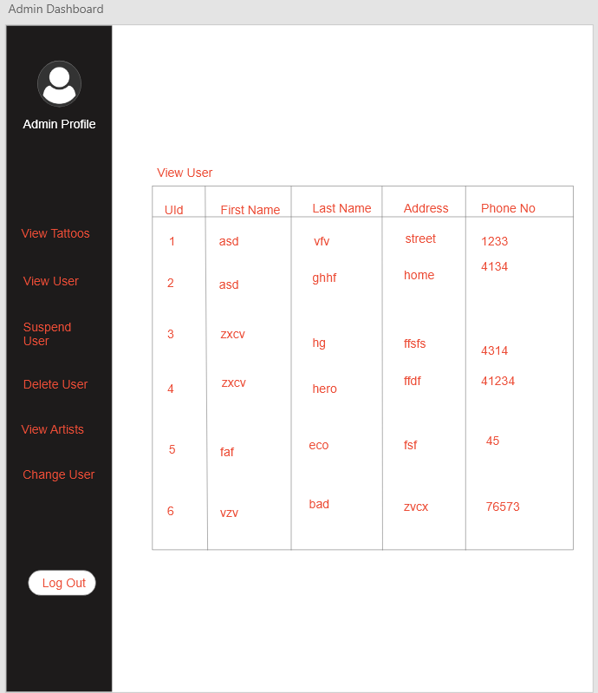

Figure 17 Admin Dashboard

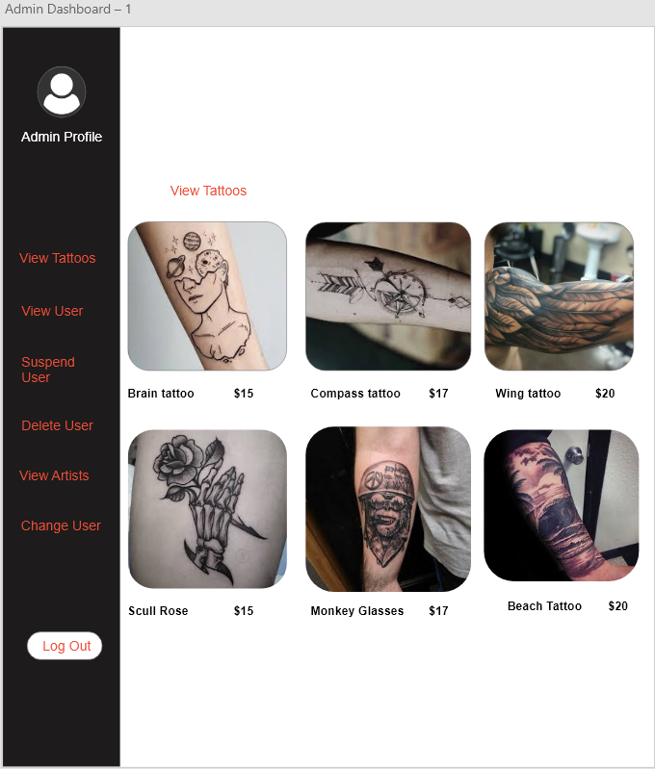

Figure 18 Admin View Tattoos

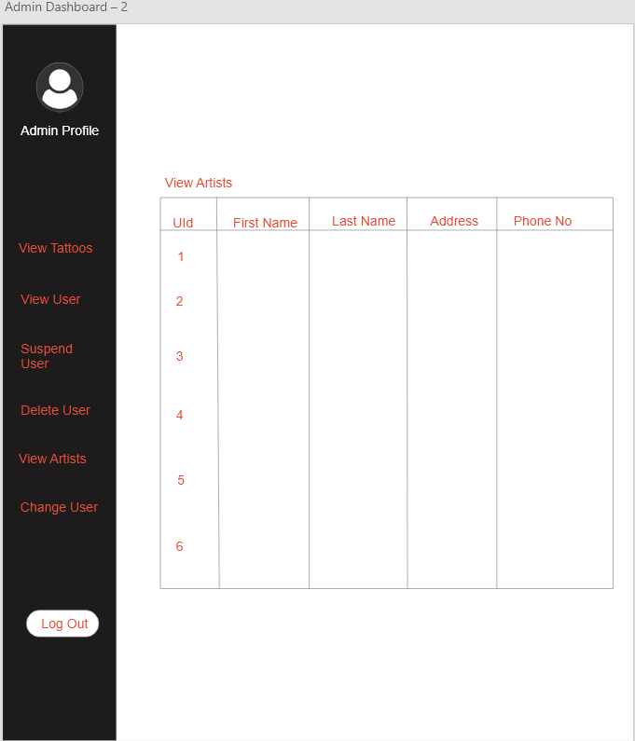

Figure 19 Admin View Artists

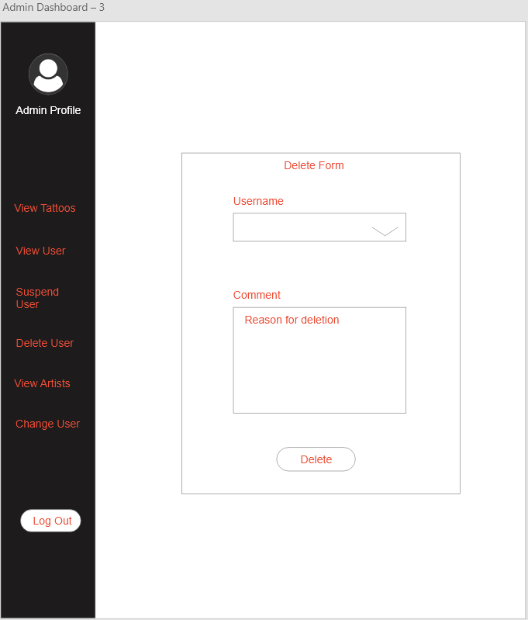

Figure 20 User Delete Form

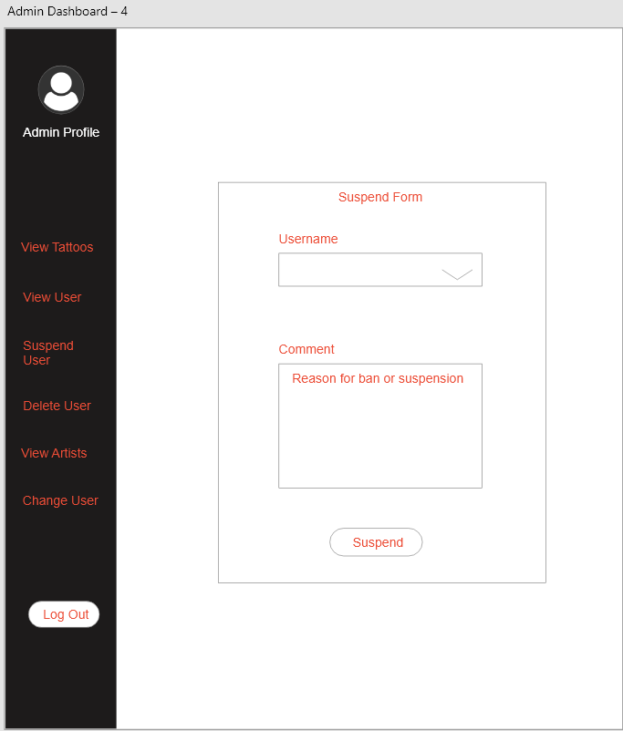

Figure 21 User Suspend Form

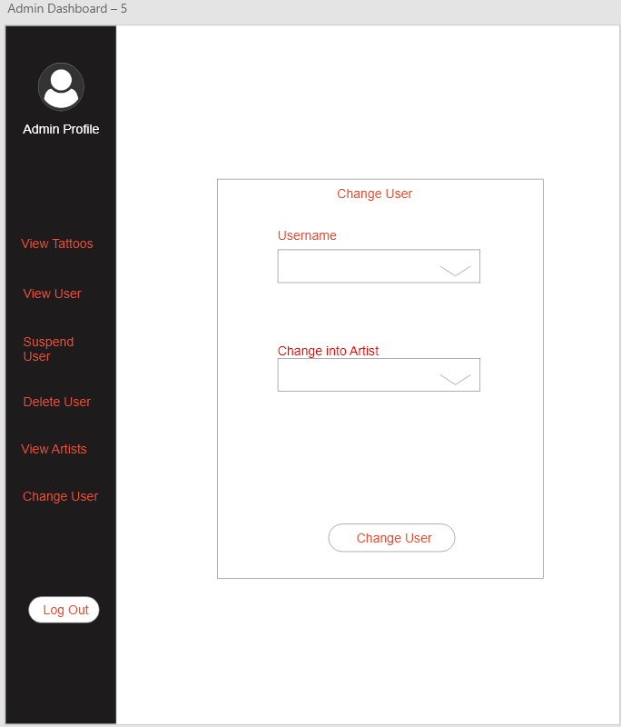

Figure 22 Change User Form

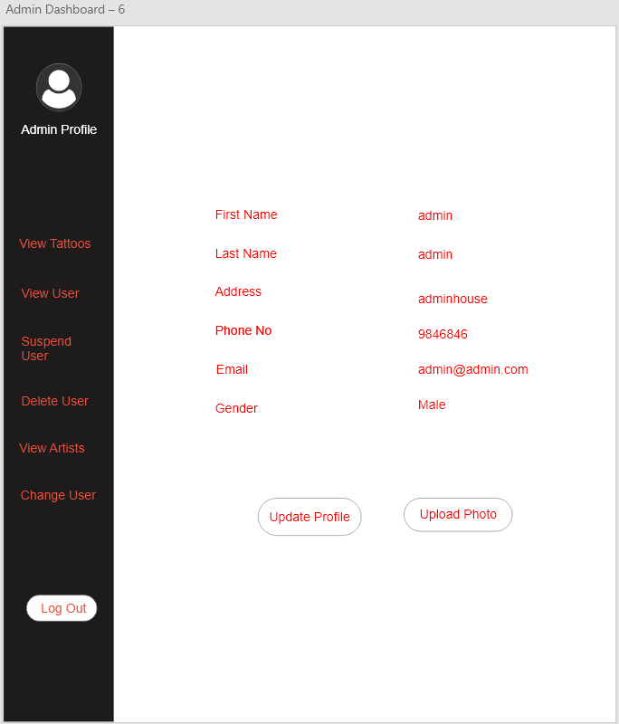

Figure 23 Admin Profile

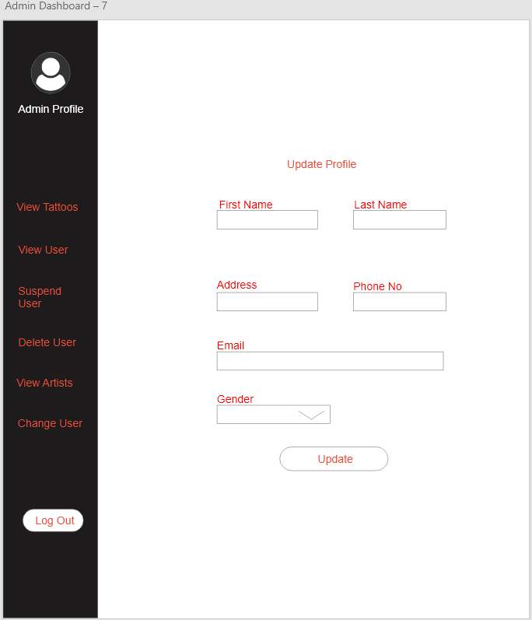

Figure 24 Admin Update Profile

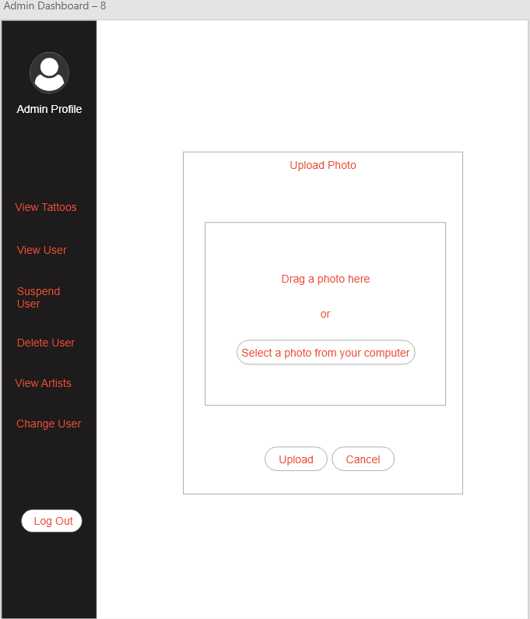

Figure 25 Upload Photo Form

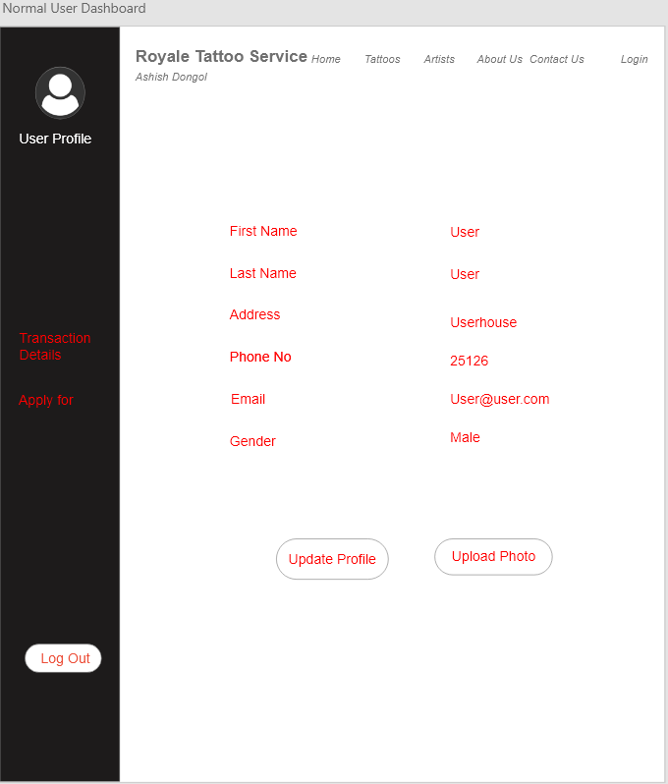

Figure 26 User Dashboard

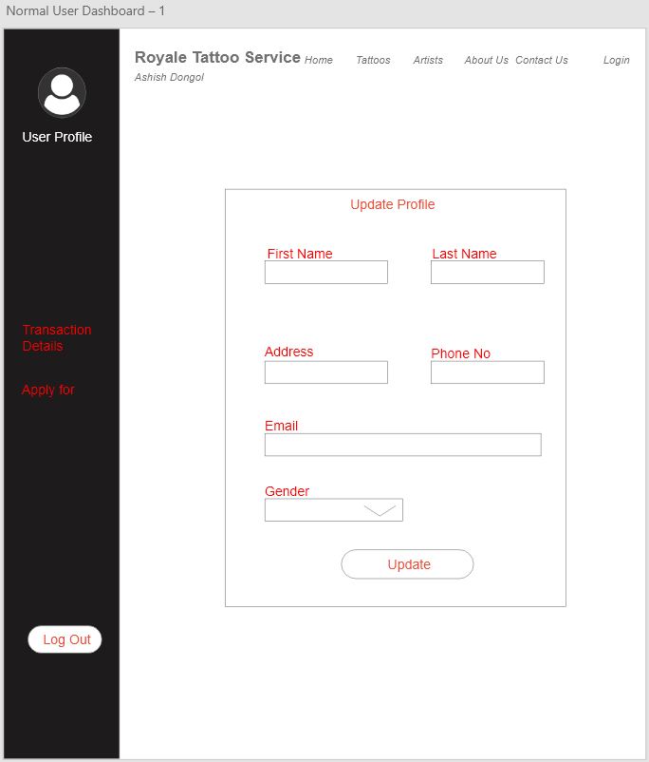

Figure 27 User Update Profile Form

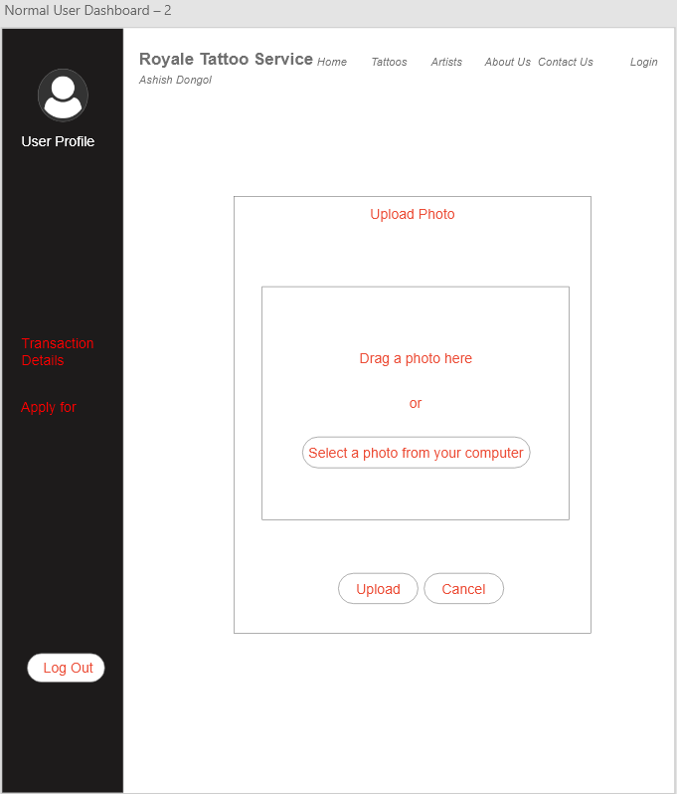

Figure 28 User Upload Photo

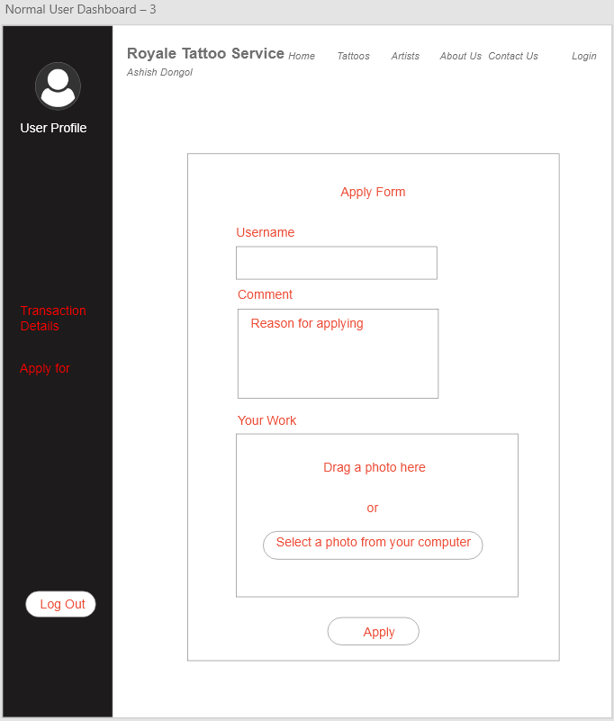

Figure 29 Artist Apply Form

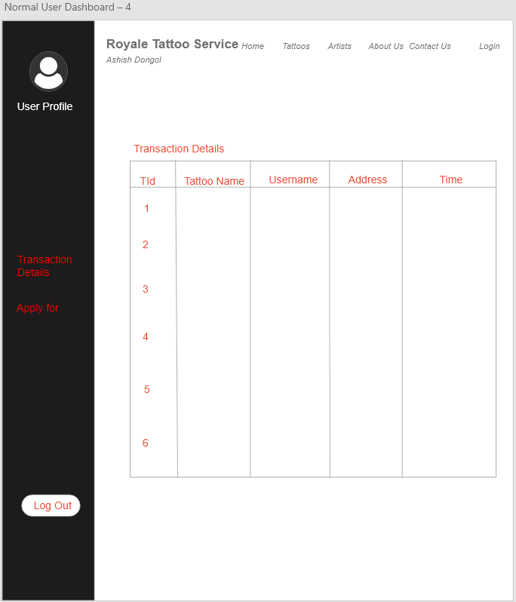

Figure 30 User Transaction Details

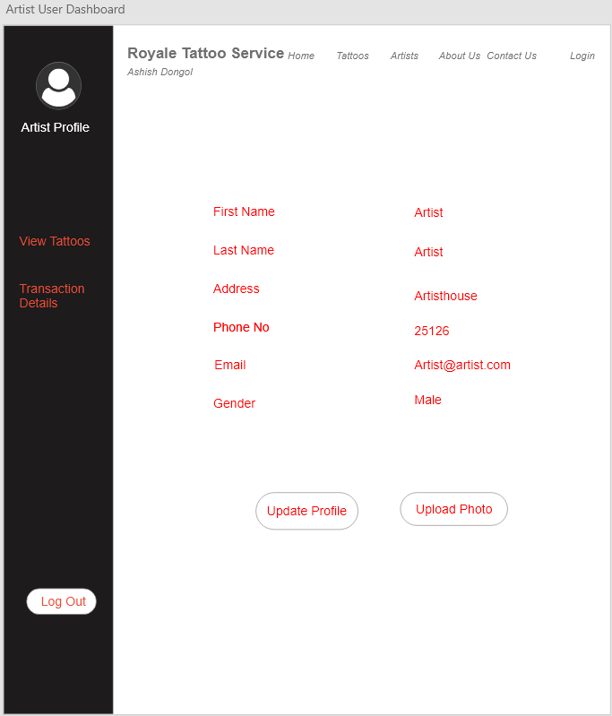

Figure 31 Artist Dashboard

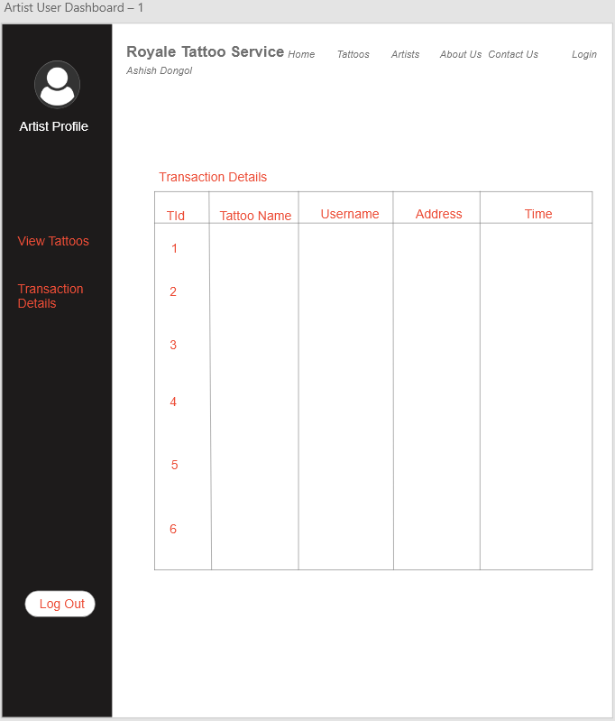

Figure 32 Artist Transaction Details

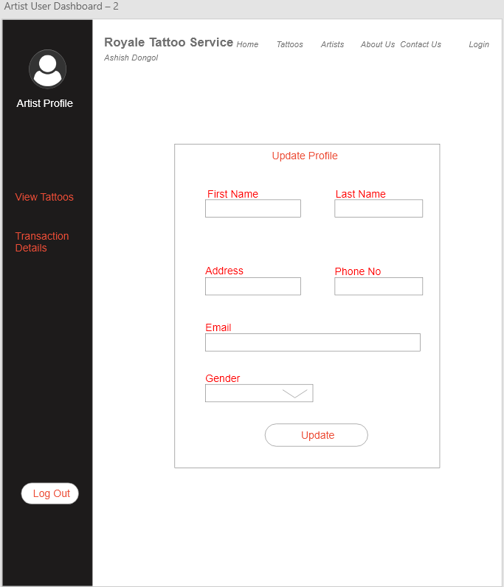

Figure 33 Artist Update Profile

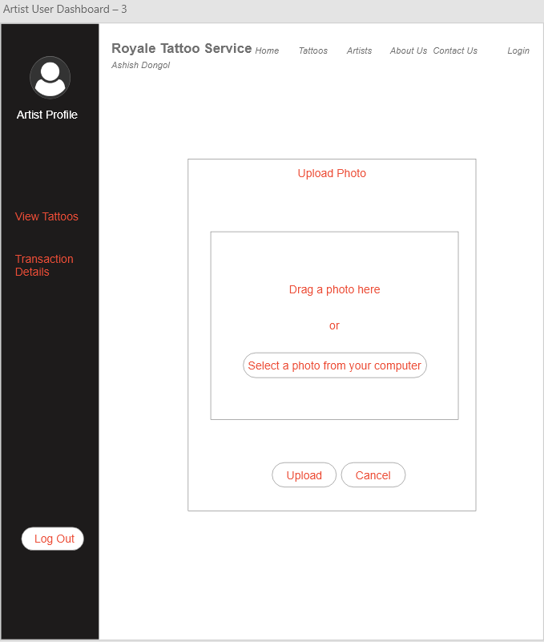

Figure 34 Artist Upload Photo

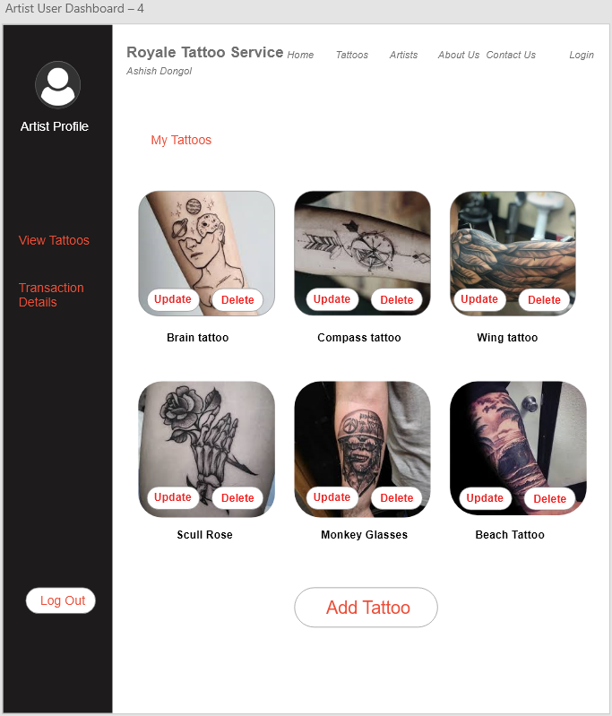

Figure 35 Artist View Tattoos

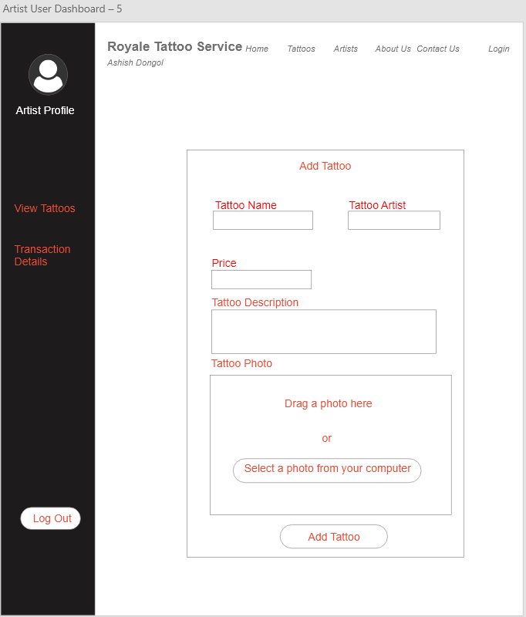

Figure 36 Add Tattoo

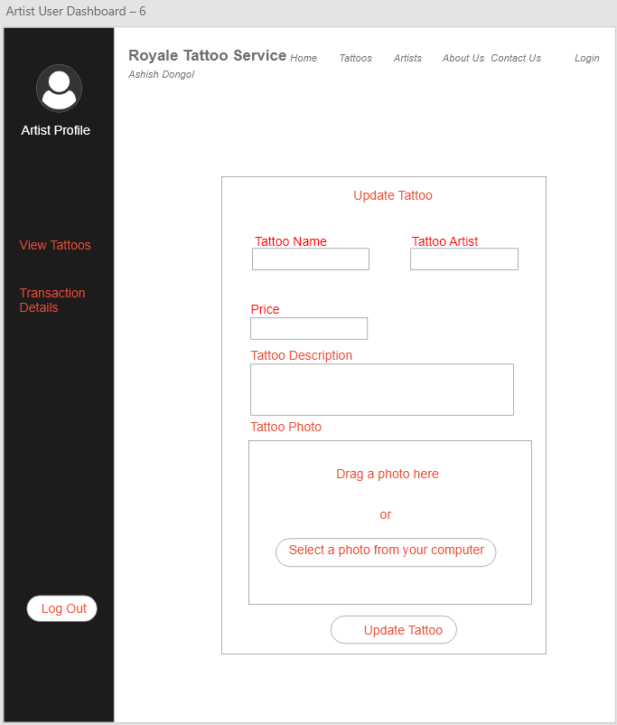

Figure 37 Update Tattoo