1. **Explore the Different Layer of Network?**

There is 7 type of Layer in a network which are as follows:-

1. Application Layer
2. Presentation Layer
3. Session Layer

To Transmit Data

1. Transport Layer

To Receive Data

1. Network Layer
2. Data Link Layer
3. Physical Layer

**Application Layer: -** It is the top most layer of network, it allows user to access network resources and the user can directly access the network at this layer. For Ex- http, ftp, smtp, dns.

**Presentation Layer: -** this layer is transfer the data in the form which is accepted by the application layer. This layer also perform the encryption and decryption the data and also perform the data compression. Ex- SSL

**Session Layer: -** The session layer controls the conversations between different computers. It establishes, maintains, and ends a session. Ex:-

Zone Information Protocol

**Transport Layer:-** The protocols of this layer provide end-to-end communication services for applications. One of the most common examples of the transport layer is TCP or the Transmission Control Protocol.

**Network Layer:-**  this layer is responsible to move data packet from source to destinations and to provide internetworking.  The network layer finds the destination by using logical addresses, such as IP (internet protocol).

**DataLink Layer:-** The main function of the data-link layer is to perform error detection and combine the data bits into frames. It combines the raw data into bytes and bytes to frames and transmits the data packet to the network layer of the desired destination host. At the destination end, the data-link layer receives the signal, decodes it into frames and delivers it to the hardware.

**Physical Layer :-** The physical layer helps you to define the electrical and physical specifications of the data connection. This level establishes the relationship between a device and a physical transmission medium. The physical layer is not concerned with protocols or other such higher-layer items. Ex- network adapters, ethernet, repeaters, networking hubs, etc.

1. **Check your DNS Server, find the IP address of any 5 websites?**

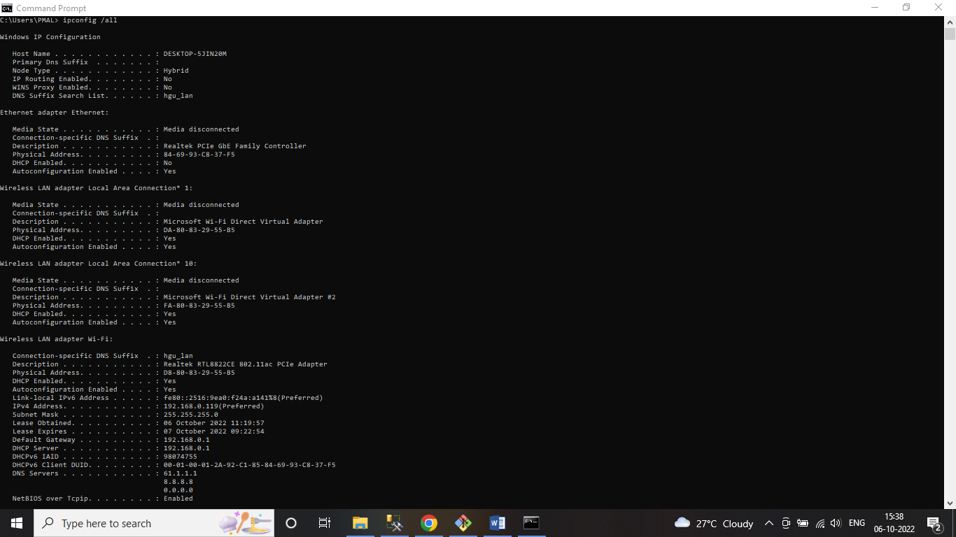

Step 1:- open cmd, then type “ ipconfig /all”.

DNS Server :- 61.1.1.1 , 8.8.8.8

IP Address of Website

1. letsupgrade.in :- 13.234.73.79
2. facebook.com :- 157.240.198.35
3. twitter.com :- 104.244.42.1
4. google.com :- 142.250.194.142
5. amazon.com :- 52.94.236.248

