1. List the city, state, and zip codes in the customer table. Your result should not have duplicates.

Solution:

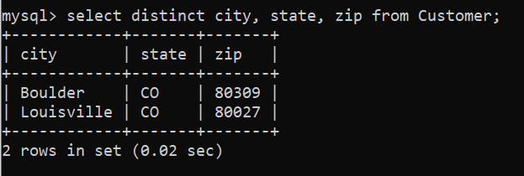

To run this query I use MySQL CLI.