2. List the name, department, phone number, and email address of employees with a phone number beginning with “3-”.

Solution:

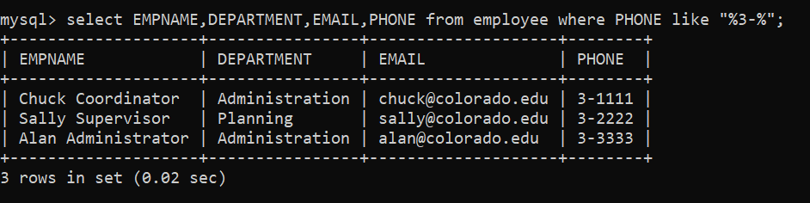

To run this query I used MySQL CLI.