3. List all columns of the resource table with a rate between $10 and $20. Sort the result by rate.

Solution:

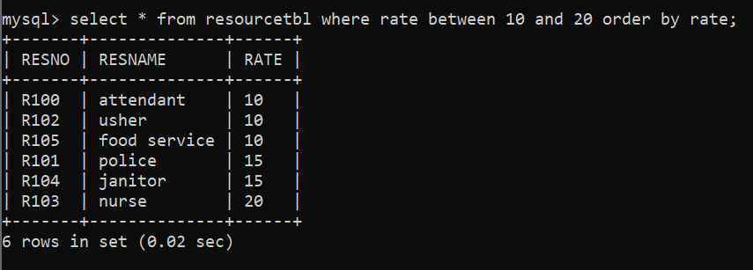

To run this Query I used MySQL CLI.