4. List the event requests with a status of “Approved” or “Denied” and an authorized date in July 2018. Include the event number, authorization date, and status in the output.

Solution:

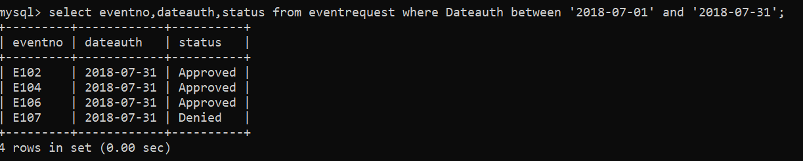

To run this query I used MySQL CLI.