6. For each event plan, list the plan number, count of the event plan lines, and sum of the number of resources assigned. For example, plan number “P100” has 4 lines and 7 resources assigned. You only need to consider event plans that have at least one line.

Solution:

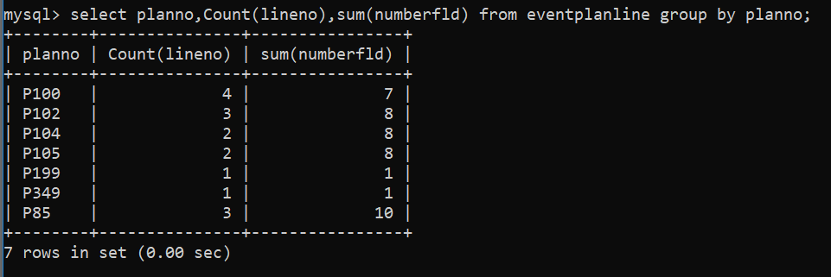

To run this Query I used MySQL CLI.