
INTERACTIVE PROCESS MANAGEMENT SYSTEM
A Terminal-Based Process Controller for Linux
A PROJECT REPORT
Submitted in partial fulfillment of the requirements for the award of the degree of
BACHELOR OF TECHNOLOGY
DEPARTMENT OF ARTIFICIAL INTELLIGENCE AND DATA SCIENCE
Project Title: Interactive Process Management System
Submitted by
T. Ashish Reddy — 2510080030
T. Karthik Bharadwaj — 2510080042
Hamesh Reddy — 2510080003
Dhanush Reddy — 2510080018
Under the guidance of
[Dr.P Kalpana]
Department of Artificial Intelligence and Data Science
Koneru Lakshmaiah Education Foundation (Deemed to be University)
Off-Campus: Bachupally-Gandimaisamma Road, Bowrampet, Hyderabad, Telangana – 500 043
Academic Year: 2026–2027

DECLARATION
We hereby declare that the project report entitled “Interactive Process Management System: A Terminal-Based Process Controller for Linux” is a record of work carried out by us as part of the Bachelor of Technology programme in the Department of Artificial Intelligence and Data Science.
We affirm that this report describes the design, implementation, and testing work undertaken for our project. The project focuses on operating-system concepts including process creation and control, signal handling, pipes, input/output redirection, and POSIX multithreading.
The material in this report has been prepared for academic submission. Wherever external documentation or technical references are used, they are acknowledged in the references section. We understand that the project must be evaluated on the basis of the implementation actually completed and demonstrated.
Student declarations and signatures:
T. Ashish Reddy (2510080030) Signature: ____________________
T. Karthik Bharadwaj (2510080042) Signature: ____________________
Hamesh Reddy (2510080003) Signature: ____________________
Dhanush Reddy (2510080018) Signature: ____________________
Place: Hyderabad
Date: ____________________
DEPARTMENT OF ARTIFICIAL INTELLIGENCE AND DATA SCIENCE

CERTIFICATE
This is to certify that the project report entitled “Interactive Process Management System: A Terminal-Based Process Controller for Linux” is submitted by the following students in partial fulfillment of the requirements for the award of the degree of Bachelor of Technology in the Department of Artificial Intelligence and Data Science.
T. Ashish Reddy — 2510080030
T. Karthik Bharadwaj — 2510080042
Hamesh Reddy — 2510080003
Dhanush Reddy — 2510080018
The project presents an educational implementation of a terminal-based process controller using Linux/POSIX programming concepts. The report is submitted for academic review and evaluation during the academic year 2026–2027.
Guide’s Signature: ____________________
Name: [Dr. P Kalpana]
Designation: [Assistance Professor]
Course Coordinator: ____________________
Head of Department: ____________________
Department of Artificial Intelligence and Data Science
Koneru Lakshmaiah Education Foundation (Deemed to be University)
Date: ____________________

ACKNOWLEDGEMENT
We express our sincere gratitude to our project guide and faculty members for their guidance, feedback, and encouragement during the development of the Interactive Process Management System.
We thank the Department of Artificial Intelligence and Data Science for providing an academic environment in which we could explore Linux system programming and practical operating-system concepts. The project helped us connect classroom concepts with hands-on implementation and debugging.
We also acknowledge the maintainers of the Linux, GNU Compiler Collection, POSIX threads, and Valgrind documentation, which served as technical references while implementing and validating the program.
Finally, we thank our families, friends, and classmates for their support throughout the project. The collaboration among team members helped us plan the modules, test behaviours, review issues, and prepare this documentation.
T. Ashish Reddy — 2510080030
T. Karthik Bharadwaj — 2510080042
Hamesh Reddy — 2510080003
Dhanush Reddy — 2510080018
Department of Artificial Intelligence and Data Science

ABSTRACT
The Interactive Process Management System is a terminal-based process controller developed to demonstrate practical operating-system and Linux system-programming concepts in one interactive application. The system provides a command-oriented interface through which users can launch programs, manage foreground and background execution, inspect process information, and perform common process-control actions.
The implementation brings together process creation and program execution using POSIX process APIs, signal handling for process control, pipes for inter-process communication, input/output redirection through file descriptors, and a background monitoring thread built with POSIX threads. The code is organized into modules for parsing, input, process operations, signals, pipes, redirection, monitoring, and threading.
The project was developed and tested in an Ubuntu/Linux environment using GCC. Compilation uses pthread support, and the application is launched as ./bin/process_manager. Functional checks covered command interaction, process execution, pipes, redirection, and background monitoring. A Valgrind run reported zero errors and no bytes remaining in use at exit for the tested execution path.
The project is intended as an educational process controller rather than a replacement for a complete Linux shell or a production-grade system administration tool. It provides a practical basis for studying process lifecycle, signal semantics, file descriptors, IPC, thread synchronization, debugging, and modular C programming.
Keywords: Linux, process management, fork(), execvp(), signals, pipes, I/O redirection, POSIX threads, mutex, GCC, Valgrind.

TABLE OF CONTENTS
PRELIMINARY PAGES
Title Page
Declaration
Certificate
Acknowledgement
Abstract
Table of Contents
CHAPTERS
Chapter 1 — Introduction, problem statement, scope and objectives
Chapter 2 — Hardware and software requirements
Chapter 3 — Technology stack and development tools
Chapter 4 — System architecture and modules
Chapter 5 — System design and workflows
Chapter 6 — Implementation details
Chapter 7 — Features and operation
Chapter 8 — Testing and validation
Chapter 9 — Build, execution and version control
Chapter 10 — Challenges and limitations
Chapter 11 — Future enhancements
Chapter 12 — Conclusion
References
Appendix A — Representative commands and user guide
Note: Page numbers in this generated report follow the page order of this document. If the report is edited, refresh the table of contents and page numbering in the word processor.

CHAPTER 1 — INTRODUCTION
1.1 Background of the Project
An operating system manages the execution of programs and allocates resources such as processor time, memory, files, and input/output devices. A process is a running instance of a program, with its own execution state and associated operating-system resources. Understanding how processes are created, monitored, interrupted, and completed is central to systems programming.
Linux exposes process-related operations through system calls and library interfaces. Functions such as fork(), execvp(), wait(), and waitpid() enable programs to create child processes, execute new programs, and coordinate with their completion. Signals allow asynchronous notifications and control requests. Pipes connect the output of one process to the input of another, while file-descriptor operations support redirection.
The Interactive Process Management System was created to bring these concepts together in a small terminal-based controller. Instead of treating process execution as an isolated command, the project exposes several related operations through a common interactive interface.
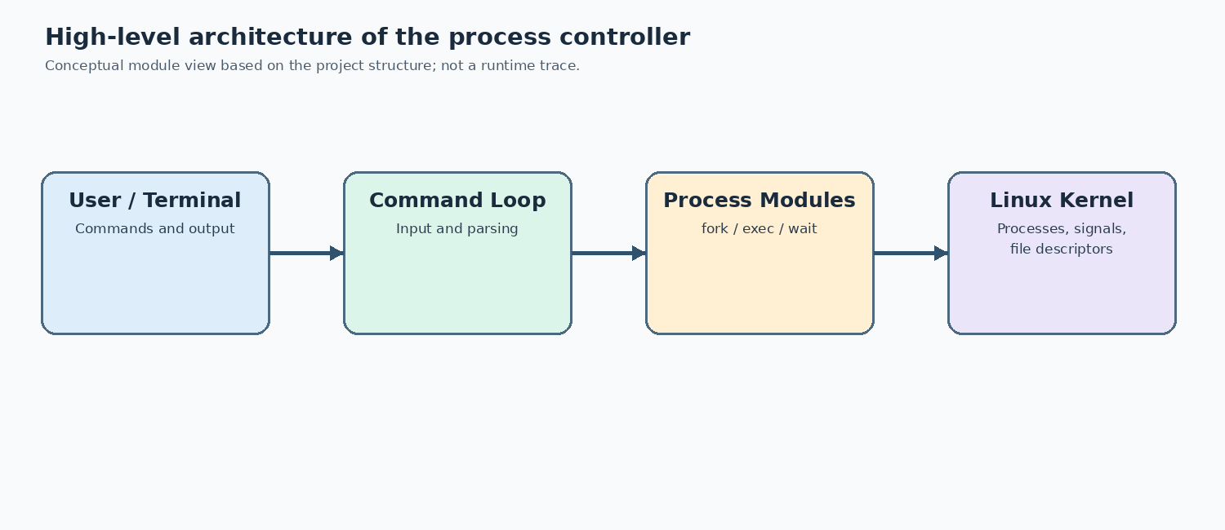
Figure 4.1: High-level architecture of the Interactive Process Management System.
The practical value of the project lies in connecting API calls to visible terminal behaviour. When a command is entered, the program must interpret the input, choose the appropriate operation, handle errors, and return control to the user. This sequence demonstrates that a process controller is not only a collection of system calls; it is also an interface that coordinates them predictably.
A useful learning exercise is to compare the parent process and its child. The child can replace its program image through an exec-family call, while the parent can wait for completion or continue accepting commands for background work. Observing these differences makes process creation, execution, and termination easier to distinguish.

CHAPTER 1 — PROBLEM STATEMENT AND SCOPE
1.2 Problem Statement
Learning process management from theory alone can make the relationships among process creation, waiting, signals, pipes, and file descriptors difficult to visualize. Separate Linux commands can demonstrate individual behaviours, but a focused program helps connect them within one implementation.
The project addresses this learning problem by implementing a modular command-line controller that launches and manages processes and demonstrates related operating-system mechanisms. The goal is educational clarity, not the complete feature set or security guarantees of a production shell.
1.3 Scope
The project scope includes an interactive command loop, command parsing, foreground/background execution, process information and control operations, signal handling, pipes, standard input/output/error redirection, and a background monitoring thread. It also includes compiling, running, and checking the application in Ubuntu/Linux.
The project does not claim to provide every shell feature, a graphical interface, persistent enterprise telemetry, advanced job-control semantics equivalent to Bash, or a hardened multi-user security boundary. Such items are possible future extensions.
A key design decision is to keep the problem bounded and demonstrable. The controller coordinates a useful subset of process-related tasks, but it does not attempt to reproduce the complete grammar or job-control behaviour of a general-purpose shell. This boundary makes the implementation easier to explain during a classroom demonstration: each supported operation can be connected to a specific module and a known operating-system concept. It also gives future work a clear direction, because additional syntax or monitoring features can be added only after the existing behaviour is tested and documented.

CHAPTER 1 — OBJECTIVES AND IMPORTANCE
1.4 Objectives
The primary objective is to develop a terminal-based process controller that demonstrates key Linux process-management mechanisms. Specific objectives are to: (1) accept and parse interactive commands; (2) launch programs through process APIs; (3) support foreground and background execution; (4) provide process-control actions; (5) handle signals; (6) connect commands through pipes; (7) redirect standard streams to and from files; (8) run a monitoring thread without blocking the interactive loop; and (9) validate behaviour through compilation, functional checks, and memory analysis.
1.5 Importance of the Application
The application makes systems concepts observable through direct interaction. It provides a setting to investigate parent-child process relationships, exit and wait behaviour, signal delivery, file-descriptor duplication, and concurrent execution. It also encourages disciplined modular C programming and debugging practices.
1.6 Target Users
The intended users are undergraduate students studying operating systems, Linux programming, and systems software; instructors demonstrating process APIs; and developers who want a compact educational example of process-control mechanisms.
The objectives are evaluated through observable outcomes rather than unsupported performance claims. A successful demonstration should show that the prompt accepts input, supported commands reach the correct module, process-control operations affect the intended PID, and file or pipe operators route data as expected. The project also aims to make the source code understandable to students by using separate header and implementation files. These outcomes help connect classroom topics to practical development tasks such as interface design, error handling, compilation, testing, and version control.

CHAPTER 2 — HARDWARE REQUIREMENTS
2.1 Hardware Requirements
The application is lightweight because it is a command-line C program. It does not require a dedicated server or specialized hardware. A typical student laptop or desktop capable of running a supported Linux distribution or Ubuntu under a virtual machine/WSL is sufficient.
Recommended development configuration:
• Processor: modern dual-core or better CPU
• Memory: 4 GB minimum; 8 GB recommended for comfortable development
• Storage: at least 1 GB free for source, build output, tools, and test files
• Display: standard monitor capable of showing a terminal
• Input: keyboard for command entry
These are practical recommendations rather than strict measured minimums. Actual resource use depends on the programs launched through the controller and the environment in which they run.
2.2 Operating Environment
The project was developed in an Ubuntu/Linux terminal environment. The recorded development prompt used the directory ~/InteractiveProcessManager. Linux system calls and POSIX interfaces are central to the design, so a native Linux environment or compatible Ubuntu environment is required for the intended behaviour.
The most important requirement is a compatible Linux environment rather than high-end hardware. A student laptop with a supported Ubuntu installation or a Linux environment under WSL is generally sufficient for compiling the modules and launching small test programs. Resource consumption will increase if the user launches resource-intensive external commands, because those programs run as child processes outside the controller’s own code.
For reproducible testing, the environment should include a working compiler, standard development headers, and permission to create test files in the project directory. A clean build after changing a header or source module helps identify dependency issues before runtime testing begins.

CHAPTER 2 — SOFTWARE REQUIREMENTS
2.3 Software Requirements
The main software requirements are:
• Ubuntu/Linux environment with POSIX process and thread support
• GCC compiler
• Standard C library and development headers
• POSIX threads library support
• GNU Make is optional if a Makefile is introduced; the documented build can be run directly with GCC
• Valgrind for memory diagnostics, when available
• Git for source control and GitHub for remote repository hosting
2.4 Development Tools
GCC compiles the C source files and reports warnings or errors. Compiler flags such as -Wall, -Wextra, and -g enable useful warnings and debugging information. The -pthread option enables appropriate POSIX thread compilation and linking. The terminal is used to run the controller and issue test commands. Git records changes, while Valgrind helps detect invalid memory operations and leaks.
2.5 Runtime Assumptions
The controller expects permission to execute the requested programs and access files used for redirection. Some signals and process operations can behave differently depending on process ownership and permissions. Test commands should be run only on processes that the user is authorized to control.
Before compiling, the developer should confirm that the terminal is using the intended project directory and that the required compiler and development headers are installed. The pthread option is important because the program contains a thread-related module; leaving it out can cause compilation or linking failures on some toolchains. The project should be rebuilt after changes to source or header files so that the executable matches the current code. External commands invoked by the controller may have their own package and permission requirements.

CHAPTER 3 — TECHNOLOGY STACK
3.1 C Programming Language
C is suitable for systems programming because it provides low-level control over data, memory, file descriptors, and library interfaces. The project uses C source files and header files to separate implementation from declarations. The modular layout supports focused debugging and easier maintenance.
3.2 Linux and POSIX APIs
The implementation uses process and file APIs such as fork(), execvp(), wait()/waitpid(), kill(), open(), dup2(), and close(), alongside signal handling and pipe operations. The exact availability and behaviour of APIs depend on the POSIX/Linux environment.
3.3 POSIX Threads
POSIX threads (pthread) provide the background monitoring capability. pthread_create() starts a thread, and a mutex provides mutual exclusion around shared monitoring state where required. The build command includes -pthread.
3.4 GCC and Debugging
The project is compiled using GCC with warning and debug flags. A representative command is gcc -Wall -Wextra -g -pthread -Iinclude src/*.c -o bin/process_manager. This compiles C files from src/, includes declarations from include/, and writes the executable to bin/process_manager.
3.5 Git and GitHub
Git is used for tracking source changes and organizing milestones. The repository supports remote backup and review. Commits should describe the changes they contain, such as adding redirection or POSIX thread monitoring.
The technology stack is intentionally small: C, Linux/POSIX interfaces, GCC, pthreads, and common debugging utilities. This keeps the focus on systems concepts instead of framework configuration. Header files declare the interfaces shared by modules, while source files contain the implementations, helping the team reason about responsibilities and compile the program as a single executable.
The compiler flags used during development have distinct purposes. Warning flags surface suspicious code, the debug flag preserves information useful to a debugger, and pthread support enables the monitoring thread to be compiled and linked correctly. Warnings should be reviewed rather than hidden, even when the executable builds successfully.
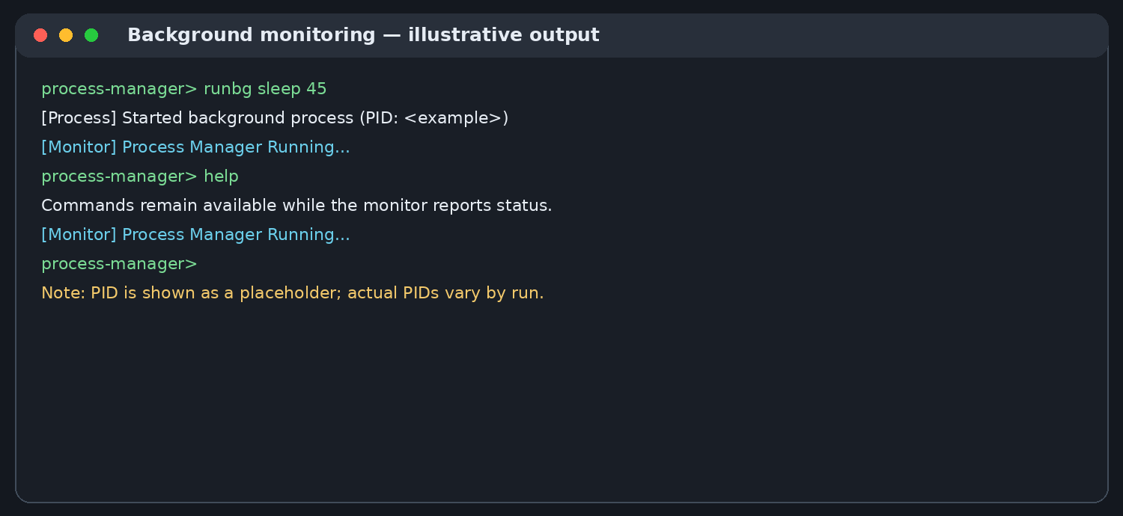
Figure 7.2: Representative background monitoring output (illustrative; process IDs and timing vary).

CHAPTER 3 — KEY SYSTEM CALLS AND LIBRARIES
3.6 Process Creation and Execution
fork() creates a child process. After a successful fork, parent and child continue from the point of the call, with different return values. The child commonly calls an exec-family function such as execvp() to replace its process image with the requested program. If execution succeeds, execvp() does not return to the original child code.
3.7 Waiting for Child Processes
wait() and waitpid() allow a parent to collect child status and coordinate completion. Waiting is especially important for foreground execution and for avoiding unreaped terminated children. Background process handling requires careful consideration of when and how child status is collected.
3.8 Signals
Signals communicate events or control requests. SIGINT is commonly associated with an interrupt, SIGTERM requests termination, SIGKILL forces termination and cannot be caught or ignored, SIGSTOP stops a process, SIGCONT resumes a stopped process, and SIGCHLD informs a parent about child-state changes.
3.9 File Descriptors
open() obtains a file descriptor, dup2() maps a descriptor onto another descriptor, and close() releases a descriptor. Standard input, standard output, and standard error conventionally use descriptors 0, 1, and 2. Correct redirection requires handling errors and closing unused descriptors.
These APIs form a sequence rather than independent features. A child is first created, then the child can replace its process image with the requested program, and the parent can collect its termination status when appropriate. Signals can be used to request a state change or termination, while pipe and file-descriptor calls define how bytes move between processes and files. Correctness depends on checking return values and respecting which process is responsible for each operation. This distinction is especially important when explaining why a child PID differs from its parent PID.

CHAPTER 4 — SYSTEM ARCHITECTURE
4.1 Architectural Overview
The system follows a modular command-line architecture. The user interacts with a terminal prompt. Input handling collects a command, parsing identifies the command and arguments, and the main controller dispatches the request to the relevant module. Process operations manage execution and control, while signal, pipe, redirection, monitoring, and threading modules provide supporting functionality.
High-level flow:
User / Terminal
↓
Input Collection → Command Parser
↓
Command Dispatch in Main Controller
├── Process Management
├── Signal Handling
├── Pipe / IPC Operations
├── I/O Redirection
└── Background Monitor Thread
The diagram is a logical representation of the module responsibilities and should be updated if the implementation is reorganized. It is not intended to imply a networked client-server architecture.
The architecture follows a modular command-line design. The main loop coordinates user interaction, parsing translates text into an operation, and specialized modules perform process operations, signal handling, pipes, redirection, and monitoring. This separation makes it easier to trace a bug to the relevant responsibility and reduces the need to place every feature inside one large source file.
The Linux kernel remains responsible for scheduling processes, maintaining process identifiers, enforcing permissions, and managing file descriptors. The application requests these services through operating-system interfaces; it does not implement its own scheduler or replace the kernel’s process table.

CHAPTER 4 — MODULE DESCRIPTION
4.2 Source and Header Organization
The source tree separates interface declarations and implementation. The include/ directory contains headers such as input.h, monitor.h, parser.h, pipes.h, process.h, redirect.h, signals.h, and thread.h. The src/ directory contains corresponding C implementations and the program entry point.
Representative source files include src/main.c, src/parser.c, src/process.c, src/signals.c, src/pipes.c, src/redirect.c, src/monitor.c, and src/thread.c. The executable is produced at bin/process_manager.
4.3 Separation of Responsibilities
Input collection is kept distinct from parsing so terminal interaction does not need to duplicate tokenization logic. Process-related functions are grouped separately from redirection and pipe handling. Signal functions isolate asynchronous event handling. Thread-related code owns the monitoring thread and synchronization primitives.
4.4 Design Benefits
A modular structure improves readability and localizes defects. A change to redirection can be reviewed in its own module, while the main loop remains responsible for command flow. Header files provide declarations that allow modules to interact through explicit interfaces.
The module boundaries also provide a practical debugging strategy. If the command prompt does not accept a line, the input or main-loop path should be checked first. If the line is accepted but the wrong operation is selected, the parser and dispatch logic are likely places to inspect. If an external command starts but data is not routed correctly, the process, pipe, or redirection module deserves attention. A clear division of responsibility reduces the number of unrelated code paths that need to be inspected at once.

CHAPTER 5 — COMMAND WORKFLOW
5.1 Interactive Session
At startup, the application displays its banner and presents the process-manager> prompt. The user enters a command, the program reads the input, parses the command and arguments, then dispatches the request. Depending on the command, the controller may execute a program, perform a control operation, configure redirection, or return help and status information.
5.2 Process Execution Workflow
A typical execution workflow consists of validating the command, creating a child process where needed, executing the requested program in the child, and handling the parent’s wait behaviour according to foreground/background mode. Error paths should report failed process creation or execution rather than silently treating the operation as successful.
5.3 Foreground and Background Execution
Foreground execution normally waits for the child to finish before returning the prompt. Background execution allows the controller to accept additional input while the launched program continues running. The parent must still account for child completion and status collection.
5.4 Operational Example
The user can run a short command such as pwd or ls to verify basic execution, then use a longer-running program such as sleep to observe foreground/background behaviour. These examples are illustrative and should be executed in a test directory.

CHAPTER 5 — PROCESS STATES AND SIGNAL FLOW
5.5 Process Lifecycle
A process may be created, executing, stopped, continued, or terminated. These states are controlled by the operating system and may be observed through system tools. A process that has terminated but whose parent has not yet collected its status may temporarily appear as a zombie. This is a lifecycle condition rather than a process still executing instructions.
5.6 Signal-Based Control
The controller uses signal mechanisms to request process actions. A stop/resume sequence can be demonstrated using SIGSTOP and SIGCONT; a graceful termination request uses SIGTERM; SIGKILL is reserved for cases where forced termination is necessary. Signals should be sent only to the intended process identifier.
5.7 Parent and Child Coordination
The parent-child relationship is important for tracking completion. waitpid() can wait for a specific child and can be used with options that alter whether the call blocks. A robust implementation should handle interrupted waits and validate returned process identifiers and status values.
5.8 Safety Considerations
Process identifiers can be reused by the operating system, so commands must validate target IDs and provide clear feedback. The user should avoid experimenting with critical system processes. A teaching controller should prefer explicit feedback and conservative defaults.
Process state and signal delivery should be discussed carefully during testing. A signal is a request delivered to a process, not a guarantee that every operation has completed at the exact instant the command is issued. For example, a stopped process can later be continued, while a terminated child may still need to be waited for by its parent. The controller therefore needs to distinguish sending a control signal from collecting process status. Exact state transitions depend on the target program and the timing of operating-system scheduling.

CHAPTER 5 — PIPES AND I/O REDIRECTION
5.9 Inter-Process Communication with Pipes
A pipe provides a unidirectional byte stream between processes. In a command pipeline, the producer’s standard output is connected to the consumer’s standard input. For example, ls | grep src sends directory-listing output to grep, which filters lines containing src.
5.10 Pipe Workflow
A typical pipe implementation creates a pipe, forks the required child processes, duplicates the appropriate pipe ends onto standard input/output, closes unused descriptors, and executes the commands. Closing unused ends is important because open descriptors can prevent readers from observing end-of-file.
5.11 I/O Redirection
The project supports common redirection forms: > to overwrite standard output, >> to append standard output, < to read standard input from a file, and 2> to redirect standard error. The implementation uses file-descriptor operations such as open(), dup2(), and close().
5.12 Redirection Examples
Examples for demonstration include ls > output.txt, echo hello >> output.txt, a program reading from input.txt with <, and redirecting error output with 2> error.txt. Test files should be created in a safe project directory. Exact accepted command syntax depends on the parser implemented in the project.
Pipes and redirection solve related but different problems. A pipe connects the output of one process to the input of another, allowing the receiving process to transform or filter data. Redirection connects a standard stream to a file, which is useful for saving output, supplying repeatable input, or separating error messages from normal output. Both mechanisms rely on file descriptors, so descriptors must be connected to the intended endpoints and closed when no longer needed. The examples in this report are representative; output depends on files and commands available in the execution directory.

CHAPTER 6 — IMPLEMENTATION OVERVIEW
6.1 Implementation Approach
Implementation proceeded incrementally, adding core command handling and process operations before extending the system with signals, pipes, redirection, and monitoring. Each feature was compiled and exercised after integration. This incremental approach makes it easier to identify which module introduced a build or runtime problem.
6.2 Main Controller
src/main.c contains the entry point and interactive control loop. It presents the application prompt, accepts input, and directs parsed commands to the appropriate operation. The main loop should remain responsive and should provide a clear exit path.
6.3 Input and Parser Modules
The input module handles reading user input. The parser module interprets command text and arguments for dispatch. Parsing must distinguish command tokens from operators used for pipes and redirection. Malformed or incomplete input should be rejected or reported rather than passed blindly to execution functions.
6.4 Process Module
The process module encapsulates process creation and related actions. Process APIs should check return values, distinguish parent and child execution paths, and report errors with enough context to support debugging.
The implementation is divided across source and header files so that declarations and operations remain understandable. For example, process-related functions belong in the process module, signal-specific behaviour is isolated in the signal module, and redirection logic is kept separate from the main command loop. Such modularity does not eliminate all coupling, but it makes interfaces explicit and supports focused testing.
Each system call should be treated as an operation that can fail. Invalid PIDs, missing files, permission errors, unsuccessful process creation, and failed descriptor duplication are normal conditions that a robust program must consider. Diagnostic messages and careful return-value checks help distinguish an application defect from an environmental limitation.

CHAPTER 6 — SIGNALS, PIPES, AND REDIRECTION IMPLEMENTATION
6.5 Signal Module
The signal module groups signal-related behaviour and process-control operations. Signal handlers should perform only safe, limited work and avoid relying on non-async-signal-safe operations. More complex processing is generally better handled in the normal control flow after the signal has been recorded.
6.6 Pipe Module
The pipe module supports command communication by connecting file descriptors. The key implementation concerns are creating the pipe before forking, mapping read/write ends correctly, closing descriptors that are not needed by each process, and waiting for the relevant children.
6.7 Redirection Module
The redirection module interprets redirection operators and arranges the appropriate standard descriptors before executing the target program. The file must be opened with flags and permissions that match the operation. Append mode differs from overwrite mode, and standard error uses descriptor 2 rather than descriptor 1.
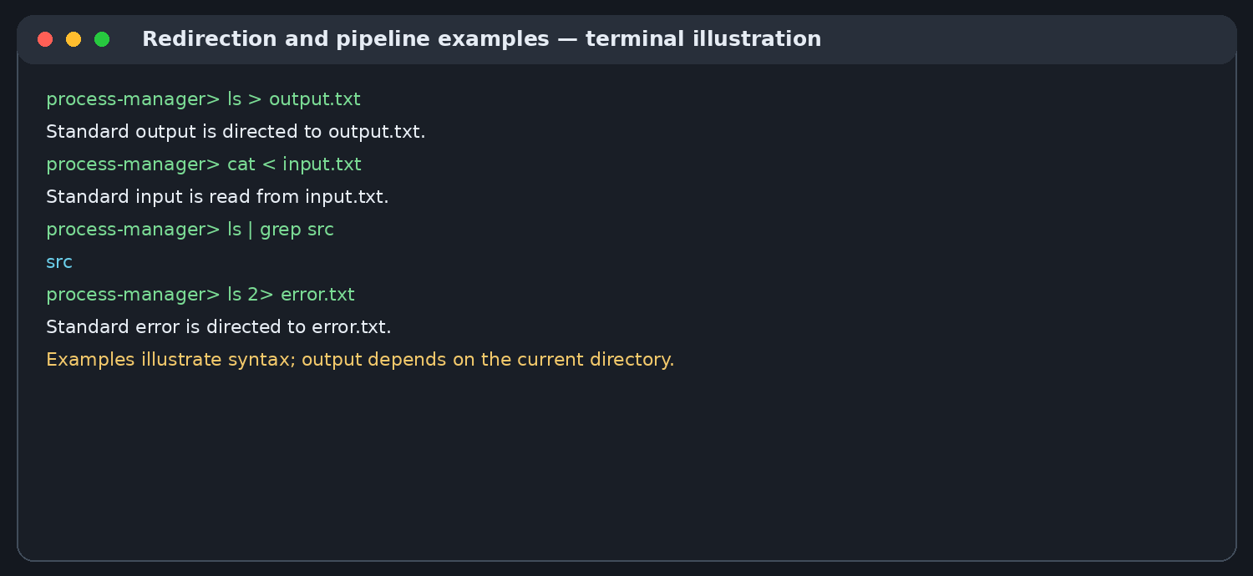
Figure 7.3: Example command patterns for pipes and I/O redirection (illustrative output).
6.8 Error Handling
System calls can fail because of invalid arguments, missing files, insufficient permissions, or resource limits. The implementation should check return values and provide diagnostics. A useful test plan includes both successful operations and expected failures, such as redirecting from a nonexistent input file.
Signal, pipe, and redirection code is sensitive to ordering. A child process should prepare its intended input/output connections before executing the external program. Pipe endpoints that are not used by a process should be closed, because an unused write endpoint can prevent a reader from observing end-of-file. Likewise, signal handlers should do only the work appropriate for signal context and should avoid unsafe operations. These considerations explain why operating-system programming requires more attention to resource ownership and lifecycle than a simple sequential program.

CHAPTER 6 — THREADING AND MONITORING
6.9 Background Monitor
The project includes a monitoring thread that periodically prints a status message while the interactive controller continues accepting commands. The demonstrated message is similar to [Monitor] Process Manager Running... and is emitted at approximately ten-second intervals.
6.10 Thread Creation
pthread_create() starts the monitoring thread. The main thread continues the command loop while the monitor performs its periodic task. A detached thread can release its thread resources automatically when it finishes, but a detached thread should not outlive resources it still needs.
6.11 Mutex Synchronization
A mutex is used to protect shared monitoring state where concurrent access is possible. The usual sequence is lock, access or update the protected data, then unlock. Every successful lock must be paired with an unlock, including error paths where applicable.
6.12 Responsiveness and Limitations
The monitor demonstrates background work without intentionally blocking command entry. Periodic terminal output can still interleave with the prompt, which is a presentation limitation of simple terminal interfaces. A more advanced implementation could coordinate output or use a dedicated status area.

CHAPTER 7 — FEATURES AND OPERATIONS
7.1 Interactive Terminal Interface
The application displays a startup banner and a command prompt. Commands are entered in the terminal and dispatched by the controller. The interactive loop is the central user-facing feature and provides a single place to access the project’s process-management operations.
7.2 Process Launching
The process controller can launch external programs using process creation and execution APIs. A basic smoke test is to execute commands that produce short, predictable output, such as pwd or ls. Longer-running commands can be used to observe waiting and background execution.
7.3 Foreground and Background Operation
Foreground operation keeps the command interaction associated with the running task until the foreground process finishes. Background operation allows the user to issue further commands while a child continues to run. The user should keep track of process identifiers when performing control operations.
7.4 Process Information and Control
The project includes process information and control actions represented by commands such as INFO, PAUSE, RESUME, TERMINATE, and KILL, along with normal execution and background execution commands. The exact argument order should be followed from the implementation’s help output.
The features are designed to complement one another. Process execution creates work for the operating system; process information and control operations let the user inspect or influence that work; signals communicate control requests; and pipes or redirection change how data flows between commands and files. The monitoring thread adds a periodic status message without replacing the main command loop.
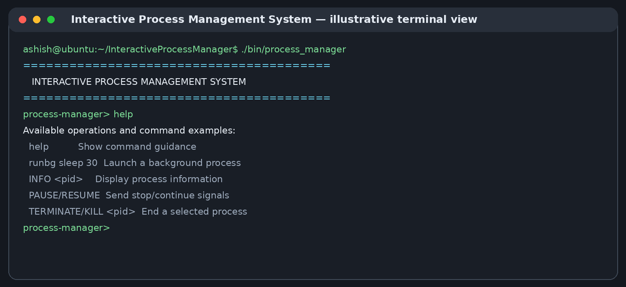
Figure 7.1: Representative terminal interface and help command (illustrative, not a captured live session).
Feature availability should be understood within the implemented command set. The controller is an educational project and should not be assumed to support every syntax rule, quoting rule, job-control convention, or shell expansion provided by Bash. Users should consult the help output and project guide for the operations supported by this version.

CHAPTER 7 — SIGNALS, IPC, REDIRECTION, MONITORING
7.5 Signal Handling Feature
Signals provide the control mechanism for stopping, continuing, or terminating a process. The project demonstrates signal-related concepts and child-state notifications. The distinction between a termination request (SIGTERM) and forced termination (SIGKILL) is important when explaining the implementation.
7.6 Pipe Feature
Pipes allow one process to consume another process’s output. Examples such as ls | grep src, ls | wc, and pwd | wc demonstrate producer-consumer communication. These examples should be run from the project directory to make the output easy to interpret.
7.7 Redirection Feature
Redirection supports overwriting output, appending output, reading input from a file, and redirecting error output. The use of dup2() illustrates how a process’s standard streams can be connected to files without changing the program’s normal output calls.
7.8 Background Monitoring Feature
The monitor thread periodically reports that the process manager is running. This demonstrates concurrency and synchronization with POSIX threads. The main loop remains available for user commands while the monitoring thread continues its periodic activity.
The user-facing benefit of combining these features is that a single session can demonstrate multiple concepts without requiring separate example programs for every topic. A user can launch work, observe process behaviour, send a control signal, and examine how output is directed. The monitoring thread provides a periodic status message while the main thread remains available for commands. The monitor message is a simple liveness indicator rather than a detailed CPU or memory profiler, and the report keeps that distinction explicit.

CHAPTER 8 — TESTING STRATEGY
8.1 Testing Objectives
Testing was used to check that the controller compiles, starts, accepts commands, executes programs, and integrates process control, pipes, redirection, and monitoring. The tests are functional checks rather than a formal performance benchmark.
8.2 Build Verification
A representative build command is:
gcc -Wall -Wextra -g -pthread -Iinclude src/*.c -o bin/process_manager
The compiler output should be reviewed for errors and warnings. A successful build is followed by running ./bin/process_manager and checking that the banner and prompt appear.
8.3 Functional Smoke Tests
The initial tests use simple commands with predictable output. The tester should confirm that the prompt returns after foreground completion, that background tasks do not prevent further command entry, and that invalid input produces understandable feedback.
8.4 Integration Testing
Integration checks verify that parsing and dispatch work with process execution, that pipes connect output to input, that redirection affects the intended descriptor, and that the monitoring thread does not stop the command loop. Tests should be repeated after code changes.
Testing should cover both successful operations and predictable failure cases. Useful checks include launching a short command, running a background task, inspecting a process, sending a control signal, reading from a file, writing to a file, and piping output through a simple filter. Repeating a test after rebuilding helps verify that the observed behaviour is not caused by an older binary.
The recorded Valgrind run reported zero bytes in use at exit and zero errors for that execution. This is useful evidence about the tested path, but it does not prove that every input, external program, or error condition is free of memory problems. Broader validation requires running additional commands and examining their outputs.
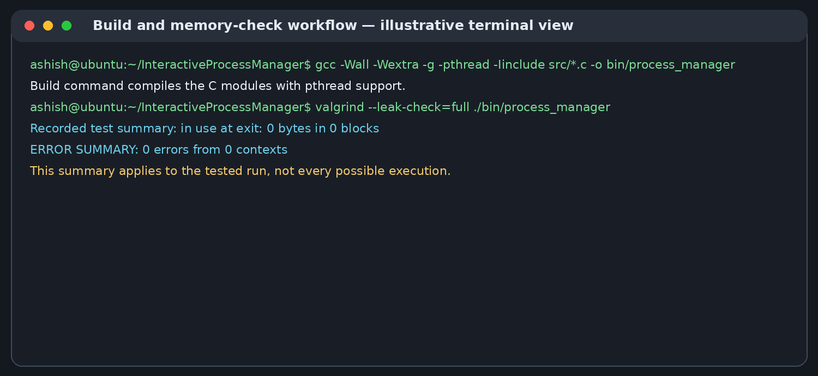
Figure 8.1: Representative build and memory-check workflow using the recorded test summary.

CHAPTER 8 — TEST CASES AND RESULTS
8.5 Representative Test Matrix
Test case 1 — Application startup: launch ./bin/process_manager; expected result: startup banner and interactive prompt.
Test case 2 — External command: execute a short command such as pwd; expected result: command output and return to prompt.
Test case 3 — Background command: launch a longer-running task in background; expected result: prompt remains available.
Test case 4 — Pipe: run ls | grep src; expected result: filtered listing reaches the consumer.
Test case 5 — Output redirection: run a command with >; expected result: output is written to the target file.
Test case 6 — Append redirection: use >>; expected result: new output is appended.
Test case 7 — Input redirection: use <; expected result: the program reads from the specified file.
Test case 8 — Error redirection: use 2>; expected result: standard error is redirected to the specified file.
8.6 Monitoring and Memory Checks
The background monitor was observed printing periodically while commands such as runbg and help remained usable. A Valgrind run reported in use at exit: 0 bytes in 0 blocks, all heap blocks freed, and ERROR SUMMARY: 0 errors from 0 contexts for the tested run.
8.7 Interpretation
These results support the basic functional behaviour exercised during development. They should not be interpreted as proof of complete correctness under every input, every operating-system condition, or every possible concurrent process state.
A test matrix is most useful when it records the command, the expected behaviour, the observed result, and any environmental assumptions. Process identifiers should be treated as variable values rather than fixed constants, and tests should use short-lived commands where possible. Redirection tests should verify the resulting file contents, not merely that the command returned to the prompt. Signal tests should confirm the target process and its resulting state. Negative tests, such as an invalid PID or unavailable input file, help reveal whether error paths remain understandable.

CHAPTER 9 — BUILD AND EXECUTION
9.1 Project Directory
The project directory used during development is ~/InteractiveProcessManager. The relevant directories are src/ for C source files, include/ for header files, and bin/ for the compiled executable. Additional directories may include documentation and screenshots.
9.2 Compile the Application
From the project root, compile the source files with:
gcc -Wall -Wextra -g -pthread -Iinclude src/*.c -o bin/process_manager
If the bin directory does not exist, create it before compiling with mkdir -p bin. Compilation should be repeated after source changes. The -pthread option is necessary for the thread-enabled version.
9.3 Run the Application
Start the application with:
./bin/process_manager
The program should display its banner and the process-manager> prompt. Use the built-in help output or project-specific command guidance to confirm accepted command syntax.
9.4 Version Control
Git can be used to inspect changed files with git status, stage intentional changes with git add, create a descriptive commit, and push to the configured remote. Generated binaries and test output files should be included only if the project’s version-control policy calls for them.

CHAPTER 9 — USER ENVIRONMENT AND REPRODUCIBILITY
9.5 Reproducing a Basic Test Session
A basic reproducibility sequence is: open the Ubuntu terminal; navigate to the project root; compile the source; launch the executable; run a short command; exercise one process-control operation; test a pipe; test redirection; observe the monitoring thread; then exit and inspect any generated files.
9.6 Test Files
The redirection tests may use files such as input.txt, output.txt, and error.txt. Keep these in the project directory or another controlled test location. Inspect the contents after each operation to confirm overwrite and append behaviour.
9.7 Diagnostic Tools
Compiler warnings are useful signals during development. For example, warnings about unused signal parameters can be resolved by explicitly marking the parameters unused or by using them where appropriate. Valgrind complements compiler diagnostics by detecting certain runtime memory errors.
9.8 Reproducibility Notes
Results depend on the commands available on the host system and the permissions of the user running the controller. For academic demonstrations, use short, safe commands and keep test files separate from important personal or system files.
For a demonstration, begin with a clean terminal, navigate to the repository root, and compile the current source files before launching the binary. Keep test files in the project directory so that relative paths in redirection examples are easy to follow. Use short commands that finish quickly and avoid assuming that process IDs or monitor timing will be identical on another machine. If the build fails, fix the earliest compiler error and rebuild before proceeding; if a runtime test behaves unexpectedly, record the command and relevant output for later diagnosis.

CHAPTER 10 — CHALLENGES AND LIMITATIONS
10.1 Parsing and Command Structure
Command parsing becomes more complicated when operators such as pipes and redirection are included. A parser must distinguish operators from ordinary arguments and preserve the intended order of operations. Inconsistent tokenization can cause valid commands to be rejected or arguments to be passed incorrectly.
10.2 Process Lifecycle Management
Foreground and background execution have different waiting requirements. Failing to collect child status can leave zombie processes, while waiting in the wrong place can block the prompt. The parent must balance responsiveness with correct child lifecycle management.
10.3 Signal Handling
Signals are asynchronous and have rules about which operations are safe inside handlers. A handler that performs too much work or uses unsafe library calls can create unpredictable behaviour. Signal handling must also account for the fact that some signals cannot be caught or ignored.
10.4 Descriptor Management
Pipes and redirection create additional file descriptors. Every process must close unused descriptors, and the code must handle failures from open(), pipe(), dup2(), and close(). A leaked pipe end can prevent a reader from receiving end-of-file.
One challenge in process management is that parent and child processes execute independently after creation. Signal timing, process termination, and waiting behaviour can therefore differ between runs. Tests should use short, controlled commands and avoid assuming that a particular PID or exact timing will always recur.
Another challenge is handling file descriptors safely. Redirection changes where standard input or output is connected, so descriptors should be opened with appropriate flags, duplicated to the intended standard descriptor, and closed when no longer required. Incorrect cleanup can cause resource leaks or unexpected output routing.

CHAPTER 10 — SOLUTIONS AND KNOWN LIMITATIONS
10.5 Debugging and Build Corrections
During development, compiler errors were corrected iteratively. One example was a missing semicolon after pthread_mutex_unlock(&monitor_lock) in the thread module. Recompiling after the correction confirmed that the syntax issue was resolved.
10.6 Monitoring Output
A periodic monitor message can appear while the user is typing. This is an expected limitation of a simple terminal UI unless output is coordinated with the input line. The monitor demonstrates concurrency but is not a full terminal dashboard.
10.7 Scope Limitations
The controller is an educational application and should not be described as a complete shell replacement. Advanced shell grammar, job-control terminal groups, command substitution, quoting rules, pipelines of arbitrary length, environment management, and robust signal forwarding may require further work depending on the implemented command set.
10.8 Security and Robustness
The controller executes programs with the privileges of the user who launched it. It is not a sandbox. Users should not run untrusted commands or use process-control functions against system-critical processes. Production use would require broader validation, privilege boundaries, and extensive testing.
The development process illustrates the value of incremental correction. Compiler diagnostics can point to a missing punctuation mark or mismatched declaration, while runtime testing can expose incorrect assumptions about process state or file descriptors. After fixing a defect, the affected feature should be retested along with nearby functionality, because changes to shared headers or dispatch code can affect more than one command. The current project remains an educational implementation and should not be presented as a fully compatible shell or as a security boundary for untrusted workloads.

CHAPTER 11 — FUTURE ENHANCEMENTS
11.1 Resource Monitoring
A future version could display CPU and memory statistics for managed processes, using suitable Linux interfaces. Metrics should be labelled with their sampling interval and limitations so that users do not confuse periodic samples with exact instantaneous measurements.
11.2 Process Tree Visualization
A process-tree view could show parent-child relationships and process identifiers. This would help explain process creation, reparenting, and lifecycle changes.
11.3 Improved Job Control
Future work could add stronger job-control semantics, process groups, terminal foreground ownership, and improved Ctrl+C/Ctrl+Z forwarding. These features require careful handling of terminal and signal behaviour.
11.4 Better Parser and Error Reporting
A more complete parser could support quoted arguments, escaped characters, multiple pipeline stages, and clearer diagnostics for malformed input. Parser tests could be automated to cover edge cases.
Future work could add a structured process table, clearer exit-status reporting, command history, improved parsing of quoted arguments, and more complete job-control support. These enhancements should be implemented incrementally and tested against a written specification so that new behaviour does not destabilize the existing command loop.
Other possible extensions include configurable monitoring intervals, richer process metrics, automated regression tests, and a documented set of examples. These are proposed improvements, not claims about the current implementation. Any addition should preserve the project’s educational focus and explain the underlying operating-system mechanism.

CHAPTER 11 — EXTENSIBILITY AND IMPROVEMENTS
11.5 Structured Logging
The system could record process launch, exit, and control events in a structured log. Logs should avoid claiming persistence unless they are written to a file and should handle log rotation if they grow over time.
11.6 Monitoring Interface
A terminal UI could separate status output from command input, reducing interference between the monitor thread and the user’s prompt. Another option is a single-threaded event loop that schedules periodic updates.
11.7 Build Automation
A Makefile could provide consistent all, clean, and debug targets and make compiler flags explicit. Automated tests could compile the project and run controlled test cases on each change.
11.8 Documentation
The project can be improved with a complete command reference, module-level comments, a test log, architecture diagrams, and a troubleshooting guide. Documentation should distinguish implemented functionality from planned enhancements.
A maintainable extension should have a clear user-facing purpose, a defined interface, and tests that demonstrate its expected behaviour. For example, structured logging would need a consistent event format and careful treatment of process identifiers and timestamps. A process table would need a strategy for refreshing state and distinguishing processes that have exited. More advanced parsing would require explicit rules for quotes, escapes, operators, and malformed input. Planning these details first reduces the chance of adding features that work only for one demonstration command.

CHAPTER 12 — CONCLUSION
12.1 Summary
The Interactive Process Management System demonstrates a collection of Linux operating-system concepts through a terminal-based process controller. Its modules cover interactive input, parsing, process execution and control, signals, pipes, I/O redirection, and a POSIX background monitoring thread.
12.2 Achievements
The project was compiled using GCC in an Ubuntu/Linux environment. The team integrated the major modules and tested representative commands. Foreground/background behaviour, pipe-based command communication, redirection operations, and periodic monitor output were exercised. A Valgrind run reported zero errors and no bytes remaining in use at exit for the tested path.
12.3 Learning Outcomes
The work strengthened practical understanding of process creation, execution replacement, waiting, signal semantics, file descriptors, IPC, thread creation, mutex synchronization, compilation, debugging, memory checking, and version control. It also highlighted the importance of checking system-call return values and testing interactions among modules.
12.4 Final Remarks
The result is an educational platform that connects operating-system theory with practical C programming. The system can be extended with richer job control, resource monitoring, improved parsing, and automated testing while retaining its modular structure.
The project brings together several important systems-programming ideas in one compact application. Its value is not measured only by the number of commands; it also comes from exposing how process creation, waiting, signals, pipes, file descriptors, and threads interact. The implementation offers a practical base for demonstrations, code review, and future coursework.
Through development, the team gained experience with compiling multiple C modules, interpreting compiler diagnostics, coordinating source changes, testing process behaviour, and using a memory-checking tool. These skills are transferable to other Linux utilities and low-level software projects.

REFERENCES
The following technical references provide background for the operating-system and programming interfaces used in the project. They are not substitutes for the source code and behaviour of the implemented system.
1. The Open Group, *The Open Group Base Specifications, Issue 7 (POSIX.1-2017)*, process, signal, file, and thread interfaces. https://pubs.opengroup.org/onlinepubs/9699919799/
2. Linux man-pages project, fork(2), exec(3), wait(2), waitpid(2), signal(7), pipe(2), dup2(2), open(2), and pthread_create(3). https://man7.org/linux/man-pages/
3. GNU Compiler Collection, GCC documentation. https://gcc.gnu.org/onlinedocs/
4. Valgrind Developers, Valgrind User Manual. https://valgrind.org/docs/manual/
5. GNU Project, GNU Bash Reference Manual, for general shell and pipeline concepts. https://www.gnu.org/software/bash/manual/
6. Git documentation, reference manual. https://git-scm.com/doc
7. Linux kernel documentation, process and scheduling-related material. https://docs.kernel.org/
The report uses these references for API terminology and conceptual descriptions. Implementation-specific statements are based on the project structure and the development/testing details available for this project.

APPENDIX A — USER GUIDE
A.1 Start the Program
Open an Ubuntu/Linux terminal and change to the project directory. Compile the program, if necessary, using the command documented in Chapter 9. Run ./bin/process_manager and wait for the interactive prompt.
A.2 Explore Commands
Use the program’s help facility to review the exact supported syntax. The command names used during project work include normal execution, background execution (runbg), help, process information, pause, resume, terminate, and kill operations. Use the syntax displayed by the program rather than guessing argument order.
A.3 Try a Pipe
Use a short pipeline such as ls | grep src to observe how the output of one process is passed to another. The result depends on the files present in the current directory.
A.4 Try Redirection
Use > to overwrite a test output file, >> to append, < to read from an input file, and 2> to redirect error output. Inspect the resulting files after each operation.
--- Troubleshooting ---
A.5 Compilation Fails
Read the first compiler error carefully. Later errors may be consequences of the first one. Confirm that source files contain only C code and do not include Markdown code fences. Re-run the documented GCC command after corrections.
A.6 Thread Link or Build Problems
Ensure the build command includes -pthread for the POSIX thread implementation. Check for missing semicolons, mismatched braces, and declarations that do not match header files.
A.7 Redirection Does Not Work
Confirm that the parser recognizes the operator, that the target directory is writable, and that the open flags match overwrite or append behaviour. Inspect the file after running the command.
A.8 Process Does Not Stop
Confirm that the PID identifies the intended process and that the current user has permission to signal it. SIGKILL cannot be caught or handled by the target process, but it should be used cautiously. Never experiment on critical system processes.

APPENDIX B — REPRESENTATIVE COMMANDS AND BUILD
B.1 Build
gcc -Wall -Wextra -g -pthread -Iinclude src/*.c -o bin/process_manager
B.2 Run
./bin/process_manager
B.3 Representative demonstrations
Representative demonstrations (run only commands supported by the current build):
1. pwd — inspect the current directory
2. ls | grep src — demonstrate a pipe
3. ls > output.txt — redirect standard output to a file
4. echo hello >> output.txt — append output to a file
5. Use < input.txt with a command that reads standard input
6. Use 2> error.txt to redirect standard error
7. Launch a long-running command in the background and observe monitor output
These examples illustrate the concepts and may need to be entered through the controller’s supported syntax. The controller is not assumed to implement every feature of Bash’s grammar.
--- Module Map and Project Summary ---
B.4 Representative Project Structure
InteractiveProcessManager/
├── include/
│ ├── input.h
│ ├── monitor.h
│ ├── parser.h
│ ├── pipes.h
│ ├── process.h
│ ├── redirect.h
│ ├── signals.h
│ └── thread.h
├── src/
│ ├── main.c, input.c, parser.c, process.c
│ ├── signals.c, pipes.c, redirect.c
│ └── monitor.c, thread.c
└── bin/
└── process_manager
B.5 Project Summary
Project: Interactive Process Management System
Type: Terminal-based Linux process controller
Language: C
Environment: Ubuntu/Linux
Build: GCC with POSIX thread support
Core concepts: processes, signals, pipes, file descriptors, redirection, threads, mutexes
Memory check: Valgrind reported zero errors and zero bytes in use at exit for the recorded test run.
Prepared by the student team listed on the cover page.
Department of Artificial Intelligence and Data Science

