Alfresco Share: User interface to allow user to interact with their content n managed by A.U

dashboard:

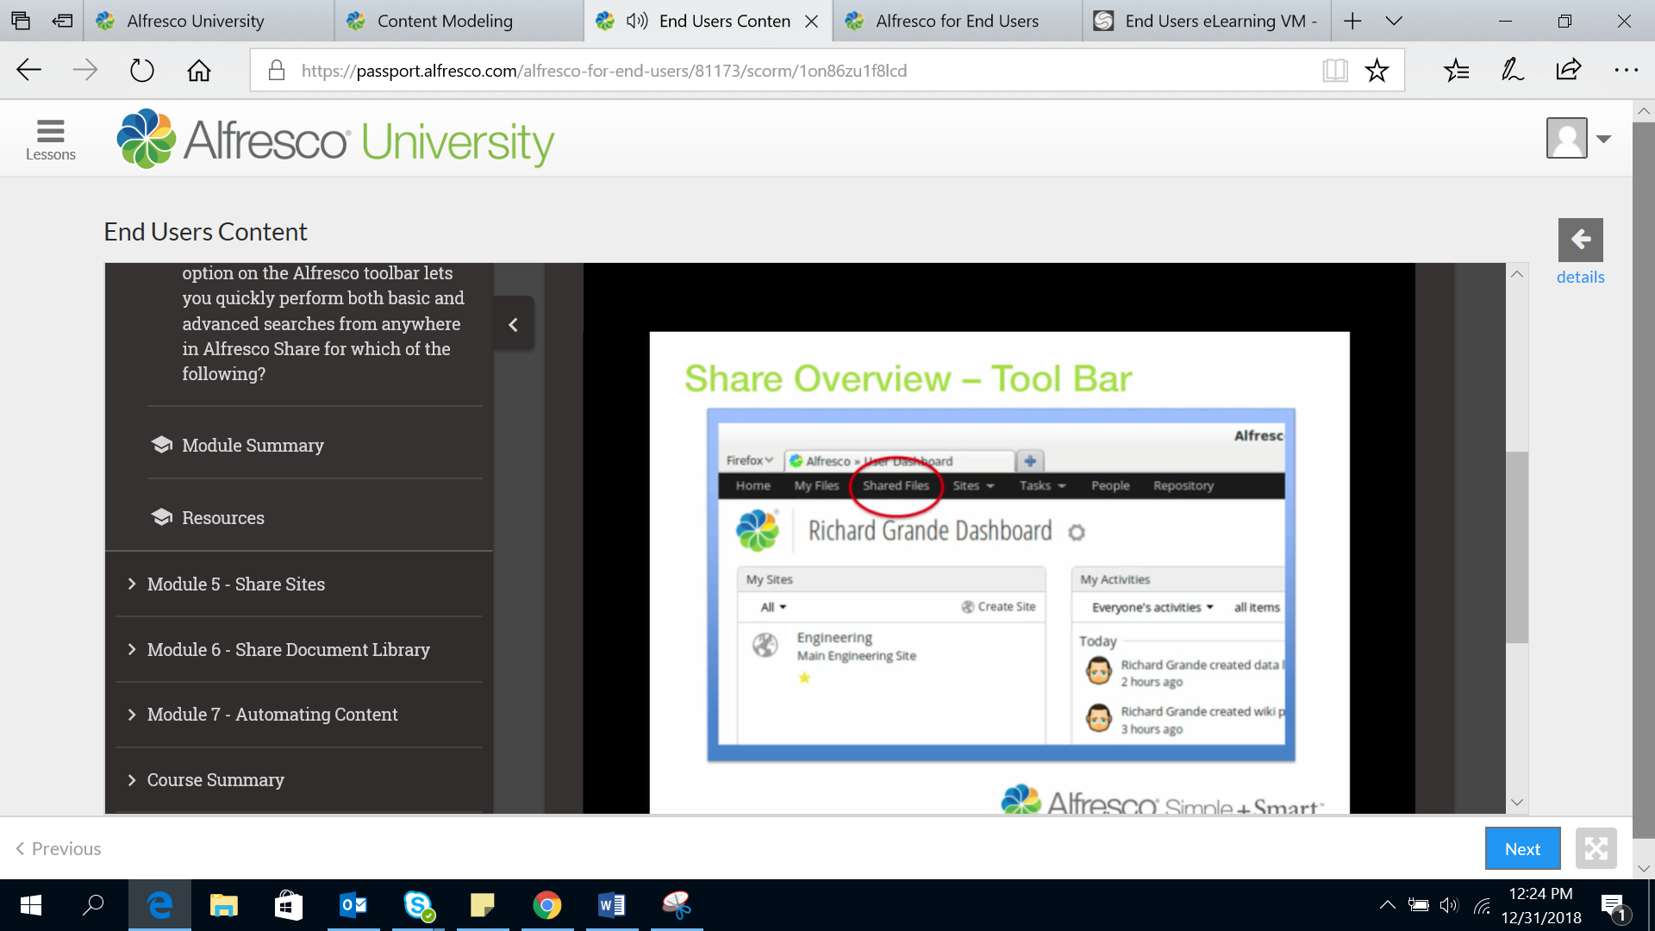

My files:where user can store their data and keep it as private where no user can access it

Shared file: where u can store and share data globally like drive

Sites: are project area where u can share ur content with other site members

Task: to keep track of data

People: Where we can search n find any alfresco users

Reposatory:Show all the repository where user have access to work.

\*We can also configure our dashboard.

Each section on dashboard are known as Dashlets and we can manage them as per our requirement