Date: -10.11.2022

Program: -To perform Selection Sorting.

#include<stdio.h>

#define SIZE 10

void selection_sort(int[],int);

int main()

{

int a[SIZE],n,i;

printf("enter how many elements:");

scanf("%d",&n);

for(i=0;i<n;i++)

{

printf("enter element %d:",i+1);

scanf("%d",&a[i]);

}

selection_sort(a,n);

for(i=0;i<n;i++)

printf("%d\n",a[i]);

return 0;

}

void selection_sort(int a[],int n)

{

int minpos;

int i,j,t;

for(i=0;i<n-1;i++)

{

minpos=i;

for(j=i+1;j<n;j++)

{

if(a[minpos]>a[j])

{

minpos=j;

}

}

if(minpos!=i)

{

t=a[i];

a[i]=a[minpos];

a[minpos]=t;

}

}

}

Output: -

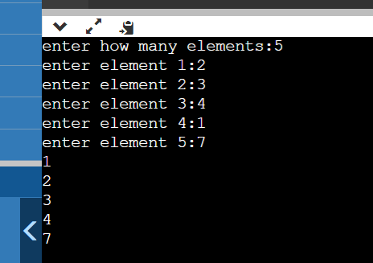

Program: - To perform Insertion Sorting

#include<stdio.h>

#define SIZE 10

void insertion_sort(int [],int);

int main()

{

int a[SIZE],i,n;

printf("enter how many elements:");

scanf("%d",&n);

for(i=0;i<n;i++)

{

printf("enter element %d:",i+1);

scanf("%d",&a[i]);

}

insertion_sort(a,n);

for(i=0;i<n;i++)

printf("%d\n",a[i]);

return 0;

}

void insertion_sort(int a[],int n)

{

int i,j,item;

for(i=1;i<n;i++)

{

item=a[i];

for(j=i-1;j>=0&&a[j]>item;j--)

a[j+1]=a[j];

a[j+1]=item;

}

}

Output: -

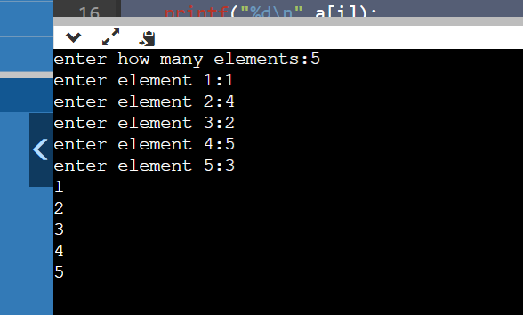

Program: - To perform Quick Sorting.

#include<stdio.h>

#define SIZE 10

int partition(int [],int,int);

void quick_sort(int [],int,int);

int main()

{

int a[SIZE],n,i;

printf("enter how many elements:");

scanf("%d",&n);

for(i=0;i<n;i++)

{

printf("enter element %d:",i+1);

scanf("%d",&a[i]);

}

quick_sort(a,0,n-1);

for(i=0;i<n;i++)

printf("%d\n",a[i]);

return 0;

}

int partition(int a[],int lb,int ub)

{

int down,up,t,pivot;

down=lb;

up=ub;

pivot=a[lb];

while(down<up)

{

while(a[down]<=pivot&&down<up)

down++;

while(a[up]>pivot)

up--;

if(down<up)

{

t=a[down];

a[down]=a[up];

a[up]=t;

}

}

a[lb]=a[up];

a[up]=pivot;

return(up);

}

void quick_sort(int a[],int lb,int ub)

{

int mid;

if(lb>=ub)

return;

mid=partition(a,lb,ub);

quick_sort(a,lb,mid-1);

quick_sort(a,mid+1,ub);

}

Output: -

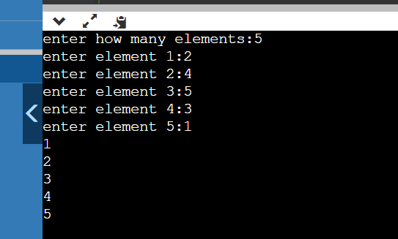

Program: - To perform Heap Sorting.

#include<stdio.h>

#define SIZE 10

void insheap(int[],int,int);

int delheap(int[],int);

void heapsort(int[],int);

int main()

{

int a[SIZE],i,n;

printf("enter how many elements:");

scanf("%d",&n);

for(i=0;i<n;i++)

{

printf("enter element%d:",i+1);

scanf("%d",&a[i]);

}

heapsort(a,n);

for(i=0;i<n;i++)

printf("%d\n",a[i]);

return 0;

}

void insheap(int tree[],int n,int item)

{

int ptr,par;

n++;

ptr=n;

while(ptr>0)

{

par=(ptr-1)/2;

if(item<=tree[par])

{

tree[ptr]=item;

return;

}

tree[ptr]=tree[par];

ptr=par;

}

tree[0]=item;

}

int delheap(int tree[],int n)

{

int item,ptr,last,left,right;

item=tree[0];

last=tree[n];

ptr=0;

left=1;

right=2;

while(right<=n)

{

if(last>=tree[left]&&last>=tree[right])

{

tree[ptr]=last;

return(item);

}

if(tree[right]<=tree[left])

{

tree[ptr]=tree[left];

ptr=left;

}

else

{

tree[ptr]=tree[right];

ptr=right;

}

left=2*ptr+1;

right=left+1;

}

if(left==n-1&&last<tree[left])

{

tree[ptr]=tree[left];

ptr=left;

}

tree[ptr]=last;

return(item);

}

void heapsort(int a[],int n)

{

int item,j;

for(j=0;j<n-1;j++)

insheap(a,j,a[j+1]);

while(n>0)

{

item=delheap(a,n-1);

a[n-1]=item;

n--;

}

}

Output:-

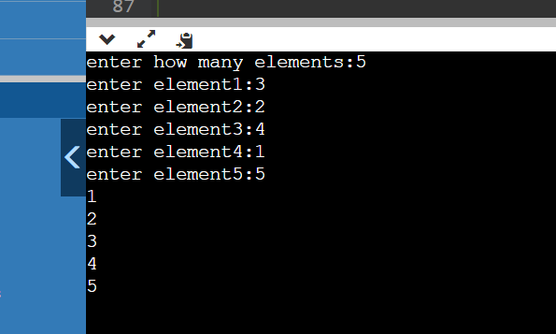

Program: -To perform Shell Sorting

#include<stdio.h>

#define SIZE 10

void shell_sort(int[],int);

void main()

{

int a[SIZE],i,n;

printf("enter how many elements:");

scanf("%d",&n);

for(i=0;i<n;i++)

{

printf("enter element %d:",i+1);

scanf("%d",&a[i]);

}

shell_sort(a,n);

for(i=0;i<n;i++)

printf("%d\n",a[i]);

}

void shell_sort(int a[],int n)

{

int i,j,item,span;

span=n/2;

while(span>=1)

{

for(i=span;i<n;i++)

{

item=a[i];

for(j=i-span;j>=0&&a[j]>item;j-=span)

a[j+span]=a[j];

a[j+span]=item;

}

span=span/2;

}

}

Output:

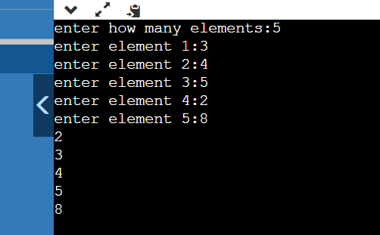

Program: - To perform Merge Sorting.

#include<stdio.h>

#include<stdlib.h>

void merge(int a[],int ub,int mid,int lb)

{

int i,j,k;

int n1=mid-ub+1;

int n2=lb-mid;

int leftarray[n1],rightarray[n2];

for (int i = 0; i < n1; i++)

leftarray[i] = a[ub + i];

for (int j = 0; j < n2; j++)

rightarray[j] = a[mid + 1 + j];

i = 0,

j = 0;

k = ub;

while (i < n1 && j < n2)

{

if(leftarray[i] <= rightarray[j])

{

a[k] = leftarray[i];

i++;

}

else

{

a[k] = rightarray[j];

j++;

}

k++;

}

while (i<n1)

{

a[k] = leftarray[i];

i++;

k++;

}

while (j<n2)

{

a[k] = rightarray[j];

j++;

k++;

}

}

void mergeSort(int a[], int ub, int lb)

{

if (ub < lb)

{

int mid = (ub + lb) / 2;

mergeSort(a, ub, mid);

mergeSort(a, mid + 1, lb);

merge(a, ub, mid, lb);

}

}

void printArray(int a[], int n)

{

int i;

for (i = 0; i < n; i++)

printf("%d ", a[i]);

printf("\n");

}

int main()

{

int a[] = { 12, 31, 25, 8, 32, 17, 40, 42 };

int n = sizeof(a) / sizeof(a[0]);

printf("Before sorting array elements are - \n");

printArray(a, n);

mergeSort(a, 0, n - 1);

printf("After sorting array elements are - \n");

printArray(a, n);

return 0;

}

Output: -

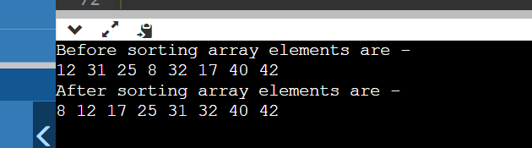

**PRACTICAL FILE**

**ON**

**Data Structure Using C**

**[CSIT124]**



**SUBMITTED TO: SUBMITTED BY:**

**Ms. Neetu Narayan Name: Ashish Gupta**

**ASSOCIATE PROFESSOR Enrolment No.: A2305221299**

**B.Tech. 3CSE6X**

**COMPUTER SCIENCE AND ENGINEERING**

**AMITY SCHOOL OF ENGINEERING &TECHNOLOGY**

**AMITY UNIVERSITY, UTTAR PRADESH**

**SESSION- 2022-2023**