Trader Performance & Bitcoin Market Sentiment
An Analysis of Hyperliquid Trading Behavior Across Fear & Greed Regimes
Prepared for: Primetrade.ai — Data Science Hiring Assignment
Dataset window: Jan 19, 2024 – May 1, 2025 | 34,589 trade fills | 8 accounts | 127 traded assets

1. Executive Summary
This report examines how trader profitability, activity, and risk-taking on Hyperliquid vary with Bitcoin market sentiment, measured by the Fear & Greed Index. Daily sentiment classifications were merged with 34,589 individual trade fills from 8 accounts spanning January 2024 through May 2025, yielding 17,371 closed trades with non-zero realized PnL.
Three findings stand out:
- Fear pays more per trade, but less often. Win rates climb steadily from Extreme Fear (71.8%) to Neutral/Greed (~94-95%), yet the average profit per trade in Fear and Extreme Fear regimes is 2-6x larger than in Greed or Extreme Greed. Traders take fewer, larger, higher-conviction bets when the market is scared — and those bets pay off disproportionately when they land.
- Shorting fear is the single most profitable pattern in the dataset. Short positions closed during Fear generated $1.29M in PnL from just 1,839 trades (avg. $701/trade) — more than any other sentiment/direction combination, including all of Extreme Greed combined.
- Activity itself is contrarian. Traders execute far more trades per active day during Fear (135/day) than during Greed (71/day) or Extreme Greed (76/day), despite Fear covering fewer calendar days in the sample. Total trading volume is also highest during Fear ($275M) and lowest during Extreme Fear ($15.8M), suggesting extreme panic freezes activity while moderate fear invites it.

2. Data & Methodology

2.1 Datasets
- Bitcoin Market Sentiment Dataset — daily Fear & Greed Index classification and numeric score (Extreme Fear, Fear, Neutral, Greed, Extreme Greed), Feb 2018 – May 2025.
- Hyperliquid Historical Trader Data — 34,589 trade-level fills across 8 accounts and 127 coins, including execution price, size, side, direction (open/close, long/short), realized PnL, fees, and timestamps.

2.2 Processing
- Trade timestamps were converted to calendar dates (IST) and left-joined to the daily sentiment classification. Only 6 of 34,589 rows (0.02%) had no matching sentiment date and were excluded from sentiment-based aggregates.
- "Closed trades" are the 17,371 fills with a non-zero Closed PnL value; fills with zero PnL are typically position-opening trades and are used only for volume/activity metrics, not profitability metrics.
- Trades are tagged Long or Short based on the Direction field ("Open Long"/"Close Long" → Long; "Open Short"/"Close Short" → Short). Closed trades with a "Sell" or "Auto-Deleveraging" direction (1,048 rows, 6.0% of closed trades) are spot-style fills without an explicit long/short tag and are excluded from the Section 4 long/short split. These are heavily concentrated in the Neutral sentiment period (898 of the 1,048, representing 31% of Neutral's closed trades and about $203K — roughly a third — of Neutral's total PnL), so the Neutral long/short figures in Section 4 should be read as directional trades only, not Neutral's full profit picture.

3. Profitability by Market Sentiment
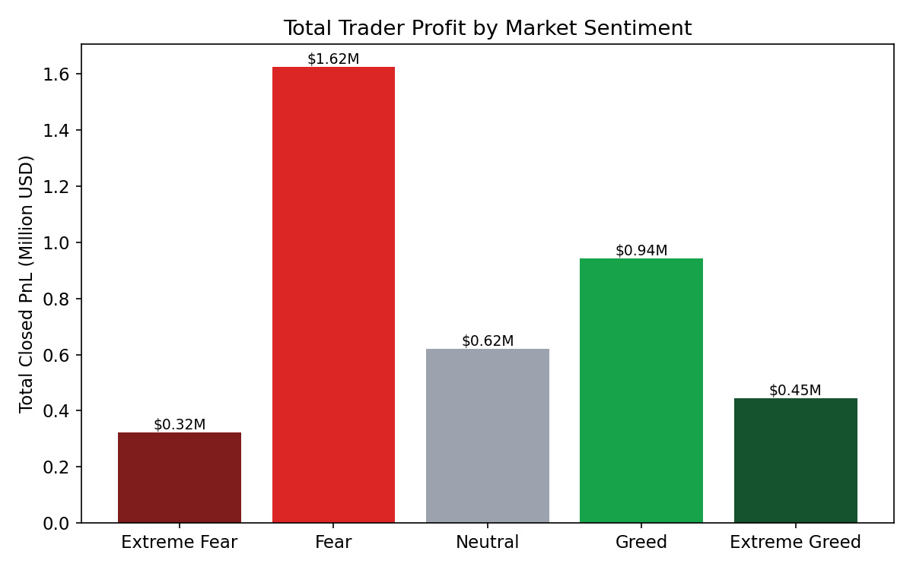
Fear produced the largest aggregate profit pool by a wide margin: $1.62M in total closed PnL, more than the next two sentiment regimes (Greed and Neutral) combined. Extreme Fear, despite far lower trading volume, still generated $323K — a strong return relative to the capital deployed.
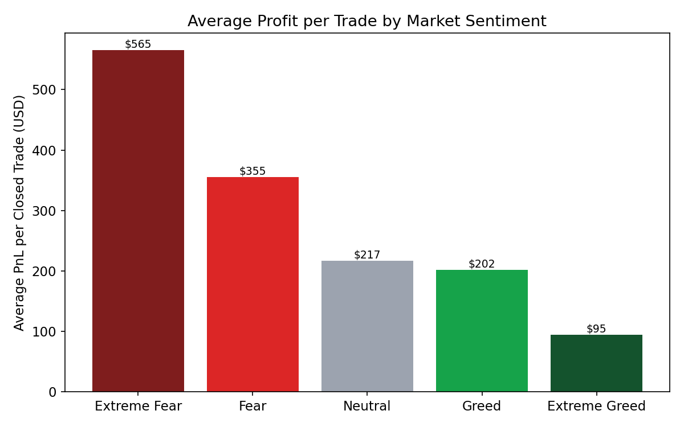
Average profit per closed trade tells a sharper story: Extreme Fear trades average $565 in profit, more than five times the $95-$217 average seen in Greed, Neutral, and Extreme Greed. This is consistent with fear-driven markets producing fewer but higher-conviction, higher-payoff trades — likely a mix of contrarian entries and volatility-driven price swings that reward correctly-timed positions handsomely.
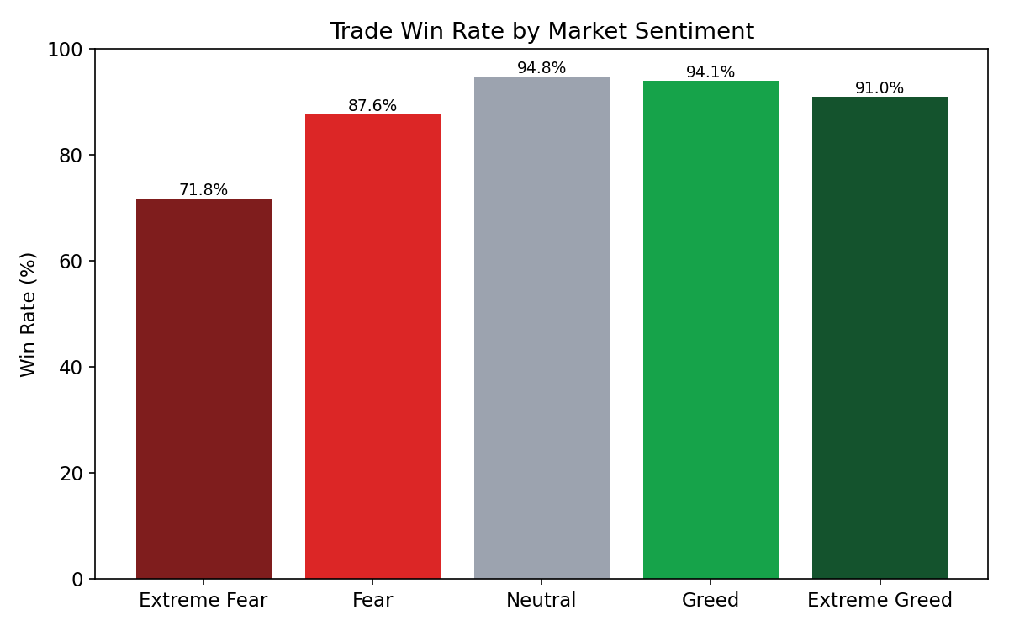
Win rate moves in the opposite direction of average payoff. Extreme Fear has the lowest win rate (71.8%) of any regime, while Neutral (94.8%) and Greed (94.1%) traders win most of the time but for smaller amounts. This is a classic asymmetric payoff pattern: fear-regime trades resemble higher-variance, higher-expected-value bets, while greed/neutral-regime trades resemble lower-variance, consistent singles.

4. Long vs. Short Positioning
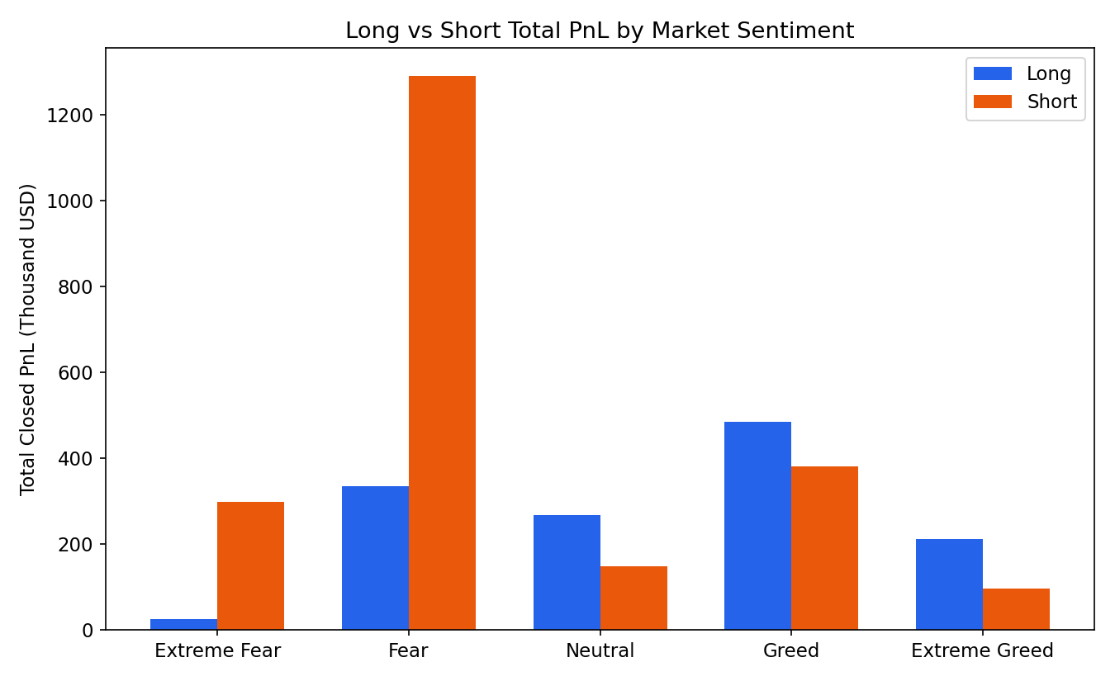
Splitting closed PnL by position direction reveals where the Fear-regime profit is coming from: short positions closed during Fear alone accumulated $1.29M in profit from 1,839 trades (avg. $701/trade, 84.2% win rate) — the single largest PnL contribution of any sentiment/direction pair in the dataset, exceeding the combined total of all Extreme Greed trading. Short positions in Extreme Fear were similarly lucrative on a per-trade basis ($1,184 avg.), though on much lower volume.
By contrast, Long positions dominate volume and win-rate during Greed and Neutral periods but contribute comparatively modest average payoffs ($165-$176/trade). Taken together, this suggests the highest-value trading pattern in this dataset is opening or holding short exposure into and through Fear conditions, then closing as sentiment stabilizes — while long exposure during calmer, more optimistic markets remains reliable but lower-margin.
Note: Neutral's Long ($267,664) and Short ($148,783) figures above sum to $416,446, not Neutral's full $619,966 in closed PnL — the remaining ~$203K comes from spot-style "Sell" fills that carry no long/short tag (see Section 2.2) and is omitted from this chart by construction.

5. Trading Activity & Volume
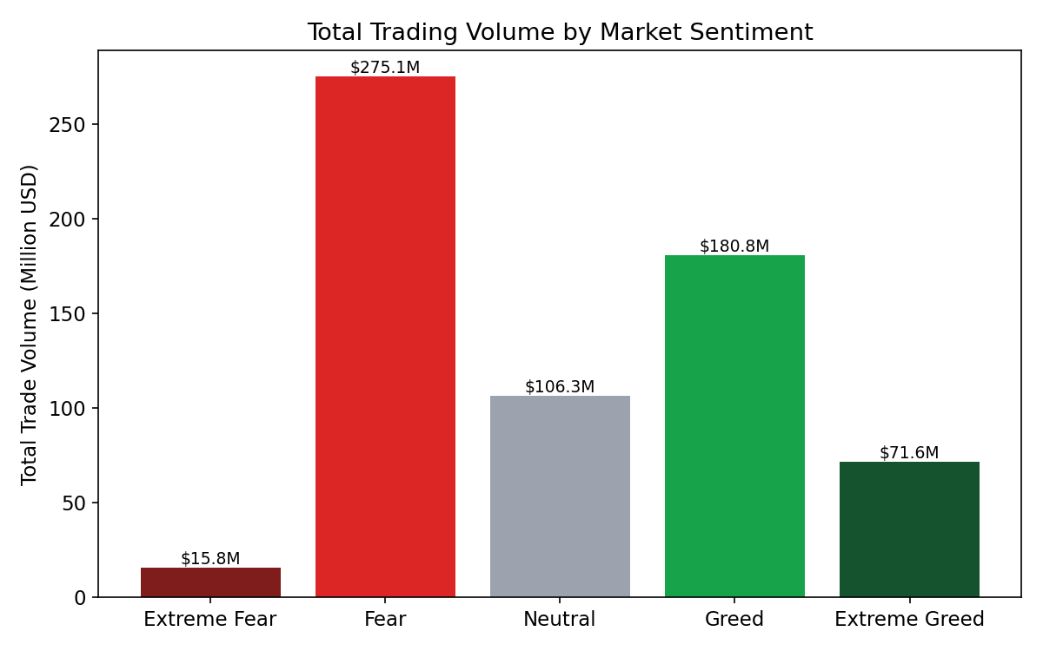
Total trading volume is highest during Fear ($275M) and Greed ($181M), and lowest during Extreme Fear ($15.8M) and Extreme Greed ($71.6M). Combined with the trades-per-active-day figures below, this indicates traders in this dataset are most active during moderate sentiment swings and pull back sharply during the most extreme fear readings — consistent with risk-off behavior once panic peaks, even though the trades that do get placed during Extreme Fear are the most profitable per trade.
Sentiment | Avg. Trades / Active Day | Total Volume | PnL Std. Dev (risk)
Extreme Fear | 103.8 | $15.8M | $5,524
Fear | 134.9 | $275.1M | $3,079
Neutral | 100.9 | $106.3M | $1,077
Greed | 71.2 | $180.8M | $2,582
Extreme Greed | 75.8 | $71.6M | $932

Risk (measured as the standard deviation of per-trade PnL) is highest in Extreme Fear and Fear, more than 3-5x the risk level seen in Neutral or Extreme Greed conditions. Higher average payoff in fear regimes comes paired with proportionally higher variance — the "fear pays more" pattern is a higher-risk, higher-reward one, not a free lunch.

6. Trading Activity Over Time
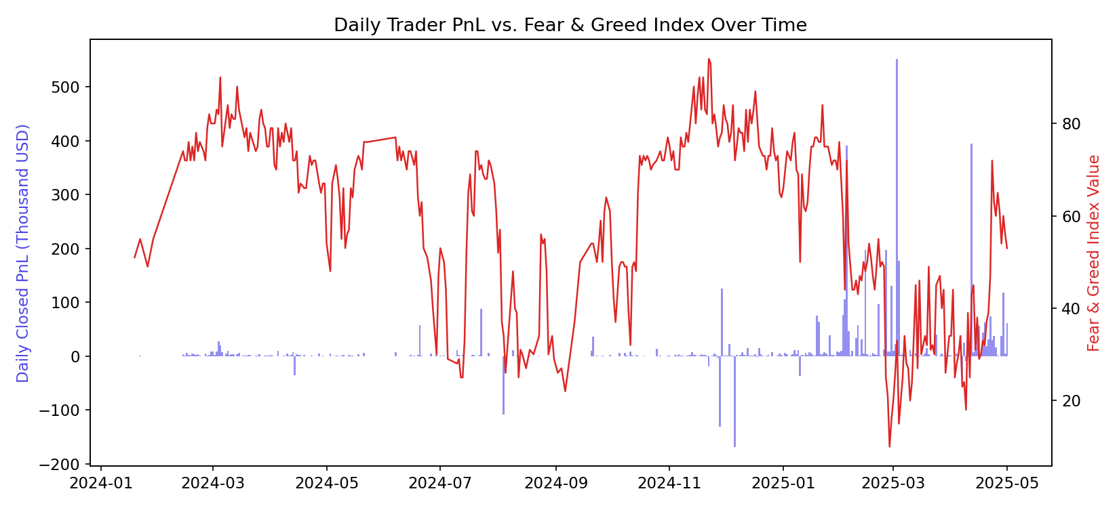
Daily closed PnL (bars) plotted against the Fear & Greed Index value (red line) shows profit spikes cluster during periods when the index is low or falling, and the largest single win in the dataset — a $135,329 ETH trade — occurred on April 12, 2025, during a Fear reading. The weak negative correlation between the daily sentiment score and daily PnL (r ≈ -0.14) is consistent with the pattern above: lower sentiment scores are modestly associated with higher trading profits, though the relationship is noisy day-to-day and sentiment alone does not reliably predict any single day's outcome.

7. Account & Asset Concentration

7.1 Accounts
Trading activity and profit are highly concentrated: of 8 accounts in the dataset, two accounts (ending ...9012 and ...c4ff1) account for the majority of both trade count and total realized profit ($1.60M and $0.84M respectively), while win rates across accounts range from 77.7% to a perfect 100% (on accounts with far fewer trades, where a small sample makes a 100% win rate less statistically meaningful).

7.2 Assets
BTC, ETH, and SOL dominate volume, together accounting for roughly 95% of total dollar volume traded and the large majority of total closed PnL ($823K, $810K, and $969K respectively). No coin in the dataset shows net negative aggregate PnL across the full period, though this reflects the specific accounts sampled rather than a market-wide pattern.

8. Actionable Insights for Trading Strategy
- Treat Fear as a signal to increase conviction, not exposure size indiscriminately. The data supports selectively sizing up short positions specifically during Fear regimes, where the historical win rate (84%) and average payoff ($701/trade) combination is the strongest in the dataset — but position sizing should still account for the 3-5x higher PnL variance observed in these regimes.
- Be cautious about scaling activity down in Extreme Fear. Trade volume drops sharply in Extreme Fear even though per-trade profitability is highest — this looks like traders under-participating exactly when the historical edge is largest, a bias worth deliberately correcting for rather than reinforcing.
- Don't mistake high win rate for high value. Greed and Neutral regimes have the best win rates but the lowest average payoff — appropriate for capital preservation or high-frequency strategies, but a poor regime for concentrating risk capital expecting outsized returns.
- Concentration risk is real. With profit and volume concentrated in 2 of 8 accounts and 3 of 127 assets, any strategy derived from this dataset should be validated on a larger, more diversified account sample before being treated as generalizable across the broader trader population.
- Use the Fear & Greed Index as one input among several. The correlation between daily sentiment score and daily PnL is real but weak (r ≈ -0.14) — useful for tilting risk appetite, not for timing individual trades in isolation.

9. Limitations
- The dataset covers only 8 accounts, which may not represent the broader Hyperliquid trader population or generalize to other venues.
- Sentiment is measured once daily at the BTC market level and applied uniformly to all trades that day, regardless of intraday sentiment swings or asset-specific sentiment (e.g., altcoin-specific news).
- Realized PnL reflects trades that were actually closed within the sample window; open positions at the end of the period are not captured, which can understate or overstate regime-level profitability depending on unrealized gains/losses.

