**PHP**

**Hypertext pre-processor**

**php** is the scripting language.

**Programming language**- which need to be compiled, *Source code compiled to machine code*

**Scripting**- is the piece of code. Scripts are run on browsers, it never gone run on console. *Scripting language need to be interpreted*.

**Client-side scripting**- which is happening on the browser ex- we did the validations like email is correct or not. Ex- Js and typescript Js is loosely typed/weak type language.

* Web browser executes client-side scripting.
* Source code is used to transfer from webserver to user’s computer over the internet and run directly on browser.
* It also used for validations and functionality for user events.
* It allows for more interactivity.
* It *cannot* used for validations and functionality for user events.
* These scripts cannot access the file system that resides on the web browser.
* It is used to create the cookies which stores the data on the user’s computer.

**Server side**- web server is used to execute the server-side scripting.

* Used to create a dynamic-pages.
* It can also access the file system residing at the webserver.
* A server-side environment that runs on a scripting language is a web browser.

**php**

* Its previous name is not too much popular so its new name is **Hypertext pre-processor.**
* It is open source, interpreted and object-oriented scripting language.
* Executed at server side.
* Static webpages and dynamic web pages.
* Dynamic pages which are comes from the server. Live data coming from the server. php is targeted for that
* php is faster than asp and jsp.
* php can also embedded with html
* Laravel, joomla, WordPress, cake php, codeminiator and many more.
* X- cross platform
* A- apache
* M- mysql
* P- php
* P- perl
* Php code is interpreted

php used for

* build website and web apps and to build CLI tools

About PHP

* To execute the php file we need server.
* If we save file as .php then it does not required ending tag.

If we using xampp then code is need to save on this location.

xampp/htdocs

**php is case sensitive- only for the variable php**

ex-

<?PHP

ECHo "hello mca sem 2";

?>

**Echo –** is a language is constructor. You can use parenthesis,

**Echo is a statement which Is used to display output**

* Echo can use with brackets or without brackets.
* Echo does not return any value, print returns a value
* You can also pass multiple values by putting commas (,)
* Echo is faster than print statement

**Constants-** when we defined the constant we do not need to call it using dollar sign (that we used for variables)

Constants can be defined in 2 ways. We cannot change the value of the constants once it is defined.

1. Using function

Ex-

<?php  
define('STATUS_PAID','the payment is done succesfully');  
echo *STATUS_PAID*;  
?>

1. Using const keyword

Ex-

<?php  
const *ph*="this is how we print";  
echo *ph*;  
?>

The main difference between the const keyword and define function is constant created with const keyword are defined at compile time.

While constant created with define function is defined at run time.

Constant is generally used for static data. Php also have predefined constants. Which are

echo *PHP_VERSION*;

php also contains some magic constants- these are the constants whose value will be changed.

echo *__LINE__*

echo *__FILE__*;

**Variables**

$ - dollar symbol Is used to create a variable

Variables are case sensitive

$_12name this is valid variable

Keyword are not allowed as a variables

**Variable types**

**After the execution of every variable except the global variable is released from memory. It will not persist after the execution**

**To solve this, we make a variable as a static.**

1. Local variable- any variable declare inside of the body of the function is local variable. We can not access the local variable outside of the functions.

<?php

function local_var()

{

$num=45;

echo "loal variable:".$num;

}

local_var();

//echo "local variable: ".$num;

?>

1. Global variable- declare in the script area, to access the global variable we need ‘**global’** keyword.

<?php

$name=”

If we want to use the global variable inside of the function or block the we use global keyword.

Ex--

<?php

$n='th';

function fun(){

$n="sh";

echo "name is=".$n;

}

fun();

echo "name is=".$n;

?>

1. Static variable

<?php

function static_php(){

static $num1=3;

$num1++;

$num2=7;

$num2++;

echo "static number:".$num1."<br>";

echo "number:".$num2;

}

static_php();

?>

o/p

4

8

If we execute the function again then we get o/p

<?php

function static_php(){

static $num1=3;

$num1++;

$num2=7;

$num2++;

echo "static number:".$num1."<br>";

echo "number:".$num2;

}

static_php();

static_php();

?>

o/p

5

8

As variables other than global release memory after the execution, so it starts again from the beginning, but the static variable is not get relased so it will start from where it is.

**Reference variable-**

When we create one variable and assign value in it and again use it as a variable using double dollar

Ex-

<?php

$x="abc";

$$x=200;

echo "the val is:".$abc;

?>

<?php

$x="abc";

//$$x=200;

${$x}."</br>;

echo "the val is:".$abc;

?>

Variable variable

<?php  
$foo="man";  
$$foo="pintu";  
echo $foo,$$foo."<br>";  
*//echo "$foo,$$foo"; this will only print the value of one variable. another variable will print as it is.*echo "$foo,${$foo} <br>";  
echo "$foo, {$$foo}";  
?>

Constant in php

To declare the constant there are 2 ways

1. By defining function
2. By using constant keyword.

When we create constant no need to use doll ($) sign.

So, we cannot use double dollar to modify.

**Data Types in php**

1. Scalar type – bool, int, float, string
2. Compound- array, object, callable, iterable
3. Special type- (resource, null)

Constant

Data types with the type

<?php  
$b=true;  
$i=12;  
$f=23.2;  
$st="Hello World";  
  
echo $b."<br>";  
echo $i."<br>";  
echo $f."<br>";  
echo $st."<br>";  
  
echo gettype($b)."<br>";  
echo gettype($i)."<br>";  
echo gettype($f)."<br>";  
echo gettype($st)."<br>";  
  
var_dump($b);  
?>

**Type Juggling/Type Coercion**

It can be understood with the help of example

var_dump

In PHP, the var_dump() function is used for debugging and inspecting the contents and structure of a variable. It provides detailed information about the variable, including its type, value, and length (for strings and arrays). The function is particularly helpful when working with complex data structures or when trying to troubleshoot issues in your code.

<?php  
function sum(int $x, int $y){  
 var_dump($x,$y);  
 echo '<br>';  
 return $x+$y;  
}  
$sum=sum(2.5,"5");  
echo $sum;  
?>

**Strict type**

It only allowed to pass the values of the mentioned type, we can not pass the string values in integer variable.

<?php  
declare(strict_types=1);  
function sum(int $x, int $y){  
 var_dump($x,$y);  
 echo '<br>';  
 return $x+$y;  
}  
$sum=sum(25,4);  
echo $sum;  
?>

Type cast

<?php  
$s=(int)"34";  
var_dump($s);  
?>

Global variable second method.

Form Design

When to use get and post

Get method is used when your information is not sensitive.

Post method https carries data to the server when data is not a case sensitive.

After submitting where we are looking 🡪 this is called action

Method – which data your are sending according to that we use different methods, get and post

Get- allows you to see the information which is carried out through the url

name attribute- it will help us to get that details onto the another page.

When you submit the form data is

To access the value which have submitted by php we can use associated array with global variable.

To get the global variable take the name which we have added in the name field

<html>  
<head>  
 <title>example of get and post</title>  
</head>  
<body>  
 <form method="GET" action="welcome.php">  
  
 <label>User Name</label>  
 <input type="text" name="uname" placeholder="Enter your username"><br><br>  
 <label>Password</label>  
 <input type="password" name="pass"><br><br>  
 <input type="submit" name="submit" value="login">  
 </form>  
</body>  
</html>  
<?php  
  
?>

<?php  
echo "Your user name is ".$_GET["uname"];  
  
?>

O/p - Your user name is MANGESH



Using POST



<html>  
<head>  
 <title>example of get and post</title>  
</head>  
<body>  
 <form method="post" action="welcome.php">  
  
 <label>User Name</label>  
 <input type="text" name="uname" placeholder="Enter your username"><br><br>  
 <label>Password</label>  
 <input type="password" name="pass"><br><br>  
 <input type="submit" name="submit" value="login">  
 </form>  
</body>  
</html>  
<?php  
  
?>

<?php  
echo "Your user name is ".$_POST["uname"];  
  
?>

o/p

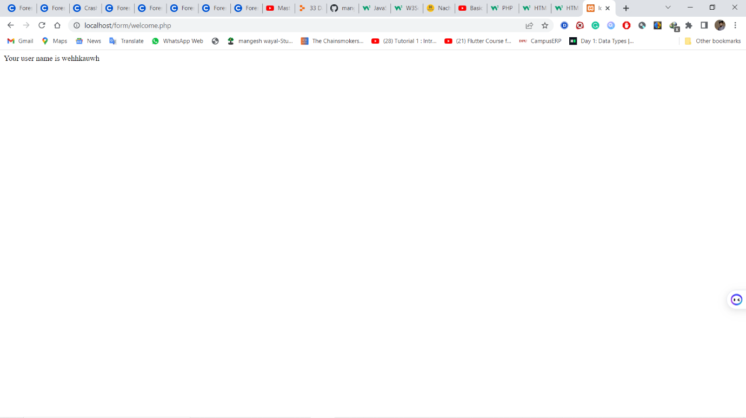

Using request

<?php  
echo "Your user name is ".$_REQUEST["uname"];  
  
?>

REQUEST- it is a global variable which can work with get and post

Is used for Get form data send with both [post and get] method

*All the global variables are written in upper case*.

**isset()** -is the function used to check whether variable has been set or not it always return true of false value.

var_dump- it gives the values in Boolean, it values is present then it returns true or it returns false.

Program to add two numbers

<html>  
<head>  
 <title>example of get and post</title>  
</head>  
<body>  
 <form method="get" action="welcome.php">  
  
 <label>User Name</label>  
 <input type="number" name="uname" placeholder="Enter your username"><br><br>  
 <label>Password</label>  
 <input type="number" name="pass"><br><br>  
 <input type="submit" name="submit" value="login">  
 </form>  
</body>  
</html>  
<?php  
  
?>

o/p-

<?php  
$s=$_REQUEST["uname"];  
$g=$_REQUEST["pass"];  
echo "Your user name is ".$s+$g;  
//echo "Your user name is ".$_REQUEST["pass"];  
//var;  
//$str="man";  
//var_dump(isset($str));  
?>

1. include- we can include html file in php, it does not give error if file is not present. It does not affect the execution (does not stop the script)

ex. <?php  
include ("menu.html");  
echo "include";  
?>  
<h1>this is my menu page</h1>

1. require – it also allows to import html file in php. But it throws the fatal error it stops the execution of program.

Ex<?php  
require("menu.html");  
echo "include";  
?>  
<h1>this is my menu page</h1>

**Database Connectivity Using PHP**

**mysqli_connect();**

**PDO: construct();**

**Regular Expression Matching**

**Session and Cookies**

Cookie is small piece of information stored as a file in the users browser by the web server.

Once cookie is created it send to webserver as *header information* with every HTTP request.

Types of cookies

1. session cookies
2. persistent cookie

session- is only period while page not get closed

persistent cookie- whenever we open the page it is present there

In PHP we have method setcookie() to store the cookie

Required parameters are name and value expire, path, domain, secure is optional

setcookie(name,value,expire,path,domain,secure)

session always stored data on server side

<?php  
session_start();  
$_SESSION["username"]="i am mangesh";  
$_SESSION["userid"]="1";  
  
?>  
<?php  
*//get the session variable values*$username=$_SESSION["username"];  
echo "Username is:".$username;  
?>  
<a href="index.html">go to the index html</a>  
<!DOCTYPE html>  
<html lang="en">  
<body>  
<?php  
echo "session variable is set";  
?>  
</body>  
</html>

Session_unset and session_destroy method to destroy session.

**Typescript**

It is superset of javascript. It is only different in declaring the variable type.

Typescript is compiled which is used to convert the typescript to the javascript.

Function

**Laravel**

Install composer from the composer setup

Then install larval by creating new file and putting command in terminal

composer create-project laravel/laravel example-app

after that if Laravel is not recognised then

*composer global remove laravel/installer*

after that input a command

*composer global require Laravel/installer*