1. Top 10 highest revenue generating products

select top 10 product_id, sum(sale_price) as Total_sales

from df_orders

group by product_id

order by Total_sales desc;

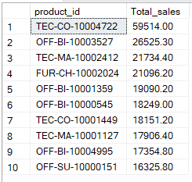

1. Top 5 highest selling products in each region

with cte as(

select Region,product_id, sum(sale_price) as Total_sales

from df_orders

group by product_id,Region

)

, cte2 as(

select *, DENSE_RANK() over (partition by Region order by Total_sales desc) as drnk

from cte

)

select Region, Product_id, Total_sales from cte2 where drnk <= 5;

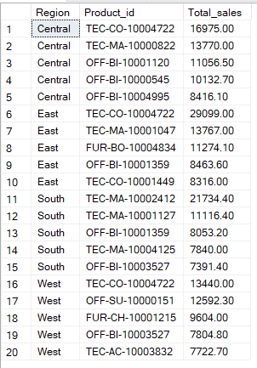

1. Month over month growth comparison for 2022 and 2023 sales

with cte as(

select year(order_date) as Order_year, month(order_date) as Order_month, sum(sale_price) as sales

from df_orders

group by year(order_date), month(order_date)

)

select order_month,

sum(case when order_year=2022 then sales else 0 end) as sales_2022,

sum(case when order_year=2023 then sales else 0 end) as sales_2023

from cte

group by order_month;

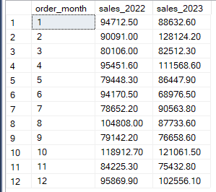

1. Highest sales month for each category

with cte as(

select format(order_date,'yyyyMM') as Order_month, category, sum(sale_price) as Sales

from df_orders

group by format(order_date,'yyyyMM'), category

)

, cte2 as(

select *,

DENSE_RANK() over (partition by category order by sales desc) as drnk

from cte

)

select Category, Order_month, Sales from cte2 where drnk=1;

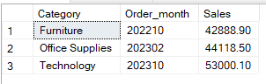

1. Highest growth subcategory by profit in 2023 compared to 2022

with cte as(

select sub_category, year(order_date) as Order_year, sum(sale_price) as sales

from df_orders

group by sub_category,year(order_date)

)

,cte2 as(

select sub_category,

sum(case when order_year=2022 then sales else 0 end) as sales_2022,

sum(case when order_year=2023 then sales else 0 end) as sales_2023

from cte

group by sub_category

)

select top 1 *, (sales_2023-sales_2022)*100/sales_2022 as Growth_percentage

from cte2

order by Growth_percentage desc;

