**group 10**

Sathvik b |1ms17IS107

nimish bongale |1ms17is077

tarun r |1ms17is123

ashish jayaram |1ms17is029

ujwal k c |1ms17is125

SMART HELMET

An effort to solve the RAGING PROBLEM of helmetless riding

Abstract

Department of Information science,

ramaiah institute of technology

A prelude to our report

The impact when a motorcyclist involves in a high speed accident without wearing a helmet is very dangerous and can cause fatality. Wearing a helmet can reduce shock from the impact and may save a life. There are many countries enforcing a regulation that requires the motorcycle's rider to wear a helmet when riding on their motorcycle, India being an example. With this reason, this project is specially developed as to improve the safety of the motorcycle's rider. Motorcyclist will be alarmed when the helmet is improperly positioned on his head. 3 end stop switches are used for detection of the rider's head. A 434 MHz Radio Frequency Module has wireless link which able to communicate between transmitter circuit and receiver circuit. The Arduino pro mini is a microcontroller which controls all the components in the system. Only when the rider wears the helmet properly then only the motorcycle's engine will start. An LED will flash if it is case.

iNTRODUCTION

Initiaiting our report

Traffic accidents worldwide have increased year by year. Muhamad Nizam Mustafa who works in planning highway unit in Ministry of Works of Malaysia stated that, the increase of road accidents is in link with the rapid growth in population, economic development, industrialization and motorization encountered by the country in 2010, motorcyclists made up more than half the road fatalities in Malaysia. Statistics provided by the Malaysian Institute of Road Safety Research (MIROS) showed that 4,067 motorcyclists died in 2010.

In India alone, about 10,000 people die every year due to helmetless riding. These statistics present a very important problem before us, and that is to do with how we can limit such deaths caused due to sheer negligence from the rider. A possible way would be to force the compulsory wearing of a helmet, using the help of basic electronics. This option was explored in depth while developing about our prototype.

Requirements

Materials necessary in order to build the prototype

There were a lot of components  used for the final project.

*ARDUINO PRO MINI*

The**Arduino Pro Mini** is a microcontroller board based on the ATmega328.   
It has 14 digital input/output pins (of which 6 can be used as PWM outputs), 6 analog inputs, an on-board resonator, a reset button, and holes for mounting pin headers. A six pin header can be connected to an FTDI cable or Sparkfun breakout board to provide USB power and communication to the board.  
The Arduino Pro Mini is intended for semi-permanent installation in objects or exhibitions. The board comes without pre-mounted headers, allowing the use of various types of connectors or direct soldering of wires. The pin layout is compatible with the Arduino Mini.   
There are two version of the Pro Mini. One runs at 3.3V and 8 MHz, the other at 5V and 16 MHz.   
The Arduino Pro Mini was designed and is manufactured by SparkFun Electronics.

SPECIFICATIONS:

|  |  |
| --- | --- |
| **Arduino Pro Mini DETAILS** | |
| Microcontroller | ATmega168 |
| Operating Voltage | 3.3V or 5V |
| Input Voltage | 3.35 -12 V (3.3V model) or 5 - 12 V (5V model) |
| Digital I/O Pins | 14 (of which 6 provide PWM output) |
| Analog Input Pins | 8 |
| DC Current per I/O Pin | 40 mA |
| Flash Memory | 16 KB (of which 2 KB used by bootloader) |
| SRAM | 1 KB |
| EEPROM | 512 bytes |
| Clock Speed | 8 MHz (3.3V model) or 16 MHz (5V model) |

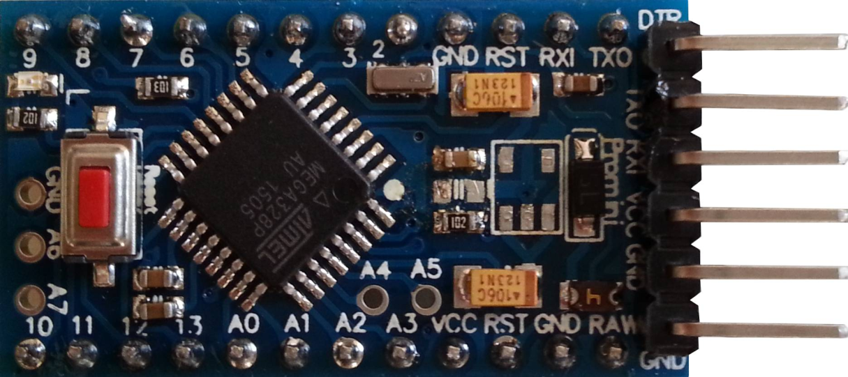

*END STOP SWITCH*

End stop switches are low friction mechanical switches which can easily be turned on with a small amount of force. In the project, this force is coming by the head of the rider. The mechanical endstop uses a lever switch to detect when it is activated. The switch is wired up so that when activated, it pulls the signal to LOW.

REASONS TO USE MECHANICAL ENDSTOPS

* Switches are the cheapest endstops in most cases.
* No need for opto pcb.
* Simple switches can be used on x and y axis.
* You could even make your own contact switch from a few pieces of metal.

LIMITATIONS:

* Switches have a limited number of on/off cycles. However, most purpose built micro-switches are rated for well over 1,000,000 cycles and will last years.
* [Needs new way to mount switch](http://reprap.org/wiki/Mechanical_Endstop#Switch_mounting), which will depend on the switch type.

PINS OF AN ENDSTOP SWITCH

|  |  |
| --- | --- |
| **Pin** | **Function** |
| +5 | This is the pin to supply +5 volts on. |
| S | This is the signal pin. It will output high (+5) if it is triggered, or low (0v) if it is clear |
| G | This is the ground pin. |

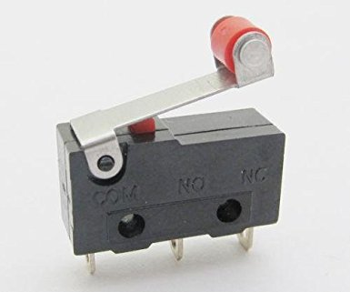

*TRANSMITTER AND RECIEVER:*

The transmitter and receiver used is a scaled down version of the RF315 transmitter receiver module.

The RF module, as the name suggests, operates at Radio Frequency. The corresponding frequency range varies between 30 kHz & 300 GHz. In this RF system, the digital data is represented as variations in the amplitude of carrier wave. This kind of modulation is known as Amplitude Shift Keying (ASK).

Transmission through RF is better than IR (infrared) because of many reasons. Firstly, signals through RF can travel through larger distances making it suitable for long range applications. Also, while IR mostly operates in line-of-sight mode, RF signals can travel even when there is an obstruction between transmitter & receiver. Next, RF transmission is more strong and reliable than IR transmission. RF communication uses a specific frequency unlike IR signals which are affected by other IR emitting sources.

This **RF module** comprises of an **RF Transmitter** and an **RF Receiver**. The transmitter/receiver (Tx/Rx) pair operates at a frequency of **434 MHz**. An RF transmitter receives serial data and transmits it wirelessly through RF through its antenna connected at pin4. The transmission occurs at the rate of 1Kbps - 10Kbps.The transmitted data is received by an RF receiver operating at the same frequency as that of the transmitter.

The RF module is often used along with a pair of encoder/decoder. The encoder is used for encoding parallel data for transmission feed while reception is decoded by a decoder. HT12E-HT12D, HT640-HT648, etc. are some commonly used encoder/decoder pair ICs.

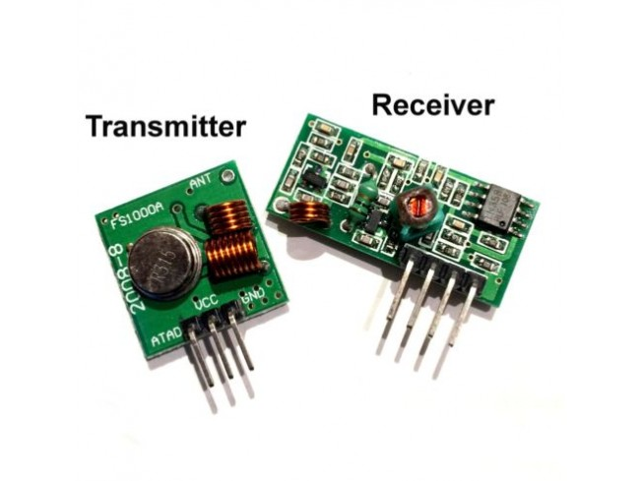

### Pin Diagram:

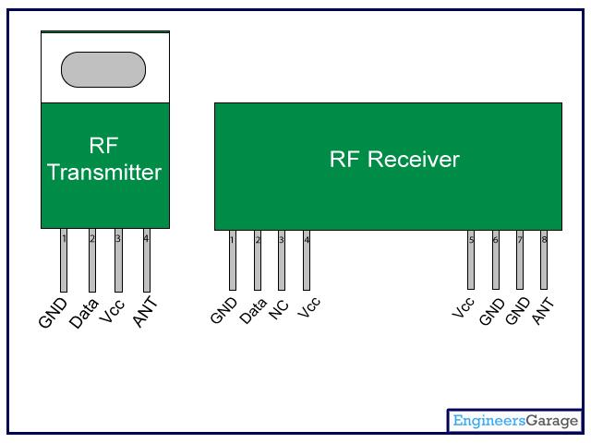

### Pin Description:

**RF Transmitter**

|  |  |  |
| --- | --- | --- |
| **Pin No** | **Function** | **Name** |
| 1 | Ground (0V) | Ground |
| 2 | Serial data input pin | Data |
| 3 | Supply voltage; 5V | Vcc |
| 4 | Antenna output pin | ANT |

**RF Receiver**

|  |  |  |
| --- | --- | --- |
| **Pin No** | **Function** | **Name** |
| 1 | Ground (0V) | Ground |
| 2 | Serial data output pin | Data |
| 3 | Linear output pin; not connected | NC |
| 4 | Supply voltage; 5V | Vcc |
| 5 | Supply voltage; 5V | Vcc |
| 6 | Ground (0V) | Ground |
| 7 | Ground (0V) | Ground |
| 8 | Antenna input pin | ANT |

*RELAY*

A **relay** is an electrically operated switch. Many relays use an electromagnet to mechanically operate a switch, but other operating principles are also used, such as solid-state relays. Relays are used where it is necessary to control a circuit by a separate low-power signal, or where several circuits must be controlled by one signal. The first relays were used in long distance telegraph circuits as amplifiers: they repeated the signal coming in from one circuit and re-transmitted it on another circuit. Relays were used extensively in telephone exchanges and early computers to perform logical operations.

A type of relay that can handle the high power required to directly control an electric motor or other loads is called a contactor. Solid-state relays control power circuits with no moving parts, instead using a semiconductor device to perform switching. Relays with calibrated operating characteristics and sometimes multiple operating coils are used to protect electrical circuits from overload or faults; in modern electric power systems these functions are performed by digital instruments still called "protective relays"

A simple electromagnetic relay consists of a coil of wire wrapped around a soft iron core (a solenoid), an iron yoke which provides a low reluctance path for magnetic flux, a movable iron armature, and one or more sets of contacts (there are two contacts in the relay pictured). The armature is hinged to the yoke and mechanically linked to one or more sets of moving contacts. The armature is held in place by a spring so that when the relay is de-energized there is an air gap in the magnetic circuit. In this condition, one of the two sets of contacts in the relay pictured is closed, and the other set is open.

This relay is connected to the bike.

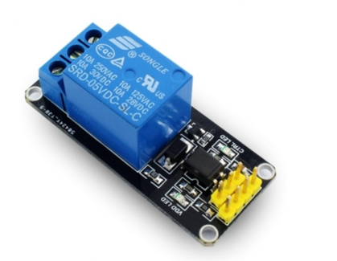

Design

Prototype development

The circuit is a simple and minimalistic circuit which can be fitted into any helmet by making very simple modifications to the helmet without changing any of the aesthetics of the helmet.

All the components off the circuits have been made as small as possible to make it easy to fit into the helmet and add a very important function.

Due to the small size of the end stop switch, almost no intrusions felt by the rider, the project causes no discomfort to the rider and ensures that the rider has a safe ride.

The connections made to the bike are simple as well which makes it easier to practically implement this for the general public.

with the bare basic circuitry and compact size, our project ensures a practical and implementable solution to the major problem of helmetless riding.

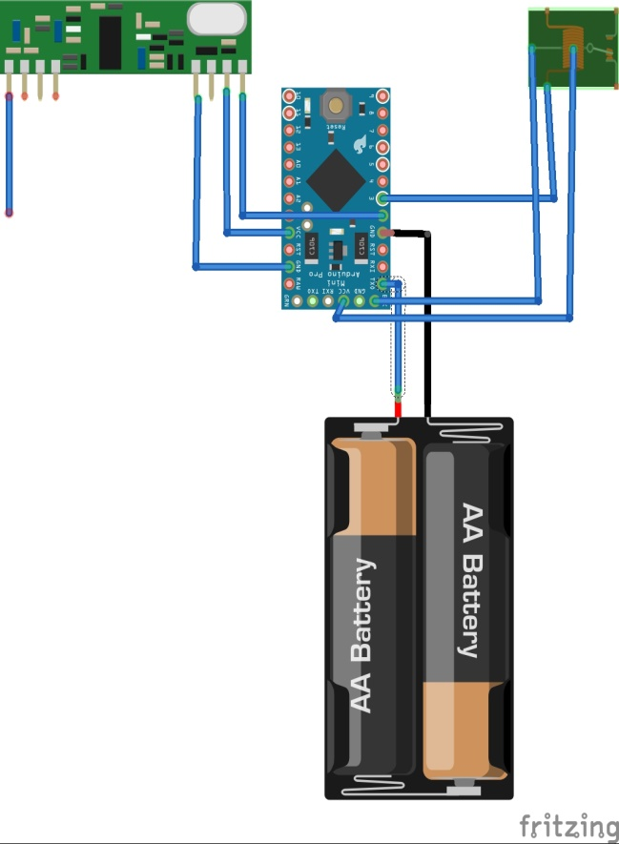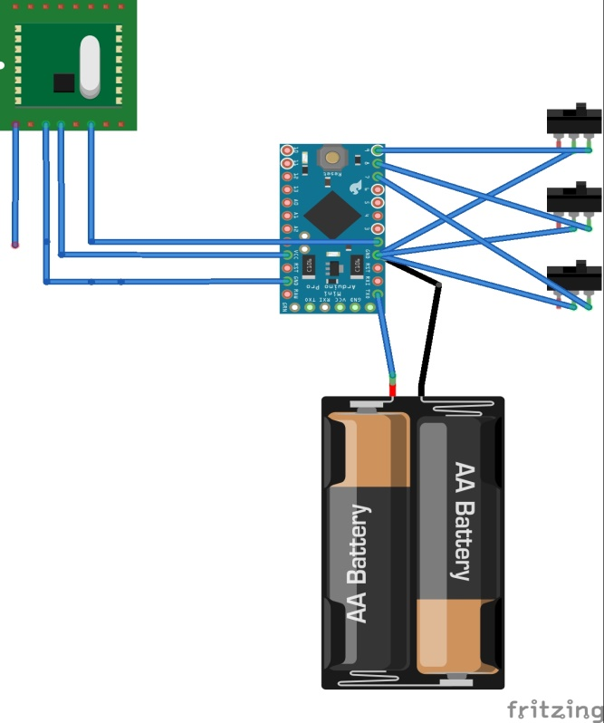

 Receiver module                                      Transmitter module

Important details

Some important factors

* Comfort of the driver
  + Comfort of the driver is the most important thing while riding because if the helmet is uncomfortable then the driver while trying to make it proper may end up in accidents.
* Minimizing Exposure of the Radiation
* Cost of the sensor and their availability
* Minimizing change in aero dynamicity of the helmet after installation of the circuit
* Reliability
* Viability
* Safety of the driver
  + The battery that we are using is a Lithium polymer battery has a polymer electrolyte instead of liquid therefore during accidents there is less chance of leaking of the electrolyte.

* Reducing complexity of circuits
  + Use of rf315 over nrf2401
    - Nrf2401 is a half- duplex communication module and uses a two way communication network which is difficult to program and we don’t need it for this project so we used a sized down version of rf315 which is easier to work with.
* Reducing size and weight  of the components
  + Use of lithium polymer battery
  + Use of arduino pro mini over arduino uno
  + Removal of a small portion of padding might affect the safety so adding an extra layer of padding might help

Photos

Some snaps of our working model

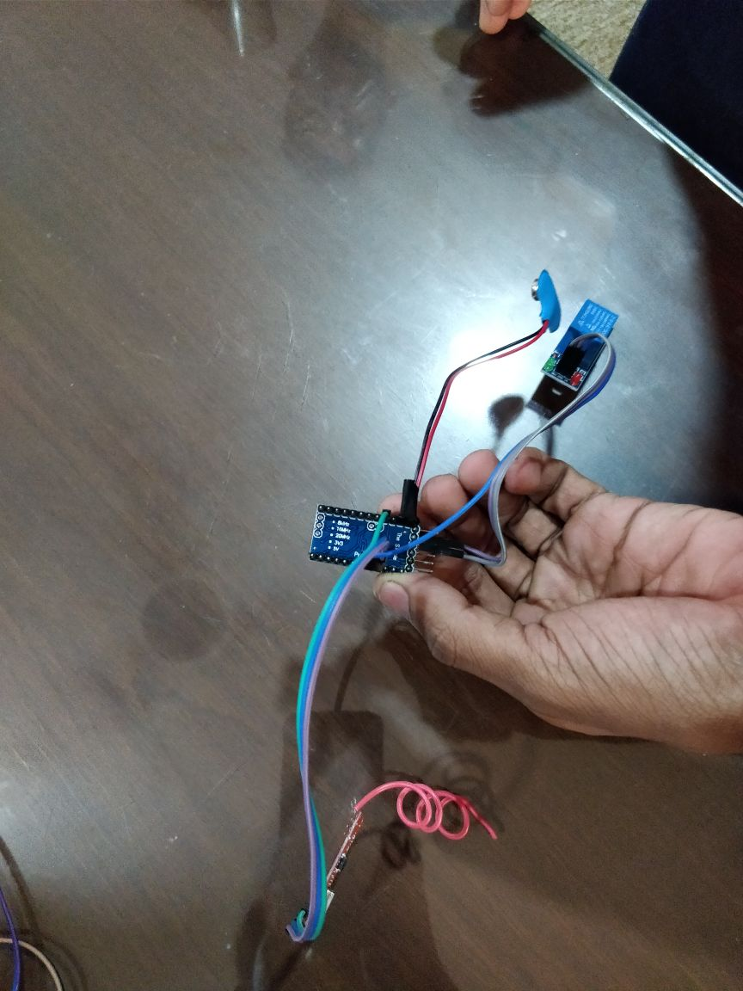 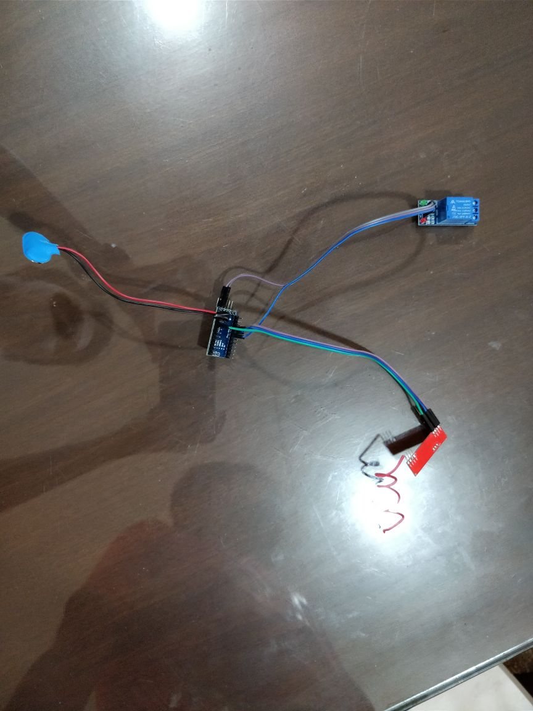

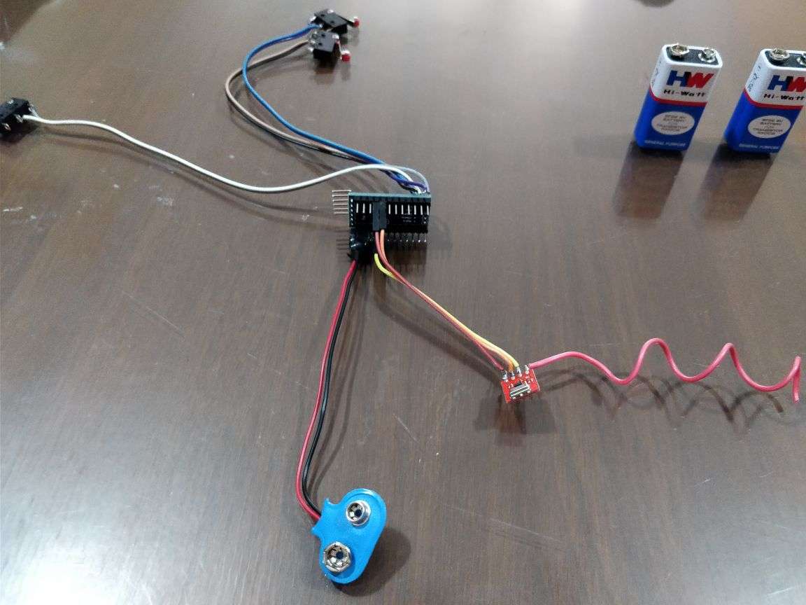 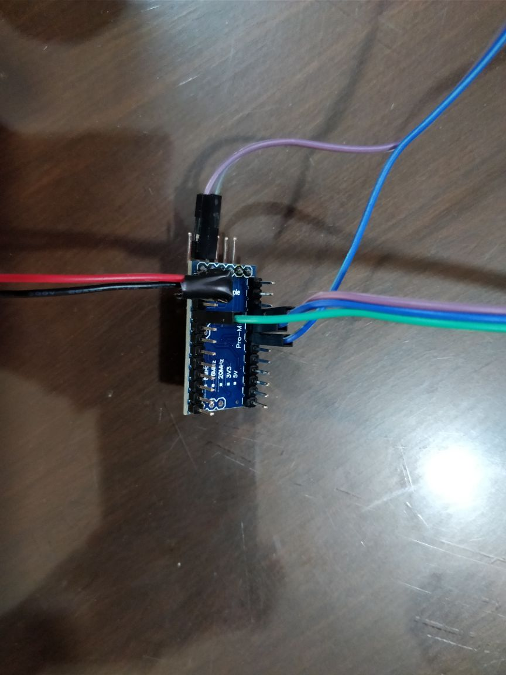

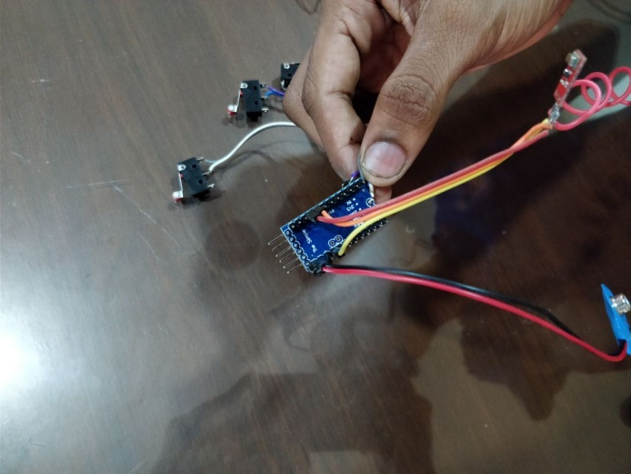 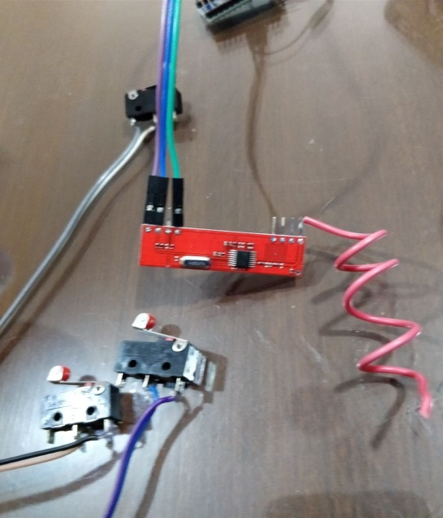

Output

The net result

When the rider is not wearing his helmet that is when the three end stop switches are off, the blinking light on the transmitting module which acts as a caution to the rider starts blinking, the green light on the receiving module will be off, and the relay module cuts the power to the engine.

When the rider wears his helmet that is when the three end stop switches are on, the blinking light on the transmitting end will go off, the green light on the receiving module will start glowing, and the relay module turns off and therefore the engine turns on.

Bibliography

Accredition of sources

**PRIMARY SOURCES**

* **www.ieeexplore.ieee.org/document16895036/?reload=true**
* **Ijser.org/research paper/intelligent-helmet-pdf**
* **Publication/271139060-smart-helmet**

**SECONDARY SOURCES**

* **www.researchgate.net**
* **Ijarece.org/wp.content/uploads12016/02/irarece-VOL-5 ISSUE-7-151-152.pdf**
* **Ijerat.com/uploads/2/3200-pdf.pdf**