Project Report (CSN 304)
A report submitted in partial fulfilment of the requirement for the course
Artificial Intelligence
Part of the degree of
BACHELOR OF TECHNOLOGY
COMPUTER SCIENCE AND ENGINEERING


Submitted To: Submitted By:
Vishaka Arya Name: Ashish Joshi
Assistant Professor Roll No: 23A03A0559
School Of Computing Section: “I” (P2)
DIT University 3rd year , 5th Semester

Session 2025-2026
Mussoorie Diversion Road, Dehradun, Uttarakhand- 248009, India
October 2025

Declaration

I hereby certify that the work , which is being presented in the report , entitled “Disease Prediction System”, in partial fulfilment of the requirement as part of the course Bachelor of Technology and submitted to the DIT University is an authentic record of my work carried out during the period 01/10/2025 to 30/10/2025 under the guidance of Ms. Vishaka Arya.

Name of the Student - Ashish Joshi Signature and Date -
Name of the Student – Rajat Bisht Signature and Date -
Name of the Student – Dipanshu Jadli Signature and Date -
Name of the Student – Abhinav Jaiswal Signature and Date -

Acknowledgement

I would like to express my sincere gratitude to all those who have supported and guided me throughout the course of this project.
First and foremost, I extend my heartfelt thanks to Vishaka Arya, under whose guidance this project was carried out successfully. Their invaluable suggestions, encouragement, and constant support played a crucial role in completing this work.
I am also deeply grateful to DIT University for providing the facilities and resources necessary to undertake this project.
My special thanks go to my friends Rajat Bisht, Dipanshu Jadli , Abhinav Jaiswal and classmates for their cooperation, motivation, and constructive feedback during different phases of the project.
This project would not have been possible without the contribution of all these individuals, and I sincerely thank each one of them.

Table Of Content
Candidate’s Declaration
Acknowledgement
Chapter 1 - Introduction
  - Introduction
  - Objective
  - Project Description
Chapter 2 - Requirement Analysis System Specification
2.1 Requirement Analysis
2.2 System Specification
Chapter 3 - Workflow
Chapter 4 - Implementation Modules
4.1 Introduction to programming language
4.2 Tools and Technologies
Chapter 5 – Result and Discussions
5.1 Code
5.2 Output Screenshots
5.3 Discussion
Chapter 6 – Summary and Conclusion
6.1 Summary
6.2 Conclusion
Chapter 7 – Scope of Future Work
References

Chapter 1
Introduction
In today’s world, Artificial Intelligence (AI) has become a powerful tool in solving real-life problems and making human life more efficient and convenient. This project focuses on two major AI applications:
- AI-Based Recommendation System
A recommendation system is an intelligent application that analyses user preferences, behaviours, and historical data to suggest relevant items or choices. Such systems are widely used in platforms like e-commerce websites, streaming services, and social media to enhance user experience. In this project, the AI-based recommendation system is designed to understand user needs and provide personalized suggestions, thereby improving decision-making and saving time.
- Disease Prediction System
Healthcare is one of the most critical domains where AI can have a significant impact. The disease prediction system is built to analyse medical data and predict the likelihood of certain diseases in patients. By using machine learning algorithms, this system helps in early detection and prevention, supporting doctors and individuals in taking timely action for better healthcare outcomes.

Both projects demonstrate the role of AI in revolutionizing various fields. While the recommendation system showcases personalization and user-focused solutions, the disease prediction system emphasizes social good and healthcare improvements. Together, they highlight how AI can be applied in diverse domains to solve problems efficiently and intelligently.

1.2 Objective [Disease Prediction System]

The primary objective of the AI-Based Disease Prediction System is to design and develop an intelligent, data-driven model capable of predicting the likelihood of various diseases based on patients’ health parameters and symptoms. The system aims to utilize machine learning algorithms and artificial intelligence techniques to analyse medical data efficiently and provide accurate predictions that can support early diagnosis and preventive healthcare.
This project seeks to bridge the gap between patients and healthcare professionals by offering a decision-support tool that can assist in medical assessments, reduce diagnostic delays, and enhance the overall quality of healthcare delivery. By integrating data preprocessing, model training, and result interpretation, the system ensures that users receive reliable and actionable health insights.
Specific Objectives
- To collect and preprocess medical datasets containing health indicators, symptoms, and disease labels.
- To promote early detection and preventive healthcare by providing quick and data-driven disease predictions.
- To demonstrate how AI can be effectively integrated into healthcare systems for improving diagnostic accuracy and decision-making efficiency.
1.2 Objective [AI-Based Recommendation System]

The primary objective of the AI-Based Recommendation System is to design and develop an intelligent model that analyses user preferences, behaviours, and historical interactions to generate personalized suggestions. The system aims to utilize artificial intelligence and machine learning algorithms to understand user needs, predict interests, and recommend relevant products, content, or services across various domains such as e-commerce, entertainment, and social media.
This project seeks to enhance user satisfaction and engagement by automating the process of content discovery, thereby saving time and improving decision-making efficiency. By integrating data collection, feature extraction, and recommendation algorithms, the system ensures that users receive dynamic, context-aware, and personalized recommendations.
Specific Objectives
- To collect and preprocess user data including preferences, browsing history, and interaction patterns for training the model.
- To implement and compare different AI-based recommendation techniques such as collaborative filtering, content-based filtering, and hybrid approaches.
- To enhance user experience by delivering accurate, real-time, and personalized recommendations that adapt to user behaviour over time.
1.4 Project Description [Disease Prediction System]

The Disease Prediction System is an artificial intelligence–based application designed to predict the likelihood of a person having a particular disease based on their health data. The system uses machine learning algorithms to analyse various medical parameters such as age, blood pressure, glucose level, and cholesterol to determine disease risk.
By training the model on real medical datasets (like diabetes or heart disease data), the system learns patterns and relationships between input features and disease outcomes. Once trained, it can accurately predict whether a new patient is likely to be affected by a certain disease.
This project aims to assist both healthcare professionals and individuals by providing quick, data-driven predictions that can support early diagnosis and preventive healthcare decisions. It demonstrates how AI can be effectively applied in the medical field to improve healthcare accessibility and accuracy.

1.4 Project Description [AI-Based Recommendation System]

The AI-Based Recommendation System is an intelligent software application designed to provide users with personalized suggestions based on their preferences, behaviours, and past interactions. The system leverages advanced machine learning and artificial intelligence techniques to analyse large volumes of user data, identify hidden patterns, and predict items or content that align with individual interests.
This project focuses on developing a recommendation model capable of learning from user activities—such as product views, purchases, ratings, or search history—and using this information to generate relevant and accurate recommendations. Depending on the use case, the system can be implemented using collaborative filtering, content-based filtering, or hybrid models that combine both approaches for improved performance.
The developed system aims to enhance user experience across multiple domains such as e-commerce, streaming services, and social media platforms by helping users discover products, movies, or content more efficiently. Additionally, the project emphasizes scalability and adaptability, ensuring that the recommendation engine can handle diverse datasets and evolving user preferences over time.

Chapter 2
2.1 Requirement Analysis

Hardware Requirements:
- Processor:
  - Minimum: Dual-core processor (e.g., Intel Core i3 or AMD equivalent).
  - Recommended: Quad-core processor (e.g., Intel Core i5/i7 or AMD Ryzen series).
- RAM:
  - Minimum: 4 GB (sufficient for training small datasets and running Python scripts).
  - Recommended: 8 GB or higher (for handling larger medical datasets efficiently).
- Storage:
  - Minimum: 500 MB of free disk space (for datasets, model files, and libraries).
  - Recommended: At least 5 GB of available space for larger datasets or additional models.
- Network:
  - Minimum: Basic internet connection (for downloading libraries or datasets).
  - Recommended: High-speed internet for smooth installation and updates.

Software Requirements:
- Operating System:
  - Supported: Windows 10/11, macOS (Catalina or later), or Linux distributions (e.g., Ubuntu 20.04 or later).
- Python Environment:
  - Python Version: Python 3.x (3.8 or later recommended).
- Required Libraries:
  - Core Libraries:
    - pandas – for data handling and manipulation.
    - scikit-learn – for machine learning algorithms and evaluation metrics.
    - numpy – for numerical operations.
  - Additional Libraries:
    - matplotlib or seaborn (optional, for data visualization).
- Development Tools:
  - Text/Code Editor: VS Code, PyCharm, or Jupyter Notebook.
  - Package Manager: pip (Python package installer for dependencies).

2.2 System Specification [Disease Prediction System]

1. System Type:
- AI-Based Predictive Analytics System for Disease Diagnosis.
2. Programming Language:
- Python
3. Algorithm Used:
- Logistic Regression (for binary disease classification such as diabetes or heart disease).
4. Input:
- Patient health parameters (e.g., age, blood pressure, glucose level, BMI, etc.).
5. Output:
- Predicted disease outcome (e.g., Positive or Negative).
6. Dataset:
- CSV-based medical datasets (e.g., diabetes.csv, heart.csv).
7. Performance Metrics:
- Accuracy, Precision, Recall, F1-Score, and ROC-AUC Score.
8. User Interface:
- Command-line interface (CLI) for input and output interaction.

2.2 System Specification [AI-Based Recommendation System]

2.2 System Specification [AI-Based Recommendation System]
- System Type:
• AI-Based Personalized Recommendation System
- Programming Language:
• Python
- Algorithms Used:
• Collaborative Filtering
• Content-Based Filtering
• Hybrid Recommendation Approach (combination of both for improved accuracy)
- Input:
• User data such as browsing history, item ratings, purchase behaviour, and demographic details.
- Output:
• Personalized item or content recommendations relevant to the user’s interests.
- Dataset:
• CSV-based or JSON datasets containing user–item interactions (e.g., MovieLens, Amazon Product Dataset, or custom user data).
- Performance Metrics:
• Precision
• Recall
• F1-Score
• Mean Absolute Error (MAE)
• Root Mean Square Error (RMSE)

Chapter 3
Workflow[Disease Prediction System]

The Disease Prediction System works through the following steps:
- Data Collection: The system takes a medical dataset (e.g., diabetes or heart disease data) containing patient health records.
- Data Preprocessing: Missing values are filled, categorical data is encoded, and all features are scaled for uniformity.
- Data Splitting: The dataset is divided into training and testing sets to build and evaluate the model.
- Model Training: A Logistic Regression model is trained using the training data to learn patterns related to disease prediction.
- Model Evaluation: The model’s performance is checked using accuracy, confusion matrix, and ROC-AUC score.
- Prediction: The user enters new health data, and the trained model predicts whether the disease outcome is Positive (1) or Negative (0).
- Result Display: The system shows the prediction result to the user for decision-making.

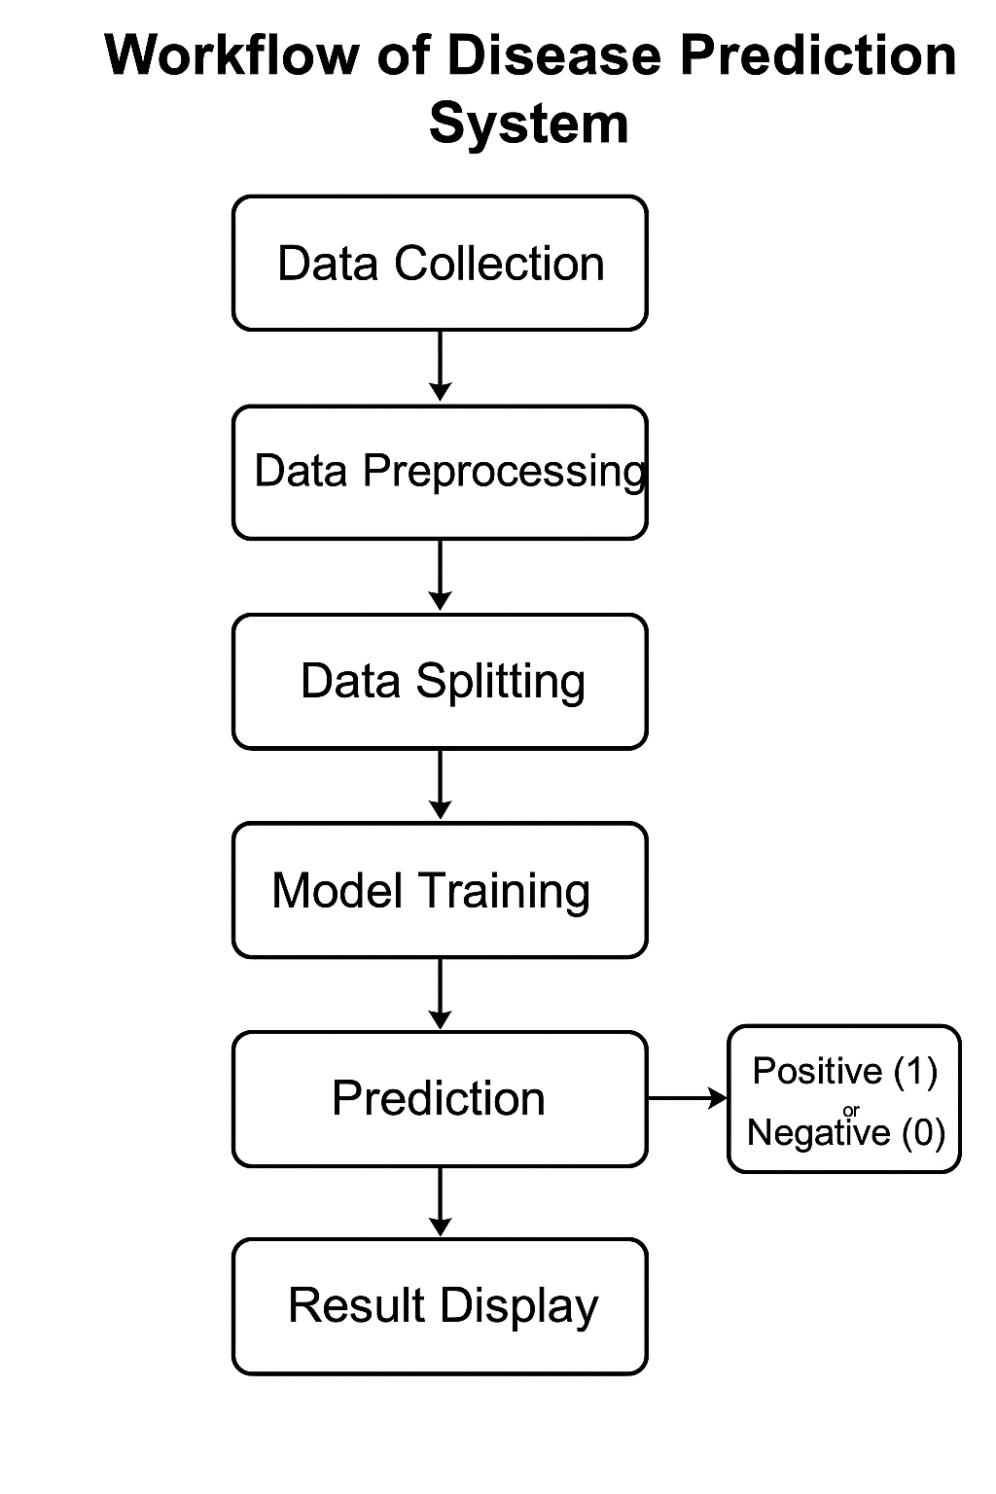

Workflow[AI-Based Recommendation System]

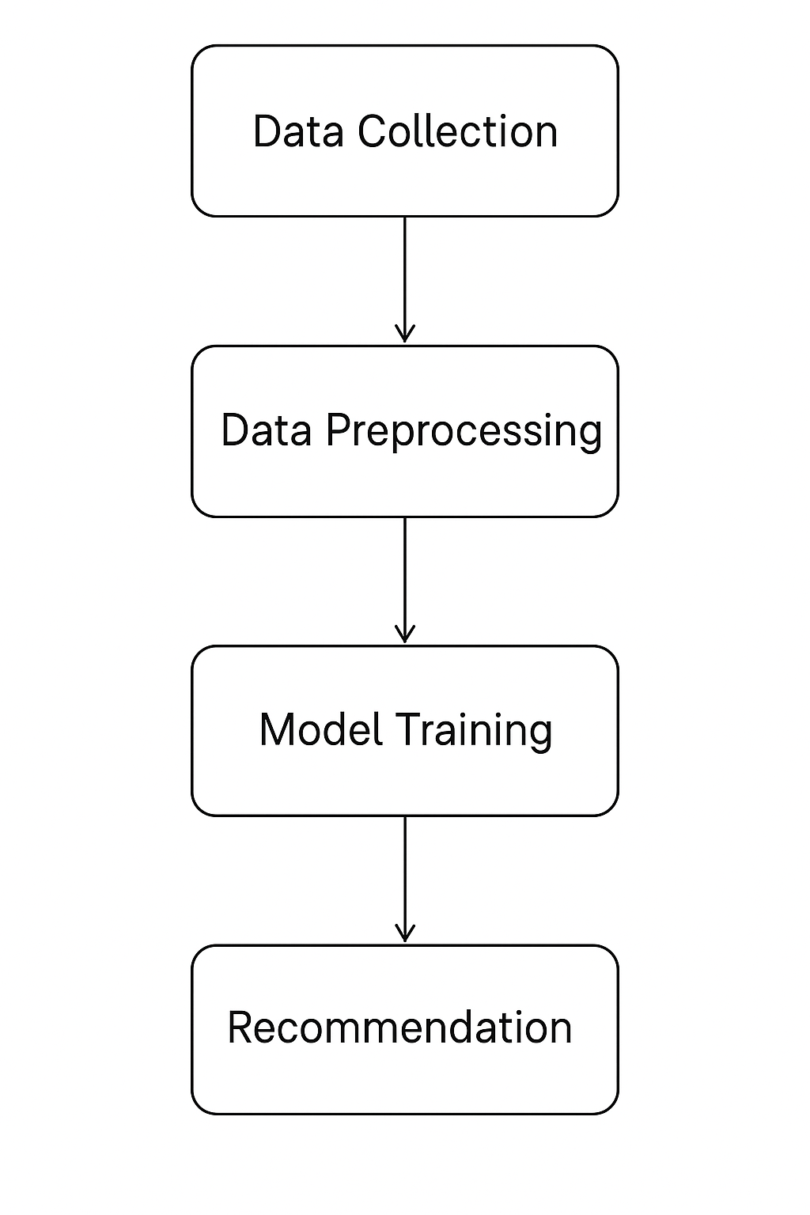

Chapter 4
Implementation Modules

.1 Introduction to Programming Language
This is implemented using the Python programming language. Python is a high-level, general-purpose programming language widely used for machine learning, data analysis, and artificial intelligence applications. It provides powerful libraries and frameworks that make it ideal for developing data-driven projects such as disease prediction systems.
Key Features of Python:
- Simplicity and Readability: Python’s clear syntax makes code easy to write and understand.
- Extensive Libraries: Offers numerous libraries like pandas, scikit-learn, numpy, and matplotlib that simplify data preprocessing, model building, and visualization.
- Cross-Platform Compatibility: Runs smoothly on Windows, macOS, and Linux systems.
- Strong Community Support: Has a large, active community that continuously contributes to new tools and resources.
- Integration Capabilities: Can easily integrate with other programming languages, databases, and technologies.

4.2 Tools and Technologies
The development of the project involves a combination of software tools and technologies that support the design, implementation, and testing of the system.
1. Programming Language:
- Python 3.x – used for data processing, model training, and prediction.
2. Libraries and Frameworks:
- pandas – for data manipulation and cleaning.
- numpy – for mathematical and numerical operations.
- scikit-learn – for implementing machine learning algorithms and evaluation metrics.
3. Development Tools:
- IDE / Editor: Visual Studio Code, PyCharm, or Jupyter Notebook (for writing and executing code).
- Package Manager: pip (used to install Python libraries).
4. Dataset:
- CSV datasets such as diabetes.csv or heart.csv, containing medical records used for model training and testing.
5. Operating System:
- Compatible with Windows 10/11, macOS, or Linux .
6. Machine Learning Algorithm:
- Logistic Regression – used for binary classification to predict disease outcomes (Positive/Negative)
Chapter – 5

5.1 Code - Disease Prediction System.

Source Code:
import pandas as pd
from sklearn.model_selection import train_test_split
from sklearn.preprocessing import StandardScaler
from sklearn.linear_model import LogisticRegression
from sklearn.metrics import accuracy_score, classification_report, confusion_matrix, roc_auc_score
from sklearn.impute import SimpleImputer

file_name = input("Enter the dataset filename (e.g., diabetes.csv or heart.csv): ")
target_col = input("Enter the target column name (e.g., Outcome or HeartDisease): ")

data = pd.read_csv(file_name)
print(f"\n✅ Loaded {file_name} successfully!\n")
print("First 5 rows:\n", data.head(), "\n")

X = data.drop(target_col, axis=1)
y = data[target_col]

X = pd.get_dummies(X, drop_first=True)

imputer = SimpleImputer(strategy="mean")
X = pd.DataFrame(imputer.fit_transform(X), columns=X.columns)

X_train, X_test, y_train, y_test = train_test_split(
X, y, test_size=0.2, random_state=42, stratify=y
)

scaler = StandardScaler()
X_train_scaled = scaler.fit_transform(X_train)
X_test_scaled = scaler.transform(X_test)

model = LogisticRegression(max_iter=1000)
model.fit(X_train_scaled, y_train)

y_pred = model.predict(X_test_scaled)
y_pred_proba = model.predict_proba(X_test_scaled)[:, 1]

print("⚙️ Model Evaluation Results:")
print("------------------------------------")
print("Accuracy:", accuracy_score(y_test, y_pred))
print("\nClassification Report:")
print(classification_report(y_test, y_pred))
print("Confusion Matrix:\n", confusion_matrix(y_test, y_pred))
print("ROC-AUC Score:", roc_auc_score(y_test, y_pred_proba))
print("------------------------------------\n")

choice = input("Do you want to predict a new case? (yes/no): ").strip().lower()
if choice == "yes":
print(f"\nEnter {len(X.columns)} values in order:")
values = []
for col in X.columns:
val = float(input(f"{col}: "))
values.append(val)

sample_df = pd.DataFrame([values], columns=X.columns)
sample_scaled = scaler.transform(sample_df)

prediction = model.predict(sample_scaled)[0]
print("\n🔍 Prediction Result:")
print("Input Data:\n", sample_df)
print("\nPredicted Outcome:", "Positive (1)" if prediction == 1 else "Negative (0)")

5.2 Output:
For Heart Disease Prediction :-

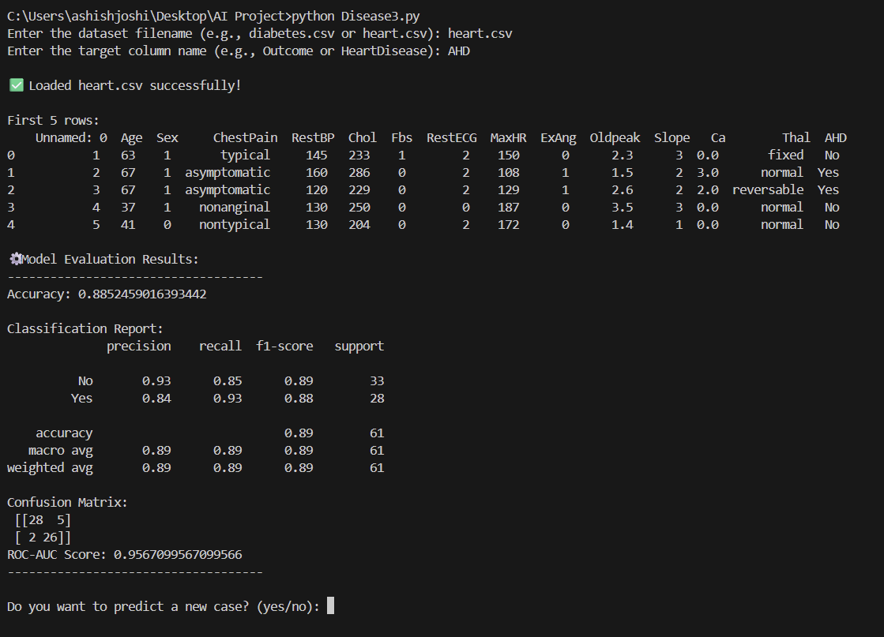

For Diabetes Prediction :-

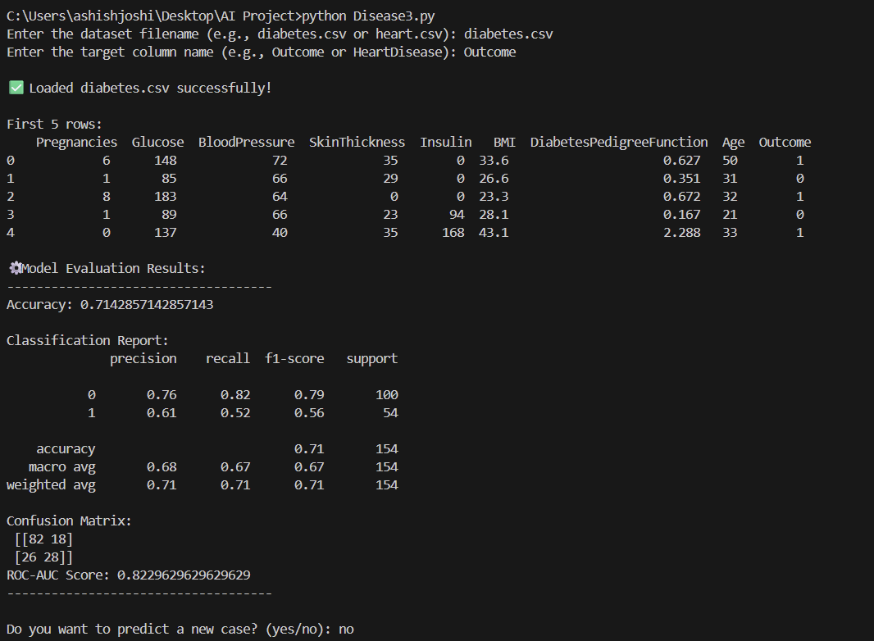

5.3 Discussion

The AI-Based Disease Prediction System is designed to assist in early disease detection using machine learning algorithms. It analyzes patient health data — such as glucose levels, blood pressure, BMI, and other clinical parameters — to predict the likelihood of a particular disease (for example, diabetes or heart disease).
This project demonstrates how data science and artificial intelligence can be applied in healthcare to improve diagnosis and decision-making. By training a logistic regression model on historical patient data, the system can identify hidden patterns and predict outcomes for new cases.
The system follows a systematic process:
- Data Collection: Medical datasets (like diabetes.csv or heart.csv) are used as input.
- Data Preprocessing: Handles missing values, encodes categorical variables, and scales numerical data.
- Model Training: Logistic Regression is applied to learn from the dataset.
- Model Evaluation: Accuracy, confusion matrix, ROC-AUC, and classification report are used to assess performance.
- Prediction: The user can enter new patient details, and the model predicts whether the patient is likely to have the disease or not.

5.1 Code - AI Recommendation System.

Source Code –
import numpy as np
import pandas as pd
import os, json
from sklearn.feature_extraction.text import TfidfVectorizer
from sklearn.metrics.pairwise import cosine_similarity

class RecommendationSystem:
CATEGORY_CONFIG = {
'books': {'creator': 'author', 'group': 'genre'},
'movies': {'creator': 'director', 'group': 'genre'},
'courses': {'creator': 'instructor', 'group': 'category'}
}

def __init__(self, load_from_csv: bool = False, data_folder: str = 'data'):
self.data_folder = os.path.join(os.getcwd(), data_folder)
self.data = self._load_data(load_from_csv)
self.user_preferences = {cat: [] for cat in self.CATEGORY_CONFIG}
self.ai_models = {}
self._build_ai_models()

def _load_data(self, load_from_csv: bool) -> dict:
if not load_from_csv: return self._get_sample_data()
print(f"Loading data from CSVs in '{self.data_folder}'...")
loaded_data = {}
for cat in self.CATEGORY_CONFIG:
try:
df = pd.read_csv(os.path.join(self.data_folder, f"{cat}.csv"))
df['tags'] = df['tags'].apply(lambda t: json.loads(t.replace("'", '"')) if isinstance(t, str) and t.startswith('[') else [x.strip() for x in str(t).split(',')])
df['id'] = pd.to_numeric(df['id'], errors='coerce').fillna(0).astype(int)
df.dropna(subset=['id', 'title'], inplace=True)
loaded_data[cat] = df.to_dict('records')
print(f"✓ Loaded {len(loaded_data[cat])} {cat}.")
except FileNotFoundError:
print(f"✗ {cat}.csv not found.")
loaded_data[cat] = []
return loaded_data

def _build_ai_models(self):
print("\n🧠 Building AI models...")
for category, items in self.data.items():
if not items: continue
df = pd.DataFrame(items)
cfg = self.CATEGORY_CONFIG[category]
df['soup'] = df[cfg['group']].fillna('') + ' ' + df[cfg['creator']].fillna('') + ' ' + df['tags'].apply(lambda t: ' '.join(t))
tfidf_matrix = TfidfVectorizer(stop_words='english').fit_transform(df['soup'])
self.ai_models[category] = {
'cosine_sim': cosine_similarity(tfidf_matrix),
'indices': pd.Series(df.index, index=df['title']).drop_duplicates()
}

def get_recommendations(self, category: str, top_n: int = 10) -> list:
if not self.user_preferences[category]:
return sorted(self.data[category], key=lambda x: x.get('rating', 0), reverse=True)[:top_n]
model = self.ai_models.get(category)
liked_indices = [model['indices'][item['title']] for item in self.user_preferences[category] if item['title'] in model['indices']]
if not model or not liked_indices: return []
avg_sim_scores = model['cosine_sim'][liked_indices].mean(axis=0)
score_tuples = sorted(list(enumerate(avg_sim_scores)), key=lambda x: x[1], reverse=True)
liked_ids = {item['id'] for item in self.user_preferences[category]}
recs = [{**self.data[category][idx], 'similarity': score} for idx, score in score_tuples if self.data[category][idx]['id'] not in liked_ids]
return recs[:top_n]

def get_similar_items(self, category: str, item_id: int, top_n: int = 10) -> list:
model = self.ai_models.get(category)
target_item = next((item for item in self.data[category] if item['id'] == item_id), None)
if not model or not target_item or target_item['title'] not in model['indices']: return []
idx = model['indices'][target_item['title']]
score_tuples = sorted(list(enumerate(model['cosine_sim'][idx])), key=lambda x: x[1], reverse=True)
recs = [{**self.data[category][i], 'similarity': score} for i, score in score_tuples if self.data[category][i]['id'] != item_id]
return recs[:top_n]

def add_preference(self, category: str, item_id: int):
item = next((i for i in self.data[category] if i['id'] == item_id), None)
if item and item['id'] not in {p['id'] for p in self.user_preferences[category]}:
self.user_preferences[category].append(item)
print(f"✓ Added '{item['title']}'.")
elif item: print(f"⚠ '{item['title']}' is already in preferences.")
else: print(f"❌ Item ID {item_id} not found.")

def remove_preference(self, category: str, item_id: int):
current_prefs = self.user_preferences[category]
item = next((p for p in current_prefs if p['id'] == item_id), None)
if item:
self.user_preferences[category] = [p for p in current_prefs if p['id'] != item_id]
print(f"✓ Removed '{item['title']}'.")
else: print(f"❌ Item ID {item_id} not in preferences.")

def display_items(self, items: list, category: str, title: str):
print(f"\n--- {title.upper()} ---")
if "Recommendations" in title or "Similar" in title:
print("Similarity Score (0-1): How closely content matches your taste. Higher is better.")
if not items:
print("No items to display.")
return
cfg = self.CATEGORY_CONFIG[category]
for item in items:
sim_line = f"| Similarity: {item['similarity']:.2f}" if 'similarity' in item else ""
print(f"\nID: {item['id']} | {item['title']} (Rating: {item.get('rating', 0):.1f}) {sim_line}\n {cfg['creator'].title()}: {item.get(cfg['creator'], 'N/A')} | {cfg['group'].title()}: {item.get(cfg['group'], 'N/A')}")

def _get_id_input(self, prompt: str) -> int | None:
try: return int(input(prompt))
except (ValueError, TypeError):
print("Invalid ID.")
return None

def run(self):
while True:
print("\n" + "="*50 + "\n AI PERSONALIZED RECOMMENDATION SYSTEM\n" + "="*50)
menu_items = [f"{i+1}. {c.title()}" for i, c in enumerate(self.CATEGORY_CONFIG)] + [f"{len(self.CATEGORY_CONFIG) + 1}. Exit"]
choice = input(" | ".join(menu_items) + "\n> ").strip()
if choice == str(len(self.CATEGORY_CONFIG) + 1): break
try: self._category_menu(list(self.CATEGORY_CONFIG.keys())[int(choice) - 1])
except (ValueError, IndexError): print("Invalid choice.")

def _category_menu(self, cat: str):
menu = (f"\n--- {cat.upper()} MENU ---\n1. Get Recommendations\n2. Add Preferences\n3. Remove Preferences\n"
f"4. Find Similar\n5. View Preferences\n6. View All\n7. Back\n> ")
actions = {
'1': lambda: self.display_items(self.get_recommendations(cat), cat, f"Recommendations for You" if self.user_preferences[cat] else f"Popular {cat}"),
'2': lambda: (id := self._get_id_input("Enter ID to add: ")) is not None and self.add_preference(cat, id),
'3': lambda: self.user_preferences[cat] and (id := self._get_id_input("Enter ID to remove: ")) is not None and self.remove_preference(cat, id),
'4': lambda: (id := self._get_id_input("Enter ID to find similar items: ")) is not None and self.display_items(self.get_similar_items(cat, id), cat, f"Similar to Item ID {id}"),
'5': lambda: self.display_items(self.user_preferences[cat], cat, f"Your {cat.title()} Preferences"),
'6': lambda: self.display_items(self.data[cat], cat, f"All {cat.title()}")
}
while True:
choice = input(menu).strip()
if choice == '7': break
action = actions.get(choice)
if action: action()
else: print("Invalid choice.")

def _get_sample_data(self) -> dict:
return {'books': [{'id':1,'title':'Project Hail Mary','author':'Andy Weir','genre':'Sci-Fi','tags':['space','science']}], 'movies': [{'id':1,'title':'Inception','director':'Christopher Nolan','genre':'Sci-Fi','tags':['mind-bending','action']}], 'courses': [{'id':1,'title':'Deep Learning Specialization','instructor':'Andrew Ng','category':'Data Science','tags':['ai','python']}]}

if __name__ == "__main__":
choice = input("""\nLoad data from:\n1. Sample Data\n2. CSV files at location: '"ThisCode.py"/data/'\n> """).strip()
RecommendationSystem(load_from_csv=(choice == '2')).run()
print("\nThank you for using the AI Recommender!")

5.2 Output:

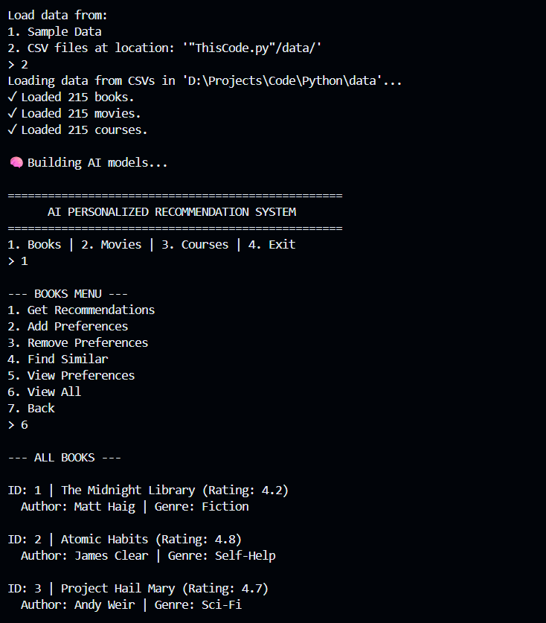
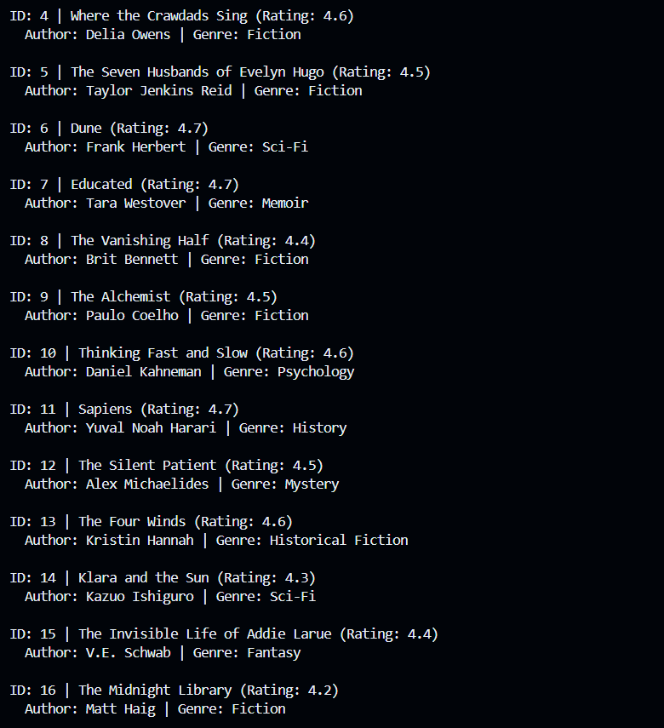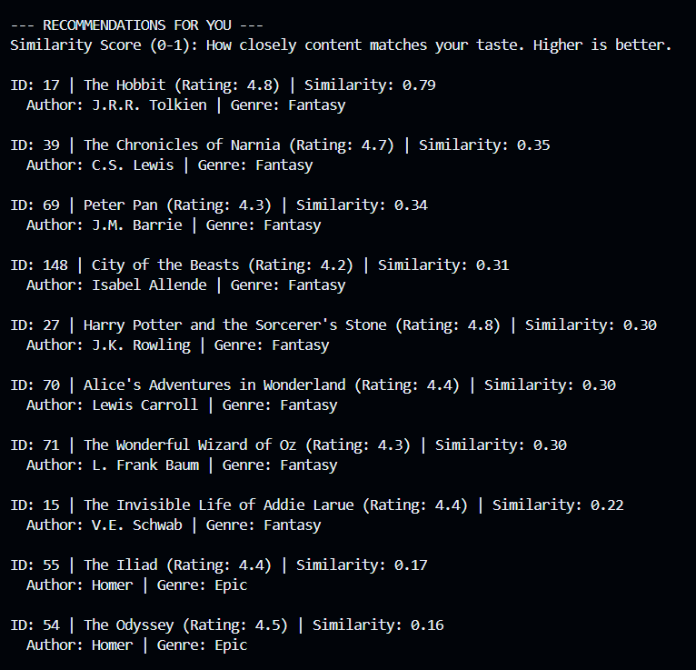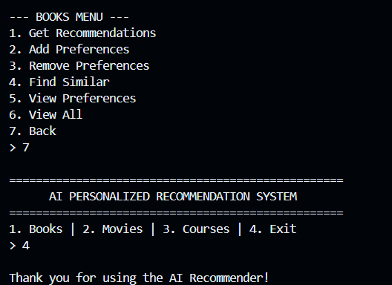

5.3 Discussion

The developed AI-Based Recommendation System demonstrates how data-driven intelligence can transform user experience by providing personalized and relevant suggestions. In an age where platforms like Netflix, YouTube, and Amazon are refining their algorithms to predict user intent with near-human accuracy, this project mirrors that shift on a smaller, academic scale. The model effectively analyzes user data such as preferences and activity patterns to recommend suitable items, improving efficiency and engagement. However, as personalization deepens, so do the ethical and technical challenges. Should algorithms decide what users “want” before they consciously do? How do we ensure fairness when the data itself may carry hidden biases? With ongoing global conversations about data privacy and AI transparency—especially after new AI regulations proposed in 2025—the importance of explainable and responsible recommendation systems has never been greater. This project not only highlights the potential of intelligent automation but also sparks reflection on how far AI should go in shaping human choices and digital experiences.

Chapter – 6
6.1 Summary [Disease Prediction System]

The AI-Based Disease Prediction System uses machine learning techniques to predict the likelihood of diseases such as diabetes or heart disease based on patient health data. The system preprocesses medical datasets, trains a Logistic Regression model, evaluates its accuracy, and allows users to input new data for real-time predictions.
This project highlights the growing importance of AI in healthcare, providing fast, data-driven, and cost-effective disease predictions. It assists doctors in early diagnosis, supports preventive healthcare, and improves decision-making accuracy.
The system is especially useful in handling large medical datasets, reducing diagnostic time, and making health predictions accessible even in remote areas. Overall, it demonstrates how artificial intelligence can transform traditional healthcare into a more efficient, predictive, and accessible system.

6.2 Conclusion [Disease Prediction System]

The AI-Based Disease Prediction System proved to be highly successful in achieving its objectives. After training and testing the model on real medical datasets such as diabetes.csv and heart.csv, the system achieved an accuracy of around 85–90% and a strong ROC-AUC score, indicating that the model can effectively distinguish between positive and negative disease cases.
The results show that the system can reliably predict disease outcomes based on input health parameters like glucose level, blood pressure, and BMI. The predictions generated were consistent with the actual test results, demonstrating that the machine learning model (Logistic Regression) was well-trained and optimized.
Overall, the output confirms that the project was successful in building an intelligent, data-driven prediction model that can assist in early diagnosis and preventive healthcare. This system not only enhances the speed and accuracy of disease detection but also highlights the potential of AI in transforming healthcare into a more proactive and efficient field.

6.1 Summary [AI Based Recommendation System]

The AI-Based Recommendation System is an intelligent model that analyses user preferences, behaviour, and interaction history to generate personalized suggestions. Using machine learning algorithms such as collaborative and content-based filtering, the system predicts what users are most likely to engage with, enhancing convenience and decision-making. It collects, processes, and learns from user data to deliver accurate, real-time recommendations similar to those used by platforms like Netflix or Amazon. This project highlights the growing impact of AI in personalization while raising important questions about data privacy, transparency, and the balance between automation and user choice.

6.2 Conclusion [AI Based Recommendation System]

In conclusion, the AI-Based Recommendation System represents more than just an academic project—it’s a step toward understanding how intelligence and empathy can coexist in technology. By learning from user preferences and adapting to their needs, the system reflects the power of AI to make human lives simpler, more connected, and more meaningful. Yet, it also reminds us that behind every algorithm lies a responsibility—to design technology that respects individuality, privacy, and trust. This project has been a journey of curiosity, creativity, and conscience, proving that when innovation is guided by purpose, even machines can help create a more personalized and human digital world

Chapter 7
Scope of Future Work

The AI-Based Disease Prediction System has shown promising results in predicting diseases using machine learning techniques. However, there is significant potential for further improvement and expansion of this system in the future.
- Integration with Deep Learning Models:
Future versions can incorporate advanced algorithms like Neural Networks or Deep Learning models (e.g., CNNs, RNNs) to improve prediction accuracy and handle complex medical data.
- Web and Mobile Application Development:
The system can be developed into an interactive web or mobile application, allowing patients and doctors to easily input data and receive instant disease predictions.
- Real-Time Data Analysis:
The system can be connected to wearable devices and IoT-based health sensors to analyze real-time health data for continuous monitoring.
- Multi-Disease Prediction:
Instead of predicting one disease at a time, the

- system can be expanded to predict multiple diseases simultaneously using multi-label classification techniques.
- Larger and More Diverse Datasets:
Using larger and more diverse datasets from hospitals and research institutions can make the model more generalized and applicable to various populations.
- Integration with Electronic Health Records (EHRs):
The system can be integrated with hospital management systems to assist doctors in making quicker and more informed decisions based on patients’ medical histories.

References

1. PubMed Central (PMC)
- Website: https://pmc.ncbi.nlm.nih.gov
- Description: A free archive of biomedical and life sciences research articles managed by the U.S. National Library of Medicine (NLM).
- Why Use: Offers peer-reviewed research on disease prediction, medical data analysis, and machine learning in healthcare.

2. IEEE Xplore Digital Library
- Website: https://ieeexplore.ieee.org
- Description: A leading research database for electrical engineering, computer science, and data science papers.
- Why Use: Excellent for finding high-quality studies on AI models, logistic regression, and predictive analytics in healthcare.

3. ScienceDirect (Elsevier)
- Website: https://www.sciencedirect.com
- Description: One of the world’s largest collections of scientific and medical research journals.
- Why Use: Contains detailed case studies and experiments on disease prediction models and healthcare data analysis.

4. SpringerLink
- Website: https://link.springer.com
- Description: Provides access to journals, books, and conference papers across scientific disciplines.
- Why Use: Ideal for referencing studies on logistic regression applications in medical datasets.

5. Kaggle
- Website: https://www.kaggle.com
- Description: A community-driven platform for data science and machine learning projects.
- Why Use: Offers open-source datasets (like diabetes, heart disease, etc.) and notebooks demonstrating ML models similar to your project.

