Task Service – Clean Architecture
Case Study Documentation
Architecture • Design Decisions • API • Testing • Cosmos DB

1. Executive Summary
This document describes the final Task Service case-study solution. The solution uses a clean, layered architecture with clear separation between the API, application, domain and infrastructure responsibilities. Azure Cosmos DB is used for persistence, while xUnit and Moq are used for unit testing.
The primary architectural goal is to keep application/business logic independent from Cosmos DB. The application service depends on ITaskRepository, while CosmosTaskRepository provides the infrastructure implementation.

2. Architecture
TaskService follows a layered architecture inspired by Clean Architecture principles, providing separation of concerns, testability, and maintainability.
High-Level Architecture
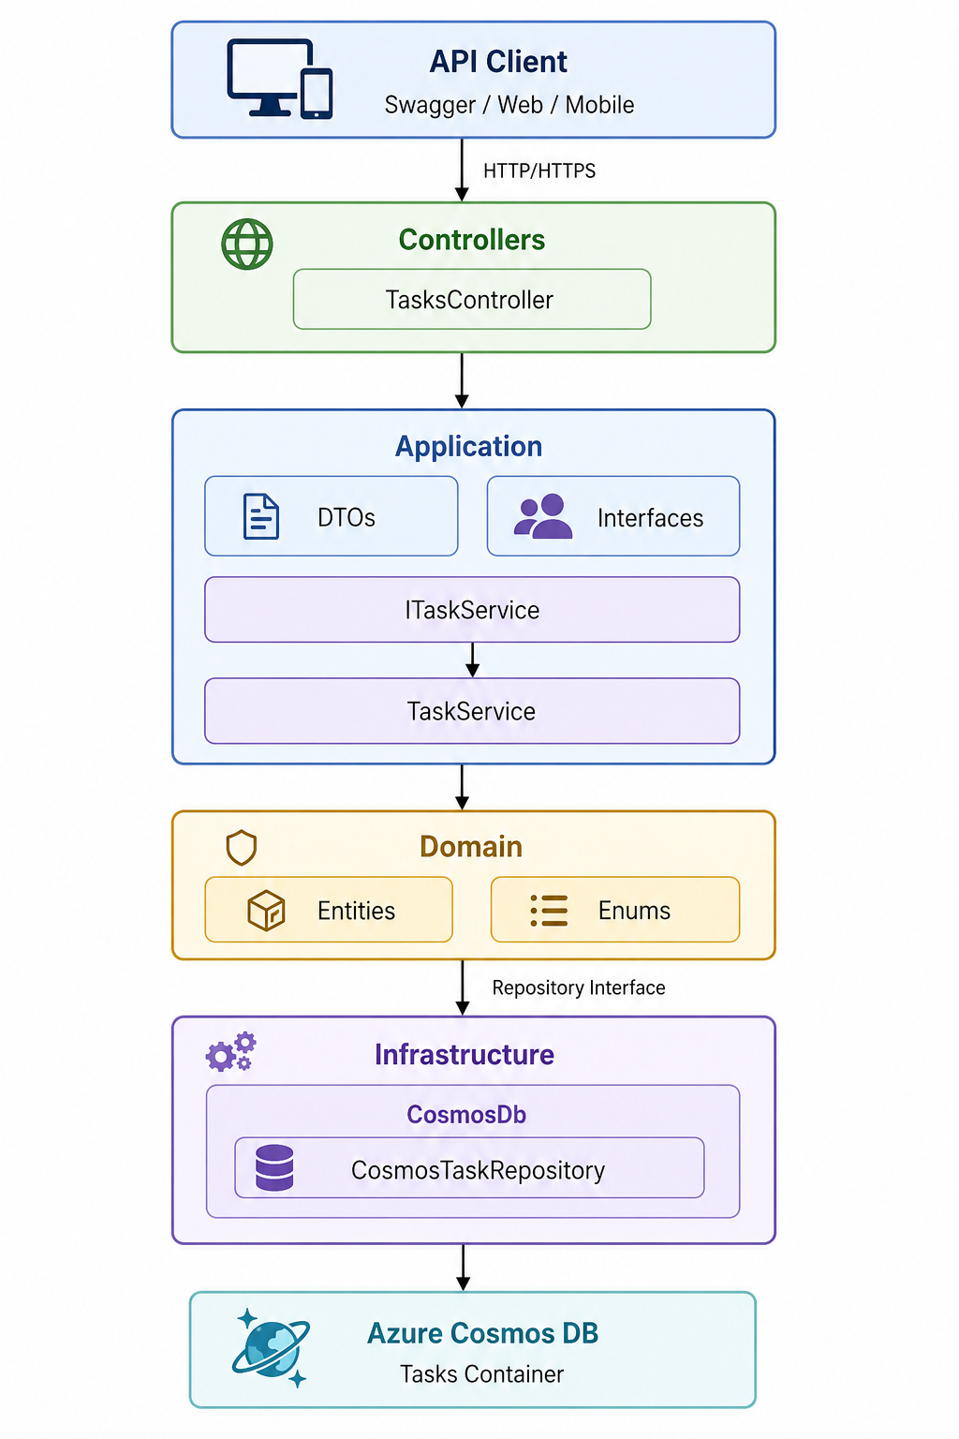

Recommended logical structure:
TaskService
│
├── Controllers
│ └── TasksController
│
├── Application
│ ├── DTOs
│ ├── Interfaces
│ └── Services
│ ├── ITaskService
│ └── TaskService
│
├── Domain
│ ├── Entities
│ └── Enums
│
├── Infrastructure
│ └── CosmosDb
│ └── CosmosTaskRepository
│
├── Middleware
│ └── ExceptionHandlingMiddleware
│
├── Exceptions
├── Options
│
└── Tests
├── Unit
│ ├── Services
│ └── Controllers
│

2.1 Request Flow
HTTP Request
↓
ExceptionHandlingMiddleware
↓
TasksController
↓
ITaskService / TaskService
↓
ITaskRepository
↓
CosmosTaskRepository
↓
Azure Cosmos DB

2.2 Dependency Direction
Controller
↓
Application Service
↓
Repository Interface
↑
Infrastructure Repository
↓
Cosmos DB
The key design decision is that TaskService does not directly depend on the Cosmos SDK. It depends on the ITaskRepository abstraction. This supports Dependency Inversion, Dependency Injection and isolated unit testing.

3. Layer Responsibilities

Controllers
Handles HTTP concerns, routing, request/response contracts and HTTP status codes. It should not contain business or persistence logic.

Application
Contains use-case orchestration, DTOs and interfaces. TaskService coordinates task operations through ITaskRepository.

Domain
Contains the core TaskItem entity and TaskStatus enum. Domain code should remain independent of infrastructure.

Infrastructure
Contains CosmosTaskRepository and the actual Azure Cosmos DB persistence implementation.

Middleware
Centralizes exception-to-HTTP response mapping and prevents duplicated try/catch logic in controllers.

Tests
Unit tests validate application and controller behavior in isolation. Integration tests validate the real Cosmos DB repository against an emulator or isolated test account.

4. Important Classes and Responsibilities
- TasksController – REST API entry point. Exposes POST, GET, PUT and DELETE endpoints.
- ITaskService – Application service abstraction used by the controller.
- TaskService – Implements task use cases, mapping, timestamps, not-found behavior and concurrency checks.
- ITaskRepository – Persistence abstraction. Keeps application logic independent of Cosmos DB.
- CosmosTaskRepository – Implements persistence using Microsoft.Azure.Cosmos.
- TaskItem – Domain entity persisted as a Cosmos document.
- CreateTaskRequest / UpdateTaskRequest – Input DTOs that define the API contract and validation rules.
- TaskResponse – Output DTO returned by the API.
- ExceptionHandlingMiddleware – Maps domain/application exceptions to consistent HTTP responses.
- CosmosDbOptions – Strongly typed Cosmos DB configuration.

5. API Design
Method | Endpoint | Purpose | Response
POST | /api/tasks | Create a task | 201 Created
GET | /api/tasks | Get all tasks | 200 OK
GET | /api/tasks/{id} | Get task by ID | 200 OK / 404 Not Found
PUT | /api/tasks/{id} | Update a task | 200 OK / 404 / 412
DELETE | /api/tasks/{id} | Delete a task | 204 No Content / 404 / 412

5.1 Example Create Request
{
"title": "Implement Task API",
"description": "Create REST API",
"status": 1,
"originalEstimatedWork": 8,
"remainingWork": 8,
"completedWork": 0
}

6. Azure Cosmos DB Design
Database: TaskDb
Container: Tasks
Partition key: /id
The current design uses task ID as the partition key because the main operations are point reads, updates and deletes by task ID. In a production system, the partition key should be validated against expected cardinality, query patterns, data distribution and RU consumption.

6.1 Cosmos DB System Properties
Property | Meaning | Application handling
_rid | Internal resource identifier | Not modeled
_self | Internal resource path | Not modeled
_etag | Document version used for optimistic concurrency | Mapped to ETag
_attachments | Legacy/internal attachment reference | Not modeled
_ts | Last modified Unix timestamp | Not modeled; application has CreatedAt/UpdatedAt

7. Exception Handling
ExceptionHandlingMiddleware provides a single location for translating known exceptions into HTTP responses and logging unexpected failures.
Exception | HTTP behavior
TaskNotFoundException | 404 Not Found
ConcurrencyException | 412 Precondition Failed
Unexpected Exception | 500 Internal Server Error
Request Cancellation | 499-style cancellation response in this implementation

8. Validation
- Title is required and limited to 200 characters.
- Description is limited to 2000 characters.
- Work values must be non-negative.
- ASP.NET Core model validation handles DTO validation before the service is invoked.

9. Testing Strategy
The test strategy separates fast isolated unit tests from integration tests that exercise real infrastructure.
Tests
│
├── Unit
│ ├── TaskServiceTests
│ └── TasksControllerTests
│
└── Integration
└── Cosmos DB / API integration tests

9.1 Unit Tests
- Create task and map response.
- Create task timestamps.
- Get existing task.
- Get missing task.
- Get all tasks.
- Get all when empty.
- Update task fields.
- Update missing task.
- Reject stale ETag.
- Preserve CreatedAt while updating UpdatedAt.
- Delete existing task.
- Delete missing task.
- Delete with stale ETag.
- Controller POST returns 201 Created.
- Controller GET returns 200 and ETag.
- Controller GET all returns 200.
- Controller PUT reads and passes If-Match.
- Controller DELETE returns 204.

9.2 Mocking Strategy
TaskServiceTests mock ITaskRepository, so service behavior can be tested without Cosmos DB. TasksControllerTests mock ITaskService, so controller behavior can be tested without invoking business logic or persistence.

9.3 Integration Tests
The final structure provides an Integration area and documents the recommended coverage. Integration tests should use the Cosmos DB Emulator or an isolated test account and should exercise the real CosmosTaskRepository rather than a mock.
- Create and persist a document.
- Read using ID and partition key.
- Replace with a valid ETag.
- Reject stale ETag with 412.
- Delete a document.
- Verify not-found behavior.

10. Configuration and Security
The sample appsettings.json is intended for local development/Cosmos DB Emulator use. For production, secrets should not be committed to source control.
- Prefer Managed Identity for Azure-hosted workloads where supported.
- Use secure configuration/secret management such as Azure Key Vault.
- Use authentication and authorization for the API.
- Use environment-specific configuration.
- Do not expose Cosmos credentials in Git repositories.

11. Local Setup and Execution
- Start the Azure Cosmos DB Emulator.
- Create database TaskDb.
- Create container Tasks with partition key /id.
- Verify the CosmosDb configuration.
- Run dotnet restore.
- Run dotnet build.
- Run dotnet test.
- Run the API using dotnet run --project src/TaskService.Api.
- Open /swagger on the HTTPS port displayed by the application.
A root endpoint is also available at / and returns the service name and running status.

12. Production-Readiness Improvements
- Managed Identity and secure secret management.
- Authentication and authorization.
- Pagination using Cosmos continuation tokens.
- Query/filter design based on Cosmos RU and partition strategy.
- Resilience/retry handling for transient failures.
- Application Insights / OpenTelemetry.
- Health checks for dependencies.
- Rate limiting.
- API versioning.
- Contract and integration tests.
- Infrastructure as Code.
- CI/CD quality gates.
- Security and dependency scanning.

16. Final Architecture Summary
HTTP
↓
ExceptionHandlingMiddleware
↓
TasksController
↓
ITaskService
↓
TaskService
↓
ITaskRepository
↓
CosmosTaskRepository
↓
Azure Cosmos DB
Cross-cutting:
Validation • Logging • Exception Handling • Cancellation • Optimistic Concurrency
Testing:
xUnit • Moq • Unit Tests • Integration Test Strategy

