CloudOps Assistant
Simple Q and A Chatbot with Python
Hands-On Assignment 3
Ashish Bhanudas Mahajan
MSCS-633 Advanced Artificial Intelligence
University of the Cumberlands
October 22, 2026

Implementation and training
CloudOps Assistant is a terminal chatbot built with Python, Django, and ChatterBot. It answers basic Cloud and DevOps questions and supports everyday team conversation. The application runs locally through the Django command python manage.py chat.
ChatterBot uses its BestMatch adapter to select responses from example conversations. Django stores the conversation data in SQLite. Training includes the English greetings and conversations corpora, plus a custom YAML corpus containing 63 question-and-answer pairs and one four-line assignment example.
Terminal learning starts ON. The /learning off command prevents new conversation writes while preserving existing answers. The /status command displays the current mode and storage. A similarity threshold of 0.90 selects a fallback for weak matches; similarity does not guarantee factual accuracy. New topics require reviewed training examples.

Source code and manifests
github.com/AshishM26/MSCS633_Assignment_3_CB
The repository contains the Python source, training corpus, tests, screenshots, and setup instructions. MANIFEST.in lists the resources included in the source distribution. requirements.txt pins Django 5.2.18, ChatterBot 1.2.15, chatterbot-corpus 1.3.3, and PyYAML 6.0.3. The project was validated with Python 3.11.15.

Django runtime evidence
The optional Django API provides a health endpoint and a CSRF-protected chat endpoint. API conversations always run with learning disabled.
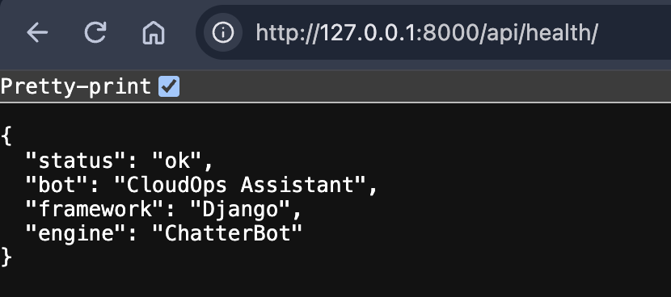
Figure 1. The local health endpoint returns the bot name, framework, and engine. This confirms application liveness, not training readiness.

Terminal conversation with learning disabled
The supplied terminal screenshot shows learning switched OFF, the reported OFF status, and successful answers about cloud computing, available topics, CI/CD, and deployment failures.
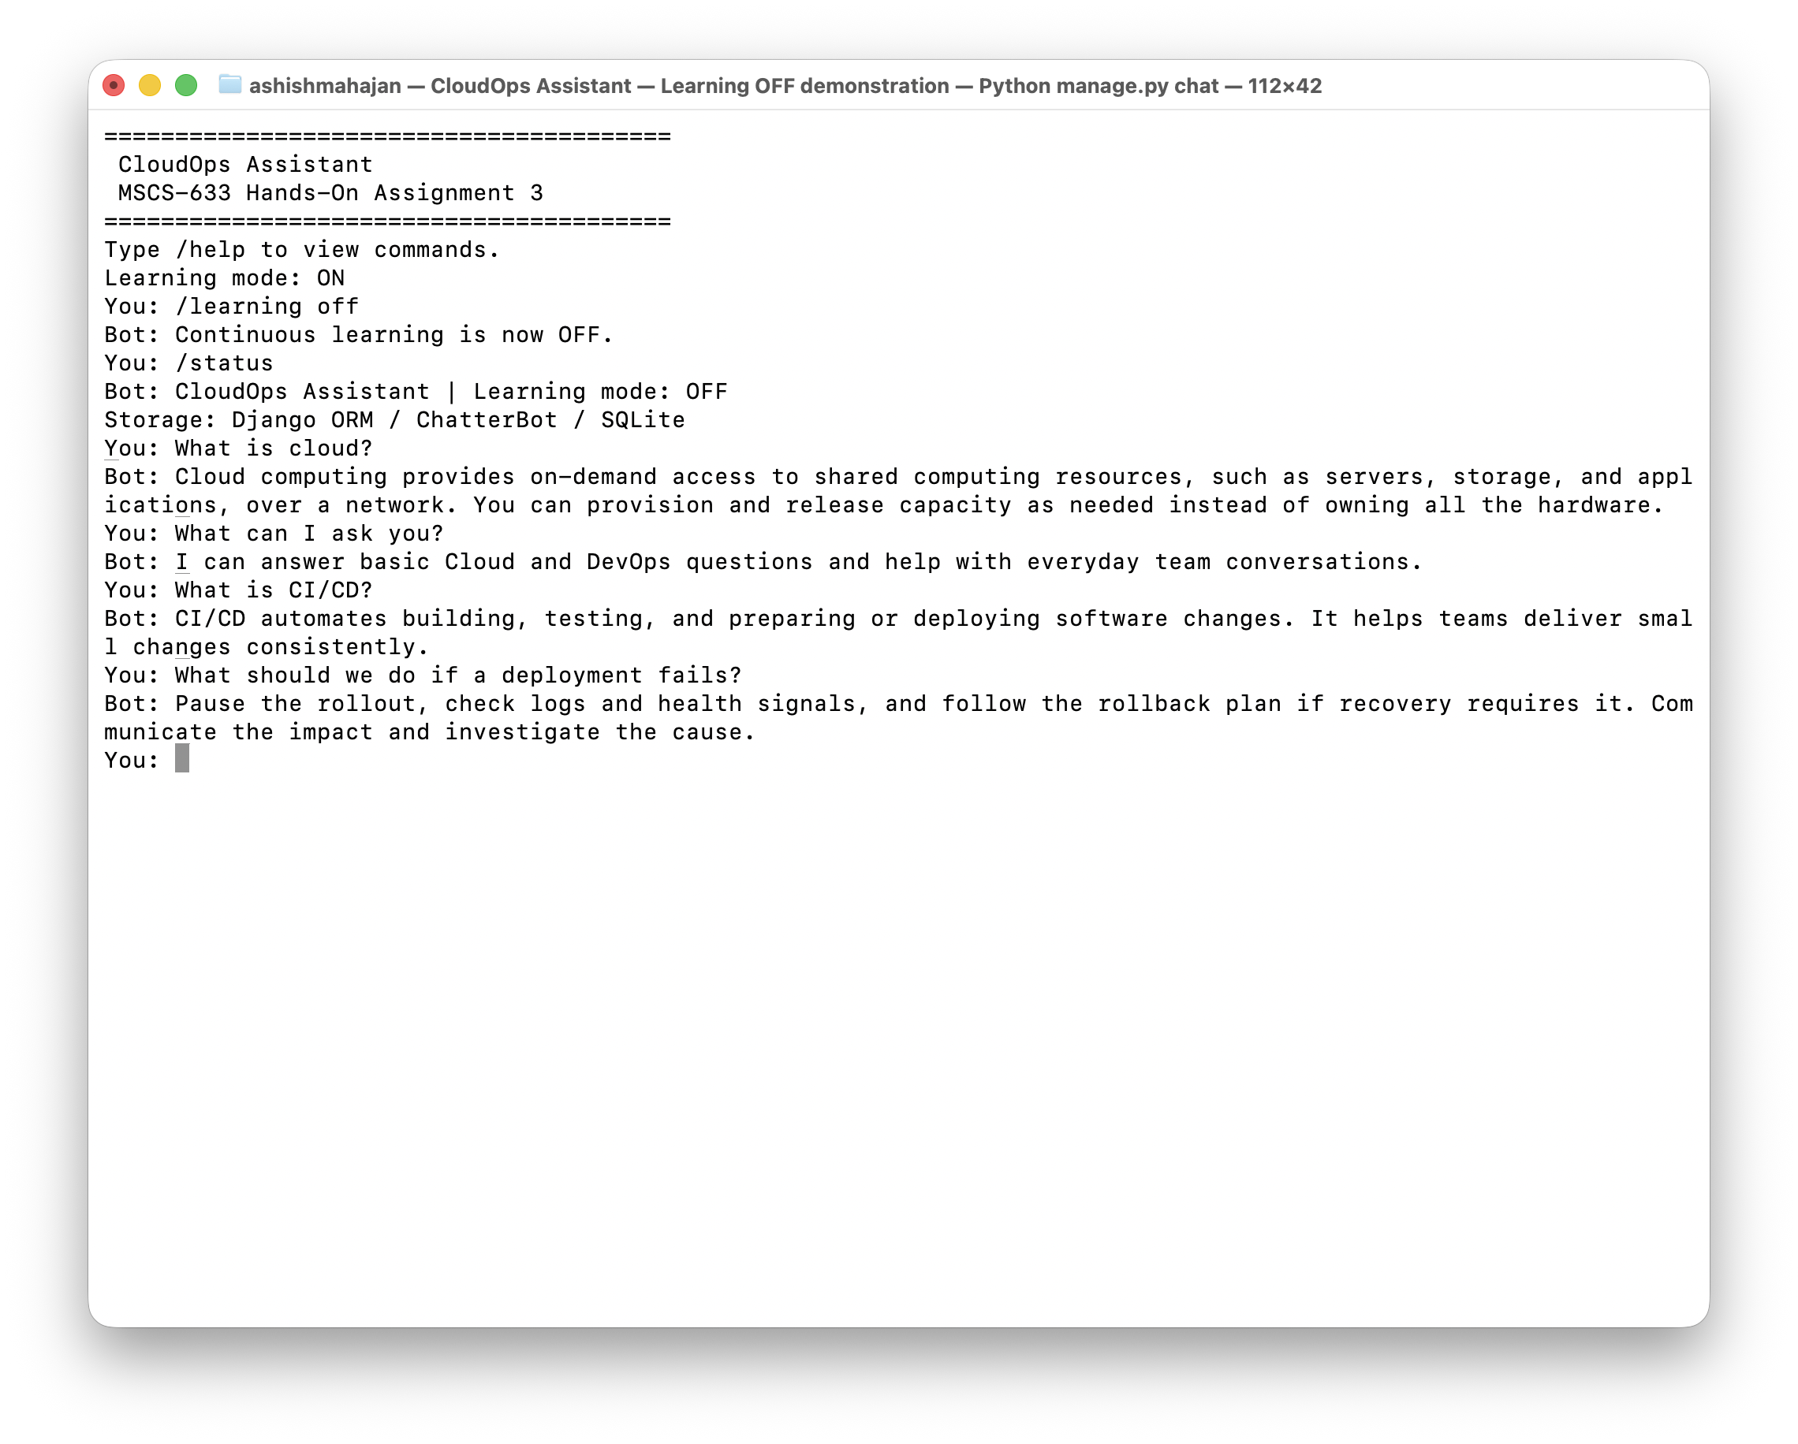
Figure 2. CloudOps Assistant continues answering trained questions after /learning off. The original screenshot is embedded without alteration.

Validation results
The final local review on October 22, 2026 used a fresh, separate SQLite database. Dependency checks, migrations, Django system checks, corpus training, and all 30 automated tests passed. The existing user database remained unchanged.
Terminal checks verified trained answers, learning toggles, blank input, unknown commands, and graceful exit. Database checks confirmed new records with learning ON and no new records with learning OFF. Live API checks returned successful health and chat responses, rejected invalid requests, and preserved read-only behavior.
The chatbot remains limited to example-based matching. Unseen wording can trigger a fallback, and repeated training can add duplicate statements. Additional reviewed examples can improve coverage.

