Program Structures and Algorithms

Spring 2024

NAME: Ashish Nevan Gade

NUID: 002889005

GITHUB LINK: https://github.com/AshishNevan/INFO6205

**Task: Determine the best predictor of runtime for sorting algorithms**

**Relationship Conclusion:**

**Hits is the best predictor for a sorting algorithm’s runtime**

**Evidence to support that conclusion:**

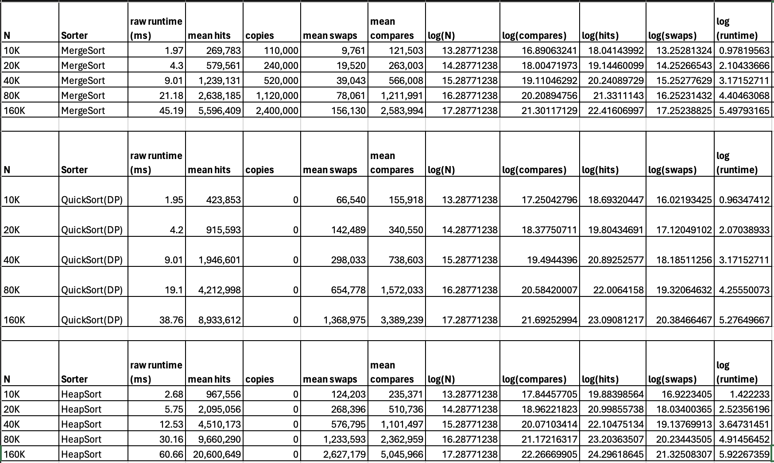

The following graphs below are plotted using various data observed during execution of 3 different sorting algorithms.

Merge sort has a high number of copies involving slower memory access times, (writing to RAM opposed to faster cache) which contribute to a higher runtime than quick sort.

Heap sort has a very high hit count, therefore is the slowest of the three.

From the graphs, we can observe high correlation between hits, compares and swaps with runtime. However, array accesses or hits are involved for swaps as well as compares. Hits are directly proportional to the time spent by the algorithm performing slower I/O tasks (reading memory). Therefore, it is safe to conclude that array accesses or hits are the best predictor of a sorting algorithm’s runtime.

**Console output:**

Non-instrumented (runtimes):

Instrumented (Statistics):

