HTML & CSS TASK : 1

**HTML code :**

**index.html :**

<!DOCTYPE html>

<html lang="en">

<head>

<meta charset="UTF-8">

<meta name="viewport" content="width=device-width, initial-scale=1.0">

<title>HTML and CSS Learning Project</title>

<link rel="stylesheet" href="styles.css">

</head>

<body>

<header>

<h1>Welcome to PayPal</h1>

<h2>Learn HTML and CSS with this Sample Project</h2>

</header>

<main>

<section>

<h2>List Example</h2>

<ol>

<li>item1</li>

<li>item2</li>

<li>item3</li>

</ol>

<ul style="list-style-type: square;"> <!--we can use [type="square"] but it's depricated in HTML5-->

<li>Employee 1</li>

<li>Employee 2</li>

<li>Employee 3</li>

</ul>

</section>

<section>

<h2>Table Example</h2>

<table border="1">

<tr>

<td>Header 1</td>

<td>Header 2</td>

</tr>

<tr>

<td>Row 1, Cell 1</td>

<td>Row 1, Cell 2</td>

</tr>

<tr>

<td colspan="2">This cell spans two columns</td>

</tr>

</table>

</section>

<section id="navigation">

<h2>Navigation Example</h2>

<p>

Visit <a href="page1.html">SamplePage1</a> or

<a href="page2.html">SamplePage2</a>.

</p>

</section>

<section>

<h2>Form Example</h2>

<form action="#" method="post">

<label for="name">Name:</label>

<input type="text" id="name" name="name">

<br>

<label for="email">Email:</label>

<input type="email" id="email" name="email">

<br>

<label for="phone">Phone:</label>

<input type="tel" id="phone" name="phone" pattern="[0-9]">

<br><br>

<input type="submit" value="Submit">

</form>

</section>

</main>

<footer>

<p>&copy; 2024 HTML and CSS Learning Project</p>

</footer>

</body>

</html>

**page1.html**

<!DOCTYPE html>

<html lang="en">

<head>

<meta charset="UTF-8">

<meta name="viewport" content="width=device-width, initial-scale=1.0">

<title>Sample Page 1</title>

<link rel="stylesheet" href="styles.css">

</head>

<body>

<header>

<h1>Sample Page 1</h1>

</header>

<section>

<p>This is a sample page with some placeholder content. Navigate back to the <a href="index.html">main page</a>.</p>

</section>

<footer>

<p>&copy; 2024 HTML and CSS Learning Project</p>

</footer>

</body>

</html>

**page2.html**

<!DOCTYPE html>

<html lang="en">

<head>

<meta charset="UTF-8">

<meta name="viewport" content="width=device-width, initial-scale=1.0">

<title>Sample Page 2</title>

<link rel="stylesheet" href="styles.css">

</head>

<body>

<header>

<h1>Sample Page 2</h1>

</header>

<section>

<p>This is another sample page with some placeholder content. Navigate back to the <a href="index.html">main page</a>.</p>

</section>

<footer>

<p>&copy; 2024 HTML and CSS Learning Project</p>

</footer>

</body>

</html>

**CSS Code :**

**styles.css**

/* General reset and global styles */

body {

font-family: Arial, sans-serif;

margin: 0;

padding: 0;

}

body section {

margin: 20px;

}

/* Header styles */

header {

background-color: #333;

color: #fff;

text-align: center;

padding: 10px;

}

/* Aside styles */

aside {

background-color: #f0f0f0;

padding: 10px;

width: 25%;

float: right;

}

/* Main content styles */

main {

padding: 20px;

}

/* Form styles */

form {

background-color: #f0f0f0;

padding: 20px;

border-radius: 5px;

margin-bottom: 20px;

}

/* Form input styles */

input[type="text"],

input[type="email"],

input[type="tel"] {

width: calc(100% - 22px);

padding: 10px;

margin: 5px 0 10px;

border: 1px solid #ccc;

border-radius: 4px;

box-sizing: border-box;

}

/* Label styles */

label {

display: block;

margin: 10px 0 5px;

}

/* Footer styles */

footer {

background-color: #333;

color: #fff;

text-align: center;

padding: 10px;

position: fixed;

bottom: 0;

width: 100%;

}

/* Enhanced Task: Input Submit Button styles */

input[type="submit"] {

background-color: #4CAF50;

color: white;

padding: 10px 20px;

border: none;

border-radius: 4px;

cursor: pointer;

}

input[type="submit"]:hover {

background-color: #45a049;

}

**Output :**

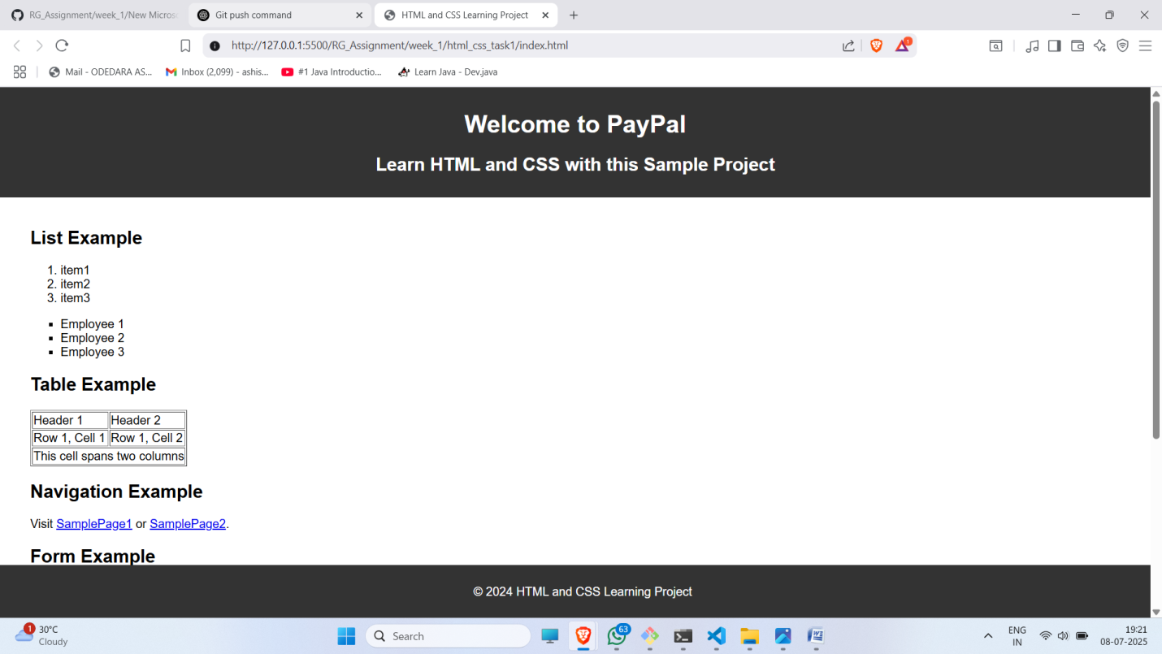

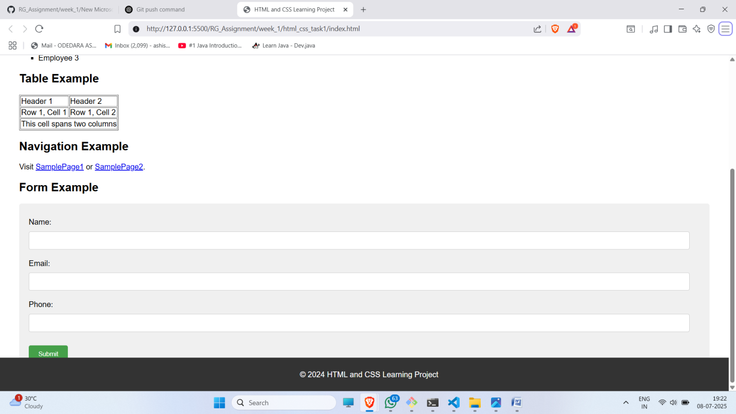

**Repository Link :**

[**https://github.com/AshishOdedra/RG_Assignment/tree/main/week_1/html_css_task1**](https://github.com/AshishOdedra/RG_Assignment/tree/main/week_1/html_css_task1)