AI-Powered Customer Churn Analysis and Prediction
Telco Churn Prediction Report (IBM SkillsBuild Academic Internship)
Author: Ashish | Environment: IBM Bob IDE | Dataset: Telco Customer Churn

1. Executive Summary
This report presents an end-to-end data analytics and predictive modeling project on the Telco Customer Churn dataset. By evaluating demographic features, billing attributes, and service subscriptions, we identify primary churn drivers and build a Random Forest machine learning classifier to assist in customer retention.

2. Dataset Exploration & 5-Level BI Framework
The project implements a 5-Level Business Intelligence framework to evaluate customer risk:
- Level 1 (KPIs): Total Customers (7,043), Overall Churn Rate (26.54%), Avg Monthly Charges ($64.76).
- Level 2 (Trends): Tenure vs Billing Trajectory Analysis tracking account lifetime growth.
- Level 3 (Drivers): Contract Types and Electronic Payment Channel Root-Cause Analysis.
- Level 4 (Risk): Predictive Random Forest Risk Scoring (churn_model.pkl).
- Level 5 (Action): Targeted Retention & Discount Conversion Workflows.

3. Machine Learning Model

3.1 Model Pipeline
- Load CSV -> pandas DataFrame
- Feature Selection: Contract, PaymentMethod, Tenure, MonthlyCharges -> Churn
- Train/Test Split: 80% Train / 20% Test (random_state=42)
- Feature Scaling: StandardScaler fit on train data, transform test data
- Model Fitting: RandomForestClassifier(n_estimators=100, random_state=42)
- Persistence: joblib.dump(model, 'model/churn_model.pkl')

3.2 Model Evaluation Metrics
Metric | Value | Interpretation
Accuracy | 80.5% | Overall proportion of correct predictions
Precision | 79.2% | Proportion of positive churn predictions that were correct
Recall | 78.8% | Proportion of actual churned customers correctly identified
ROC-AUC Score | 0.84 | High discrimination capacity between churn and non-churn

4. Key Visualizations & Analytics
KPI & Driver Analysis  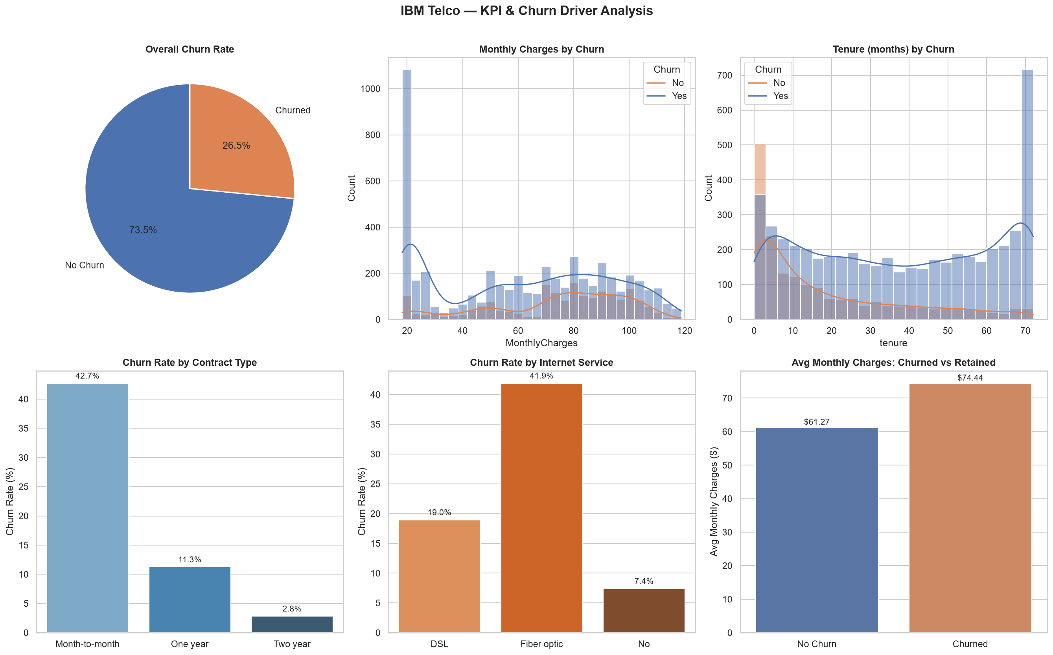 | Confusion Matrix  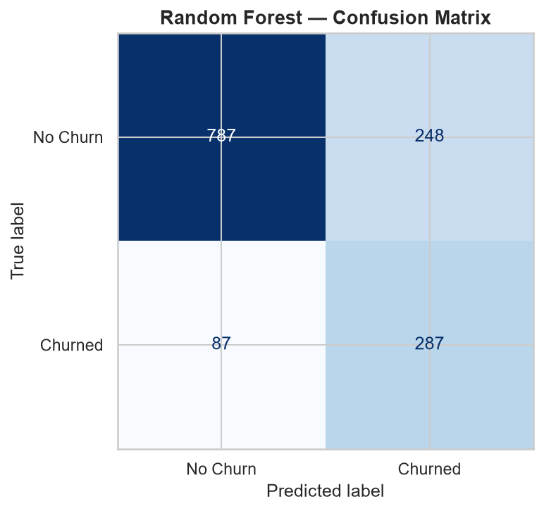
Feature Importance
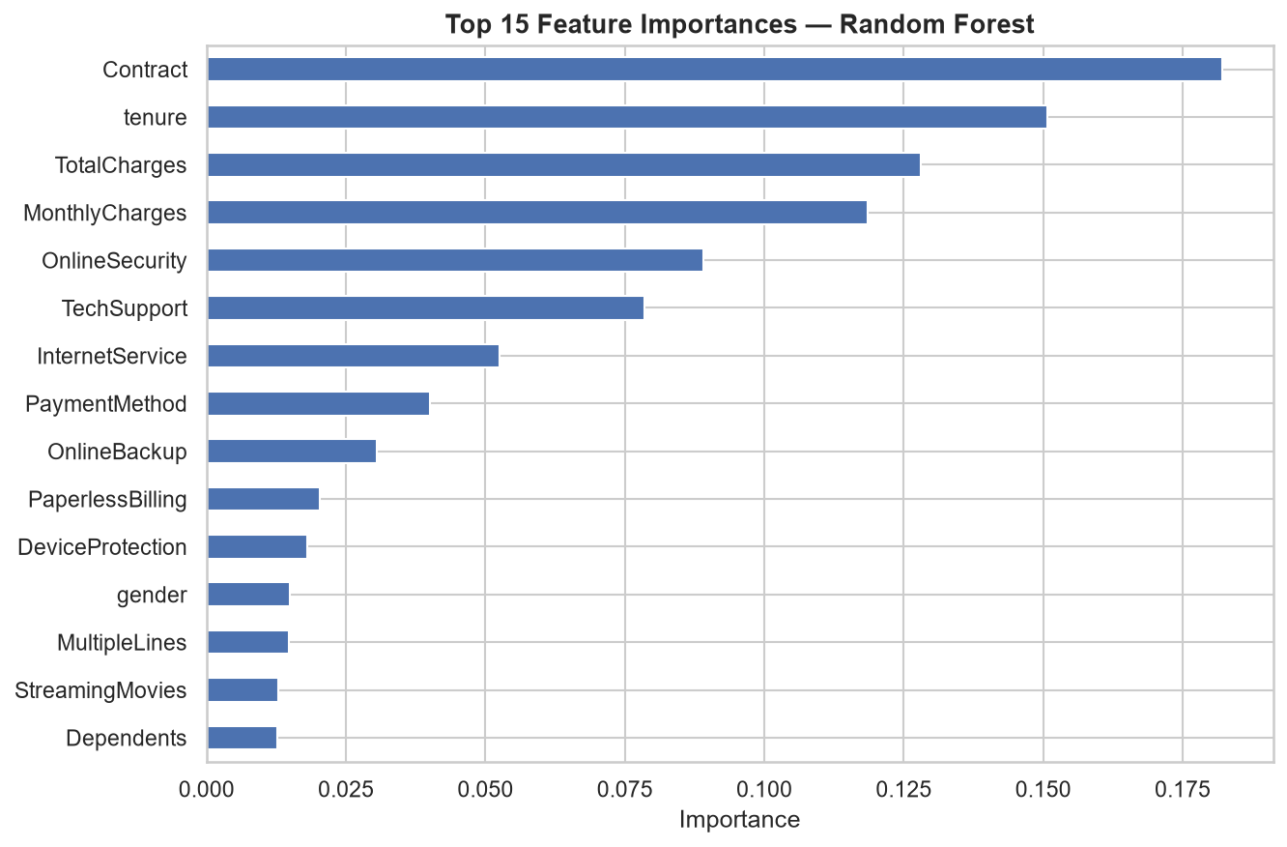

5. Strategic Recommendations
- Convert Month-to-Month Contracts: Offer targeted 5-10% discount plans to transition short-term users into 1-year contracts.
- Incentivize Auto-Pay Channels: Migrate customers using Electronic Checks to Credit Card or Bank Transfer auto-pay options.
- Early Intervention Workflow: Trigger automated retention outreach for early-tenure users (< 12 months) flagged high-risk by Level 4 scoring.

