**Here we check all the output:**

1. **On .txt file**

Here we check output of .txt file on Basic NLP Function, Advanced NLP Function and Text Visualization.

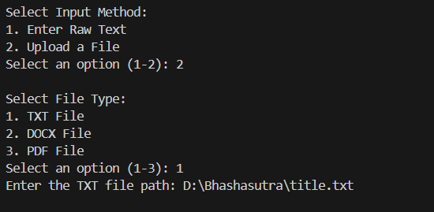

**Basic NLP FUNCTION on .txt file:**

Count Words Function:

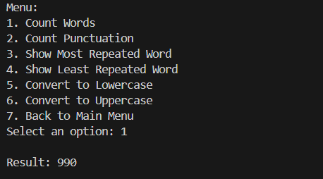

* **Count Punctuation Function:**

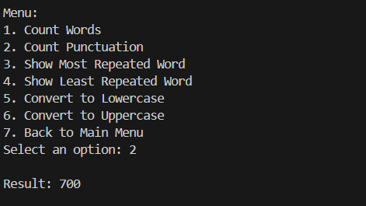

* **Show Most Repeated Word Function:**

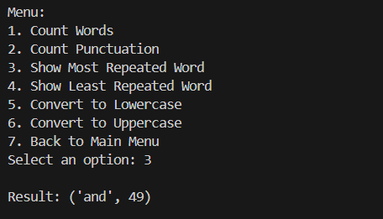

* **Show Least Repeated Word Function:**

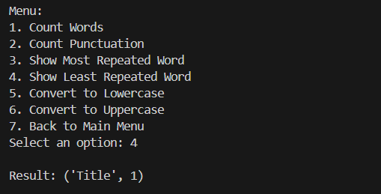

* Convert to Lowercase **Function:**

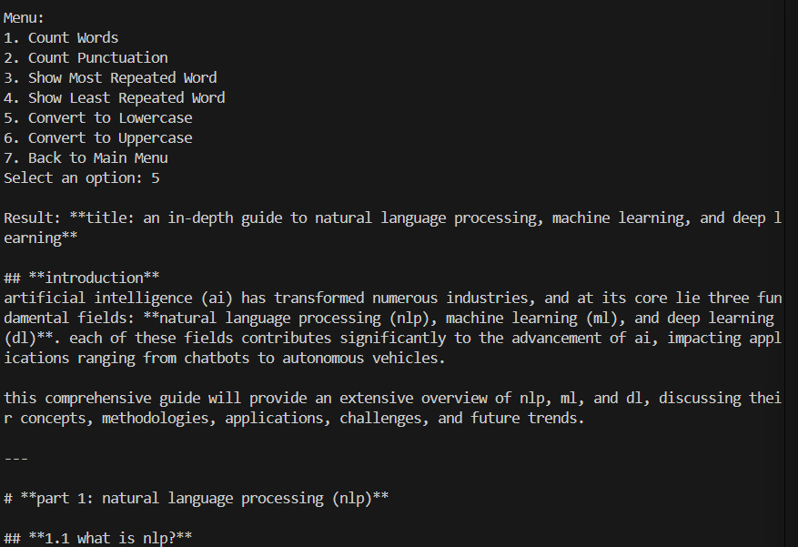

* Convert to Uppercase **Function:**

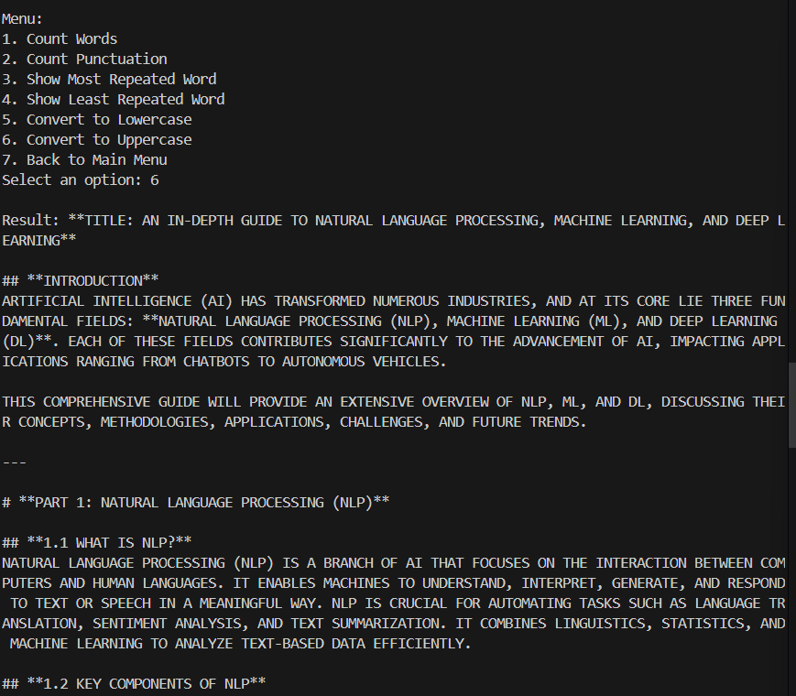

**Advanced NLP FUNCTION on .txt file:**

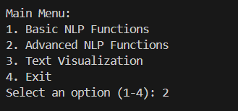

* Word Tokenization:

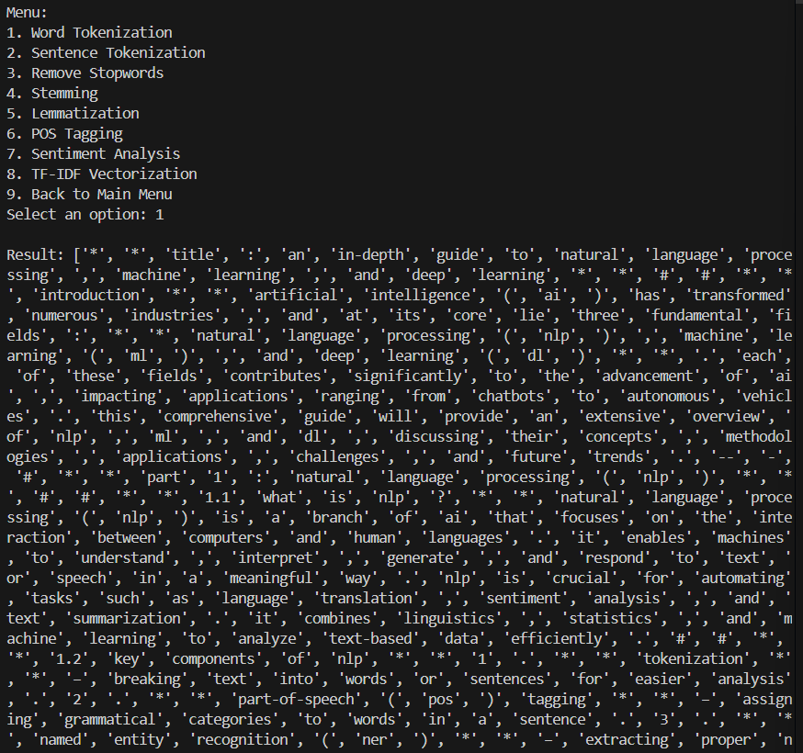

* Sentence Tokenization:

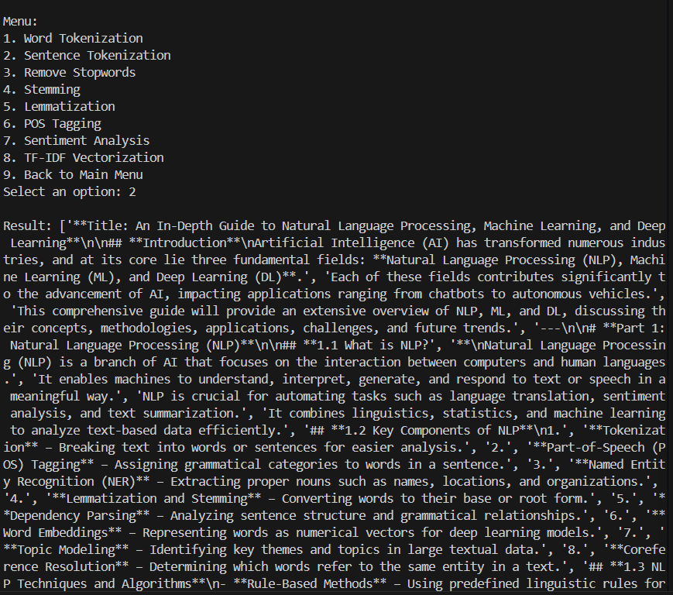

* Remove Stopwords:

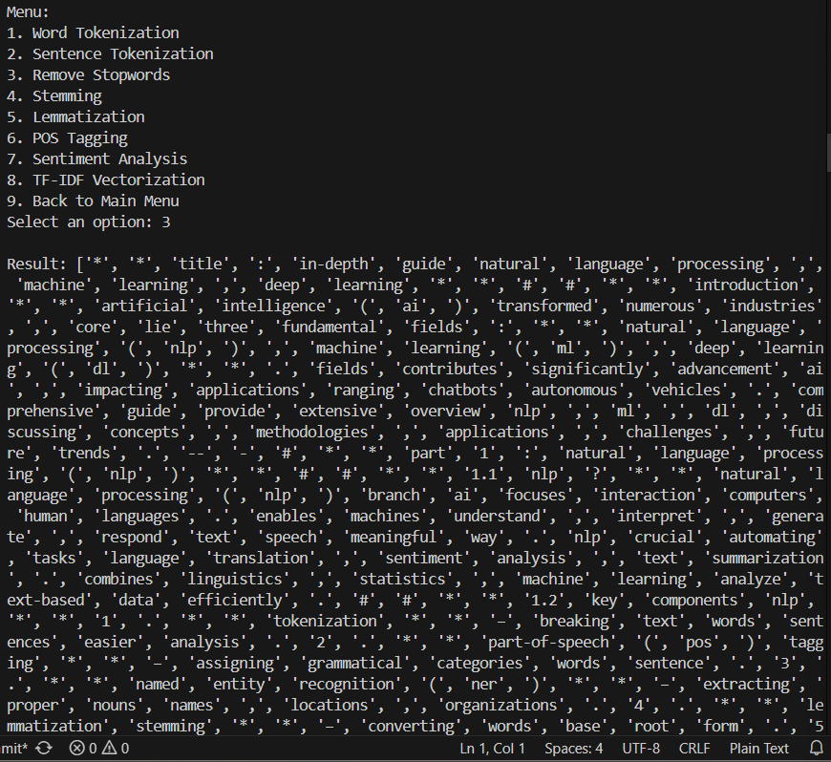

* Stemming:

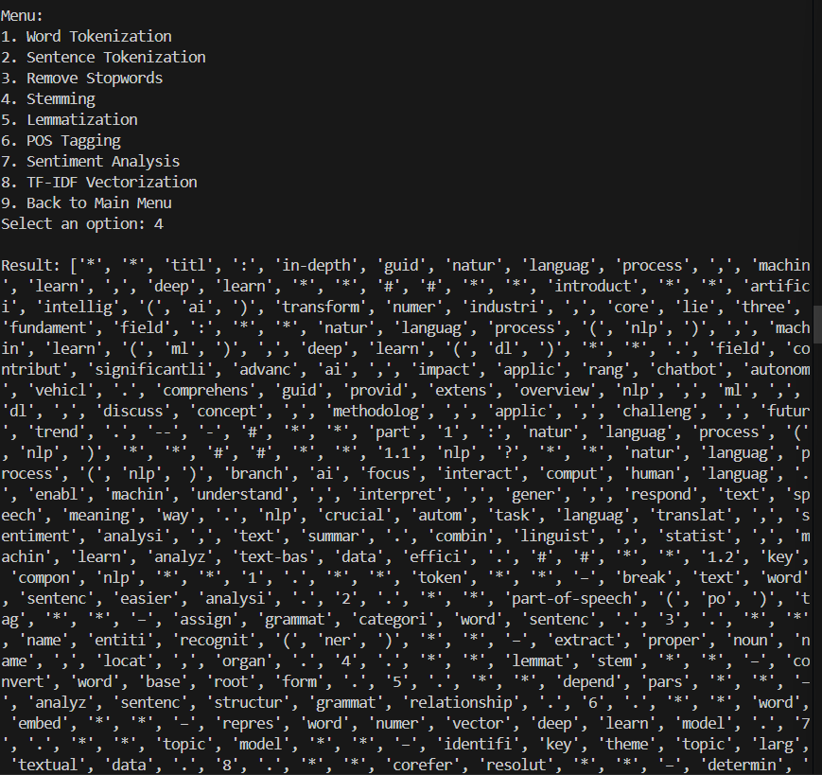

* Lemmatization:

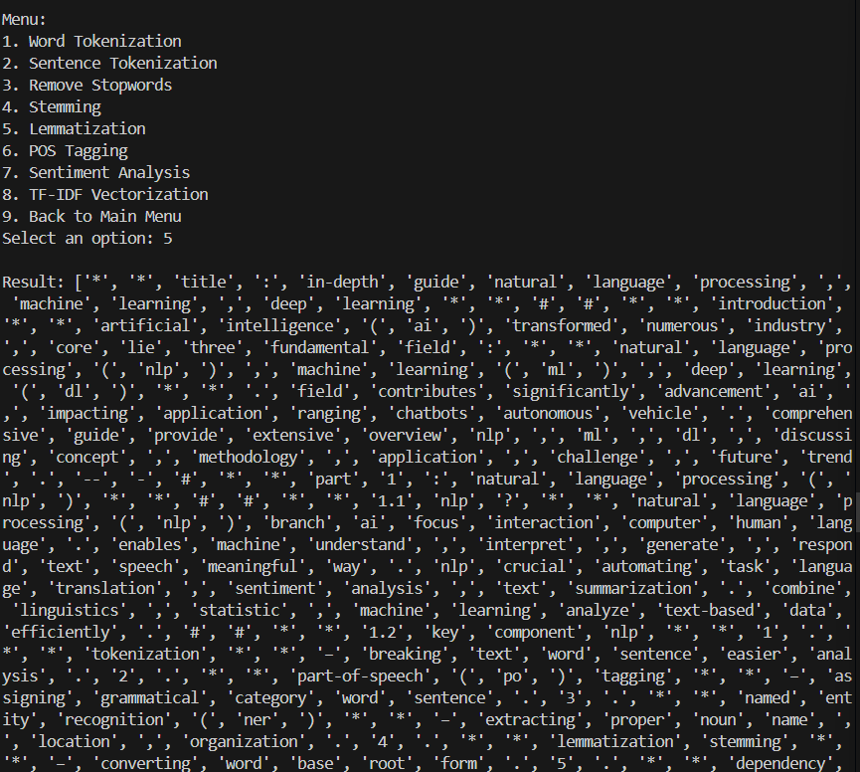

* POS Tagging:

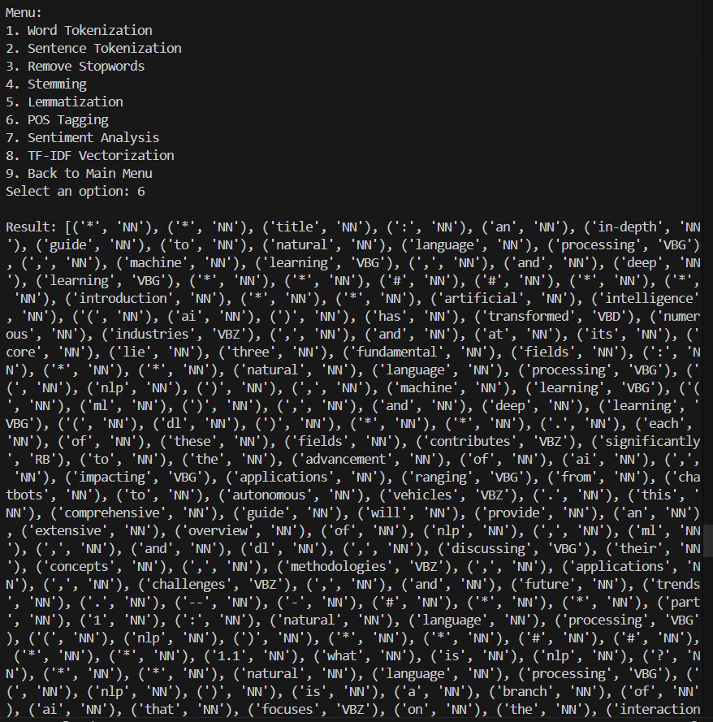

* Sentiment Analysis:

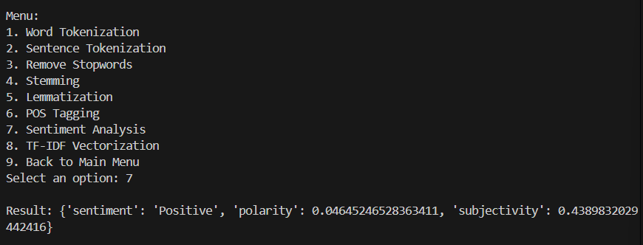

* TF-IDF Vectorization:

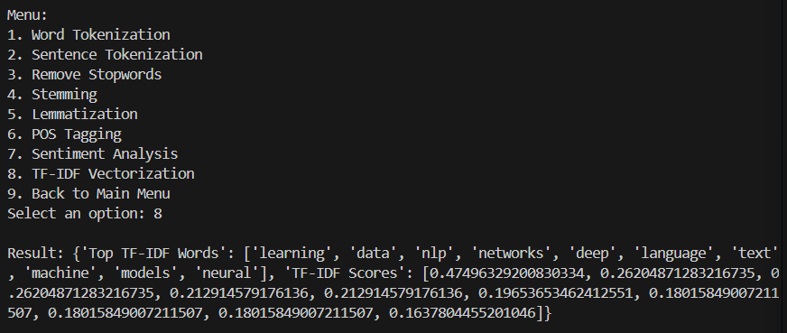

**Text Visualization on .txt file:**

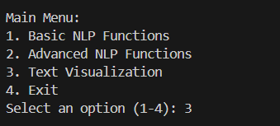

* **Generate Word Cloud:**

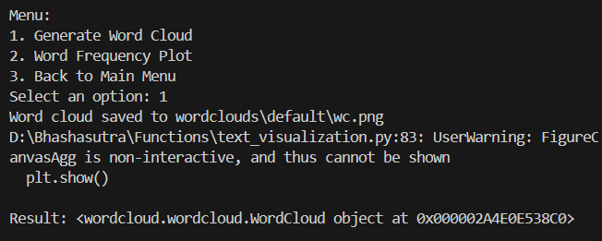

* Word Frequency Plot:

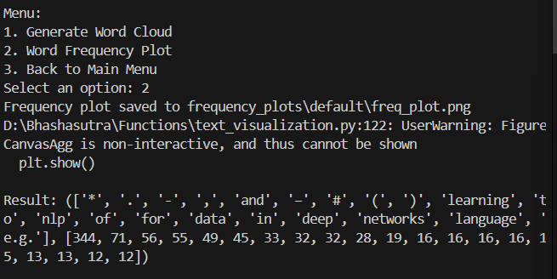

1. **On .docx file**

Here we check output of .docx file on Basic NLP Function, Advanced NLP Function and Text Visualization.

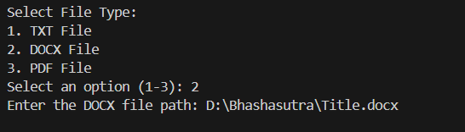**\**

**Basic NLP FUNCTION on .docx file:**

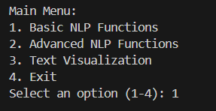

* **Count Words:**

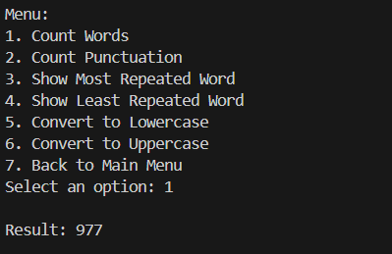

* **Count Punctuation:**

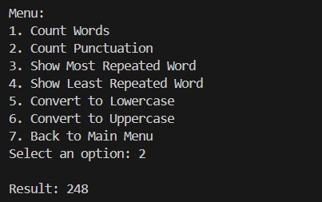

* **Show Most Repeated Word:**

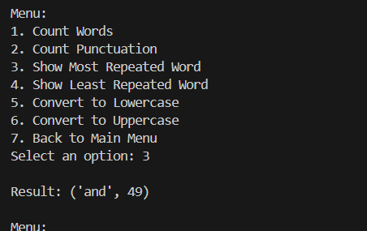

* **Show Least Repeated Word:**

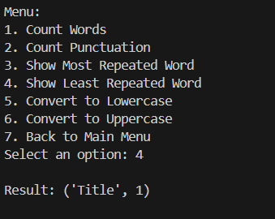

* **Convert to Lowercase:**

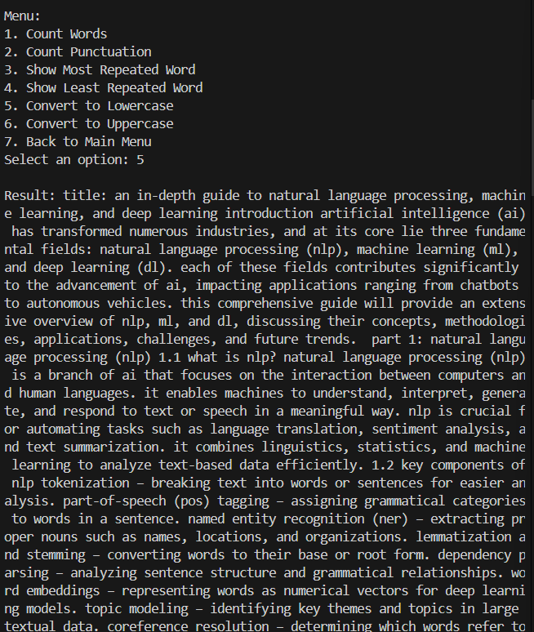

* **Convert to Uppercase:**

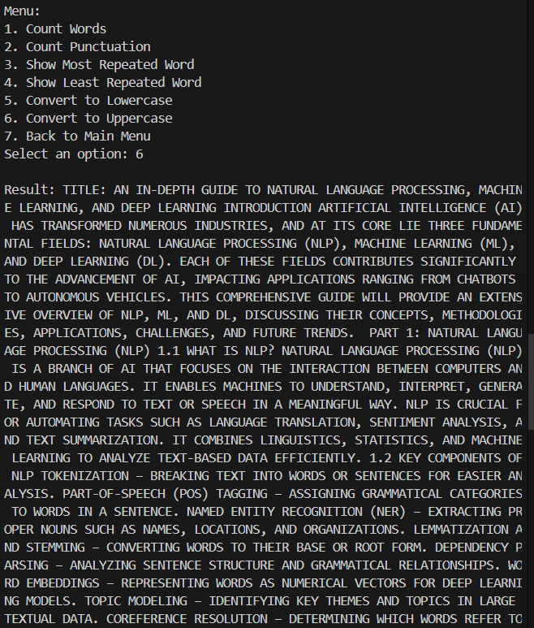

**Advanced NLP FUNCTION on .docx file:**

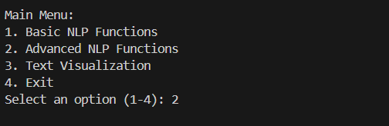

* **Word Tokenization:**

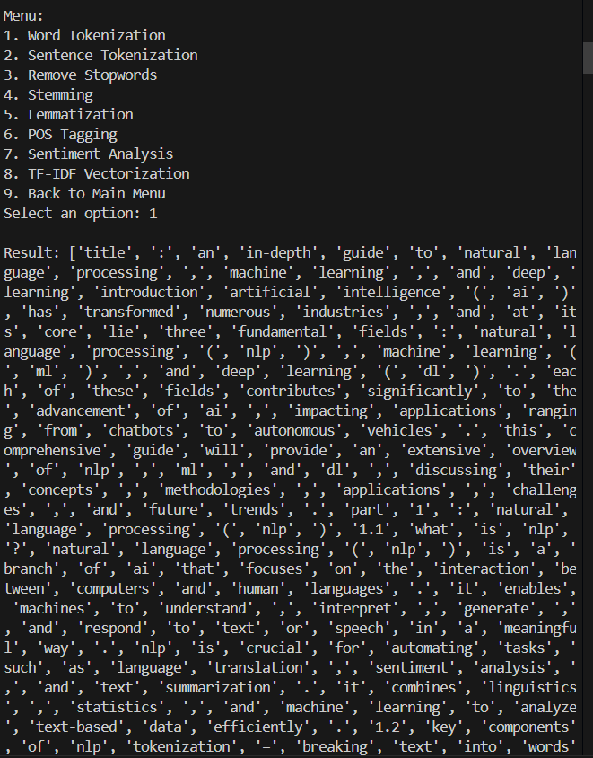

* **Sentence Tokenization:**

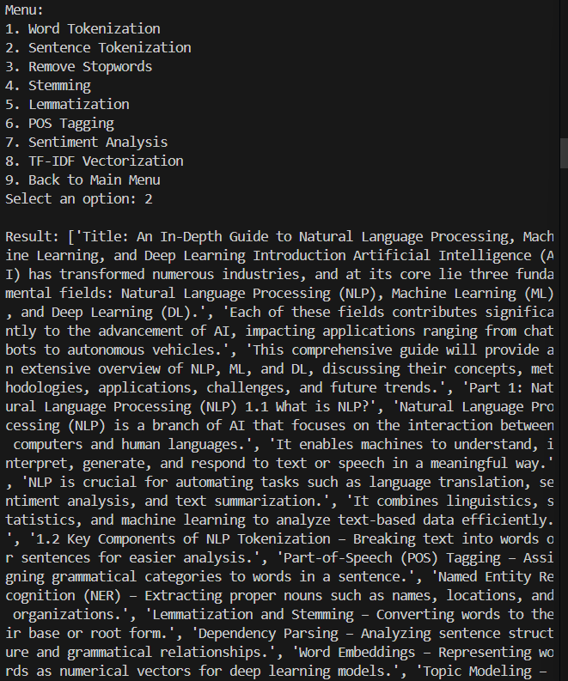

* **Remove Stopwords:**

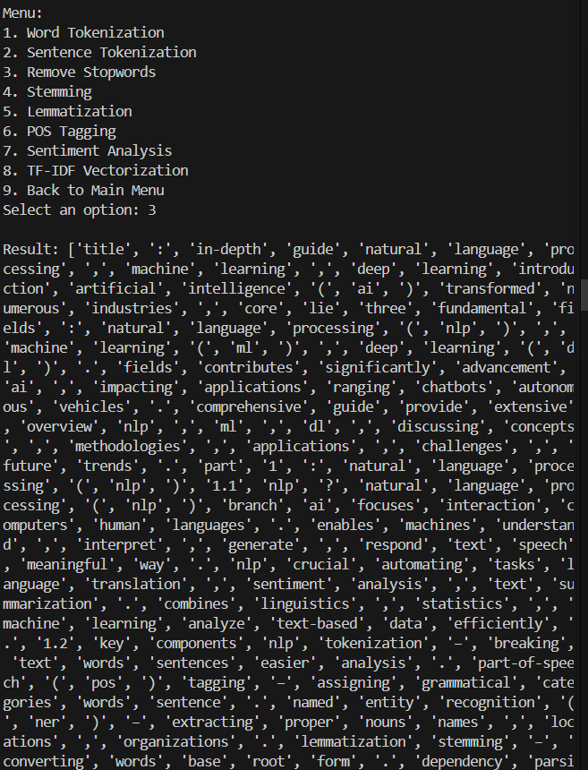

* **Stemming:**

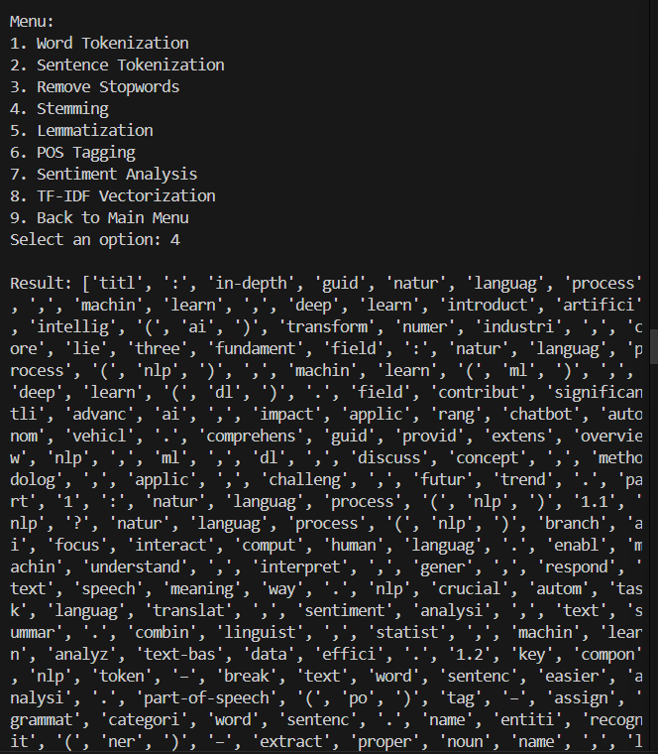

* **Lemmatization:**

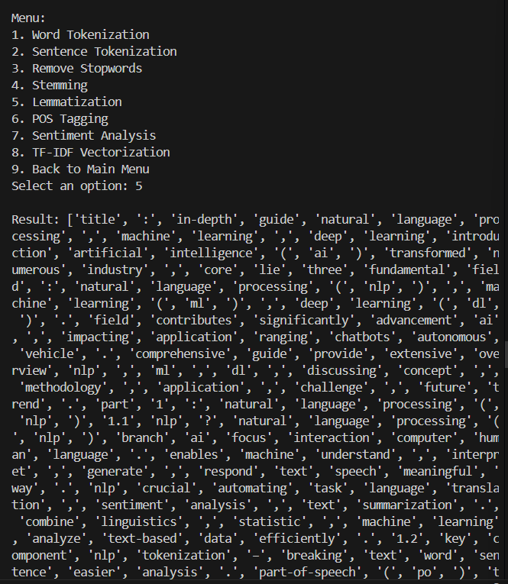

* **POS Tagging:**

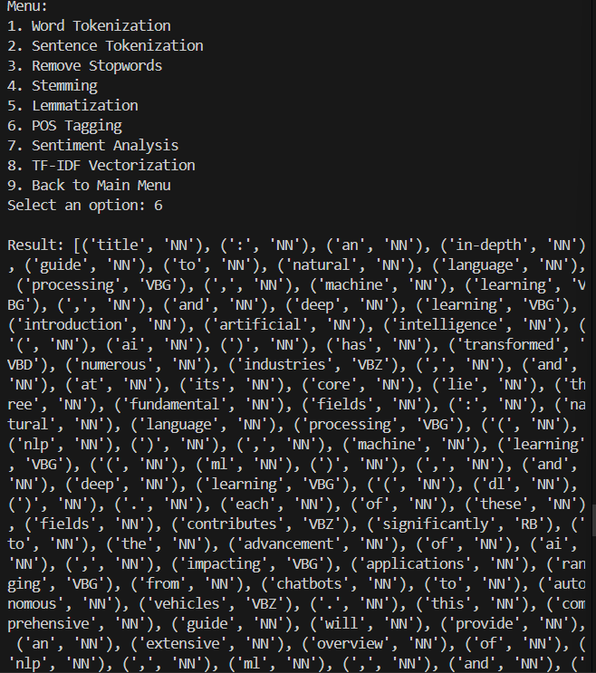

* **Sentiment Analysis:**

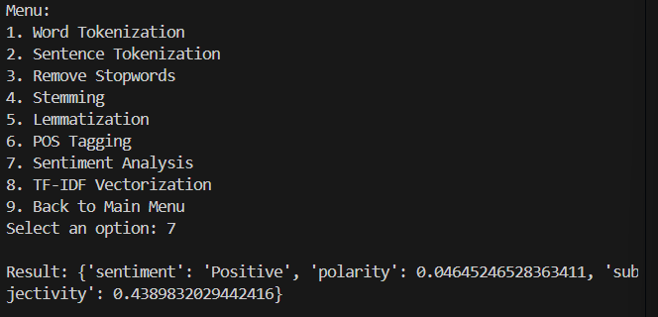

* **TF-IDF Vectorization:**

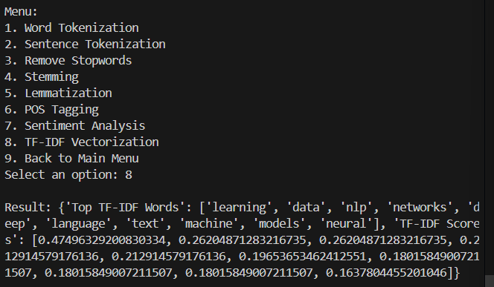

**Text Visualization on .docx file:**

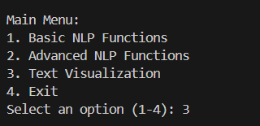

* **Generate Word Cloud:**

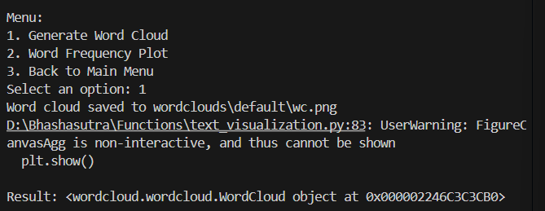

* **Word Frequency Plot:**

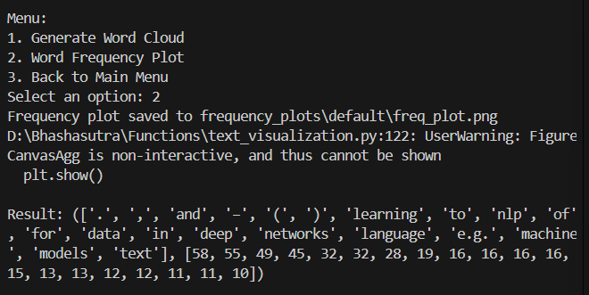

1. **On PDF file:**

Here we check output of PDF file on Basic NLP Function, Advanced NLP Function and Text Visualization.

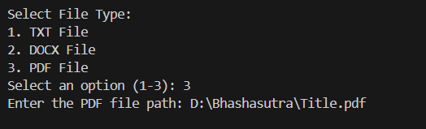

**Text Visualization on .docx file:**

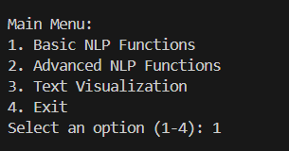

* **Count Words:**

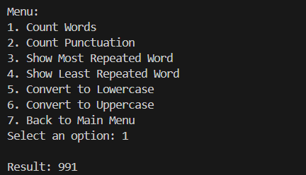

* **Count Punctuation:**

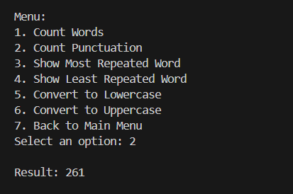

* **Show Most Repeated Word:**

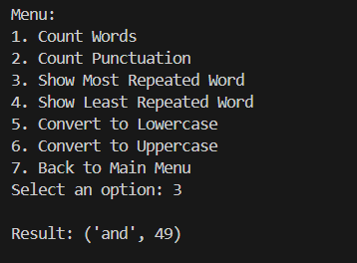

* **Show Least Repeated Word:**

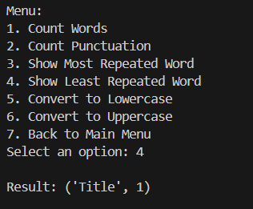

* **Convert to Lowercase:**

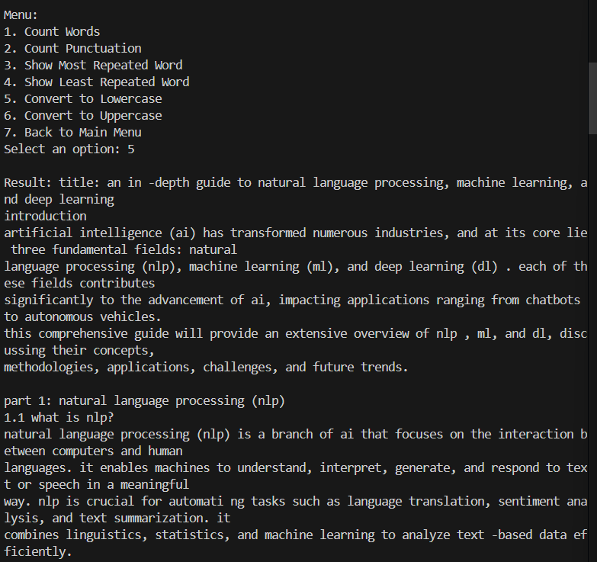

* **Convert to Uppercase:**

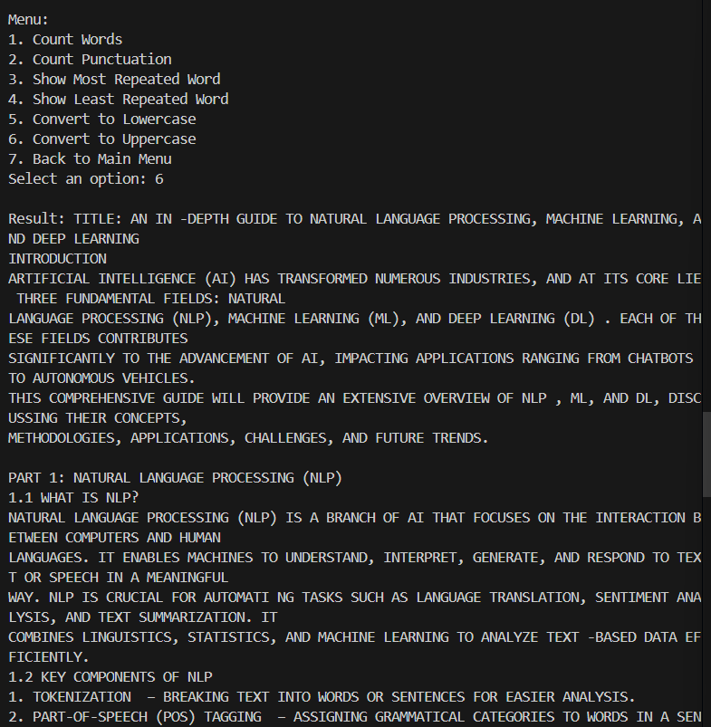

**Advanced NLP FUNCTION on PDF file:**

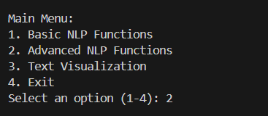

* Word Tokenization:

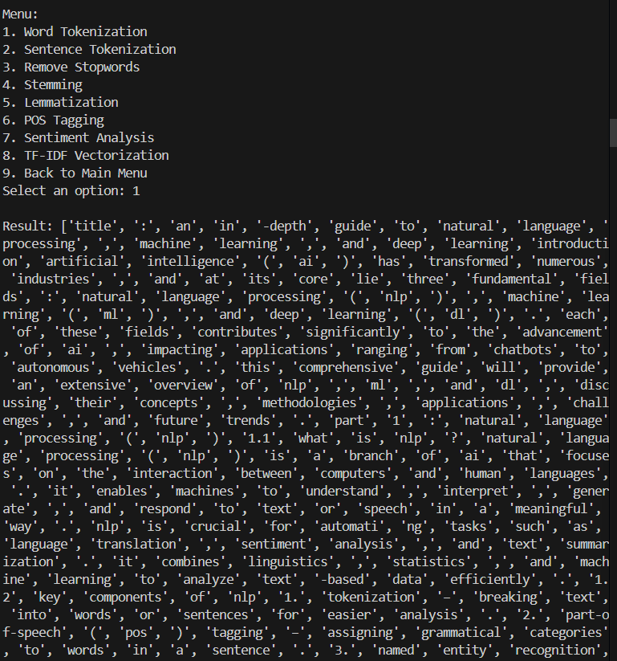

* Sentence Tokenization:

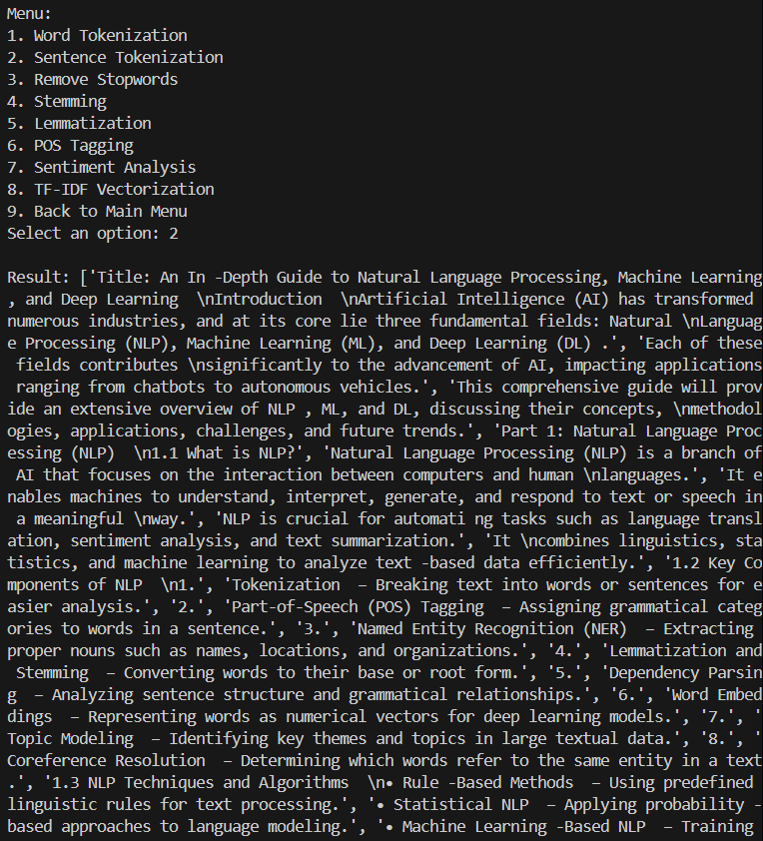

* **Remove Stopwords:**

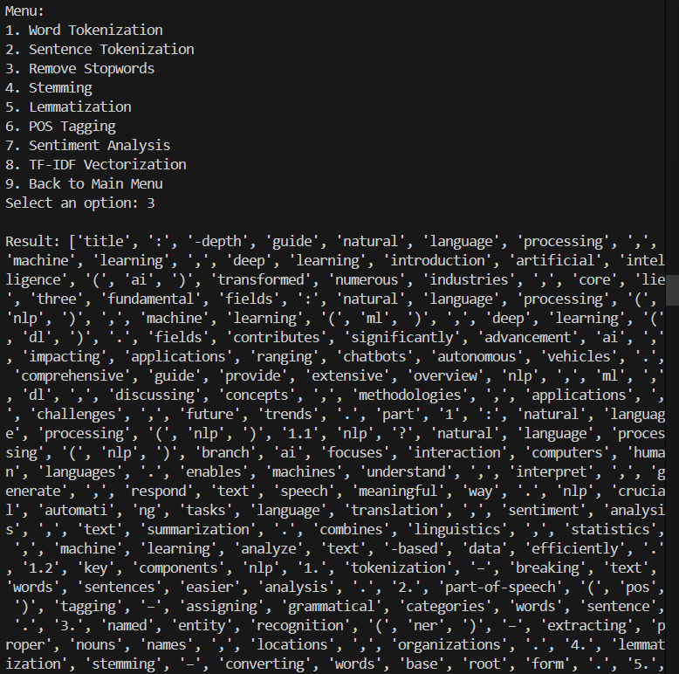

* **Stemming:**

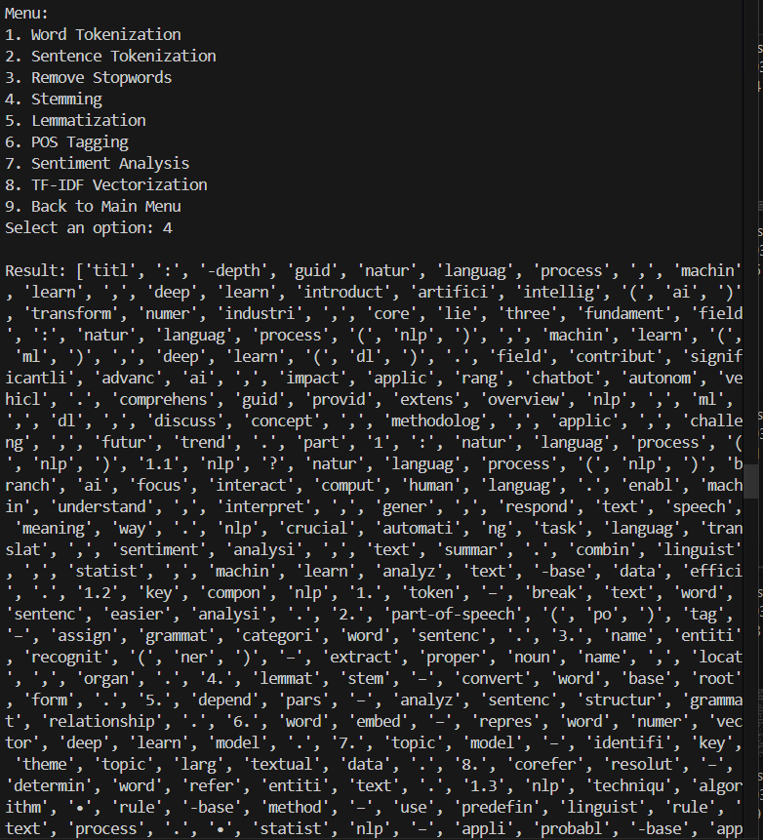

* **Lemmatization:**

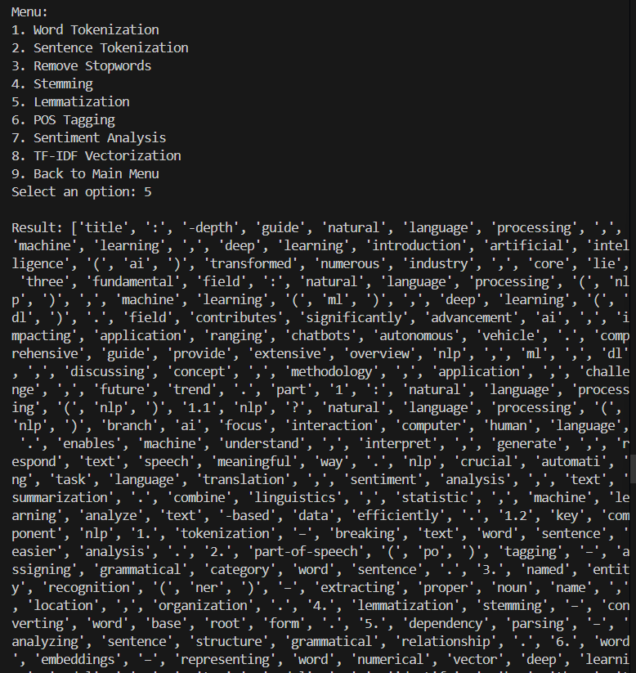

* **POS Tagging:**

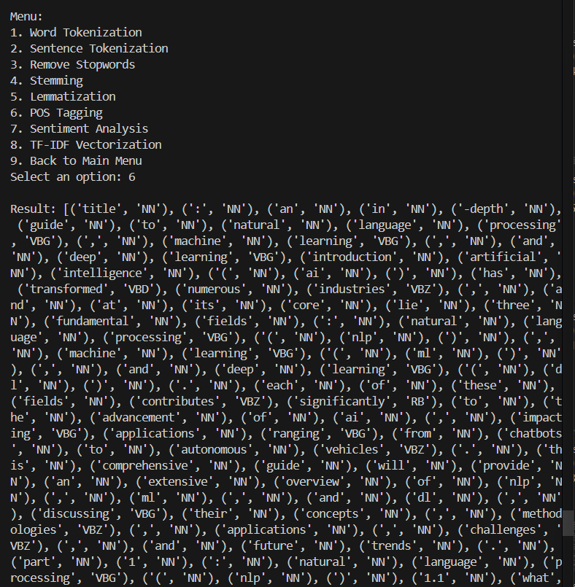

* **Sentiment Analysis:**

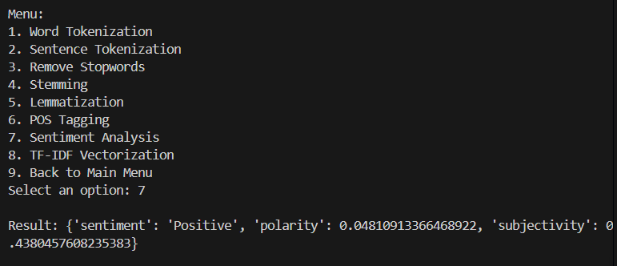

* **TF-IDF Vectorization:**

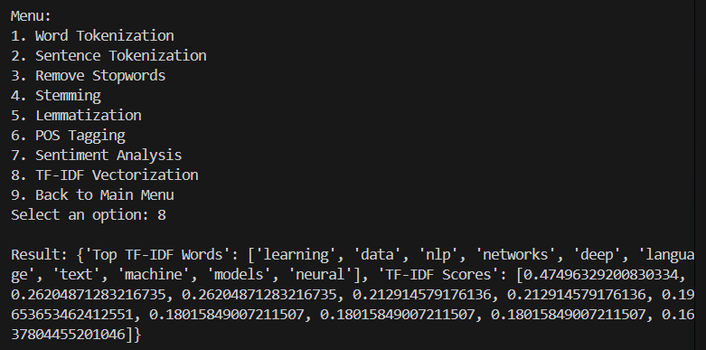

**Text Visualization on PDF file:**

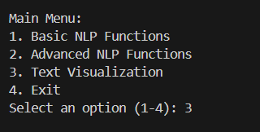

* **Generate Word Cloud:**

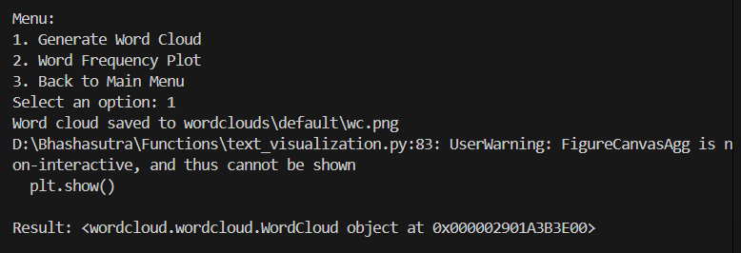

* **Word Frequency Plot:**

