**CAPSTONE PROJECT**

**Converting and Loading Tables (JSON, XML, Excel files are converted to CSV)**

**Customers(Database file)**

**Accounts (JSON)**

**Transactions (CSV)**

**Employees(XML)**

**Loans (CSV)**

**Payment History(CSV)**

**Branches(JSON)**

**CAPSTONE PROJECT**

**Basic Reports**

1. Write a spark dataframe to show the balance amount for an account_id = 1:

1. List Transactions for an account_id = 1:

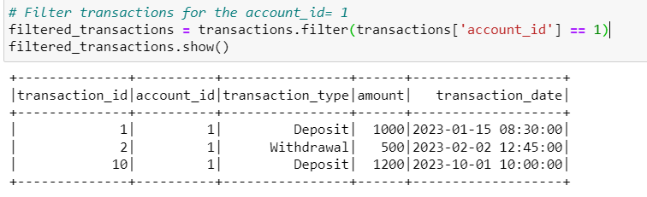

1. List Accounts with a zero balance:

1. Find the Oldest Customer:

1. Calculate the Total Interest Earned Across All Accounts:

**Account Reports**

1. List All Accounts with Customer Information:

1. Calculate Total Balance for Each Customer:

1. Find Customers with Multiple Accounts:

**Customer Transaction Reports**

1. List Transactions with Account and Customer Information:

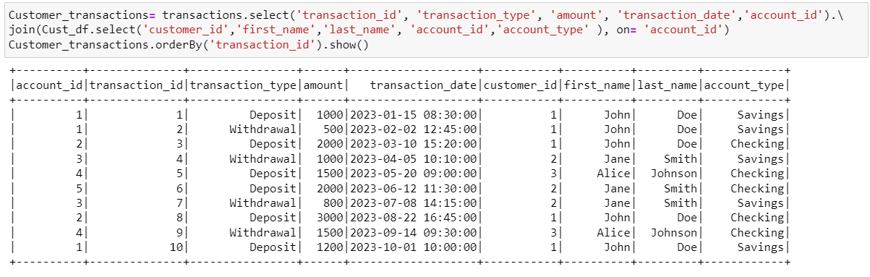

1. Calculate Average Transaction Amount:

1. Identify High-Value Customers with Total Balance:

1. List Employees and Their Assigned Customers:

1. Calculate the Total Number of Transactions for Each Account Type:

1. Find Customers with No Accounts:

(As per expected output)

List the Latest Transaction for Each Account:

1. Find Customers with No Accounts

1. Calculate the Total Withdrawals for Each Customer:

1. Find Duplicate Transactions:

