**CDBM 603 Major Assignment 2**

**Group member: - Ashish Pandya**

**Task 1:**

Imported CSV file successfully using CMD.

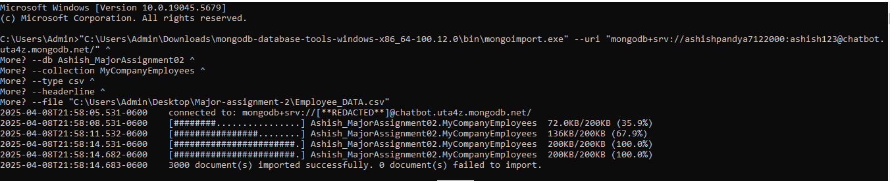

FindOne() command to show one document

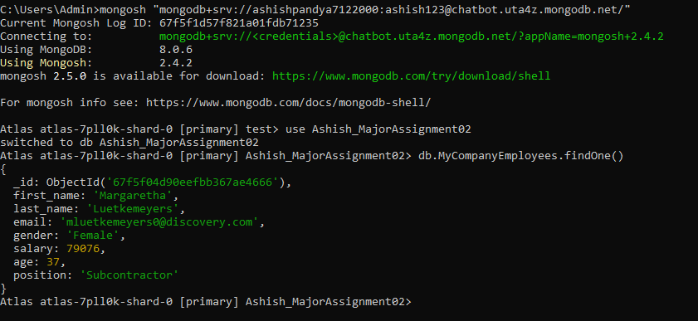

**TASK-2**

1. Show only 10 documents from the collection and display the fields “first_name”, “last_name”, “email”, but exclude “_id”. Show the total number of documents.

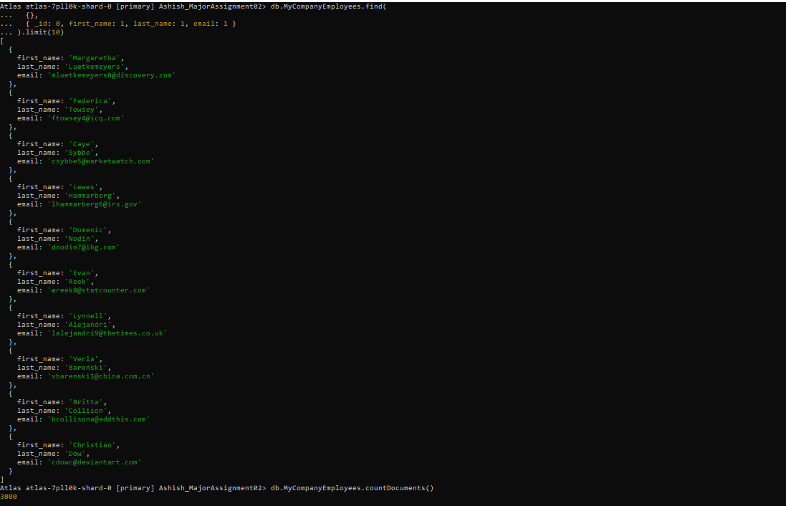

1. Count the number of employees in the position of “Surveyor”.

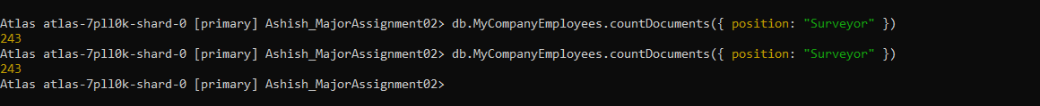

1. Find the employees who are female, age less than 50, and work as “Electricians”.

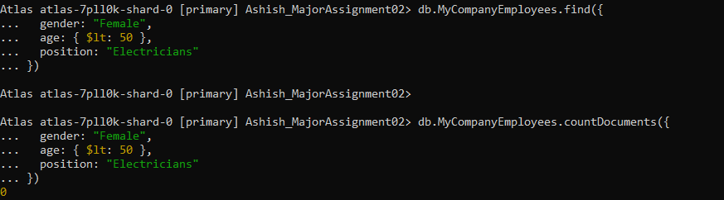

1. Find the employees who are male, age greater than 50, and work as "Engineer" or "Architect".

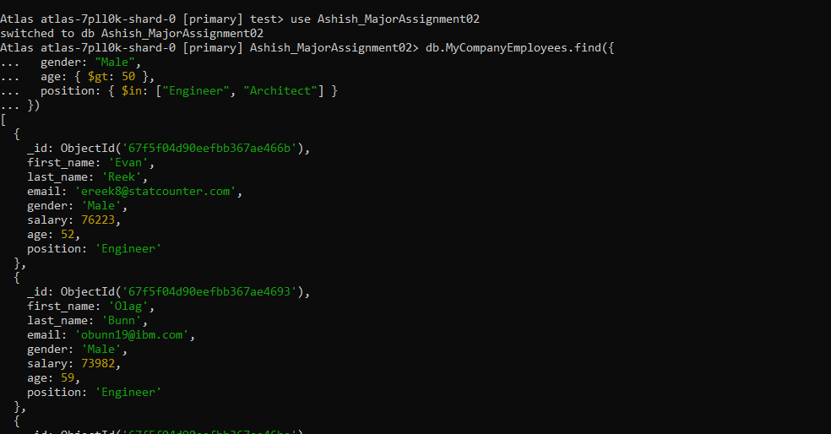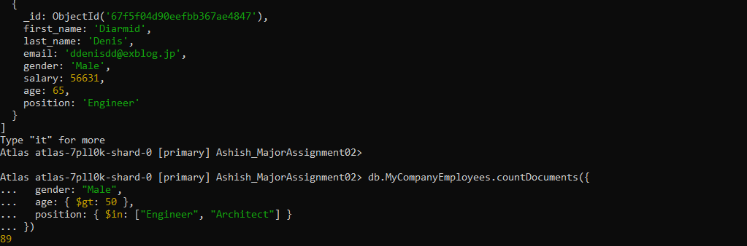

1. Find the employees with last name starting with "Dow" and salary greater than 65000.

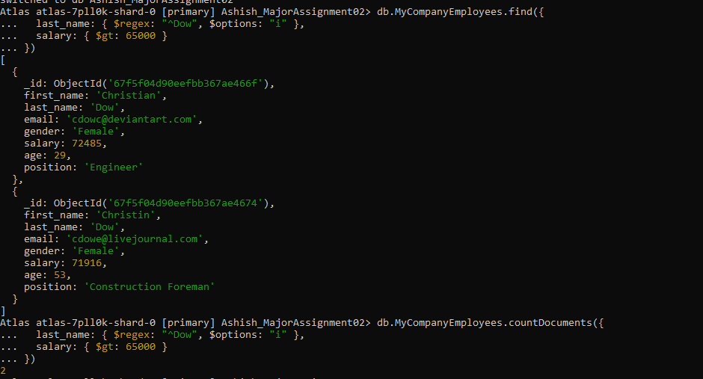

1. Find distinct positions in the company.

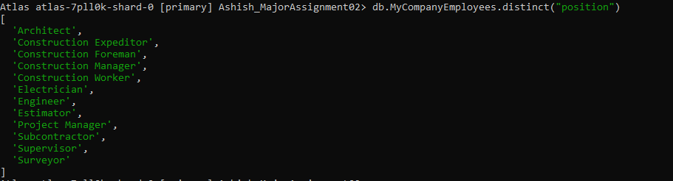

1. Find employees with salaries between 50000 and 60000, sorted by age in descending order.

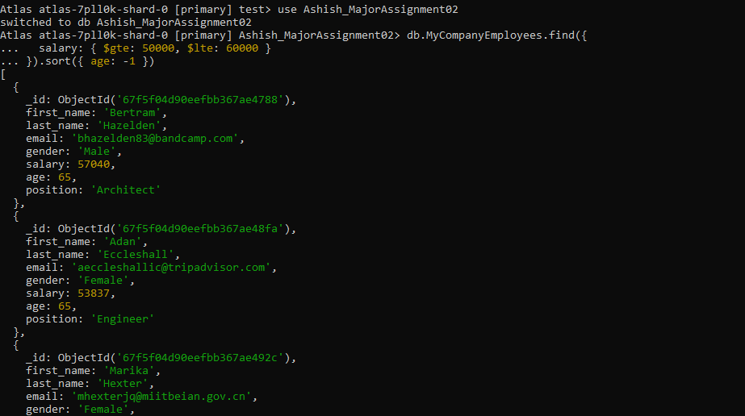

1. Count the number of male employees.



1. List the top 5 highest-paid female employees.

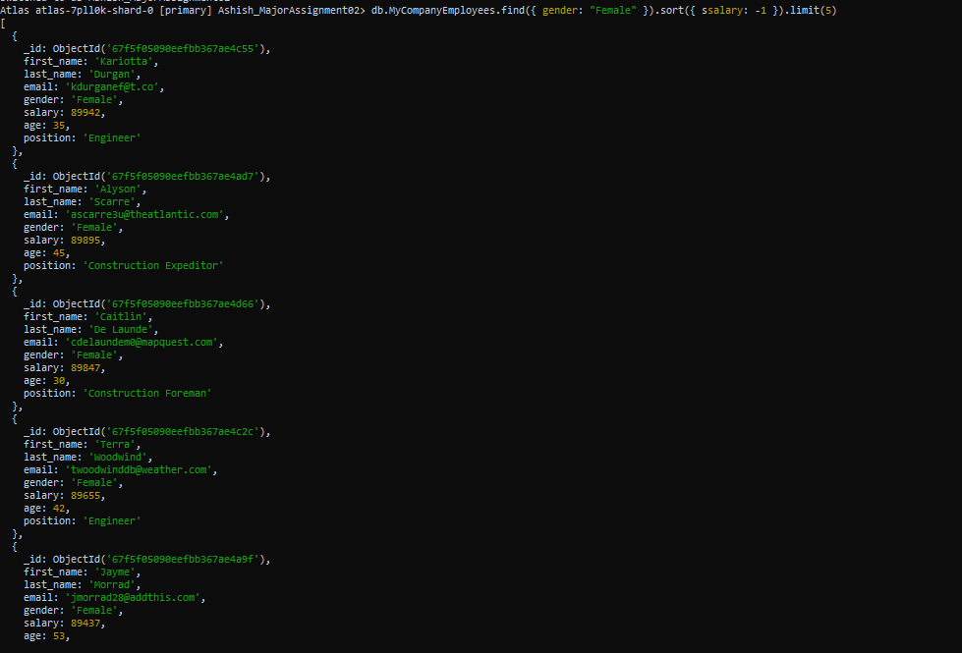

1. Retrieve employees with names containing "an" (case insensitive)

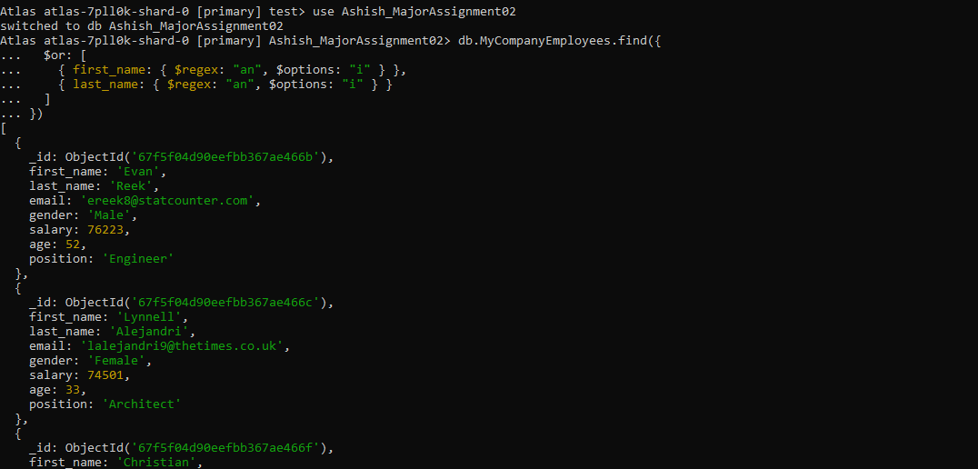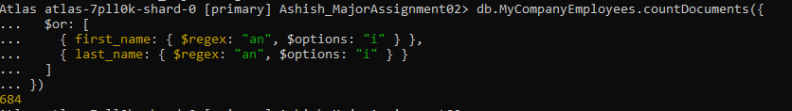

**TASK-3**

[**Task-3 Dashboard link**](https://charts.mongodb.com/charts-project-0-wkgldds/public/dashboards/455bc484-07c4-4f75-a6c0-141cc8d2f4ed)

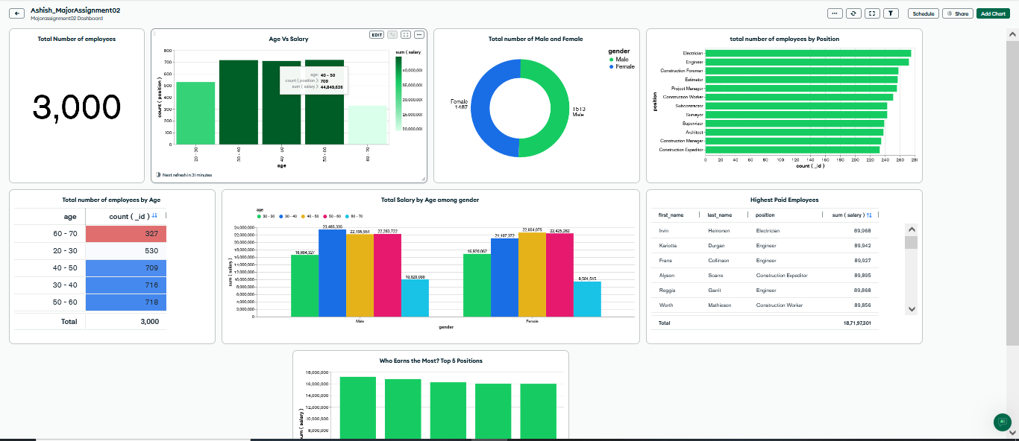

**Task-4**

