Introduction:

* Rapid depletion of fossil fuel resources on a worldwide basis has necessitated an urgent search for alternative energy sources to cater to the present day's demand.
* Also, to meet the continuously increasing demand while minimize the negative environmental impacts.

Research:

* Solar and wind energy systems are being considered as promising power generating sources due to their availability and topological advantages for local power generations in remote areas.

Cost and Features:

* The experimental results were simulated using ABC algorithm using MATLAB 2018a program.

Advantages:

* Reducing the optimal size of the components used in the proposed system with the least Levelized Cost of Energy (LCOE) by minimizing the Net Present Cost (NPC) of the system by applying swarm-based ABC algorithm.
* Developing a mathematical model of an autonomous PV-wind, diesel generator energy system with battery bank to provide electricity for an off-grid location.

System Flow chart:

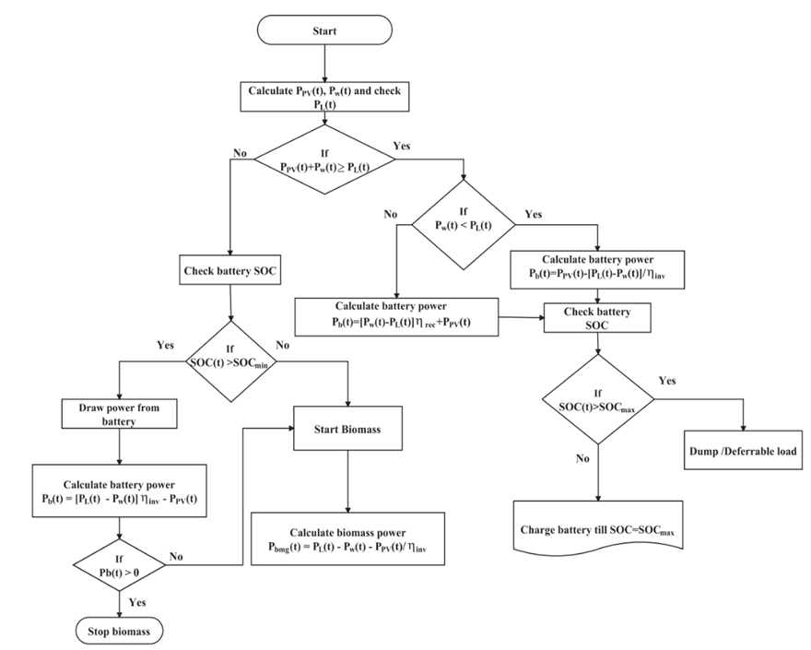

Detail requirements:

High level requirements:

|  |  |  |
| --- | --- | --- |
| **ID** | **Description** | **Status** |
| HR_01 | Solar Photo Voltaic panel | Implemented |
| HR_02 | Wind Power generation | Implemented |
| HR_03 | Diesel generator | Implemented |

Low level requirements:

|  |  |  |
| --- | --- | --- |
| **ID** | **Description** | **Status** |
| LR_01 | Battery bank | Implemented |
| LR_02 | Power Converter | Implemented |