
Major Project - II

Submitted in partial fulfilment of the requirement for the Degree of B. Tech in Electrical Engineering.

Topic

Optimization of Standalone Hybrid Power Plant using ABC algorithm

Submitted to

Department of Electrical Engineering

National Institute of Technology Silchar, Assam, 788010.

Supervisor

Dr. Nirmala Soren

Assistant Professor, EE Department, NIT Silchar

Name | Scholar ID
Pritesh Abhishek | 1713063
Ashish Raj | 1713064

1

Declaration

Ashish Raj and Pritesh Abhishek declare that this thesis titled, “Optimization of standalone hybrid power plant using ABC algorithm” and the work presented in it are our own. We confirm that:

- This work was done wholly or mainly while in candidature for a B.Tech degree at this University.

- Where any part of this thesis has previously been submitted for a degree or any other qualification at this University or any other institution, this has been clearly stated.

- Where We have consulted the published work of others, this is always clearly attributed.

- Where We have quoted from the work of others, the source is always given. With the exception of such quotations, this thesis is entirely our own work.

- We have acknowledged all main sources of help.

- Where the thesis is based on work done by ourself jointly with others. We have made clear exactly what was done by others and what we have contributed ourself.

Signed:

-------------------------------------------------------------------------

Date:

--------------------------------------------------------------------------

2

Department of Electrical Engineering

National Institute of Technology Silchar

Silchar-788010, Assam

Certificate

It is certified that the work contained in this thesis entitled "Optimization of standalone hybrid power plant using ABC algorithm." submitted by Ashish Raj and Pritesh Abhishek bearing scholar numbers 17-1-3-064 and 17-1-3-063 respectively for the award of Bachelor of Technology in Electrical Engineering is absolutely based on their own work carried out under the supervision of Dr. Nirmala Soren and this work has not been submitted anywhere else for any degree.

Dr. Nirmala Soren

Project Supervisor

Department of Electrical Engineering

National Institute of Technology Silchar

3


Department of Electrical Engineering

National Institute of Technology Silchar

Silchar-788010, Assam

Certificate

It is certified that the work contained in this thesis entitled "Optimization of standalone hybrid power plant using ABC algorithm." submitted by Ashish Raj and Pritesh Abhishek bearing scholar numbers 17-1-3-064 and 17-1-3-063 respectively for the award of Bachelor of Technology in Electrical Engineering is absolutely based on their own work carried out under the supervision of Dr. Nirmala Soren and this work has not been submitted anywhere else for any degree.

Dr. JP Mishra

Head of the Department

Department of Electrical Engineering

National Institute of Technology Silchar

4


Acknowledgement

We take this opportunity to extend my sincere thanks towards our professor and project guide Dr. Nirmala Soren ma’am for her valuable guidance rendered by him throughout this period. It is indeed with a great sense of pleasure and immense sense of gratitude that we acknowledge from her.

5


Abstract

Renewable energy resources, especially in countries with limited fossil fuel resources, are proving to be promising and environmentally friendly sources of electricity generation. In recent years, wind, solar photovoltaic (PV), and biomass-based technologies have received considerable attention for supplying electricity to remote or power-deficient areas. Solar and wind energy systems are universal, easy to access, and environmentally friendly, and they are considered as promising electricity generation sources for local energy production due to its availability and structural advantages. Hybrid solar–wind energy systems integrate two renewable sources to increase system stability and productivity while reducing power storage needs for stand-alone operations. Hybrid solar–wind systems are becoming more popular in remote region power production applications as a result of breakthroughs in renewable energy technology and a large rise in the value of fossil goods.

6

List of Tables

Table 1: Data of the components used in the proposed hybrid system, both technical and economic…………………………………………..25

Table 2: Parameters of the ABC algorithm……………………………26

7

List of Figures

Figure 1: Different components of the proposed hybrid model……….14

Figure 2: A simplified flow map depicting the proposed hybrid energy system's operating strategy……………………………………………...18

Figure 3: Flowchart of the Artificial Bee Colony algorithm…………..24

Figure 4: Load demand (in Kw) vs time (in hours)………………………..27

Figure 5: Solar Radiation (in Kw\m²) vs time (in hours)…………………..27
Figure 6: Wind Speed (in m/s) vs time (in hours)……………………….…28

Figure 7: Energy (in Kw) vs time (in hours)……………………………..…29

Figure 8: State of Battery………………………..…………………….….29

Figure 9: Variable load and renewable energy power generation…….....30

8


Contents

- Introduction………………………………………………...10

- Prime objectives……………………………………………12

- Mathematical Modelling…………………………………...13

- Problem formulation……………………………………….17

- Operational strategy………………………………………..17

- Objective function and constraints…………………………21

- Artificial Bee Algorithm…………………………………...23

- Inputs……………………………………………………….25

- Graphical results…………………………………………...29

- Numerical results…………………………………….31

- Conclusion…………………………………………...32

- References……………………………………………33

9

Introduction

Globally, the rapid depletion of fossil fuel supplies has necessitated an urgent search for alternative energy sources to meet today's demand. Another compelling reason to reduce our reliance on fossil fuels is mounting evidence of global warming. As a result, finding alternative energy sources to meet the ever-increasing demand for energy while reducing negative environmental impacts is crucial. Solar and wind energy systems are being@as promising power generating sources due to their ease availability and topological benefits for local power generations in remote areas. Engagement of wind and solar energy has become increasingly important, appealing and cost-effective, since the oil crises during 1970s.

However, a drawback, common to wind and solar options, is their uncertain nature and dependence on weather and climatic changes, and the variations of solar and wind energy may not match with the time distribution of load demand.

Fortunately, the problems caused by the dynamic existence of these resources can be partially or completely handled by combining these two energy resources in a proper mix, using one source's strengths to compensate for the other's weakness.

The hybrid solar–wind power generation systems with storage banks provide a highly efficient source of power, which is ideal for electrical loads that require higher reliability, thanks to the complementary characteristics of solar and wind energy for some locations.

Furthermore, many studies in hybrid systems have been recognised, in which several researchers have suggested a variety of traditional and evolutionary methods for achieving the optimal size of hybrid system components. Various research projects have been completed have or carried using past methods such as graphical construction method,

10

iterative method, trade off method and linear programming. Traditional methods have the drawback of sometimes trapping in local minima. To overcome these shortcomings, several meta-heuristic evolutionary algorithms have been implemented in various hybrid systems, including the genetic algorithm, particle swarm optimization, ant and bee colony algorithm, harmony quest, biogeography dependent optimization, and others. In current history, a new trend has emerged in which academics are using evolutionary algorithms to determine the best hybrid energy system size. As per the of the author's knowledge, there is relatively little work on the optimization of a hybrid PV-wind-diesel generator with an energy storage device.
To achieve optimal configurations of the suggested system, a swarm-based meta-heuristic, artificial bee colony (ABC) method was used. The The ABC algorithm differs from other algorithms (such as GA and PSO) in that it makes use of fewer control parameters. It also, like other evolutionary algorithms, has high convergence accuracy and the ability to generate optimum outputs.

11

Prime Objectives

In light of the foregoing, it has been determined that a hybrid system consisting of a PV, wind, and diesel generator, as well as an energy storage system, is required, particularly in remote or off-grid places. The size of each piece of equipment in a hybrid system is a difficult task. Despite the fact that there are studies in the literature from many angles, the suggested study focuses on a hybrid energy system that combines PV, wind, diesel generators, and energy storage. The best component size for all of the above hybrid systems has been determined utilising software tools as well as traditional and evolutionary approaches. However, no one has used evolutionary algorithms to determine the ideal size of a PV-wind-Diesel generator with a battery bank as storage. To improve the hybrid system's dependability, diesel generator resources can be combined with wind and solar sources. To meet the electricity requirement of a typical town, an autonomous hybrid PV-wind-Diesel generator with battery system is presented in this study. To achieve optimal configurations of the suggested system, a swarm-based meta-heuristic, artificial bee colony (ABC) method has been used. The ABC algorithm is distinguished from other algorithms (such as GA and PSO) by the fact that it uses a smaller number of control parameters. It also, like other evolutionary algorithms, has a high convergence accuracy and the ability to generate optimum outputs. The following are the primary goals of this project.

• To develop a mathematical model of a self-contained PV-wind diesel generator energy system with a battery bank that can power an off-grid site.
• To calculate the acceptable size of the components used in the proposed system with the lowest LCOE by lowering the net present cost (NPC) of the system using the swarm-based ABC process.

12


Mathematical Modelling

This research was primarily focused on the development of a novel hybrid system to provide dependable electricity to off-grid or remote regions.

13
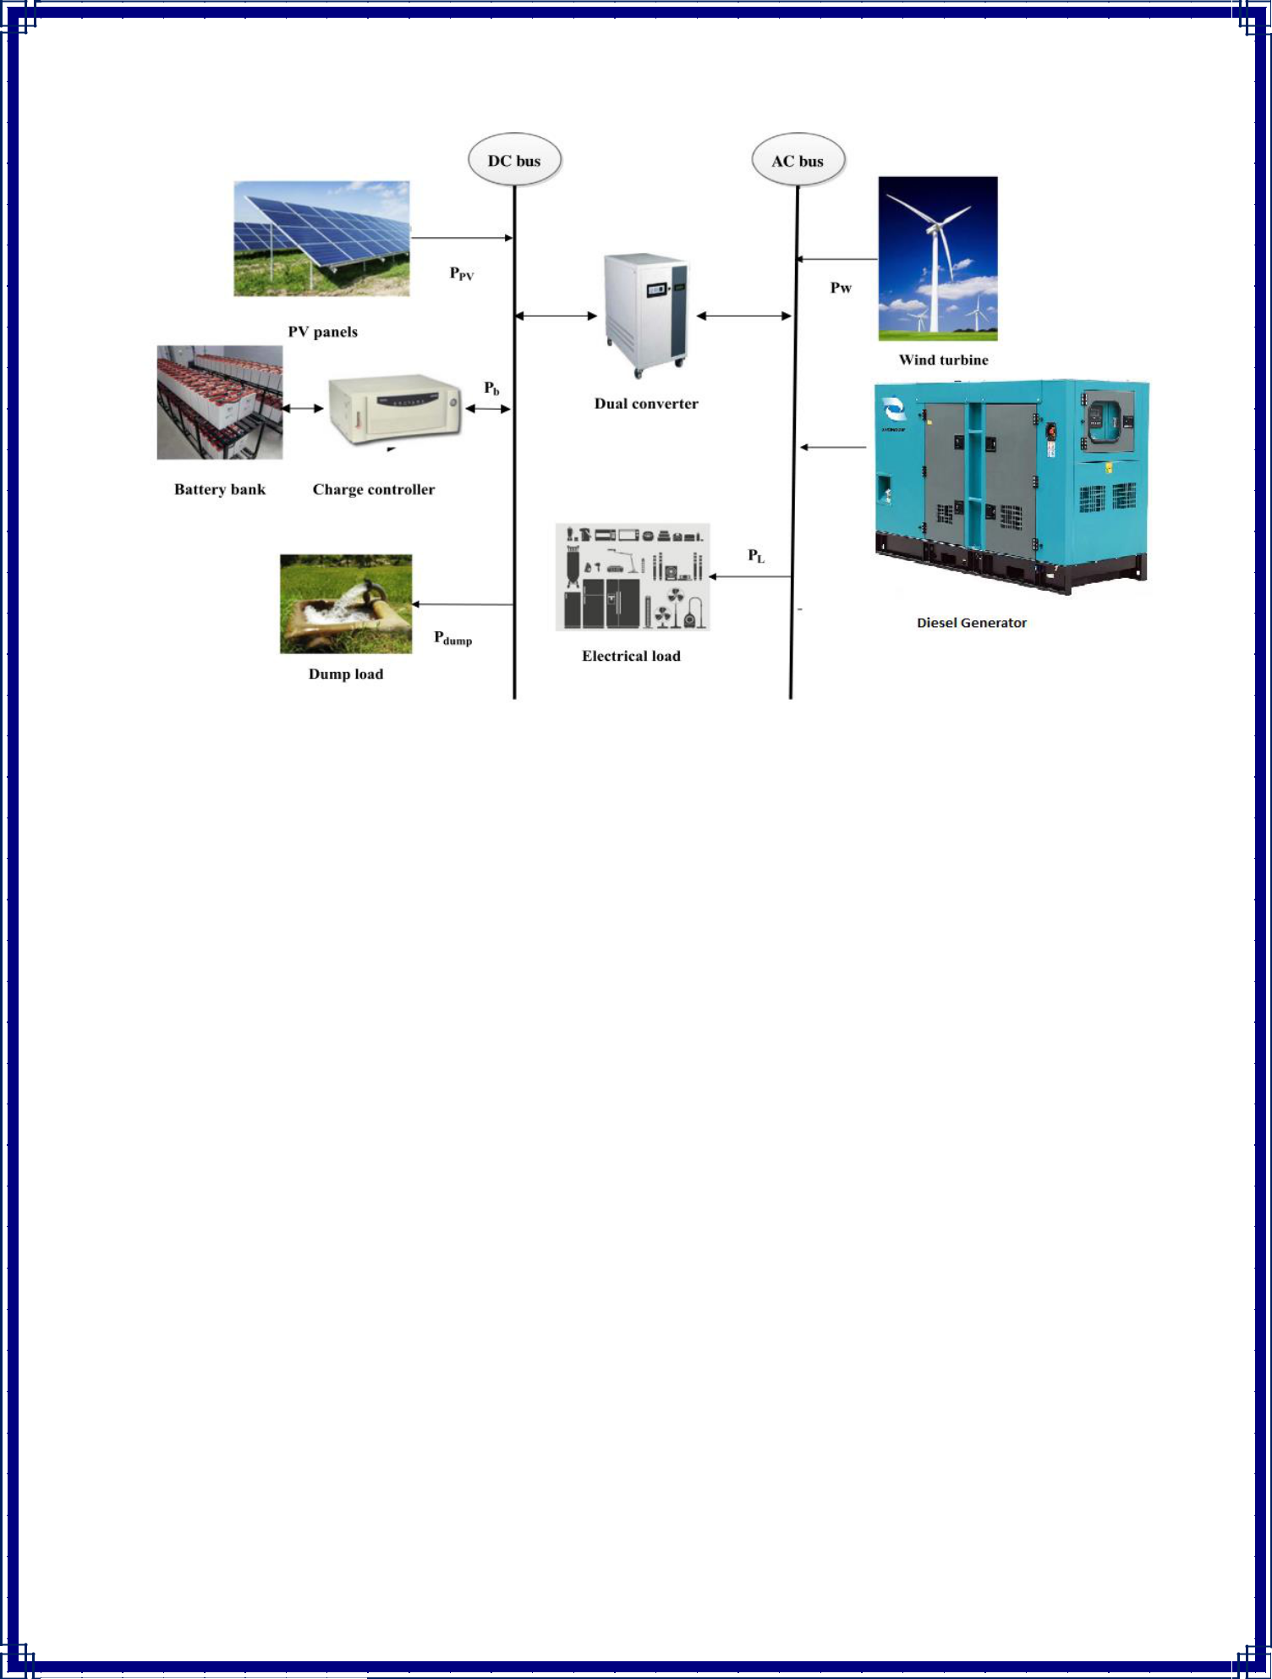

Fig 1. The suggested hybrid model's several components.

Storage devices are used to control the electricity provided by wind, solar, and diesel generators. As shown in Fig. 1, the load, wind turbines, and biomass gasifier are all linked to the AC bus. Converters are often used to connect solar PV panels and batteries to the AC bus. A charge controller is often used to ensure that the electricity flows smoothly and that the charging and discharging speeds of the batteries are kept under control.
The suggested solution is most suited for off-grid regions and agriculturally-dependent communities in underdeveloped nations where energy scarcity is a key problem. Because it is totally self-sustaining using renewable energy sources, this system will assist to reduce utility grid reliance. The goal of this project is to scale each variable to its ideal size

14
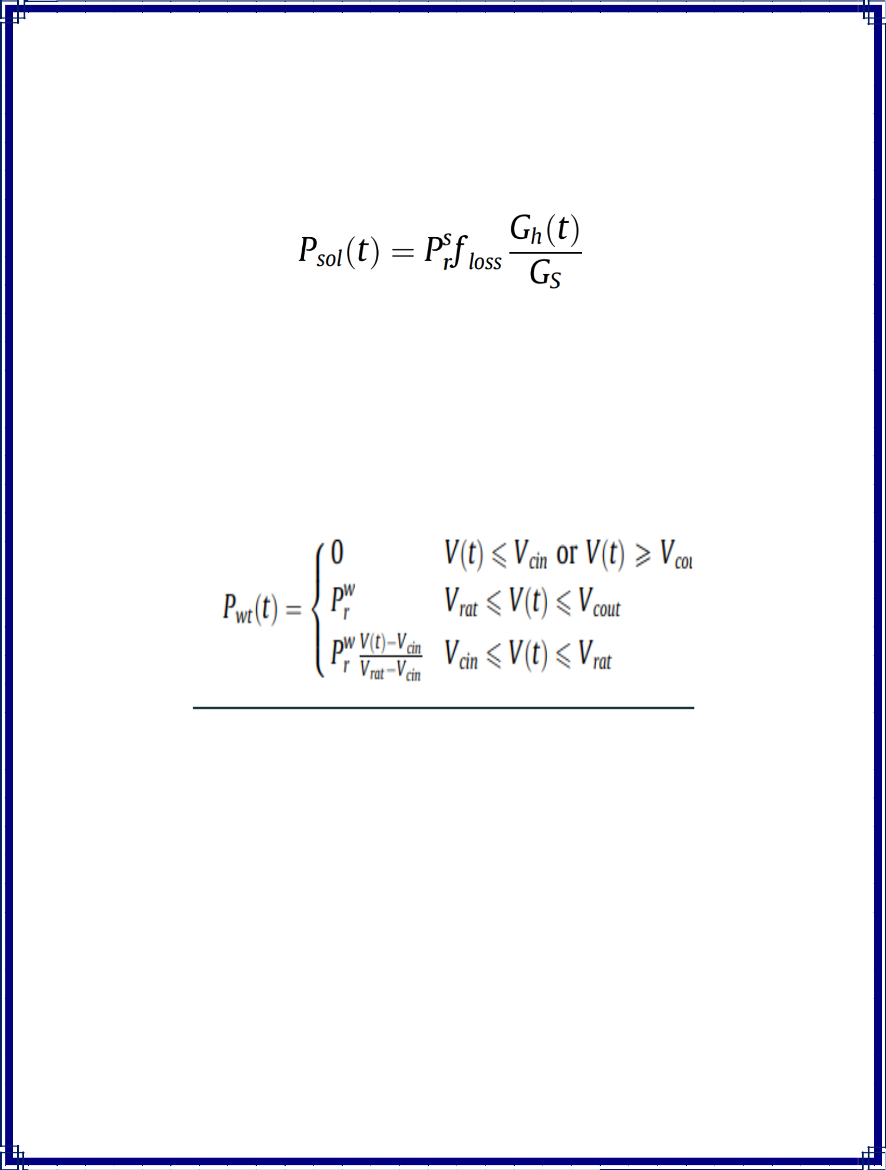
while retaining system stability. The mathematical models for various components are as follows:
- Solar photovoltaic panel:

P^{s}r :Rating of solar PV panel, floss : loss factor of solar PV panel, Gh(t): hourly solar radiation incident at surface of solar PV panel (W/m² ), and GS is the standard incident radiation (1000 W/m²).

- Wind Power Generation:

P^{w}r: Rating of single wind turbine,

Vcin: Cut in speed

Vrat: Rated wind speed

Vcout : Furlong Speed, V(t): Wind speed at desired height

- Diesel Generator

15
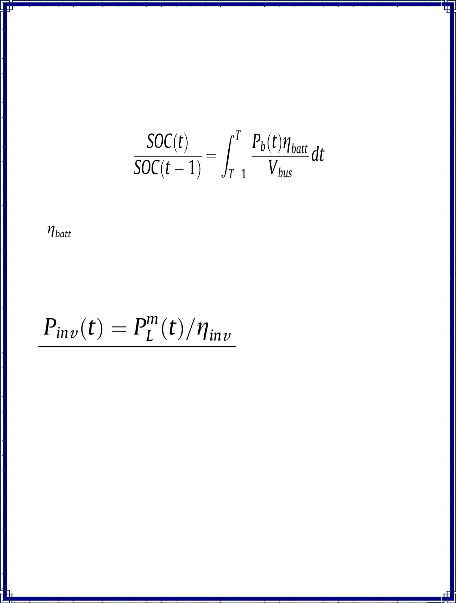
Edg = Pdg (8760*CUF) ; Pdg: Rating of diesel generator, CUF: Capacity

Utilization Factor, Edg : Output electricity of a biomass gasifier.

- Battery Bank:

Vbus: Voltage of bus, Pb(t): battery’s input/output power,

: Round trip efficiency of battery.

- Power Converter

Pinv (t): Inverter rating
P^{m}_{L}(t): Peak load demand

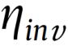: Efficiency of Inverter

16

Problem formulation

- The major purpose of the project is to create cost-effective and dependable hybrid energy system.
- Solar PV panel rating and sizing, wind turbine rating and sizing, battery bank rating and sizing, and diesel generator rating and sizing are all critical decision variables.

Operational strategy

Adequate power management is needed in any hybrid energy system to ensure system dependability. Diesel generators are used as a last resort in this system, meaning they are only used when solar, wind, and batteries are insufficient to meet load demand.

In Figure 2, a simplified flow chart of the proposed hybrid energy system's operating strategy is shown.

17
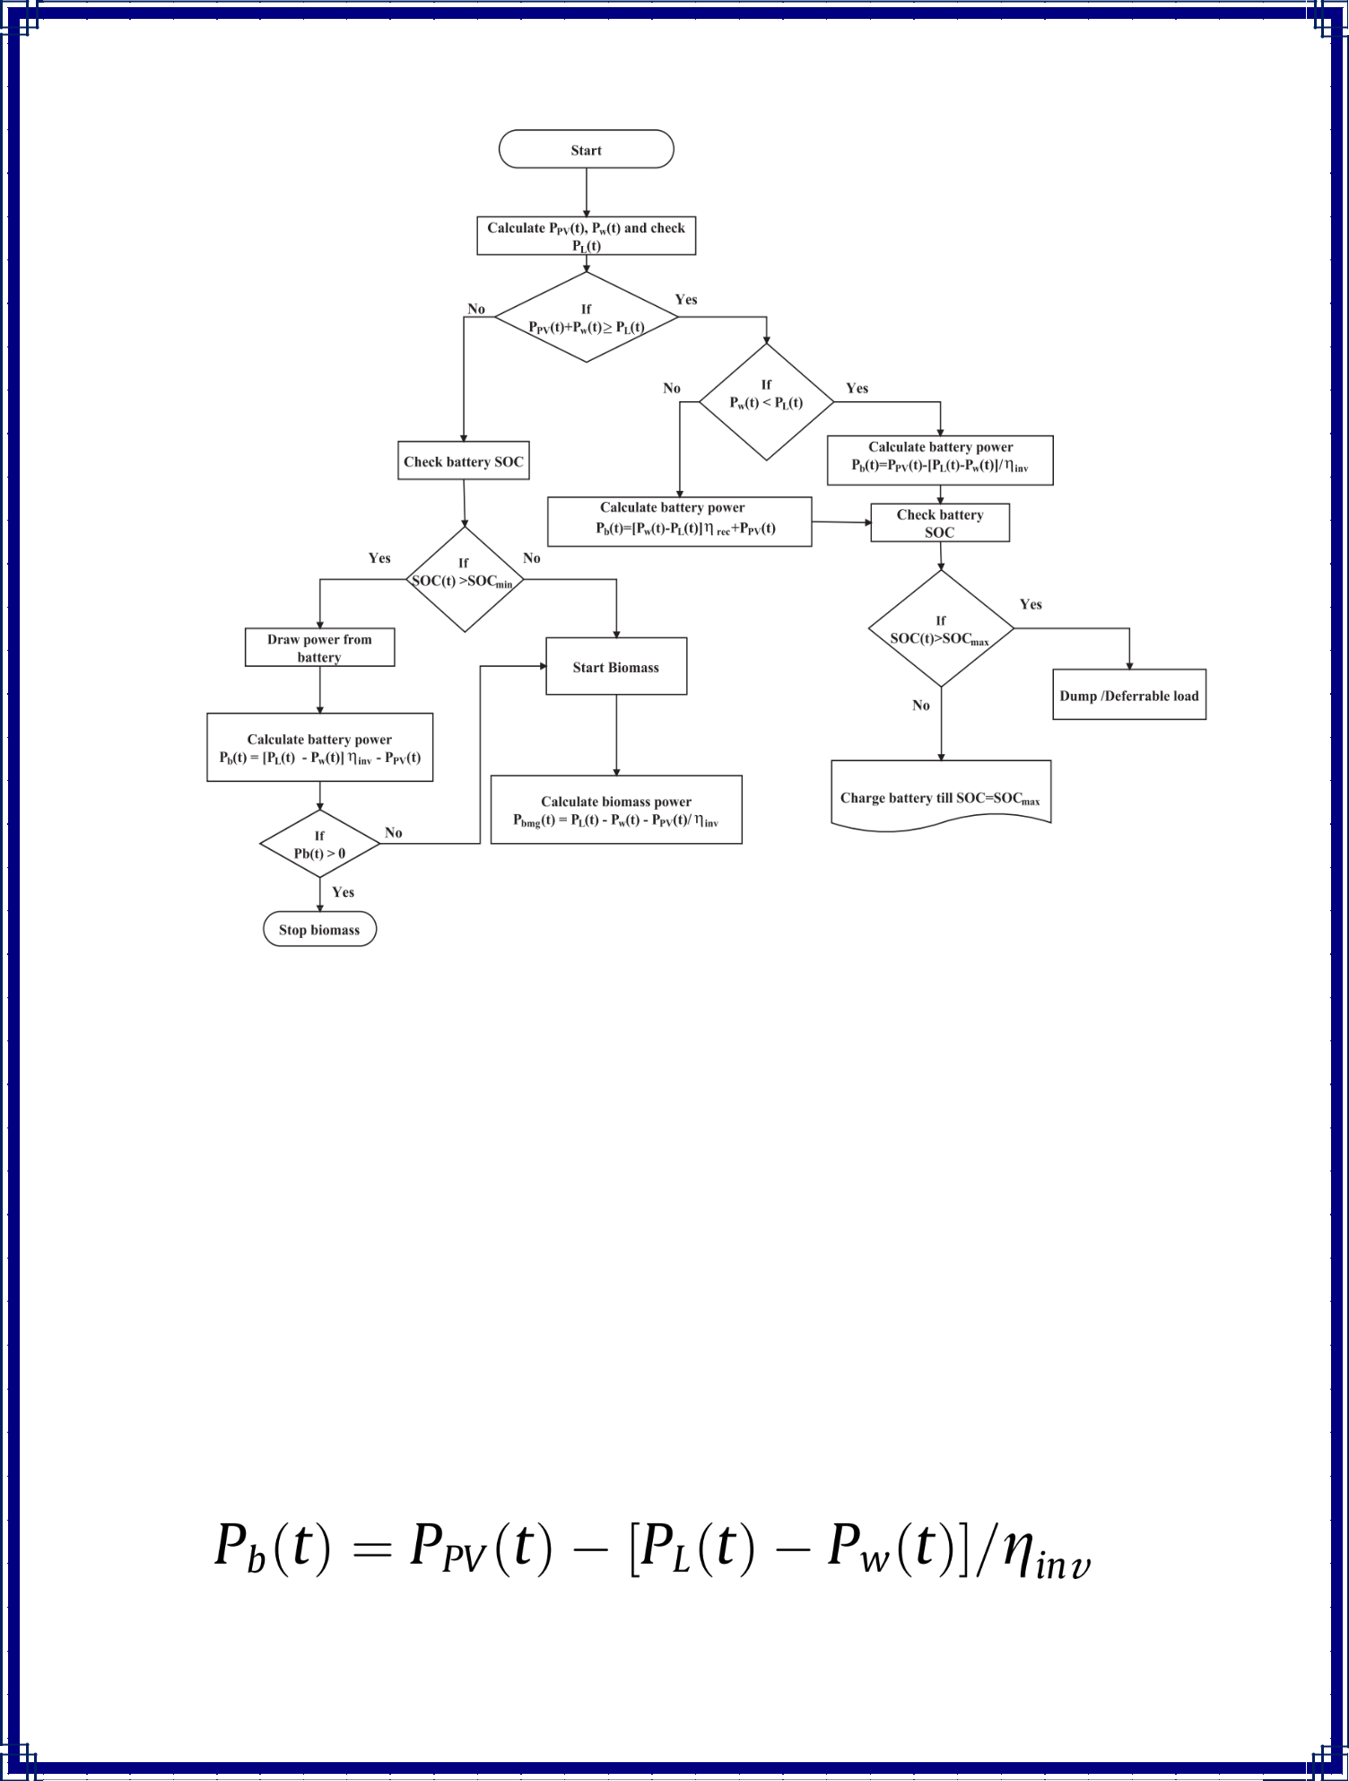

Fig 2. A simplified flow chart of the operating strategy of the proposed hybrid energy system.

The steps of operational strategy can be summarised as follows:

• If the total power produced by solar PV panels and wind turbines is sufficient, and wind power is less than load, renewable energy sources might be the only way to meet demand. After the load has been fulfilled, surplus power can be sent to the battery bank and presented as:

18
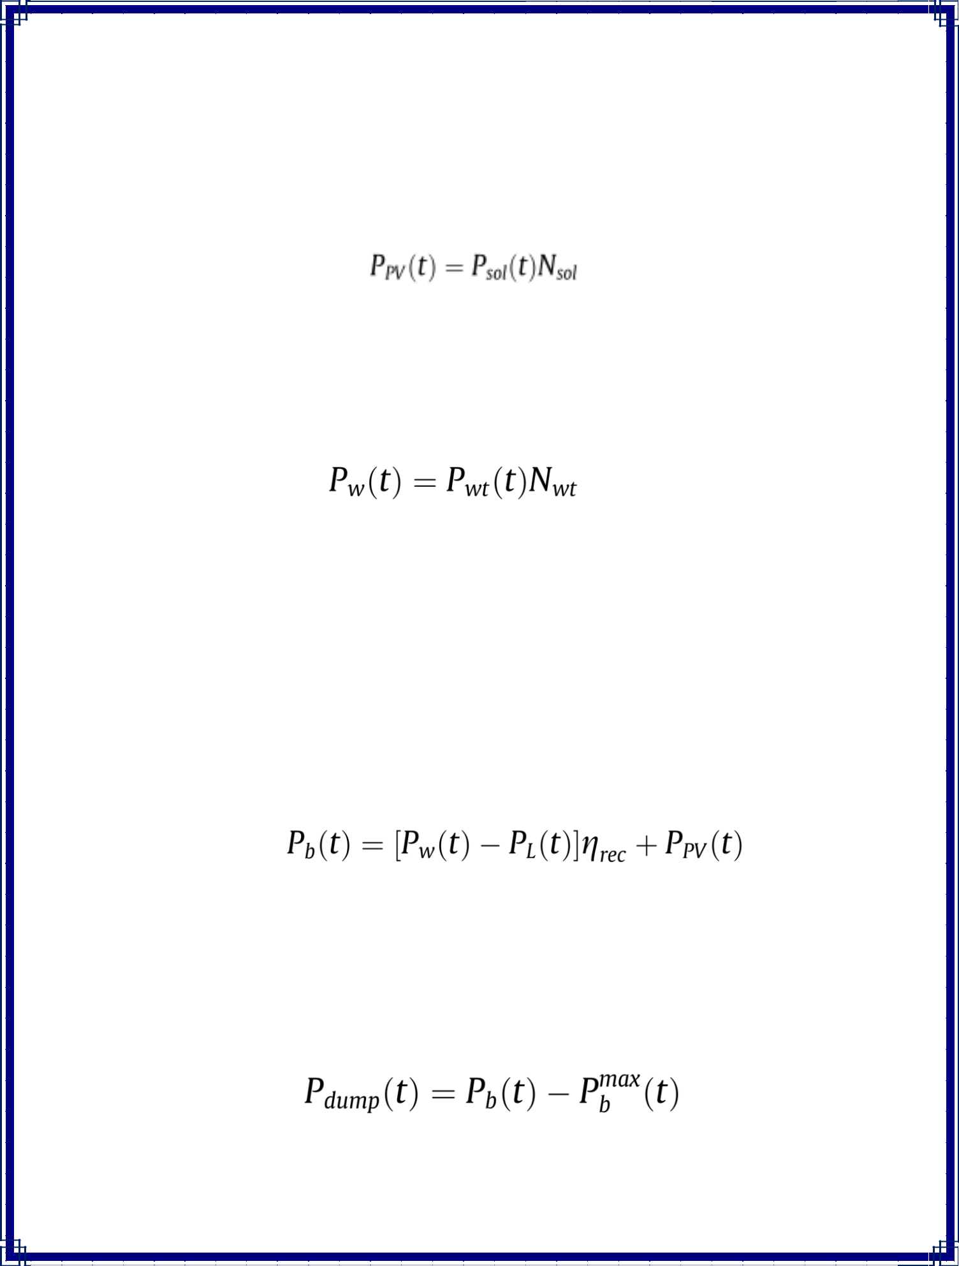
Where, PL(t) indicates load demand at any time and ηinv indicates the efficiency of the inverter. If Psol (t) is the power generated by an individual solar PV panel and Nsol represents the total number of solar PV panels, then the total power produced by solar PV panels (PPV (t)), is summarised as

Moreover, if Pwt is the power generated by an individual wind turbine and Nwt is the total number of wind turbines, then the total power generated by wind turbines (Pw (t)) can be provided as,

- If wind turbine power alone is sufficient to meet load demand, the leftover power (solar plus wind) can be supplied to the battery bank. In this scenario, the battery power may be computed as follows:

- If P_{b}(t) is more than the maximum permitted capacity of the battery bank (P^{max}_{b}), extra energy can be discharged or allocated to deferrable loads in both of the preceding instances. Excess or dump energy is calculated as,

19
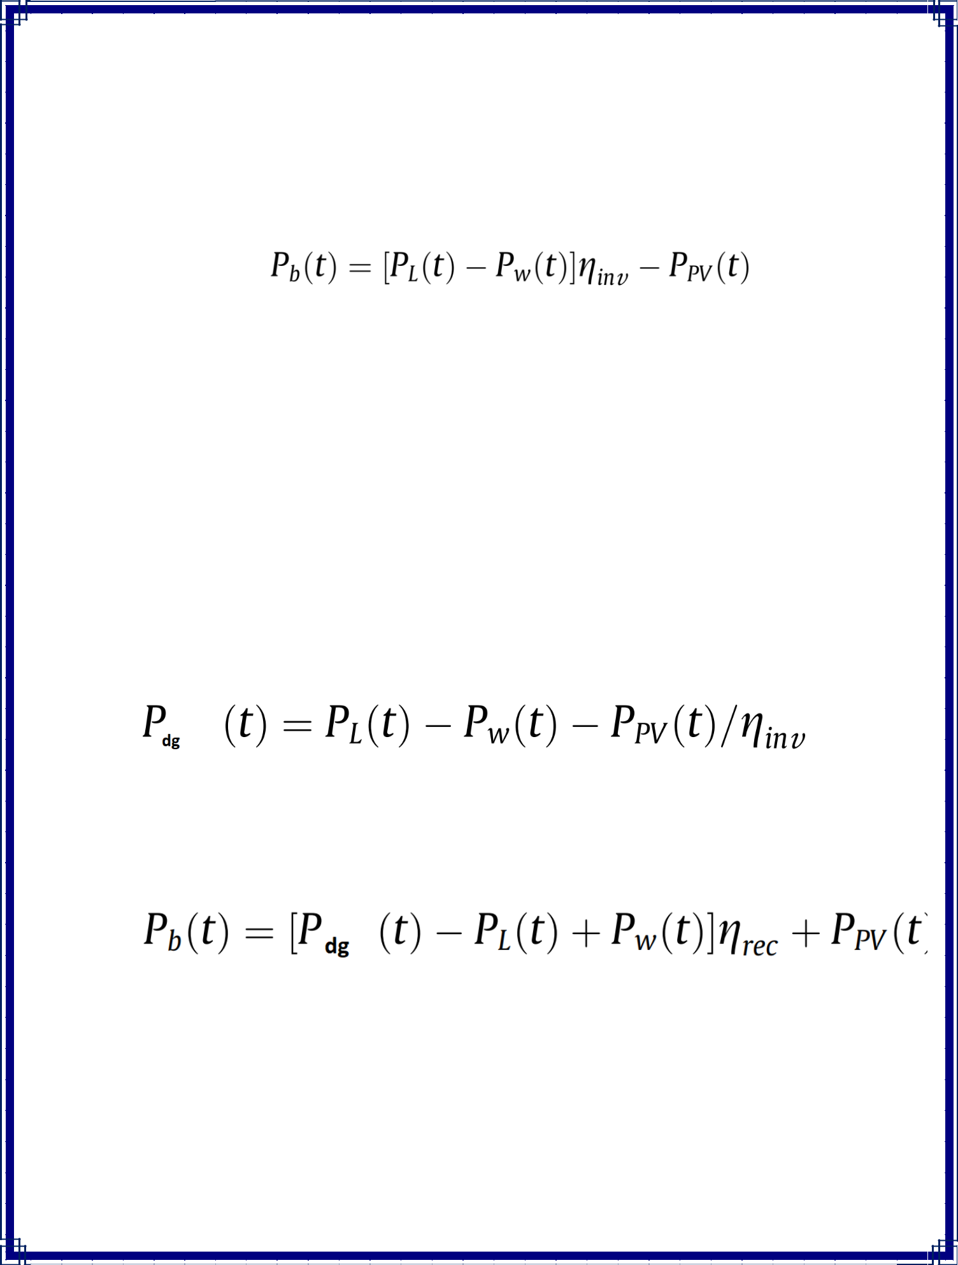

- If solar PV panels and wind turbines do not generate enough power, the battery will provide balance power, which is calculated as,

- If solar and wind power are insufficient and batteries (SOC(t) <= SOC_{min}) are likewise unable to fulfil the load requirement, a diesel generator is used to supply power to the load.
Diesel Generator can be used in two ways,
- First, it employs a load-following technique, in which it generates just the quantity of energy required to meet the principal load demand while in operation. The diesel generator's power output is computed as.

- It works at rated capacity or minimal load ratio in the second technique. If the diesel generator is functioning at full capacity, the extra electricity is used to charge the batteries, as shown below:

20
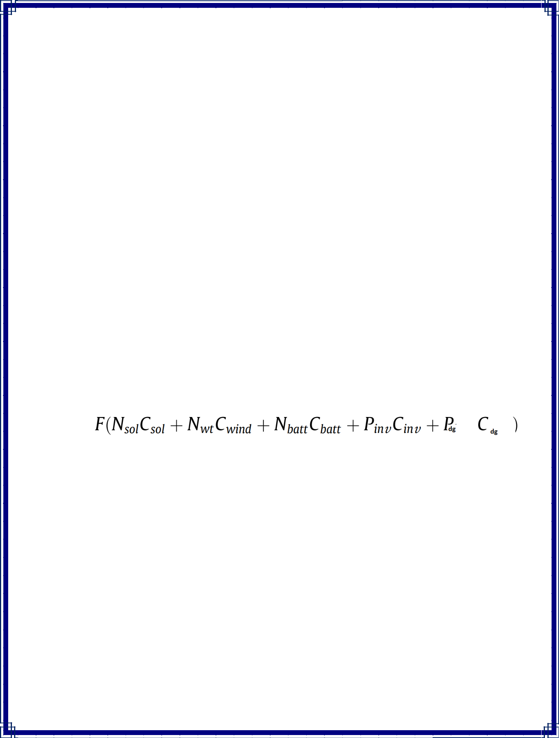
Objective function and constraints

The major goal of this research is to reduce overall NPC while ensuring optimal energy flow in the suggested hybrid system. The four primary decision factors for the best arrangement were the number of wind turbines, solar PV panels, batteries, and diesel generator rating. The annualised system cost (ASC) idea is utilised in economic analysis. While fulfilling all other requirements and criteria, the result with least ASC is shown to be optimum. The total system cost is the objective function, which includes (i) total capital cost, (ii) replacement cost, and (iii) operating and maintenance cost of the components. The price of installation and civil works are included in the component's capital costs. The main goal is to reduce the following function while staying within the limitations.
Minimize ASC:

=

where C_{sol}; C_{wind}; C_{batt} and C_{inv} are the prices of solar PV panel (per kW), wind turbine (per kW), battery (per unit) and inverter (per kW) respectively. C_{dg} is the price of diesel generator (per kW) and P_{dg} is the rating of diesel generator. P_{inv} is the rating of the inverter.

Capital and installation cost (C_{acap}), replacement cost (C_{arep}), yearly maintenance cost (C_{m}), operating cost (C_{f}), and salvage cost (C_{sal}) are all included in the ASC . Furthermore, each component's total ASC may be stated as follows:

21
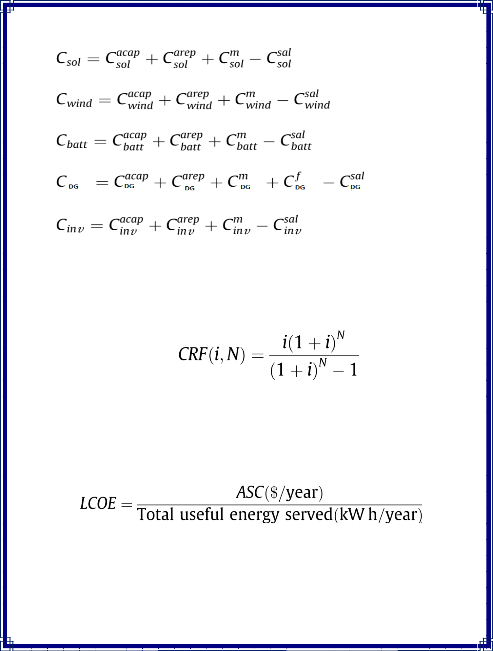

A metric known as the capacity recovery factor (CRF) can be used to assess the yearly cost of any component . CRF is a formula for calculating the present value of money that may be written as,

The best configuration is chosen based on LCOE and dependability. The LCOE is defined as the system's average price per kWh of usable energy produced, and it is expressed as follows:

22

Artificial Bee Colony Algorithm:

Some duties are done by specific individuals in a genuine bee colony. To maximise the amount of nectar in the hive, these smart bees employ efficient division of work and self-organization. Karaboga introduced the Artificial Bee Colony (ABC) method for real-parameter optimization in 2005, and it is a newly developed optimization technique that mimics the foraging behaviour of a bee colony. The ABC algorithm models three types of bees in a swarm-intelligent forage selection model in a honey bee colony: working bees, onlooker bees, and scout bees. Half of the colony is made up of working bees, while the other half is made up of observer bees. Employed bees are responsible for utilising previously examined nectar sources and telling the hive's waiting bees (onlooker bees) about the grade of the food source sites they are utilising. In the hive, onlooker bees wait and utilise the worker bees' expertise to select a food source to exploit. Scouts either randomly search the planet for a new food source based on an internal incentive or based on possible external signals to find a new food source. The following is a simple explanation for foraging bees' emergent intelligent behaviour:

23
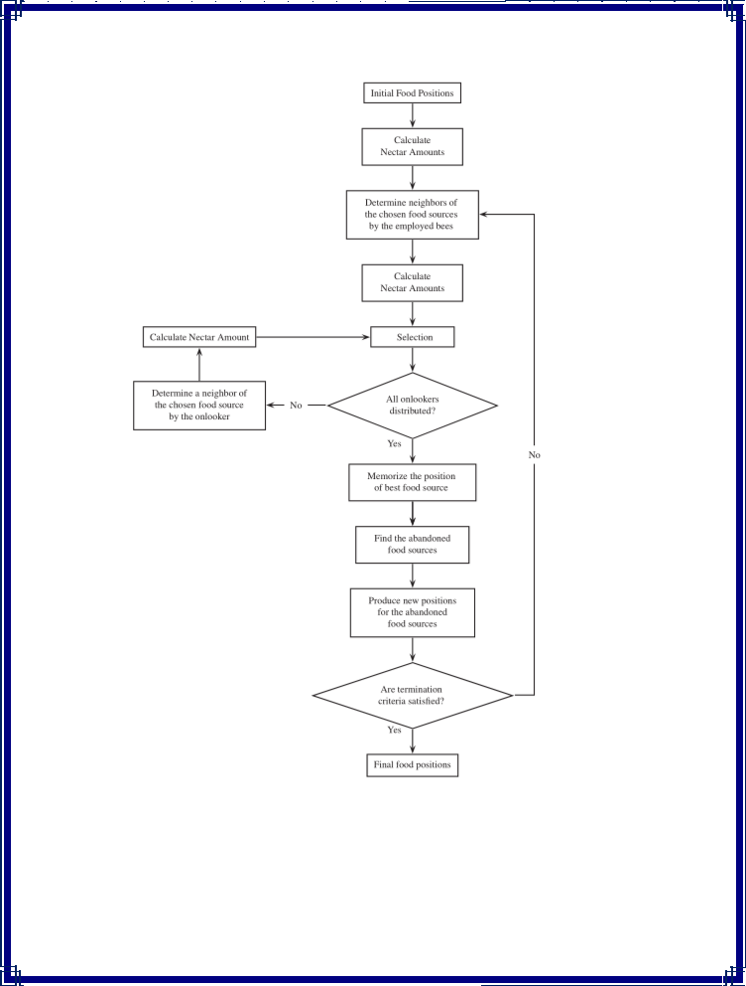

Fig 3. Flowchart of the Artificial Bee Colony algorithm.

24
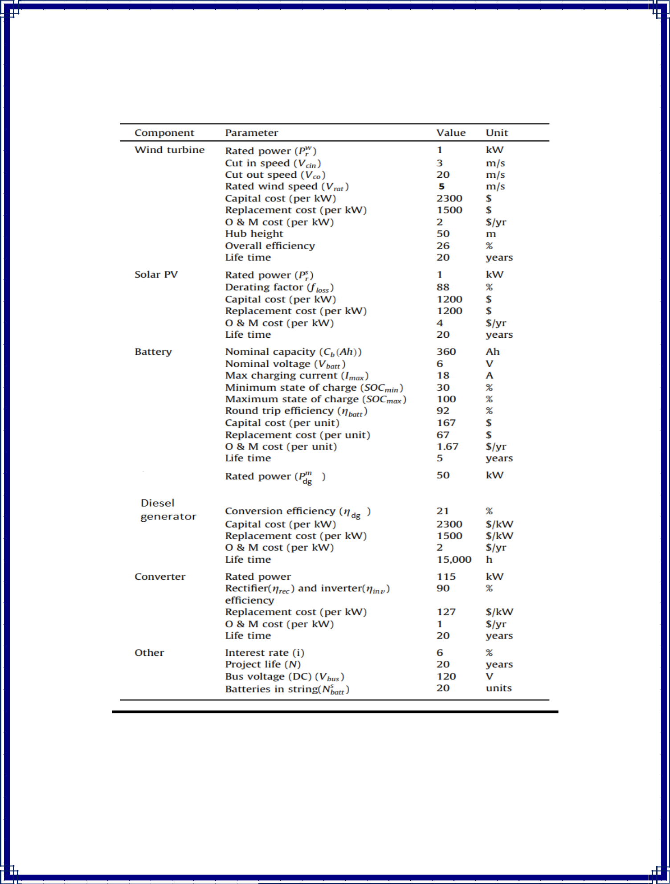
Input

Table 1.Technical and economic data of the components used in the proposed hybrid system.

25
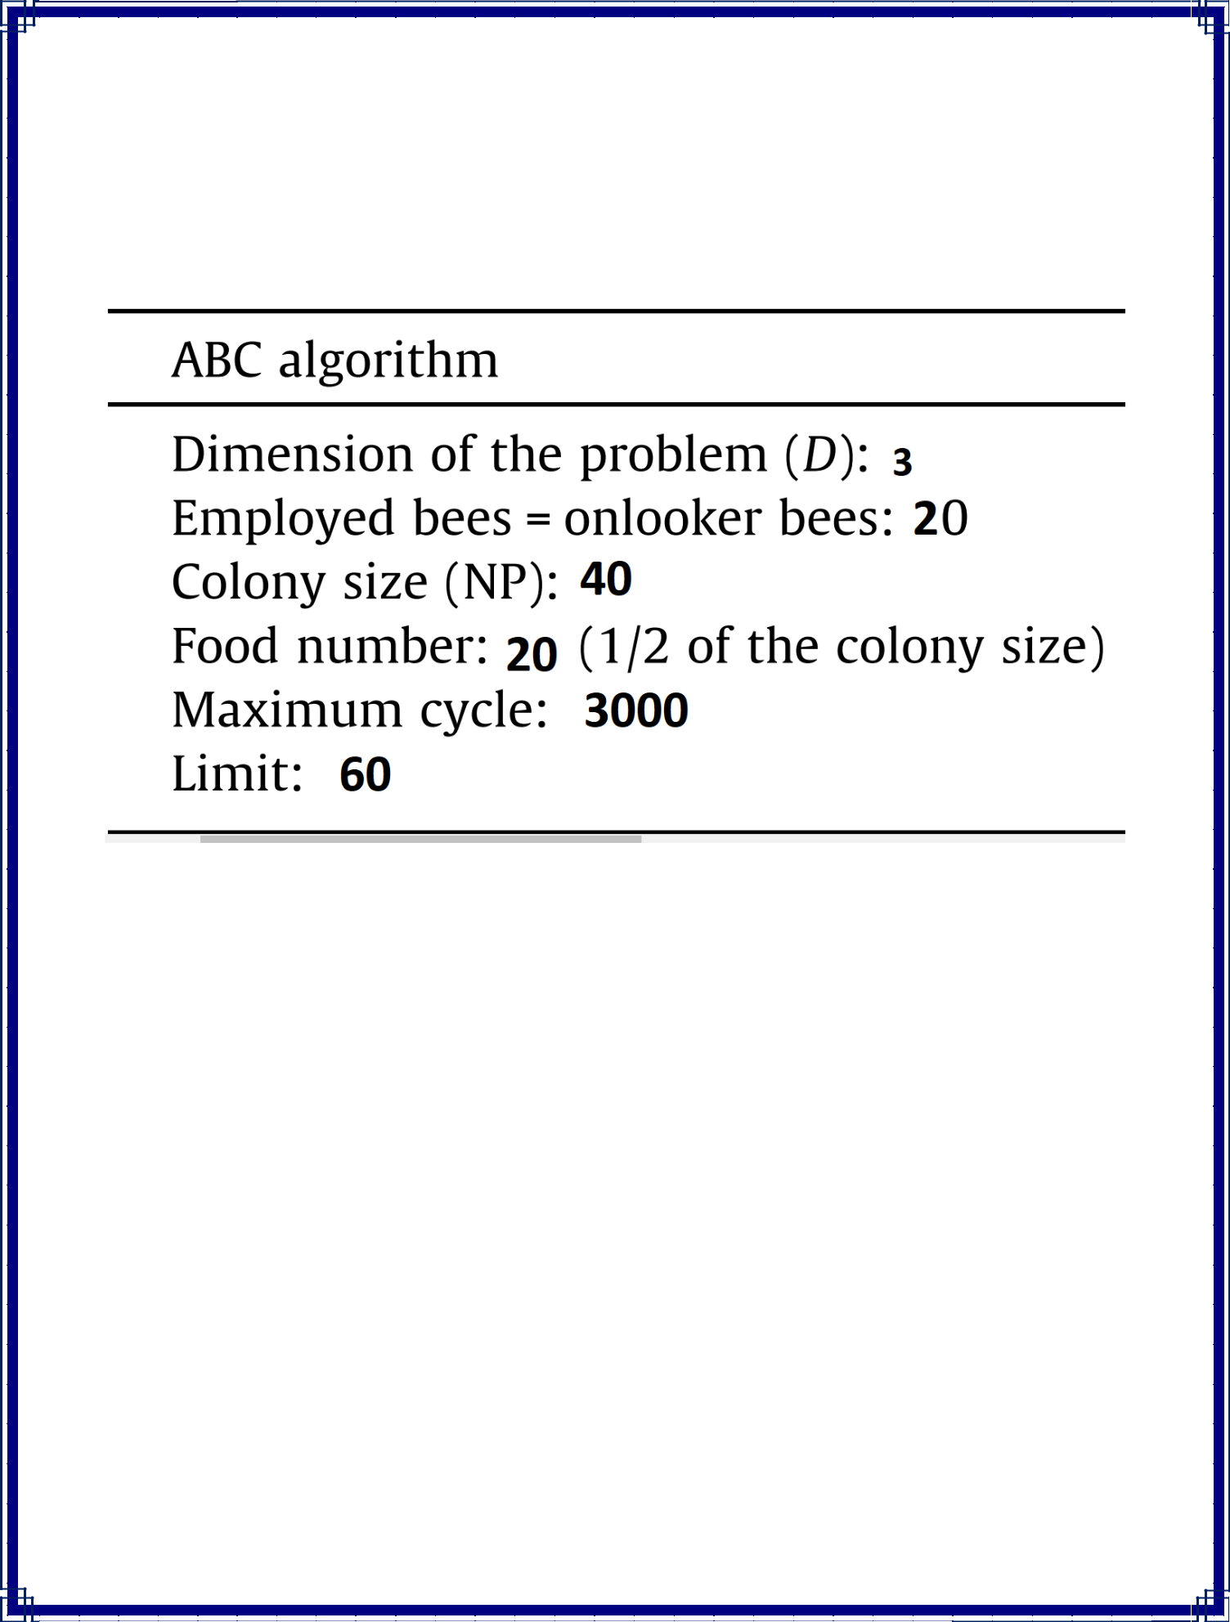

Table 2. Parameters of the ABC algorithm

26
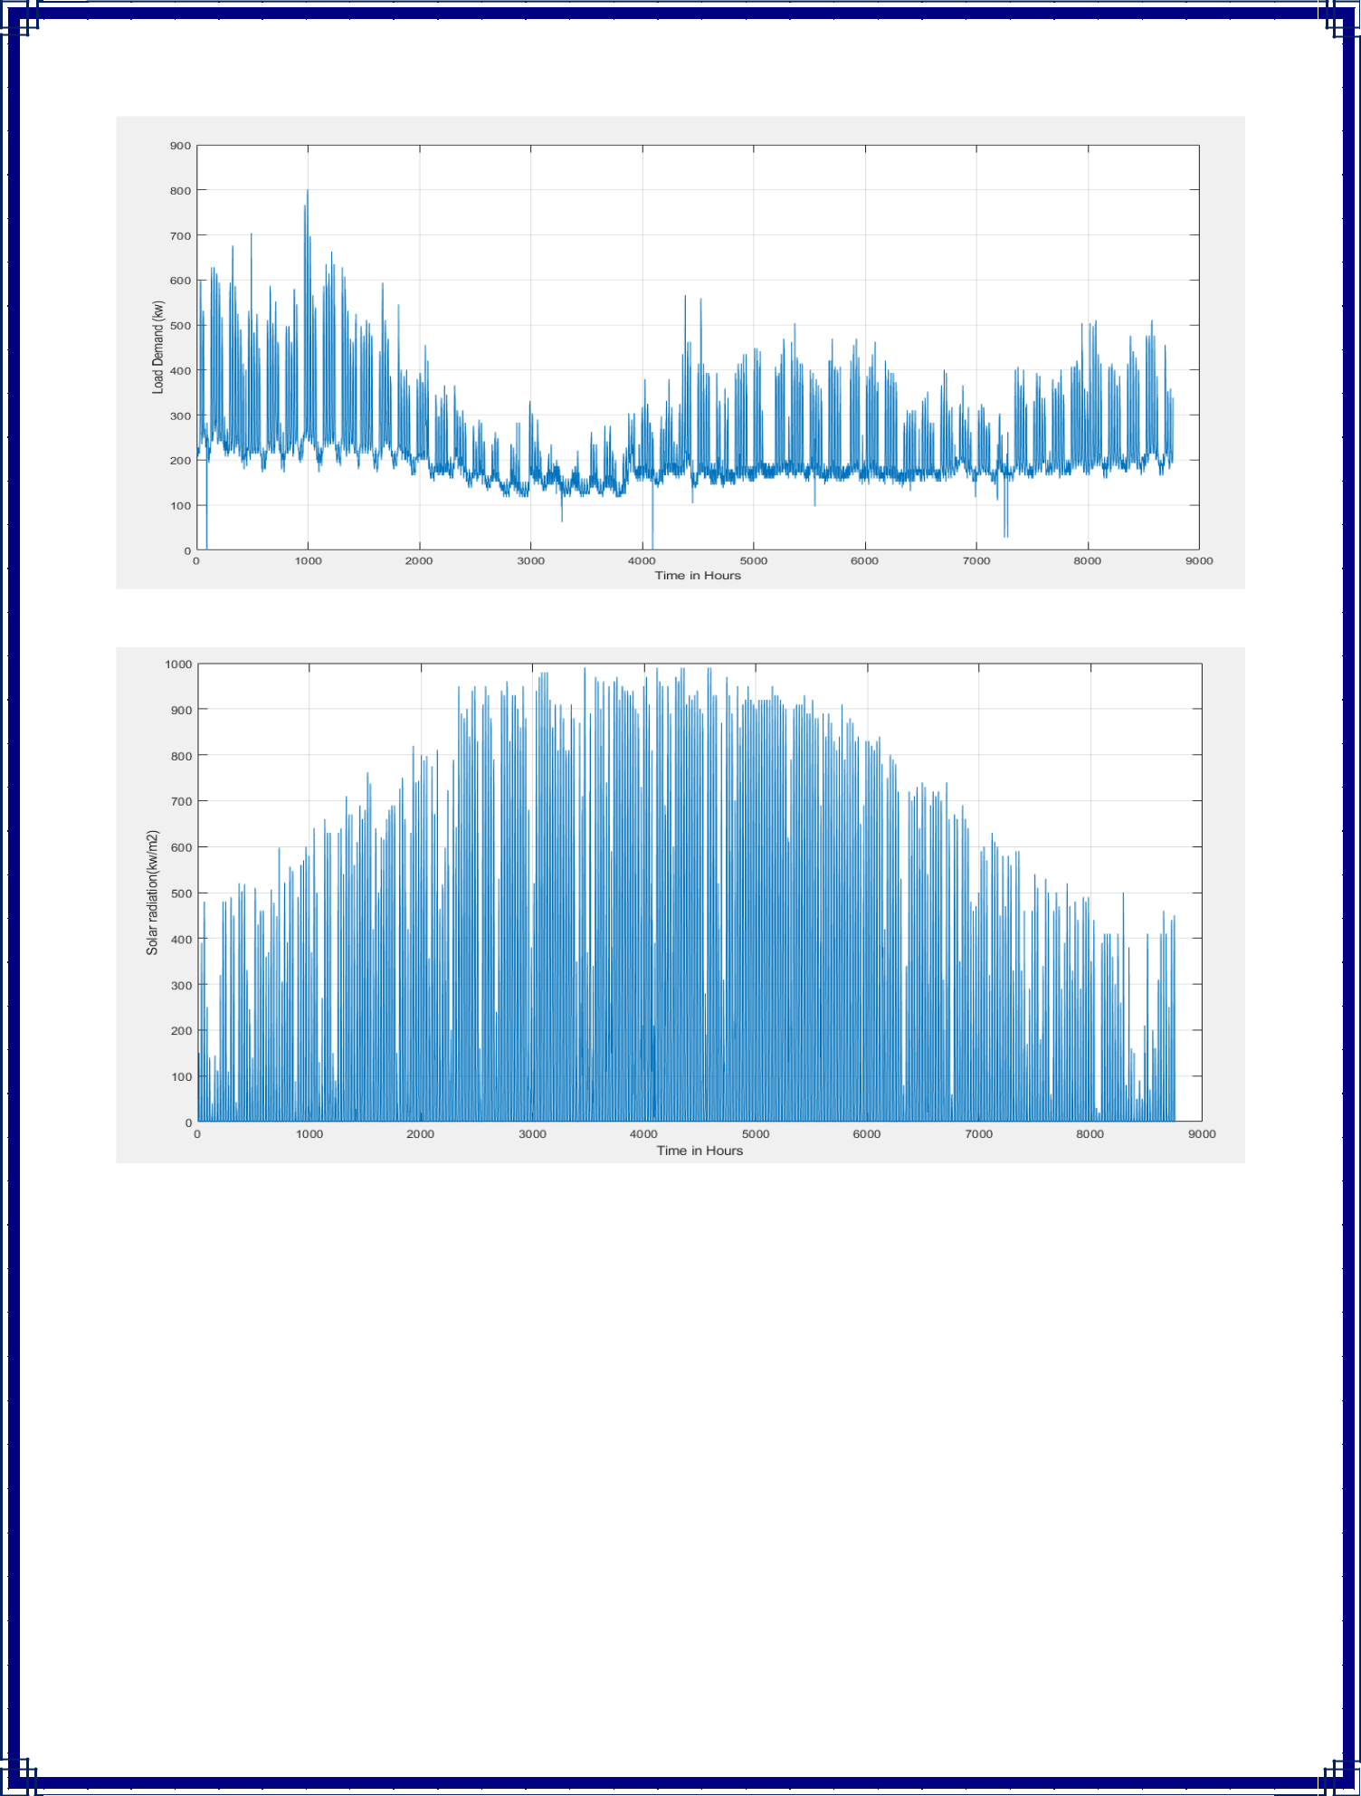

Fig 4. Load demand (in Kw) vs time (in hours)

Fig. 5 Solar Radiation (in Kw\m²) vs time (in hours)

27
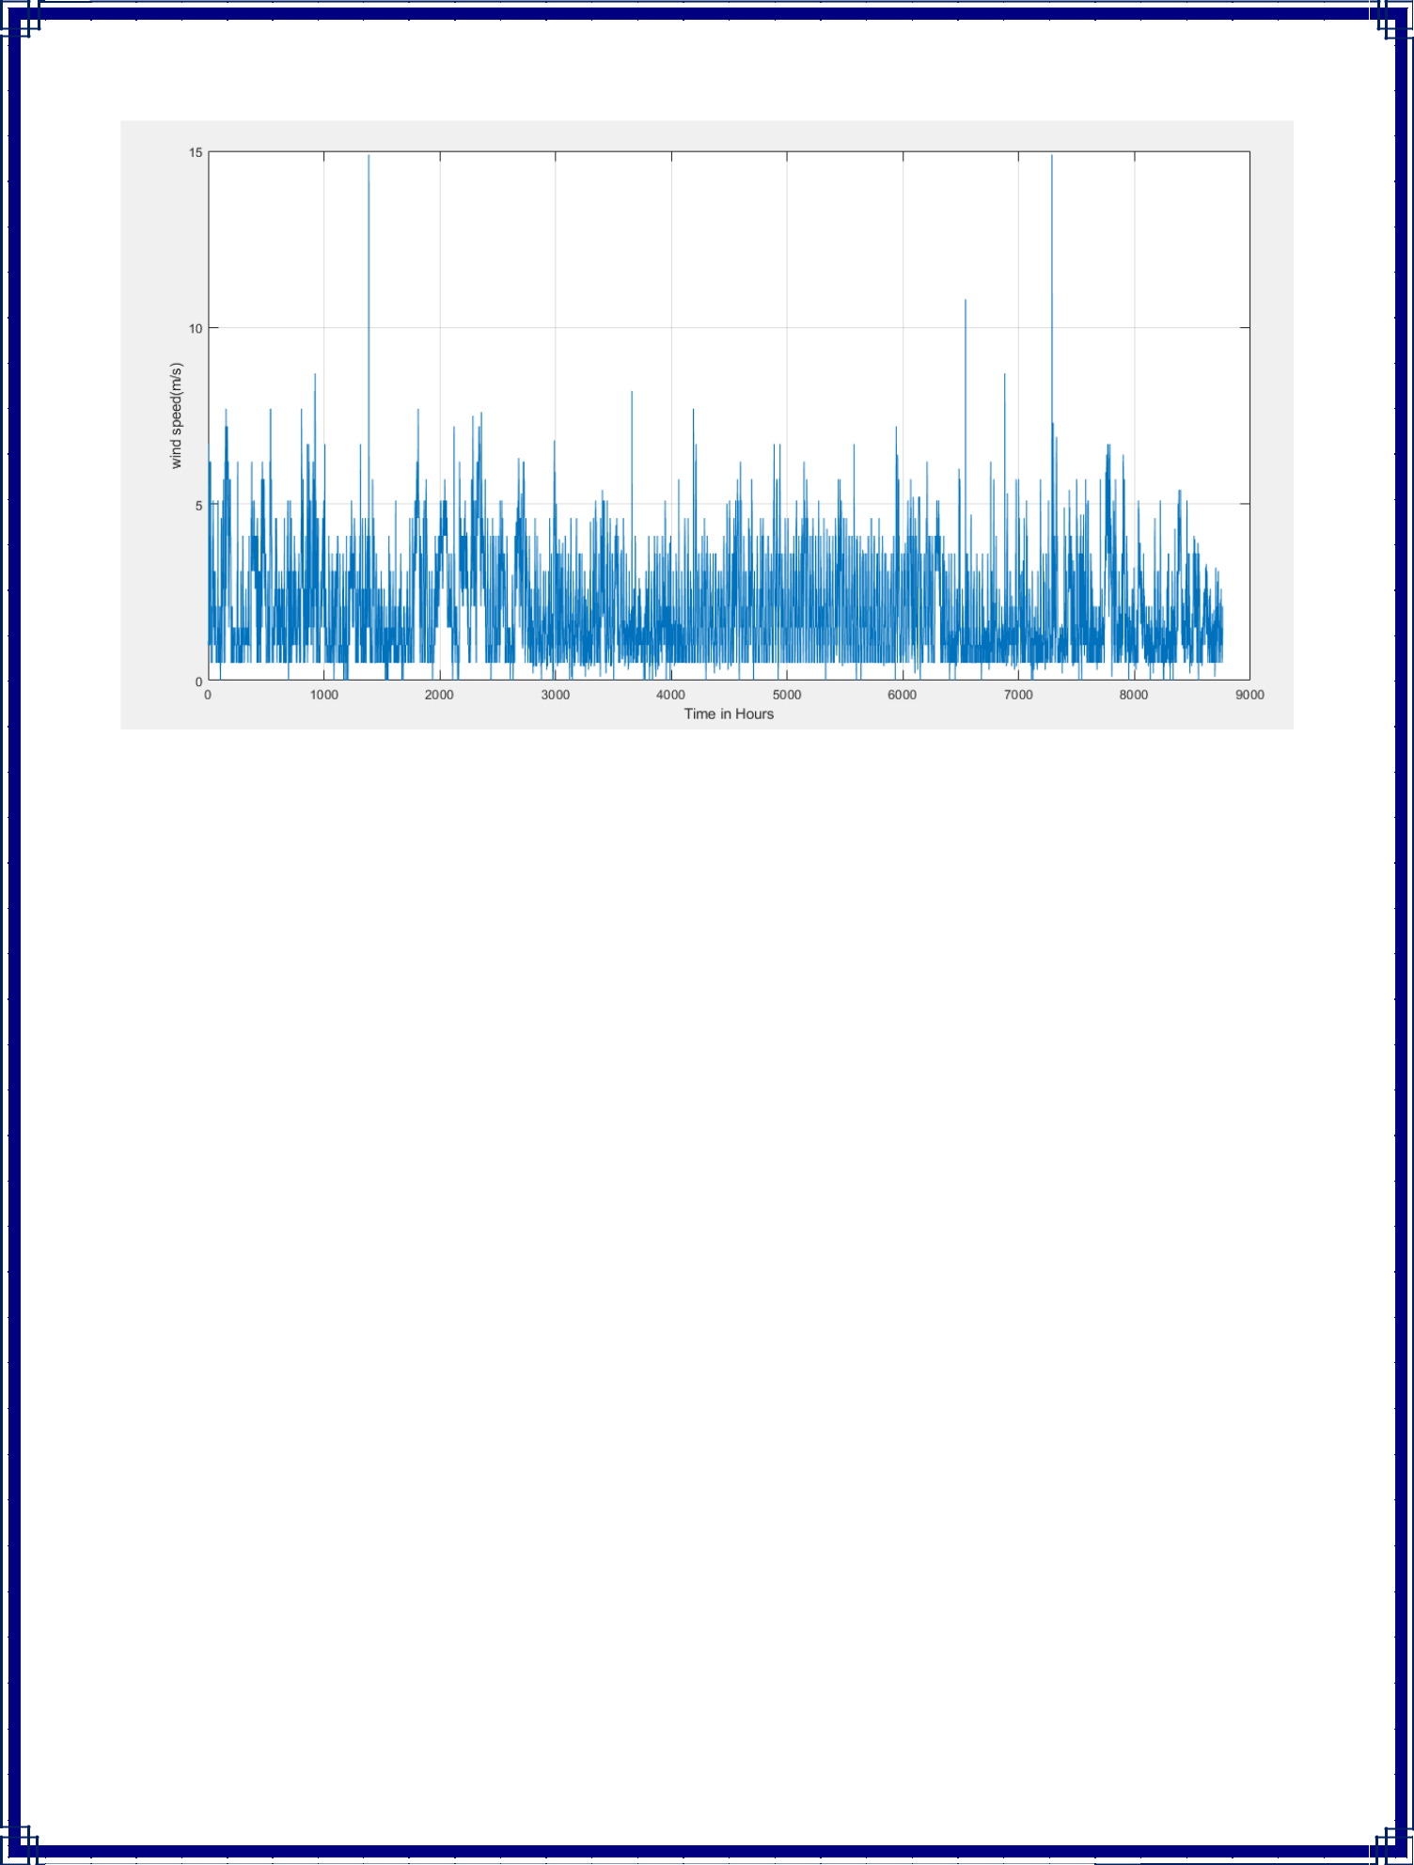

Fig 6. Wind Speed (in m/s) vs time (in hours)

28
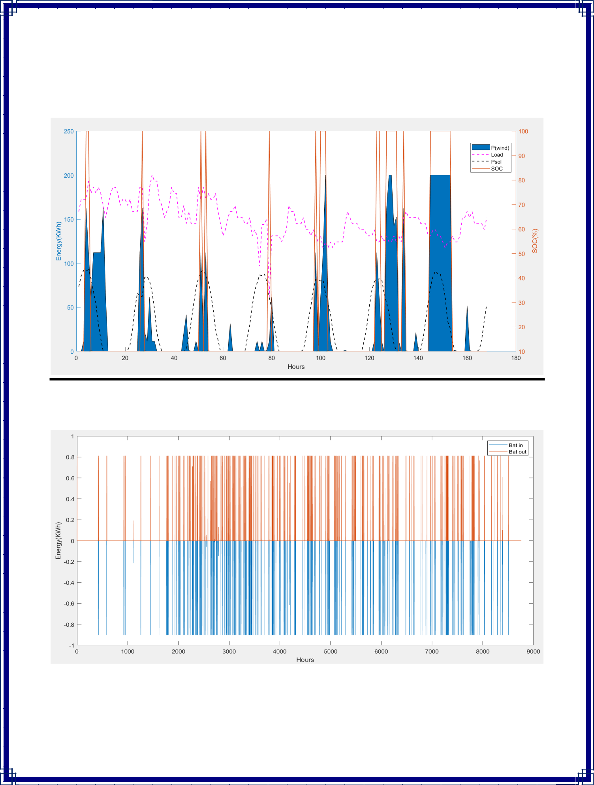
Graphical Results

Fig. 7 Energy (in Kw) vs time (in hours)

Fig. 8 State of Battery

29
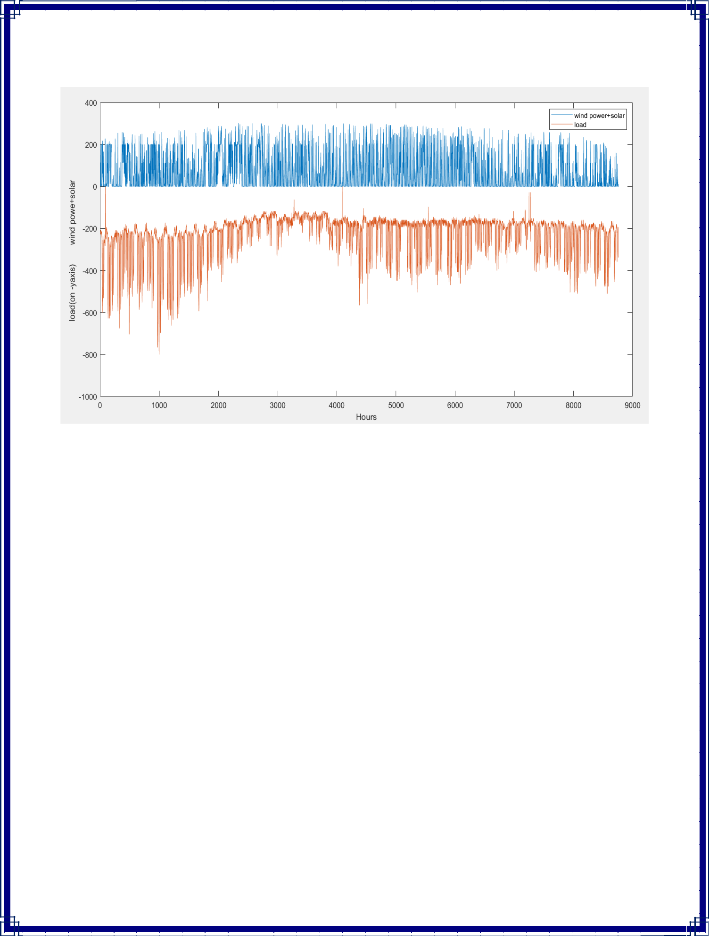

Fig. 9: Variable load and renewable energy power generation

30


Numerical Results:

The experimental results were simulated using the ABC algorithm using the MATLAB 2018a program. After simulation,we have obtained following output:-

Total Wind energy(KWh)= 4.2799*10⁵ Total Solar energy(KWh)= 1.6998*10⁵

Total DG Energy generation(KWh)= 1.4327*10⁶ Wasted Energy(KWh)= 3.5369*10⁴
LCOE_ = 0.4058 $/kWh Total NPC = 5.7636*10⁶ $ Annual_cost = 8.0836*10⁵$/yr Wind cost = 1.1842*10⁵ $/yr Solar cost = 5.8200 *10⁴ $/yr DG cost = 6.2997*10⁵ $/yr Battery cost = 225.6498 $/yr Inverter Total cost = 1.5422*10³ $/yr Bin = 271.7212

Bout =245.6063

31

Conclusion

In especially for off-grid regions, a hybrid energy system provides a more dependable, cost-effective, and acceptable source of electricity. The ABC method was used to create a mathematical model to identify the best size of components in a hybrid PV-wind-battery with diesel generator. The ABC algorithm's operational method and implementation procedures are briefly discussed first, accompanied by the mathematical modelling of the many components used in the analysis.

32


References

- Zhou W, Lou C, Li Z, Lu L, Yang H. Current status of research on optimum sizing of stand-alone hybrid solar-wind power generation systems. Appl Energy 2010;87(2):380–9.

- Karaboga D, Basturk B. A powerful and efficient algorithm for numerical function optimization: artificial bee colony (ABC) algorithm. J Global Opt 2007;39(3):459–671.

- Lazou A, Papatsoris A. The economics of photovoltaic standalone residential households: a case study for various European and Mediterranean locations. Sol Energy Mater Solar Cells 2000;62:411–27.

- Balamurugan P, Ashok S, Jose TL. Optimal operation of biomass/wind/PV hybrid energy system for rural areas. Int J Green Energy 2009;6:104–16.

- Bhattacharjee S, Acharya S. PV-wind hybrid power option for a low wind topography. Energy Convers Manage 2015;89:942–54.

33


34

