

SESSION 2025-26
Department: SOET
Program: MCA AI/ml
Course code: ETMMDL274
Course Name: Deep Learning Architectures and Techniques
Semster: 2nd
ASSIGNMENT 01

Submitted to: Submitted by: Dr. Shahid Ahmad Wani Ashish Raj
Date: 5-3-2026
Roll no:2501940024

*Assignment Title
Neural Network-Based Credit Risk Prediction Using a Multi-Layer Perceptron (MLP).

*Objective
The objective of this laboratory assignment is to implement a feedforward neural network for binary classification using tabular data. Specifically, the task is to build, train, and evaluate a Multi-Layer Perceptron (MLP) to predict credit risk, applying core concepts such as activation functions, loss functions, and optimization.

*Dataset Description & Preprocessing
For this assignment, the UCI German Credit Dataset was selected. The dataset contains 1,000 instances with attributes used to classify bank account holders into good or bad credit risks.
To prepare the structured tabular data for the neural network, the following data preprocessing steps were performed explicitly:
- Handling Missing Values: The dataset was checked for null values. No missing values were found, ensuring data completeness.
- Encoding Categorical Variables: Categorical features were converted into numerical formats using One-Hot Encoding via the Pandas get_dummies function, dropping the first category to avoid dummy variable trap.
- Target Variable Mapping: The target variable (credit risk) was mapped to 0 (Good Credit) and 1 (Bad Credit) to facilitate binary classification.
- Data Splitting: The data was split into training (80%) and testing (20%) sets using a fixed random seed (42) for reproducibility.
- Feature Scaling: All numerical features were standardized using Scikit-learn's StandardScaler to have a mean of 0 and a variance of 1, which helps the neural network converge faster.

*Model Architecture
The designed MLP architecture is a Sequential model utilizing dense (fully connected) layers. The network consists of:
- Input Layer: Implicitly defined by the shape of the scaled training features.
- First Hidden Layer: 64 neurons utilizing the ReLU (Rectified Linear Unit) activation function.
- Second Hidden Layer: 32 neurons utilizing the ReLU activation function.
- Output Layer: 1 neuron utilizing the Sigmoid activation function to output a probability between 0 and 1 for binary classification.
The model contains a total of 5,249 trainable parameters. It was compiled using the Adam optimizer and Binary Cross-entropy loss, tracking accuracy as the primary evaluation metric.

*Training Results and Plots
The model was trained for 50 epochs using a batch size of 32. Validation data (the 20% test split) was used to monitor the model's performance on unseen data at the end of each epoch.
(Below are the training and validation loss and accuracy curves)

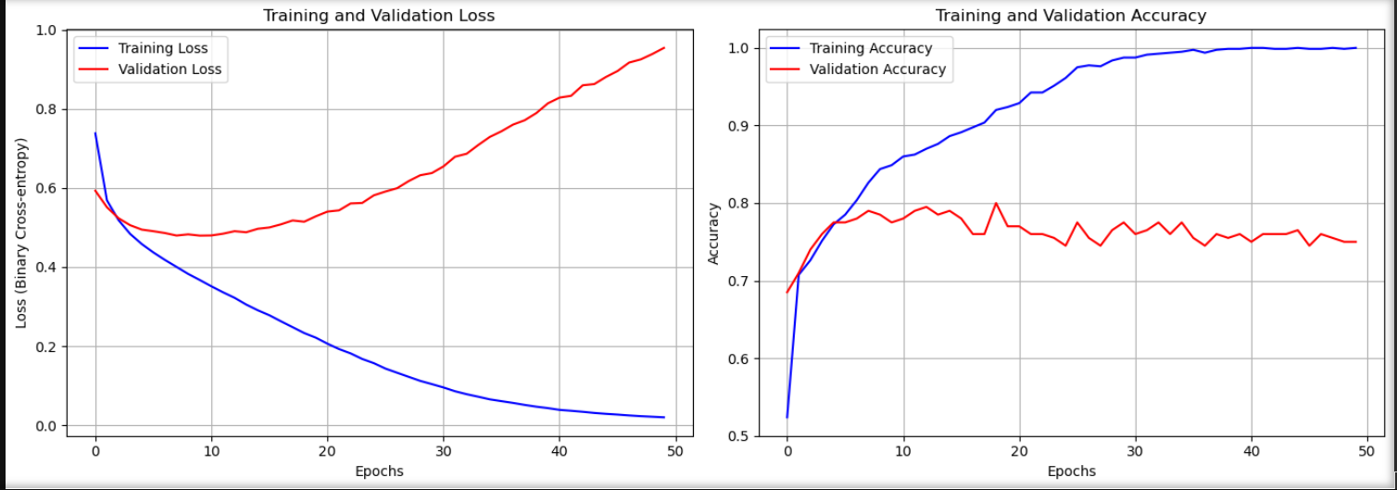

*Evaluation and Brief Discussion
The model's performance was evaluated on the test dataset using multiple metrics. The classification threshold was set at 0.5.
Performance Metrics:
- Accuracy: 0.7500 (75.00%)
- Precision: 0.5763
- Recall: 0.5763
- F1-score: 0.5763
Confusion Matrix: The confusion matrix below details the exact number of true positives, true negatives, false positives, and false negatives.

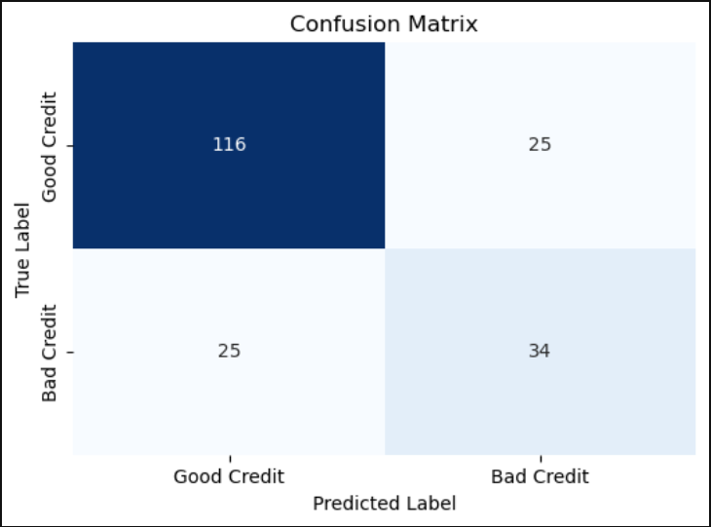

Discussion: The model achieved a respectable overall accuracy of 75%. Looking at the confusion matrix, the model is quite proficient at identifying "Good Credit" (116 correct predictions vs 25 incorrect). However, the Precision and Recall scores of ~0.57 indicate that it struggles slightly more with correctly identifying "Bad Credit" instances, misclassifying 25 of them as Good Credit.
Furthermore, analyzing the training curves reveals a clear case of overfitting. While the Training Loss continues to decrease towards zero, the Validation Loss begins to increase after approximately 5-10 epochs. In a future iteration, implementing regularization techniques such as Dropout layers or Early Stopping could help generalize the model better.

