1. Git clone chapter-7A screenshot of a computer

   Description automatically generated
2. Az –version , terraform –version and kubectl --versionA screenshot of a computer

   Description automatically generated
3. Get Kubernetes version by regionA screenshot of a computer

   Description automatically generated
4. Update cluster.tf file

1. Terraform commands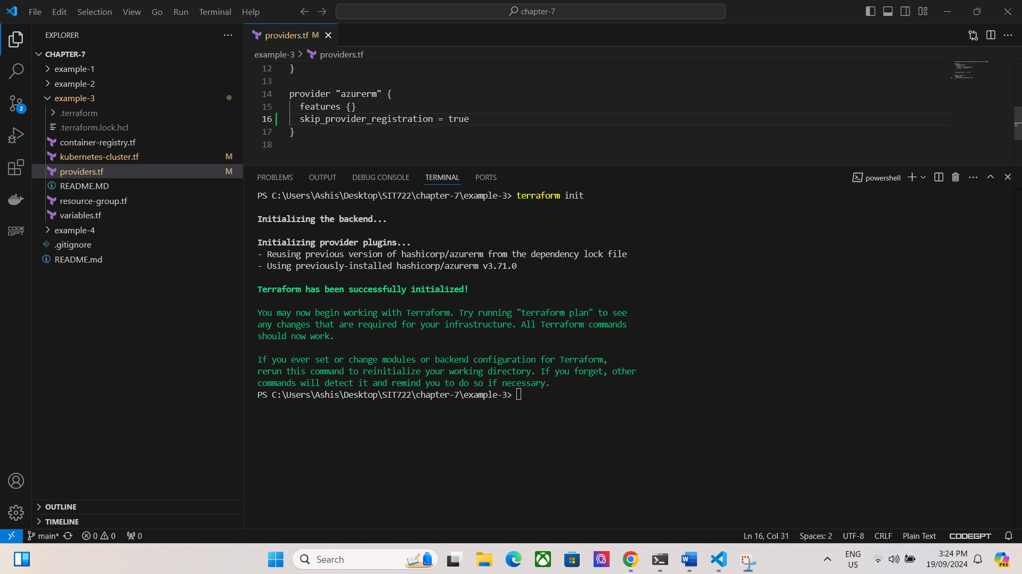A screenshot of a computer program

   Description automatically generatedA screenshot of a computer

   Description automatically generated
2. Docker pushA screenshot of a computer screen

   Description automatically generated

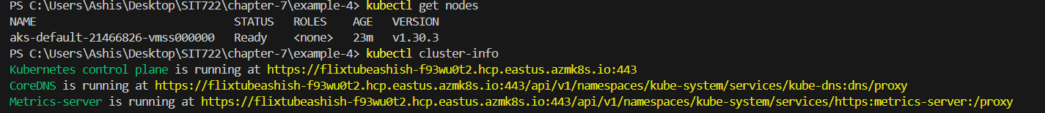

**Describe in your own words what are the four example applications(stages) each demonstrating?**

**Example 1:-** This example demonstrates how to deploy a simple application in Kubernetes. It introduces the basic concepts of creating a Kubernetes deployment running a containerized application and exposing it using a service to make it accessible.

**Example 2:-** This example showcases how to use Terraform to automate the creation of an Azure Container Registry. The registry can then be used to store Docker images which can later be deployed in Kubernetes.

**Example 3**:- In this example, along with example 2 steps . This gets the infrastructure ready for running apps in containers.

**Example 4**:- This example shows how to deploy an app to the Kubernetes cluster made in Example 3. It builds the app using a Dockerfile and then uses a YAML file to deploy and manage the app in the cluster.

In this project, the latest **Kubernetes version** used was **1.30.3**.