1. Download And install MSSQL Server 2017 and Management Studio.

* <https://www.microsoft.com/en-au/sql-server/sql-server-downloads>
* <https://docs.microsoft.com/en-us/sql/ssms/download-sql-server-management-studio-ssms?view=sql-server-2017>

1. Download and Install Asp.Net Core 2.2 SDK and Visual Studio 2019 Community Edition.
2. Here’s the Link :

* <https://dotnet.microsoft.com/download/thank-you/dotnet-sdk-2.2.107-windows-x64-installer>
* <https://visualstudio.microsoft.com/downloads/>

1. Now Click on WebApi.sln file in project.
2. Use “Package Manager Console”, and run :- **Update-Database** command
3. Now build and run the project.
4. Screenshot of API Test for UserRegistration

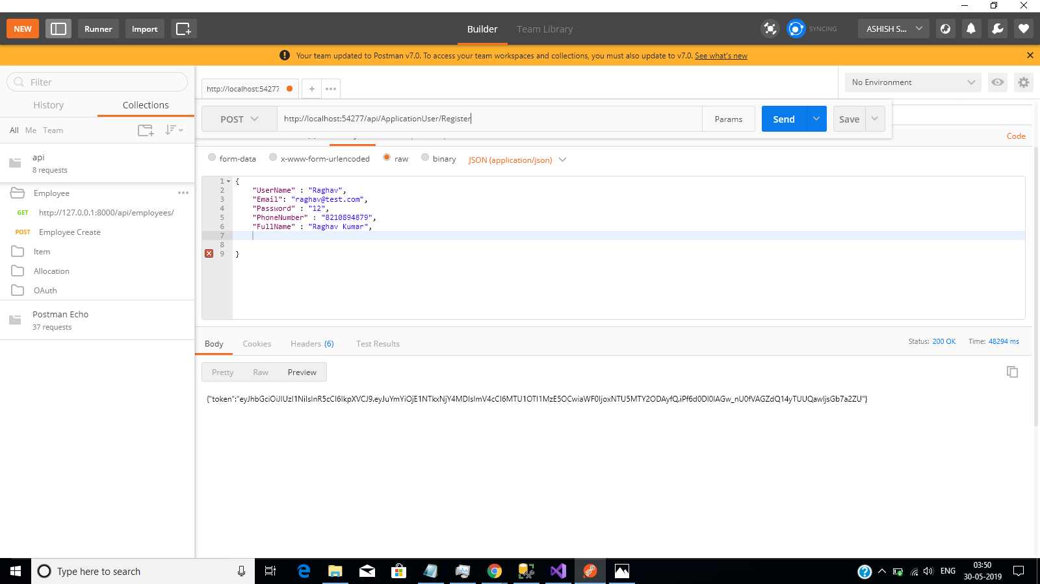

1. Screenshot of API Test for Login

