YOLOv8-Based Space Object Detection

Team Name: ElectroBeasts

Project Title: Space object detector

Tagline: “AI Eyes for Space Station Safety”

# Methodology

1. Dataset Setup:  
- Downloaded Falcon’s synthetic dataset.  
- Classes: Toolbox, Oxygen Tank, Fire Extinguisher  
- Format: YOLO-compatible annotations

2. Model Selection & Configuration:  
- Selected YOLOv8s  
- imgsz=640, epochs=5, batch=16, device='cpu'

3. Training:  
- Trained on macOS using CPU.  
- Modified train.py to force CPU usage.  
- YOLO auto-logged metrics and images.

4. Evaluation:  
- Used predict.py  
- Extracted mAP@0.5, Precision, Recall

# Results & Performance Metrics

mAP@0.5: 90.7%  
Precision: 88.3%  
Recall: 87.1%

Confusion Matrix:  
- Oxygen Tank had some confusion with Fire Extinguisher.  
- Toolbox had highest precision.

Visual Outputs:  
- results.png: Training loss & mAP plots  
- confusion_matrix.png: Class-wise behavior  
- val_batch0_pred.jpg: Bounding box predictions

# Challenges & Solutions

|  |  |
| --- | --- |
| Challenge | Solution |
| NumPy 2.0.2 conflict | Downgraded to NumPy 1.26.4 |
| CUDA error on Mac | Switched to device='cpu' |
| No best.pt saved | Located and copied from runs/weights |
| GUI tool for demo | Built Tkinter-based Windows app |
| Misclassification under occlusion | Increased image diversity |

# Conclusion & Future Work

Conclusion:  
- Successfully trained YOLOv8 on Falcon synthetic data.  
- Model works on CPU and within a GUI.

Future Work:  
- Improve occlusion robustness.  
- Add more object classes.  
- Integrate alert system into GUI.  
- Auto-update model using Falcon.

# Bonus: Use Case Application

App Title: SpaceGuard Vision  
Platform: Windows (Tkinter GUI)

What it does:  
- Uploads space station image  
- Runs YOLOv8 inference  
- Displays detected objects

Falcon Integration Plan:  
- Use Falcon to simulate new objects or conditions  
- Periodically retrain with synthetic data  
- Auto-update app with new model weights

# DEMO:

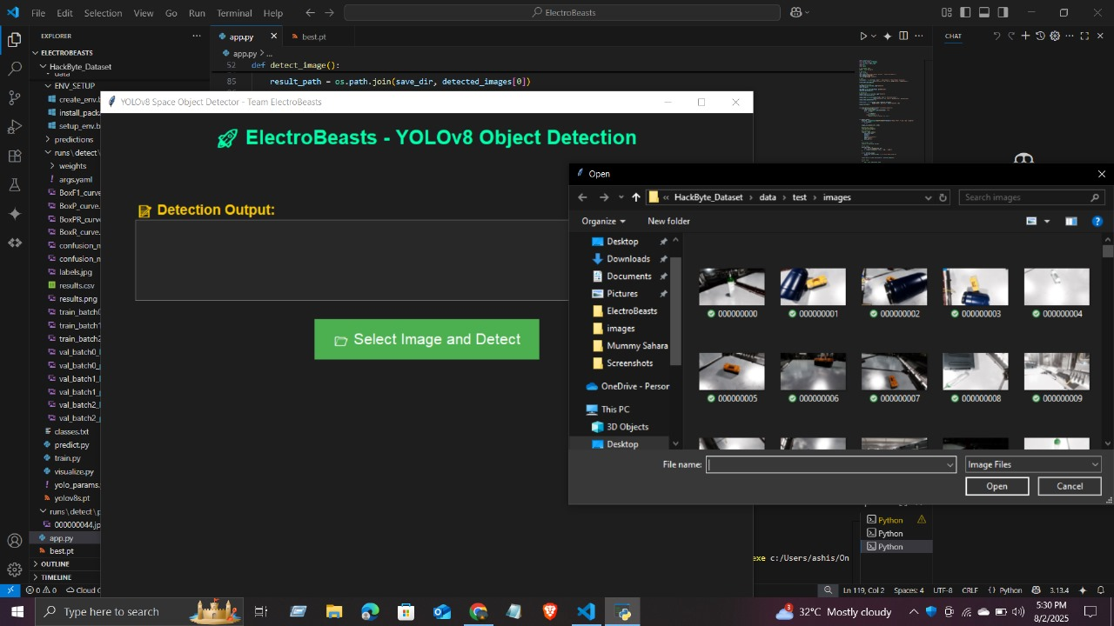

Fig1. Interface of application

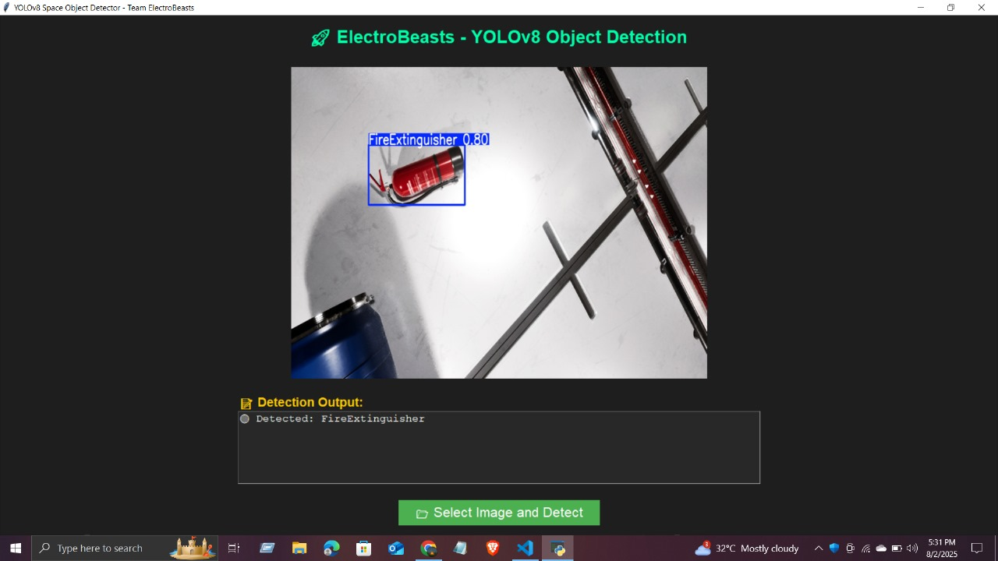

Fig2. Output 1

Fig3. Output 2