**DBS201 Lab 2 (revised Winter 2019) Name: Ashish Sheoran**

1. How does the system respond when you do not include the collection name PREMIERE when viewing the CUSTOMER table?

CUSTOMER in *LIBL type *FILE not found.

The file was not found in the library when we removed the collection name.

1. What are the shorter field names used with the CUSTOMER table?

CSTNUM

CSTLNM

CSTFNM

CSTSTR

CSTCTY

CSTSTE

CSTZIP

CSTBAL

CSTCRD

CSTSRP

1. What are the 26 column types you can use in a column definition?

These are the following column types which can be used in a column definition:

CHARACTER [length] or CHAR [length]

VARCHAR [length]

BOOLEAN

SMALLINT

INTEGER or INT

DECIMAL or DEC

NUMBERIC

REAL

FLOAT

DOUBLE PRECISION

DATE

TIME

TIMESTAMP

CLOB [length] or CHARACTER LARGE OBJECT [length] or CHAR LARGE OBJECT [length]

BLOB [length] or BINARY LARGE OBJECT [length]

ARRAY

MULTISET

XML

BIGINT

VARBINARY

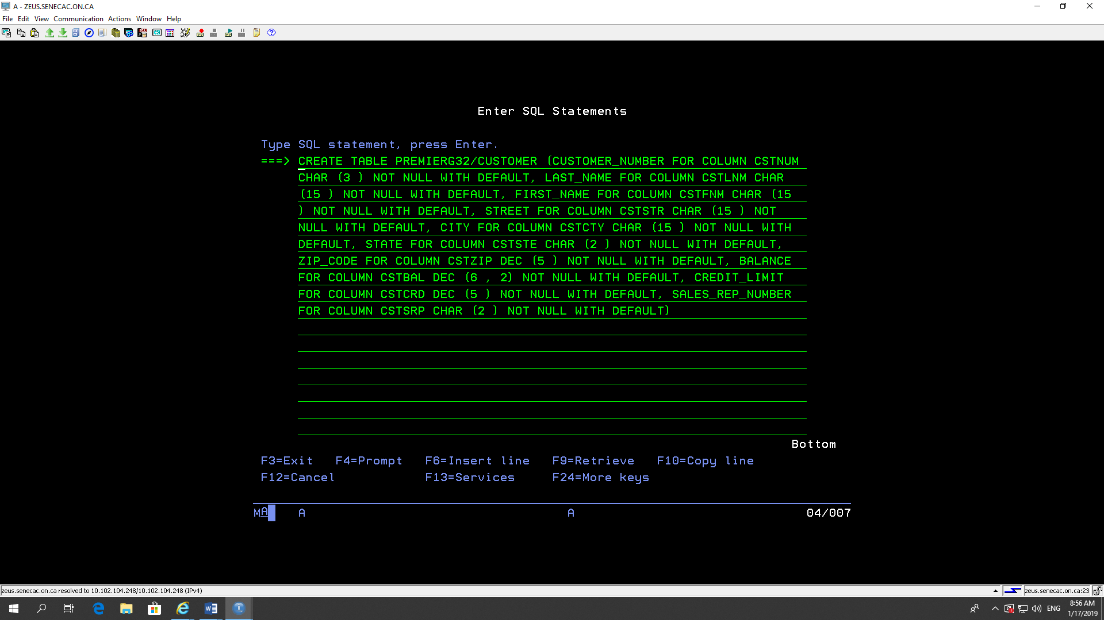

1. What warning do you get when you create the CUSTOMER table in your library?

Table CUSTOMER in WS201G32 created but was not journaled.

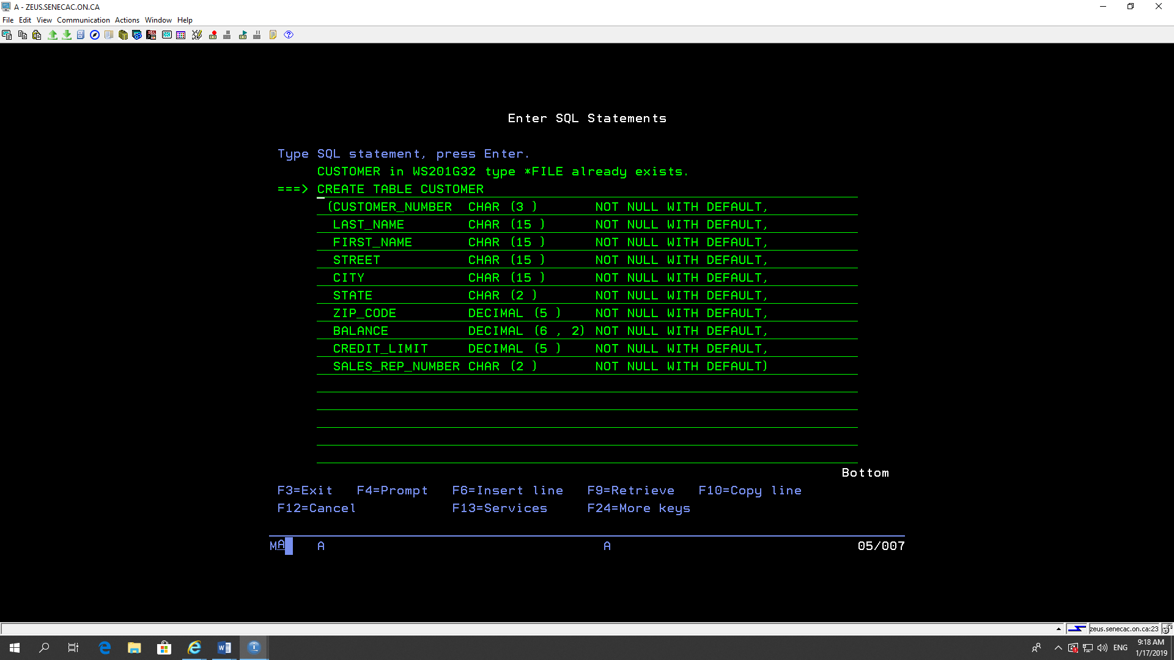

1. Write out the SQL statement to produce the SALESREP table.

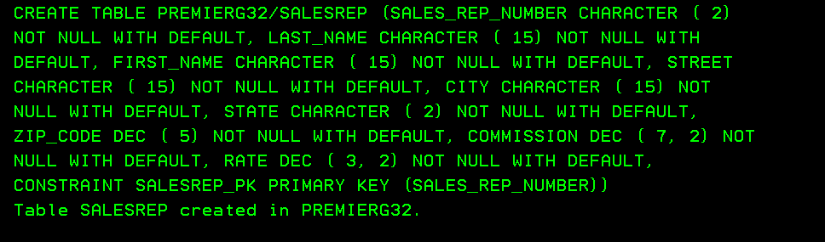

________________________________________________________________

CREATE TABLE PREMIERG32/SALESREP (SALES_REP_NUMBER CHARACTER ( 2)

NOT NULL WITH DEFAULT, LAST_NAME CHARACTER ( 15) NOT NULL WITH

DEFAULT, FIRST_NAME CHARACTER ( 15) NOT NULL WITH DEFAULT, STREET

CHARACTER ( 15) NOT NULL WITH DEFAULT, CITY CHARACTER ( 15) NOT

NULL WITH DEFAULT, STATE CHARACTER ( 2) NOT NULL WITH DEFAULT,

ZIP_CODE DEC ( 5) NOT NULL WITH DEFAULT, COMMISSION DEC ( 7, 2) NOT

NULL WITH DEFAULT, RATE DEC ( 3, 2) NOT NULL WITH DEFAULT,

CONSTRAINT SALESREP_PK PRIMARY KEY (SALES_REP_NUMBER))

Table SALESREP created in PREMIERG32.

1. Write out the SQL statement to add a row to the CUSTOMER table by just referring to values without referring to the column names.



INSERT INTO PREMIERG32/CUSTOMER VALUES(NULL, NULL, NULL, NULL,

NULL, NULL, NULL, NULL, NULL, NULL)

1. What happens when you try and add a second row to the CUSTOMER table with the same customer number as the first row?

____ Duplicate key value specified.

1. Write out the SQL statement to add a row to the SALESREP table. Include the column names.

This is achieved by INSERT (F4) and then on the first screen changing this option from N to Y.

Select fields to insert

INTO . . . . . . . . . Y

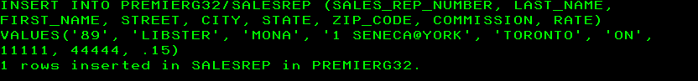_______________________________________________________________

INSERT INTO PREMIERG32/SALESREP (SALES_REP_NUMBER, LAST_NAME,

FIRST_NAME, STREET, CITY, STATE, ZIP_CODE, COMMISSION, RATE)

VALUES('89', 'LIBSTER', 'MONA', '1 SENECA@YORK', 'TORONTO', 'ON',

11111, 44444, .15)

1 rows inserted in SALESREP in PREMIERG32.

Session was saved and started again.