**DBS201 Lab 5 (revised Winter 2019) Name: Ashish Sheoran**

1. What statement will produce the OrderInfo view that includes part descriptions?

SELECT o.ORDER_DATE, o.CUSTOMER_NUMBER, ol.ORDER_NUMBER,

p.PART_NUMBER, p.PART_DESCRIPTION, ol.NUMBER_ORDERED, ol.QUOTED_PRICE,

(ol.NUMBER_ORDERED*ol.QUOTED_PRICE)"TOTAL_COST"

FROM PART p, ORDERLINE ol, ORDERS o

WHERE ol.PART_NUMBER=p.PART_NUMBER

AND o.ORDER_NUMBER=ol.ORDER_NUMBER

ORDER BY ORDER_NUMBER

SELECT statement run complete.

1. AFOUR CHAR(5) NOT NULL WITH DEFAULT 'XXXXX')

How can you get XXXXX stored in the AFOUR column row without having to type it?

When we create our table with the given syntax and assigning the column the default value as NOT NULL WITH DEFAULT ‘XXXXX’. After that when we insert into any column of the table except the AFOUR, then AFOUR will have ‘XXXXX’ as a default value.

1. When you say Not Null with default – what is the default for a date column when you do not specify a value when inserting a row?

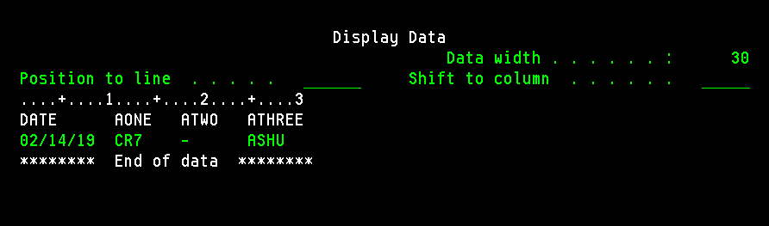

When we are inserting any row and do not specify any value for the DATE column, the default value for the date column will be today’s date.

1. What is the proper statement to produce the PGM table following the instructions on the physical design document?

CREATE TABLE PGM

(PGM_ID CHAR(3) NOT NULL WITH DEFAULT,

PGM_NAME CHAR(40) NOT NULL,

NO_SEMESTERS NUMERIC(1) NOT NULL WITH DEFAULT 6,

ADD CONSTRAINT PGM_PK PRIMARY KEY(PGM_ID),

ADD CONSTRAINT PGM_UNI UNIQUE (PGM_NAME),

PGM_CK CHECK (PGM_ID='CPA' OR PGM_ID='CPD'

AND NO_SEMESTERS>=0 ) )

Table PGM created in PREMIERG32.

1. What was the statement that removed everybody’s access to the Customer table?

REVOKE ALL ON CUSTOMER FROM PUBLIC

REVOKE of authority to CUSTOMER in PREMIERG32 completed.

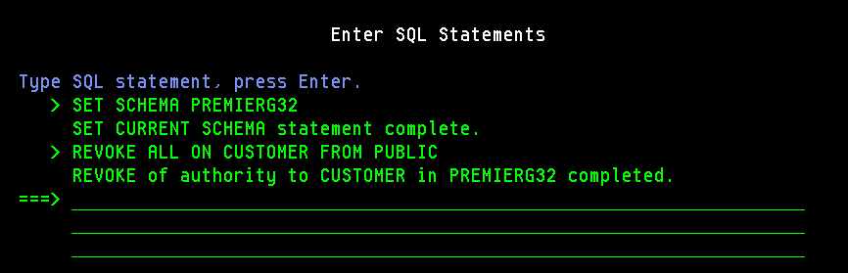

1. What piece of information is not showing on your screenshot of permissions to the CUSTOMER table.

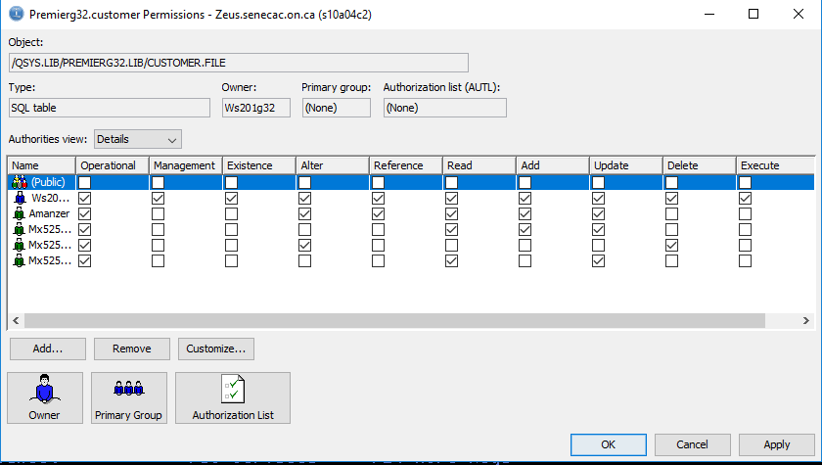

In this screenshot of permission to the CUSTOMER table, the permissions for the Public users are missing.