Transmission Control Protocol

BY:

Arshpaul Kalsi

Ashish Sheoran

Sakshi Jaidhara

## Introduction:

What is a Transmission Control Protocol (TCP)?

* + A Transmission Control Protocol “is a suite of communication protocols used to interconnect next devices on the internet”(Rouse 1). Other words its just a basic language or protocol is part of the internet.

TCP which stands for Transmission Control Protocol belongs to one of the Internet protocol suites. Development of Transmission Control Protocol was to transfer data between or through networks. It was started in the system execution in which it supplemented the Internet Protocol (IP). Thats from where the entire suite is named as TCP/IP. The 4 layer protocol stack was established through TCP/IP and it was supposed to be replaced by OSI which stands for Open Systems Interconnection.

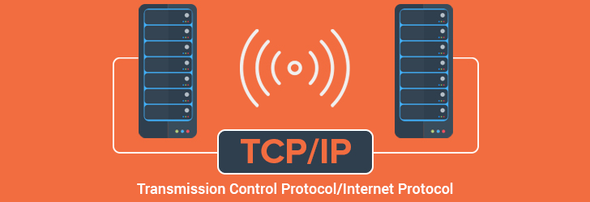

https://www.iplocation.net/tcp-ip

## History:

In 1974, The IEEE which stands for Institute of Electrical and Electronics Engineers designed a Protocol for Packet Network Intercommunication. The Transmission Control Program was the central control component of this model. The host were incorporated by datagram services and connection-oriented links. Then the Transmission Control was created after it was divided at the transport layer and also the Internet Protocol was divided at the Internet layer.

## Packet

### TCP /IP Stack

In todays day and age, the TCP/IP is a hybrid five layer model. In the hybrid 5 layer model the layer structure has layers which are independent from any other layers. The layers help other layers which are above from them.

**Application Layer:**

In the TCP/IP stack the first layer is the Application layer. The Application layer creates the digital format message from the original message by converting it. In this layer the protocols which are used are HTTP, SMTP, FTP, DNS, RIP, and SNMP. The first three protocols which are HTTP, SMTP,FTP help users in process of exchanging information. The last there which are DNS, RIP, SNMP help in Managing the networks of TCP/IP.

## Transport layer:

The Transport layer is below the Application Layer. The Transport layer takes the data which is in the format of digital. The purpose of the Transport Layer is that it adds a header to the message. When adding the header it also has a destination port numbers and source. To ensure the reliable of the delivery it has to add a sequence number to TCP protocol. The size matters as if the message is too large then the layer will fragment the message into smaller bits and then it will add headers to each part of the smaller bits. The layer after adding the header puts everything together into the original message as it got from the Application layer. The other things which this layer does it that it has control over the transmission as in the flow and the Transmission layer; there’s something thing called a packet which is that the message is encapsulated in the wrapper of TCP. Protocols of the Transmission layer are TCP and UDP.

## Internet Layer:

The Internet layer is able to accept or acknowledge the message which in a packet from the layer above which is the Transport layer. After getting the message from the Transport layer including the headers it will add the following information destination IP addresses and source.

The Internet Layer has the information of routing for the packets that go from one side to another through switched networks. This layers packet is encapsulated by a IP wrapper which is called a datagram and the protocols used by the Internet layer are IPv4 and IPv6.

**Datalink Layer:**

The Datalink layer receives information from the layer above which is the Internet Layer in form of a datagram and in this layer it adds two things which is the header and trailer parts. The header contains Media Access Control address to send on a single LAN networks and the Trailer has a Frame Check Sequence number which has to determine the corrupted bits from the Transmission layer. The WAN and LAN are supported by the Datalink layer and it also encapsulates called a frame from the Ethernet rapper. The protocols which can be used are ATM, Ethernet and lastly WLAN.

## Physical layer:

In the Physical layer gets the data in frames as in the Datalink Layer it encapsulates in frames and this layer has to convert the frames by encoding scheme to bits to transmit signals as zeros and ones by radio waves.

## Establishment Process

### Process

The process for establishment as it cannot send the data and also the Transmission process before a connection between two devices. Also the message sequence is a sequence where or how the message is able to be transmitted as the order is important. There is a process of three ways for the TCP to establish the connection. The first way is to contact and communication, the second ways is Parameter exchange and lastly the third way is sequence number synchronization. THe client and server do not know what they will be talking about before but after the connection is established they will be sending messages back and forth.

## Segment Format:

Message Type:

* + The message type is when the the type of message is sent like for an example the type of message is specified to a single task and it's clearly stated.

Message Syntax:

* + The message syntax are the three parts of the message which header, trailer and lastly data part.

Destination Port:

* + The Destination Port has 16 ports where the process is that the recipient of the message is on a device which is called a destination device and it is a notable port number for the request by the client and there’s a transient port for the server.

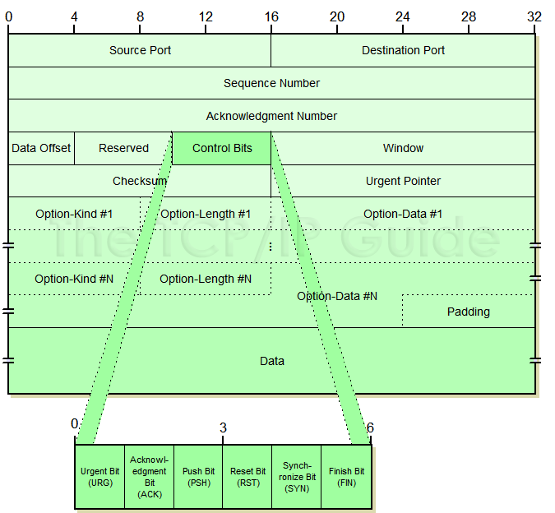

Sequence Number:.

* + For making normal transmissions, we use the first byte of the sequence number in this segment. However, in a connection request message (SYN), this message is responsible for carrying the initial sequence number (ISN) of the source TCP. As illustrated in the sequence number synchronization, the very first byte of data with the size of 4 bytes, will be given the next sequence number right after the content of this field.

Acknowledgement number:

* + When setting the ACK bit, this segment serves as an acknowledgement (in addition to other possible tasks) and this field contains the sequence number of 4 bytes in size that the source expects the destination to send next.

Data Offset:

* + Specifies the quantity of 32-bit expressions of information in the TCP header. At the end of the day, this esteem times four equivalents the quantity of bytes in the header, which should dependably be a various of four. It is known as an "information counterbalance" since it shows by what number of 32-bit words the beginning of the information is balanced from the earliest starting point of the TCP section. Its size is 4 bits.

## Control Bits:

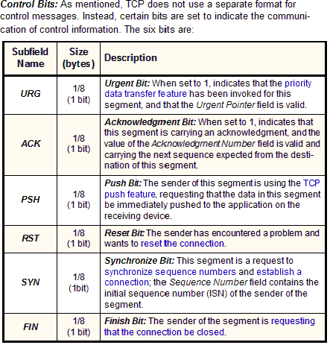

Deliverable #2

Student Assignment Submission Form

 I/we declare that the attached assignment is my/our own work in accordance with

Seneca Academic Policy.  No part of this assignment has been copied manually or electronically from any other source (including web sites) **or distributed to other students**.

 Name(s)                                                                                                                     Student ID(s)

_Arshpaul Kalsi 154344170

_Ashish Sheoran 162543177

_Sakshi Jaidhara 153592167

Work Cited

<https://searchnetworking.techtarget.com/definition/TCP-IP>

Kozierok, C. M. (2005, September 20). *The TCP/IP Guide*. Retrieved from TCP Message (Segment) Format: http://www.tcpipguide.com/free/t_TCPMessageSegmentFormat-3.htm

Kozierok, C. M. (2005, September 20). *The TCP/IP Guide*. Retrieved from TCP Connection Establishment Process: The "Three-Way Handshake" : http://www.tcpipguide.com/free/t_TCPConnectionEstablishmentProcessTheThreeWayHandsh.htm

*Transmission Control Protocol*. (2018, November 25). Retrieved from Transmission Control Protocol: https://en.wikipedia.org/wiki/Transmission_Control_Protocol#Historical_origin

Oracle. (2011). *IP Guide*. Retrieved from How the TCP/IP Protocols Handle Data Communications: https://docs.oracle.com/cd/E18752_01/html/816-4554/ipov-29.html