Functional Requirements

Ashish V. Tambadkar

Stevens Institute of Technology

MIS-620

Professor Paul Rohmeyer

**Table of Contents**

1. Introduction 3
   1. Types of Requirements 5
2. Definition 6
   1. Functional Requirements 6
3. Importance of Functional Requirements 7

3.1 Why functional requirements are important for System analysts and Developers 8

1. What could go wrong if Functional Requirements are not managed properly 10
2. Analysis and Conclusion 12
3. Bibliography 13

**Abstract**

This paper focuses on Functional Requirements of a system and why it is important for system analysts and developers to understand the significance of Functional Requirements and failing to do manage this sector may result into what sort of negative impact.

This paper will also develop knowledge about what exactly Functional Requirement is, as we move ahead in the paper, and in the end this paper will conclude with answering the above-mentioned questions.

**Keywords:** Functional Requirements, System Analysts, Developers, Significance, Manage, Negative Impact

**Introduction**

It is very important to look after what user has to say or where the user is comfortable with the product and based on that product features must be designed such that they are able to justify the needs mentioned by the user or stakeholders.

These product functions which then will be designed according to the user or stakeholders’ needs are known as Functional Requirements and we will be talking about it a lot in this paper.

Think about the Functional Requirements as things the product should do from the perspective of the business. When you have a conversation with business partners, they will depict those activities, as in which item they should take to finish some piece of their work. You can likewise imagine the Functional Requirement as being free of any technology that may be utilized.

It is critical to recall that Functional Requirements should report what a system should accomplish and not how it does it.

The main issue of these requirements is depiction of the required behavior which must be understood clearly. The described conduct may originate from business tenets, or it might be found through the requirements process.

The Heading line while writing a requirement is that it should be clear, right, unambiguous, explicit, and certain.

“Functional requirements present a complete description of how the system will function from the user's perspective. They should allow both business stakeholders and technical people to walk through the system and see every aspect of how it should work before it is built” (Scott McEwen, 2004).

From above definition we can understand the significance of Functional Requirements and keeping this idea in mind we will move ahead with by visualizing what exactly Functional Requirements are with the help of a small diagram in the next section which is Defining Functional Requirements.

**Types of Requirements**

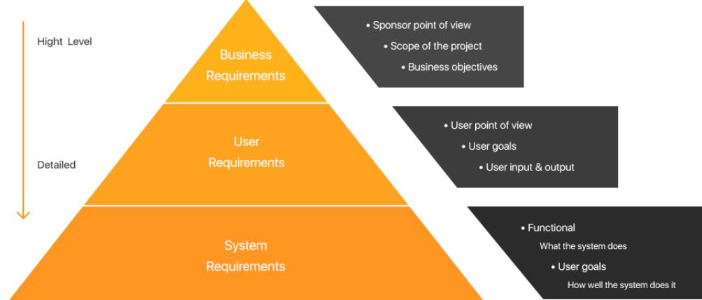

Fig1 Describes the position of Functional Requirements using a diagram. Taken from Olga Semusheva “Requirements. Why is it important?” [Blog Post]. Retrieved from [https://steelkiwi.com/blog/requirements-why-it-important**/**](https://steelkiwi.com/blog/requirements-why-it-important/)

Above Diagram helps us to understand where functional requirements belong as in it comes under system requirements and they specify what the system does and not on how it does.

**Definition**

Functional Requirements

Functional Requirements distinguishes the various capacities that the system needs to perform so as to meet the supported need, objectives, and targets according to stakeholders’ requirements.

The analysis recognizes all capacities, including support works, that are important to keep up or restore the system to operational use.

The focus is always on what should be accomplished, not on how it must to be finished. So Basically, Activities performed by a system is known as Functional Requirements.

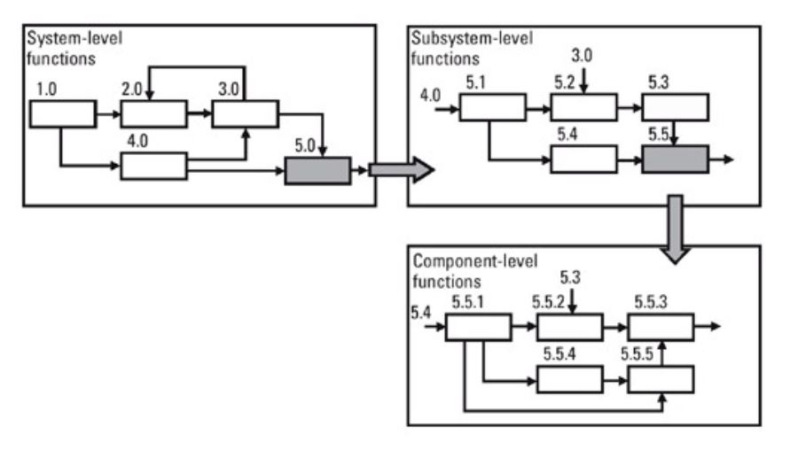

Fig2 Describes a possible way to analyze functional requirements. Adapted from Managing Complex Technical Project: A Systems Engineering Approach by Faulconbridge, R. Ian, Ryan, M.J.,2003

**Importance of Functional Requirements**

In ordinary day to day conversation with customers we lay weight on functional requirements in any case. It's important to see plainly what needs, targets, objectives and final product the customer is seeking.

Here is a famous diagram, The purpose of this diagram is to target the message "Why do we need requirements" and why is it so important ?. One should give careful consideration to Functional Requirements, sometimes talking about simple things that a few people may see diversely however, may result into completely different product.

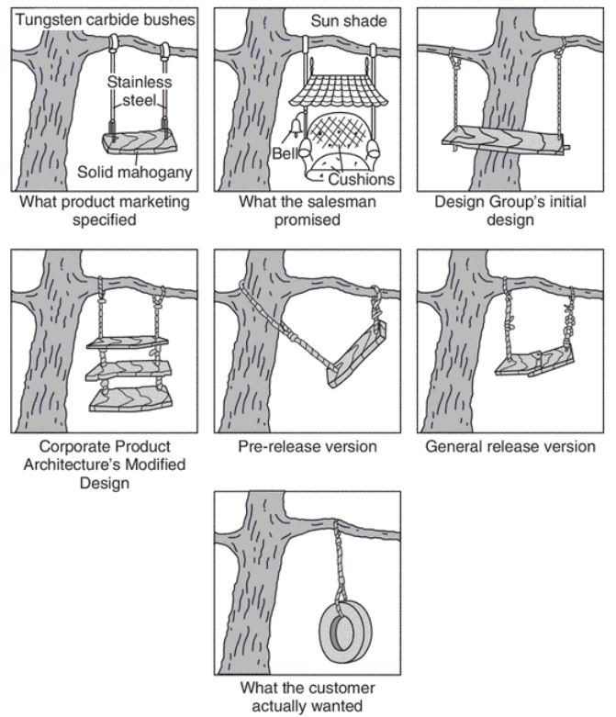

Fig3 The swing solutions. Source: Anon

Stakeholders are very important person for any system and they all have this habit of giving different names to the same thing thereby creating a huge amount of misunderstanding and since stakeholders play such a crucial role it’s advisable if we sort out roles and responsibility right at the start to avoid all the misunderstandings in the near future.

It is vital for the developer group to understand the difference between what are needs and what are features and to record them in independent documents. The Reason behind this is that Needs belong to problem area and features belong to solution area.

It is very important for system analyst and developer to understand the problem first and then come up with the solutions because you can then discover chances to sum up the arrangement once you completely comprehend the issue (Scott McEwen, 2004). As such, if you isolate needs from features, you can find features to meet multiple needs.

Requirements are the establishment of all great structure, design, portfolio, task or arrangement coordinated effort. Whenever aggregated as needed, they catch the vision and thinking from a differing range of staff and archive the arrangement as it's advancing.

Functional Requirements are statements and a system is responsible for delivering those requirements based on how the system reacts to a particular input and how the system should behave in specified circumstances.

**Why Functional Requirements is important for System analysts and Developers**

The reason for functional requirements is that once the business analyst has understood the necessary functionality of the product, he uses the functional requirements to explain to the developers what must be built [1].

System analyst acts as a mediator between Requirements and IT people. System Analyst is responsible for asking the what if? questions to the customers and important stakeholders and for that knowledge about Requirements is must.

When beginning a task, also to accomplish an alluring outcome toward the end goal of that task, it is very important to have the requirements. They ought to incorporate every one of the highlights and function a product ought to have.

Requirements must be such that every individual involved in that must understand, also it should be such that every stakeholder present over there should understand requirement in a similar way the system analyst understands.

The outcome of this would lead better information gathering from the user or customer also based on the requirements, system analyst can know which one of them are crucial for the system. As the system analyst assemble data, the person in question will utilize that data to make models that express the client's needs as far as exact preparing Functional Requirements.

Once the functional requirements are listed, the next role is of developers since they are the one’s who will design and implement the functional requirements as said by the user in detail and analyzed by system analysts.

Developers may also specify somethings related to the user interaction with the software as well the price, performance and the reliability in detail to the user.

Developers rely on requirements so that they will be able to deliver a quality product, without requirements developing a quality product is going to be a hard time especially when you don’t know how the product is going to interact with the user and will that interaction lead to a positive or negative feedback. That being said a developer can also not completely be dependent on functional requirements, but they have to be in continuous conversation with the end user such that they can justify the task handed to them by bringing out a quality product which ensures a satisfactory reaction from the end user.

**What could go wrong if Functional Requirements are not managed properly**

When technology changes rapidly, domain experts may no longer be “experts.” Techniques and solutions that worked for many years may become obsolete or irrelevant. Such technological discontinuities may require substantial new training, or the experts in the older technologies may make poor decisions for new product designs [3].

Requirements will in general change through as the time goes, with the outcome that the product as conveyed may not relate to the accessible Software requirements specifications.

In addition, meeting the majority of the requirements doesn't guarantee a quality item, rather the requirements might not have been characterized with an eye towards the nature of the end-client's understanding.

It must be remembered that most systems under development are not new; i.e., only a fraction of the requirements in the product are new or unique [Jones 2007].

Yet issues of requirements maintenance and long-term support are often missing from project plans; e.g., the project plan is created as though the requirements will be discarded after project completion. When requirements management is not planned, requirements creep can cause significant problems late in a project [3].

Requirements stored in paper form rather than in a requirements repository are difficult if not impossible to create, manipulate, and maintain. Scattered requirements are hard to find, sort, query, and maintain. Lack of access control makes it difficult to limit access to sensitive requirements and to achieve proper change control. Lack of centralized, automated management of requirements also makes it difficult to capture, analyze, and report requirements metrics (e.g., requirements stability, maturity, and completion) [Donald G,2007].

**Analysis & Conclusion**

* To conclude this paper, Functional Requirement are something which you can see directly in the final product as these requirements were specified by the user.
* Since the focus is always on what you accomplish and not on how you accomplish these requirements basically act as input to the process which then comes out as a form of output which you can see in the final product.
* The Functional Requirements are critical when beginning an undertaking on the off chance that you need to accomplish an attractive outcome toward the end goal.
* They must incorporate every detail item ought to have.
* Requirements must be understood by every single individual like System Analyst, Developer, client, owner of the product etc. and be free of any ambiguities i.e. every one of the stakeholders should comprehend requirements similarly.

**Bibliography**

[1] James Robertson, Suzanne Robertson. “Mastering the requirement process”, 2006

[2] Stellman, Andrew; Greene, Jennifer (2005). "Chapter 6: Software requirements". [*Applied Software Project Management*](https://books.google.com/books?id=IYdJocLVa8wC&pg=PA97). O'Reilly Media. pp. 97–130.

## [3] Brian Berenbach; Daniel Paulish; Juergen Katzmeier; Arnold Rudorfer (2009). [*Software & Systems Requirements Engineering: In Practice*](http://www.mhprofessional.com/). New York: McGraw-Hill Professional

[4] Scott McEwen, Requirements: An Introduction, 2004

[5] Jones, C., Estimating Software Costs, 2nd ed., McGraw-Hill, New York, 2007

[6] Donald G. Firesmith: "Common Requirements Problems, Their Negative Consequences, and Industry Best Practices to Help Solve Them ", in Journal of Object Technology, vol. 6,no.1,January-February2007,pp.17-33 <http://www.jot.fm/issues/issue_2007_01/column2>